I am a retired PhD epidemiologist highly concerned about recent decisions limiting access to vaccines. "Shared decision making" does not ensure access for vulnerable people. It ensures more hurdles - MD appointments and out of cost expenses. It discriminates against higher risk people at a tremendous cost of excess morbidity and mortality especially for working age adults. It also increases lack of clarity and guidance for vaccination during pregnancy to protect 0-6 month olds from COVID hospitalizations and death.

In simple graphics, here are pieces of evidence for the need for continued universal access to COVID vaccines:

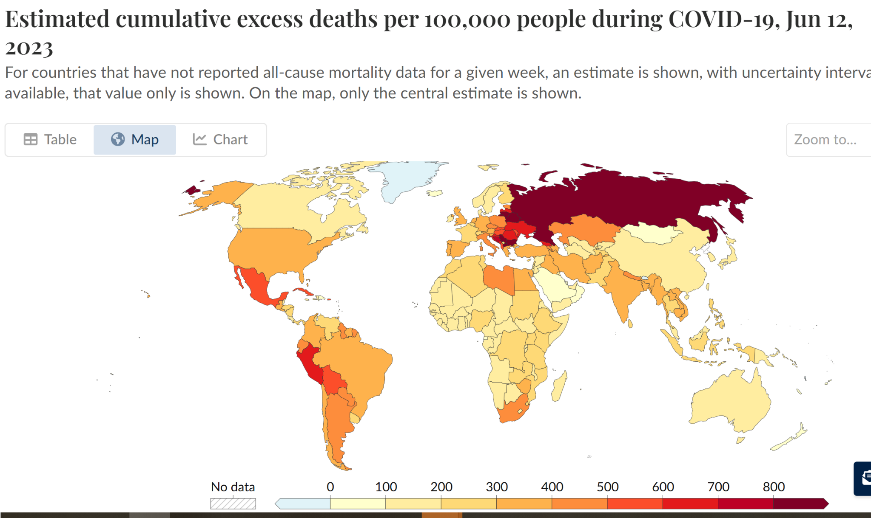

Source: https://ourworldindata.org/coronavirus

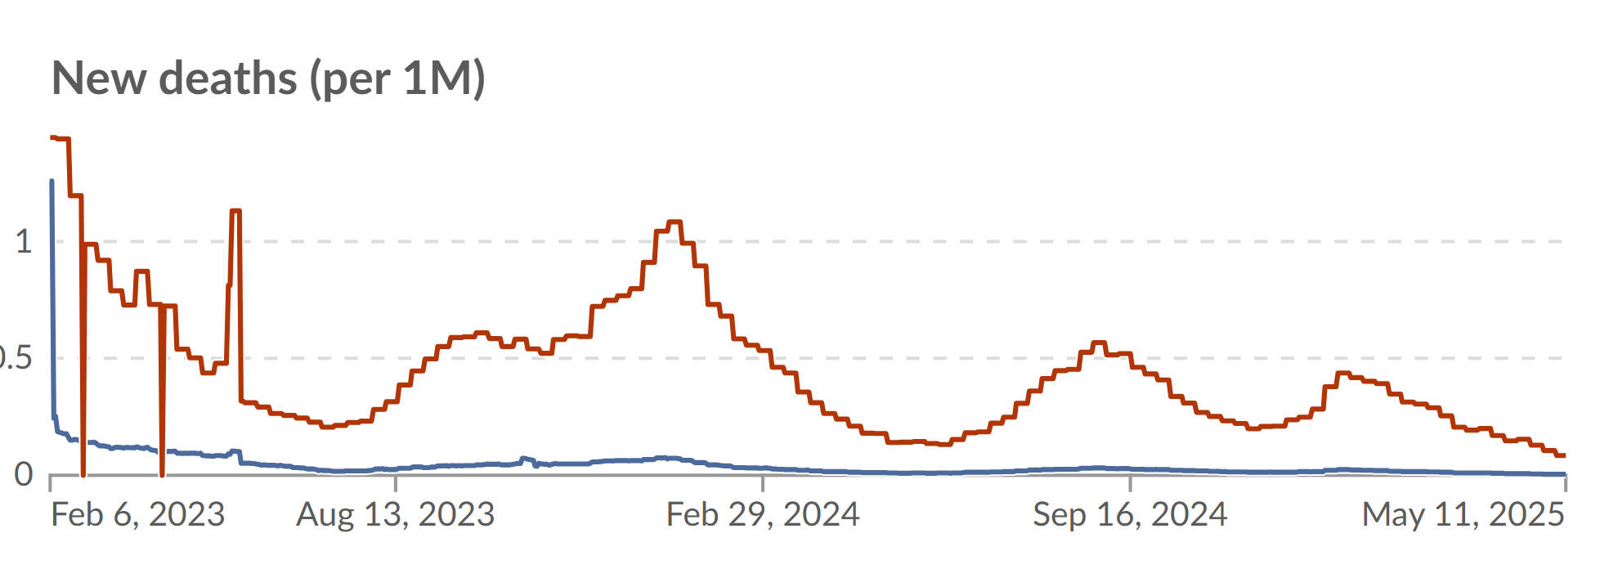



Source:

Here is where we are with respect to vaccine doses:

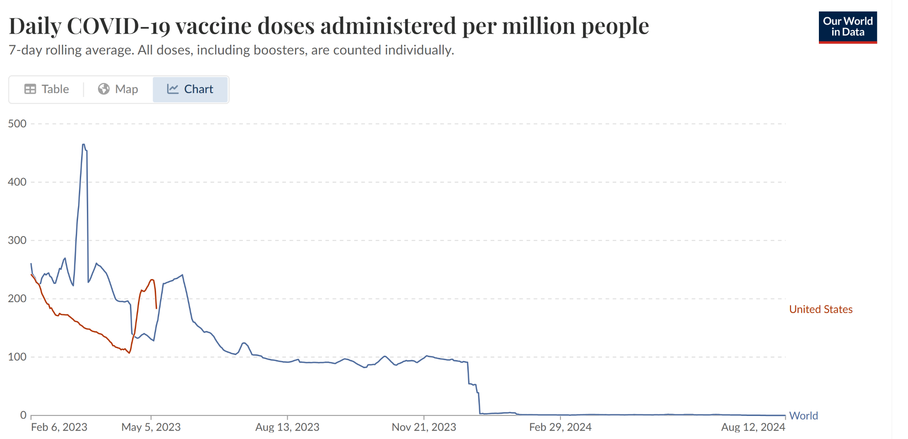

  
Source: https://ourworldindata.org/covid-vaccinations

Here is where we are with respect to infants COVID outcomes by maternal vaccine status:

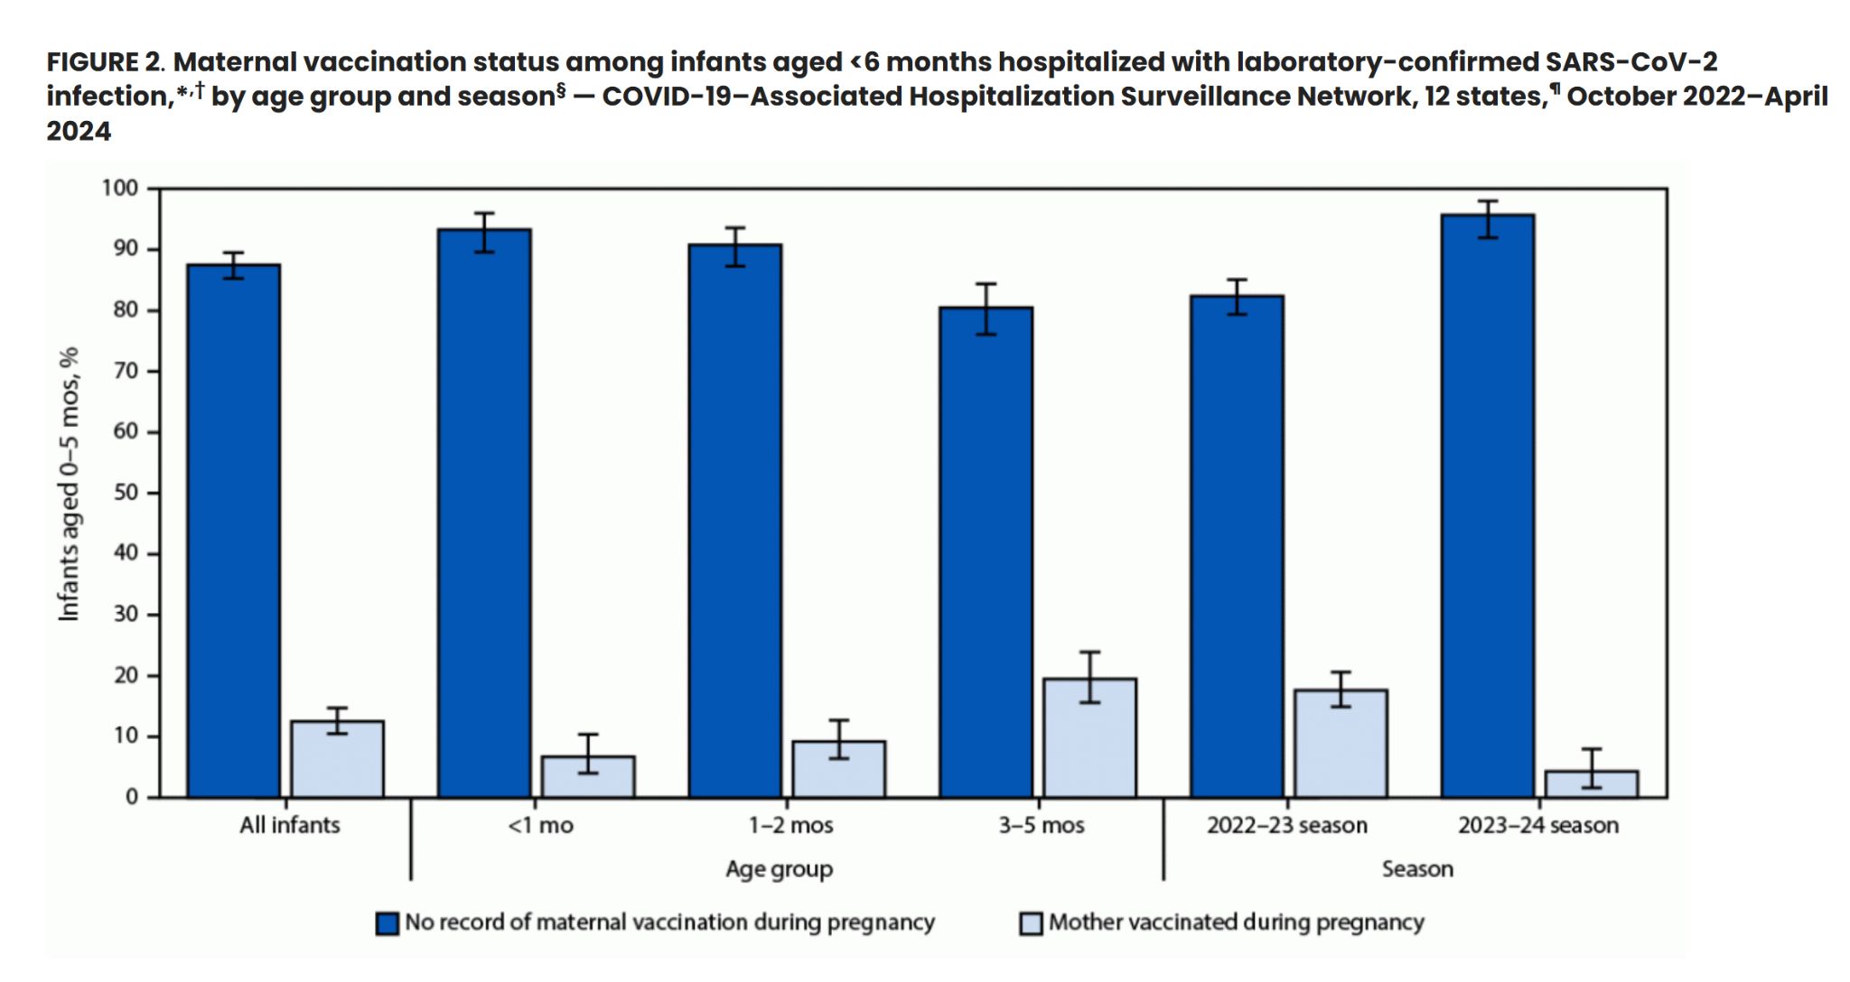

Source: https://www.cdc.gov/mmwr/volumes/73/wr/mm7338a1.htm

It’s appalling how quickly evidence-based, public health prevention and guidance has been so quickly replaced by opinion-based, political decision makers.

What these decision makers fail to embrace are fundamental principles: that vaccines save lives, that we need more effort and funding to overcome vaccine hesitancy, vaccine misinformation, and limited vaccine access.

Terminating ACIP, the distinguished scientific advisory board, is an authoritarian move that disregards the process for guidance for the United States’ public health and wellbeing.

Given the overwhelming scientific and public health evidence, we need to ensure updated, bi-annual universal (with exception of 0-6 months of age) access - not limit it.

Laura S. Diamondstone, Ph.D.