Can Vaccines Alter a Child’s Health Trajectory? by [Rob Abbott, MD](https://kellybroganmd.com/author/robkellybroganmd-com/)

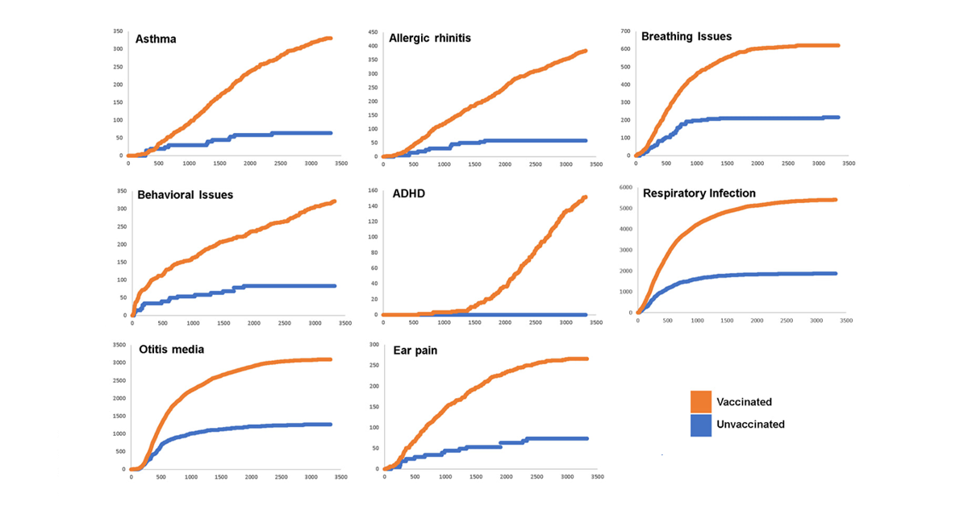

The question embodied in the title of this article is one that has never fully escaped the weaves of my inquisitive mind. In medical training we are taught that vaccines prevent acute illness, thwarting sometimes life threatening infections by various microorganisms. Certainly, the prevention of a life-threatening infection is an alteration of a child’s health trajectory, but in what direction and to what end? Surely it would seem that the only possible health trajectory from the avoidance of an acute infection would be improved health, vitality and lessened suffering, but is this picture the actual reality that we face?

Do we actually possess immunotherapies such as vaccines that carry no risk and only propel children towards improved well-being, less medical intervention and less suffering?

The dominant medical narrative at this point in time shares that vaccines, as currently administered to youth, carry minimal risks and that they prevent “avoidable” deaths from infectious disease without a reciprocal increase in total suffering over the life of the child. Sadly, we do not yet have the data to fully support or refute this dominant medical narrative as there have been essentially no clinical studies completed to date that have rigorously compared the dynamic health trajectory of children following the most recent recommended vaccine schedule to those forgoing some or all vaccines altogether. We simply do not know.

As a clinician bearing witness to the greatest rise of chronic diseases in our youth that humanity has ever seen, how can you not become curious as to why?

The issue is complex and massively nuanced. Our environments are as toxic as ever and the average child’s diet is a nutrient deficient, pro-inflammatory dumpster fire. Social and family bonds seemingly carry more tension and trauma than love and the concept of outdoor play is being eroded from the fabric of our youth. The truth is that the rise of chronic diseases in youth is related to all of these factors and still more that we have yet not named, but not having all the answers can’t stop us from being curious, from looking for clues unearthed through courageous, scientific inquiry.

This past November, a [landmark paper](https://www.mdpi.com/1660-4601/17/22/8674/htm) was released in the *International Journal of Environmental Research and Public Health* by researcher James Lyons-Weiler and integrative pediatrician Paul Thomas as they themselves sought to answer the unavoidable question, “Can vaccines alter a child’s health trajectory?”

Perhaps at this point you have an answer yourself to this question. Perhaps you have a personal experience as a mother, a father, a medical provider or as the person yourself informing your beliefs. Perhaps you have read studies pointing to vaccine’s safety and others still pointing to their harms. Perhaps you have come to this article based on its title to seek an answer that you have not yet formed at all. No matter from whence you enter this explorative space, no matter your current beliefs or understanding of this topic, I gently invite you to let these beliefs, these narratives, this current understanding go.

I invite you to explore this summary of Weiler and Thomas’ recent vaccination study with “a beginner’s mind”, waiting until after this conscious exploration to integrate your understanding of their data and their conclusions into a new personal, working narrative. This invitation now I give you.

Study Overview

The researchers examined a total of 3324 pediatric patients who received care in an integrative pediatric practice over a 10 year period. Patients could be included in the study if they were seen within 60 days of birth (essentially born into the practice) and had a final visit at least after 60 days of life. (*We will talk more about this key fact later!*) No other restrictive inclusion or exclusion criteria were utilized.

* 2763 received at least 1 vaccine (variably vaccinated group)
* 561 received no vaccines (unvaccinated group)

Demographics of Patients

* Both vaccinated and unvaccinated patients had extremely high breastfeeding rates nearing 97-98%
* There was a statistically higher percentage of unvaccinated patients with a family history of autoimmunity (likely representing an informed choice by the parents/caregivers to have the child abstain from vaccines that could be a trigger for immune dysregulation.)
* Similar percentage of males and female in both vaccinated and unvaccinated groups
* Similar birthweight in both vaccinated and unvaccinated groups
* Vaccinated patients on average received care for twice as long as the unvaccinated patients (the researchers called this Days of Care [DOC] and performed corrections/matching within their statistical analysis to correct for this as I will explain more later).

Vaccination Rates

There were markedly variable rates of vaccination in those receiving vaccines as depicted in Figure 2 in the study.

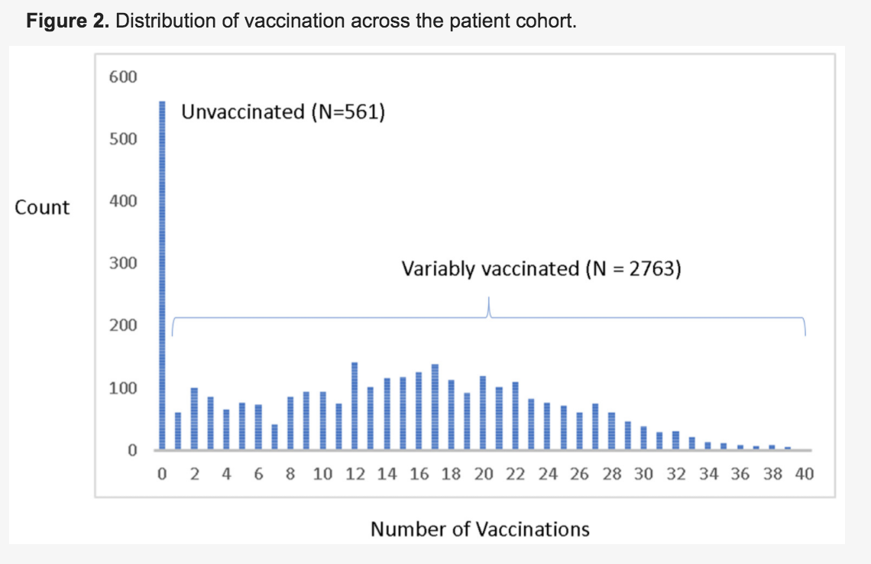

Key Study Questions

In an attempt to answer the question of whether vaccines change the health trajectory of children, the researchers employed four primary study measures.

Relative Incidence of Office Visits (RIOV)

The researchers looked at electronic medical record and billing data of patients to determine the number of patients who had an office visit associated with a specific diagnosis or disease state (ex. eczema). They wanted to know if vaccinated kids were more or less likely to have an office visit for nearly 20 separate conditions/health concerns as compared to unvaccinated kids.

Incidence of Disease

In addition to the RIOV analysis, the researchers also conducted a more standard incidence of disease analysis, essentially looking at the study groups, vaccinated and unvaccinated and seeing if there were a greater number of kids in either group developing any of the predetermined health conditions over the course of receiving care.

Diagnosed Infections Targeted by Vaccines

The researchers tracked the number of documented infections targeted by vaccines on the CDC schedule between the groups.

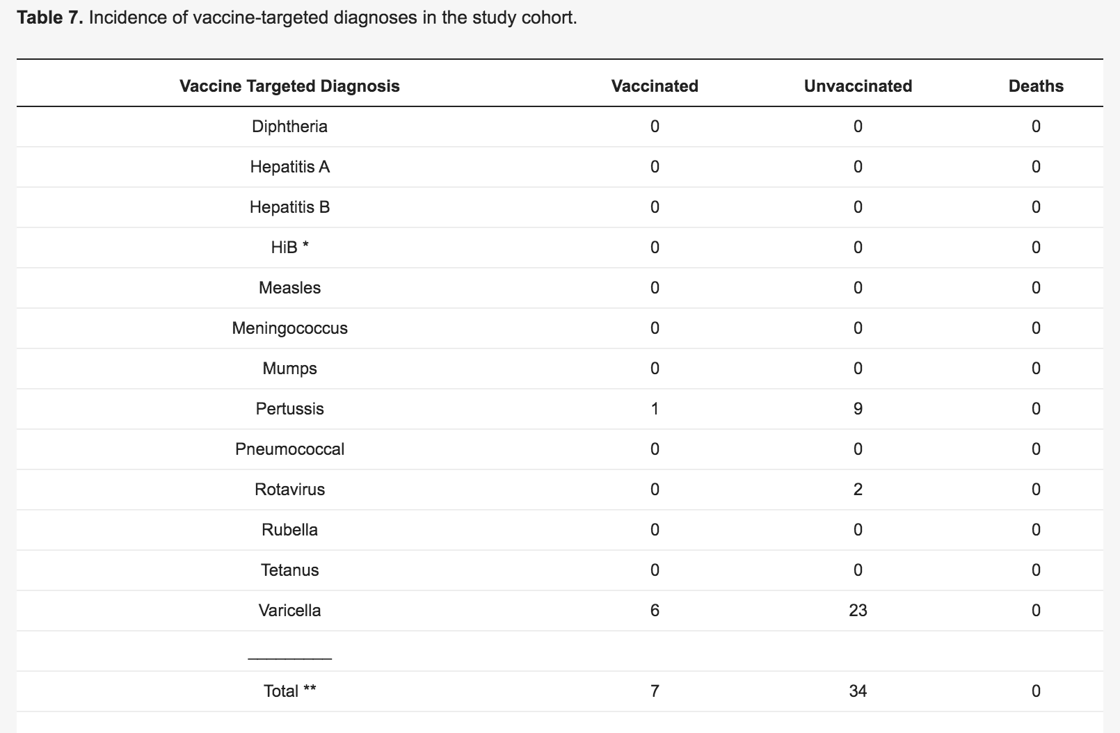

Cumulative Office Visit Risk

In addition to the relative incidence of office visits (RIOV) study measure mentioned earlier, the researchers also sought to look at the *cumulative or total* number of office visits between vaccinated and unvaccinated patients. Through this analysis, each office visit for a specific health condition, even if from the same patient, would be examined to better understand total health care utilization and potential suffering.

Statistical Analyses

The statistical analyses utilized were fairly complex, and we will not go into great detail to explain them for the sake of this summary, however, I want to acknowledge the earlier noted difference at baseline between the vaccinated and unvaccinated children around total Days of Care (DOC) in the practice. Seeing that the unvaccinated children received care on average for half as long as the vaccinated children, the researchers conducted patient matching from the variably vaccinated group in order to make two groups (vaccinated and variably vaccinated) that had the same number of children (561) and the same average Days of Care. They then performed separate statistical analyses using both the unmatched (total) and matched groups.

Key Results

General

* No kids in the unvaccinated group were diagnosed with ADHD.
* Rates of autism and developmental delay amidst the entire practice were not at high enough levels to find any significant signal for vaccines or no vaccines (incidence was below national averages).

Unmatched (Total Group) Analysis for Relative Incidence of Office Visits (RIOV)

* There were marked trends for higher RIOV for nearly all of the diagnoses studied in the vaccinated group as compared to the unvaccinated group.
* Amidst the vaccinated groups, there were marked trends for higher RIOV for those receiving a higher number of vaccines (more vaccines  = more office visits for a certain disease).

*Note: See Figure 4 of the study for these graphs*

Matched (Equal Size Groups) Analysis for Relative Incidence of Office Visits (RIOV)

* The same trends noted in the “Total Group” analysis were seen in the matched analysis, with vaccinated kids having more office visits for nearly all of the diseases studied as compared to the unvaccinated group.
* The only 2 conditions for which there were numerically more office visits in unvaccinated kids as compared to vaccinated kids were urticaria (hives) and dermatitis (skin irritation), but these were not statistically significant.

Unmatched (Total Group) Analysis for Incidence of Disease

* Similar to the RIOV analysis, the researchers found higher levels of vaccinated patients being diagnosed with the specified diseases as compared to the unvaccinated patients.
* As compared the the vaccinated group, the unvaccinated group had the greatest absolute decrease in risk for developing anemia (low hemoglobin), weight/eating disorders and respiratory infections. (no vaccines = significantly decreased risk for being diagnosed with anemia, weight/eating disorder and respiratory infections among many other conditions).

Diagnosed Infections Targeted by Vaccines

* There were no deaths from any of the infections targeted by vaccines amongst the unvaccinated group (and vaccinated group).
* As depicted in Table 7 of the study (picture below), there were more cases of unvaccinated children getting pertussis and chickenpox (Varicella) than in vaccinated children.
* No more than 6% of the unvaccinated group developed an infection targeted by vaccines and the overwhelming majority of cases were related to chickenpox.

Cumulative Office Visit Risk

Even after correcting for the difference in size between the unvaccinated and vaccinated groups, the researchers found staggering differences from the cumulative number of offices for specific diseases between the two groups, with the vaccinated patients accumulating markedly more office visits for all of the diseases studied including allergic, infectious and neuro-developmental conditions. Taken from Figure 5 of the study, the graphs shown below depict the number of office visits for patients related to various diagnoses across the lifetime of the patient in the practice. (*note: the x-axis or horizontal axis of the graphs represents days of life, the y-axis or vertical axis represents the number of office visits*).

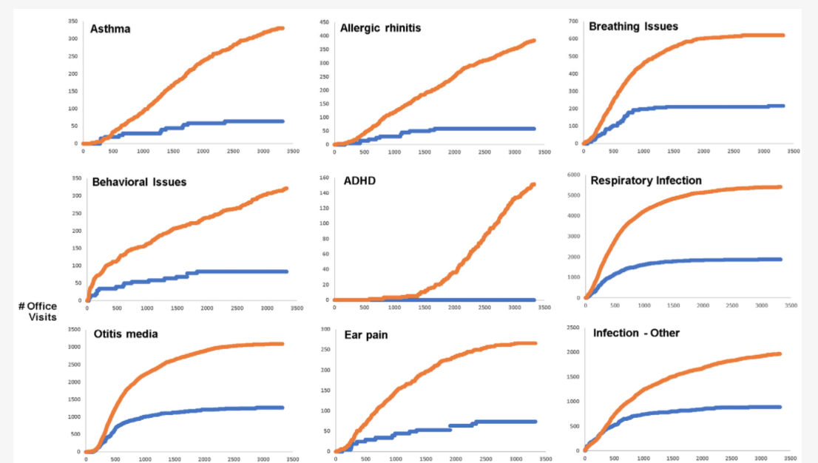

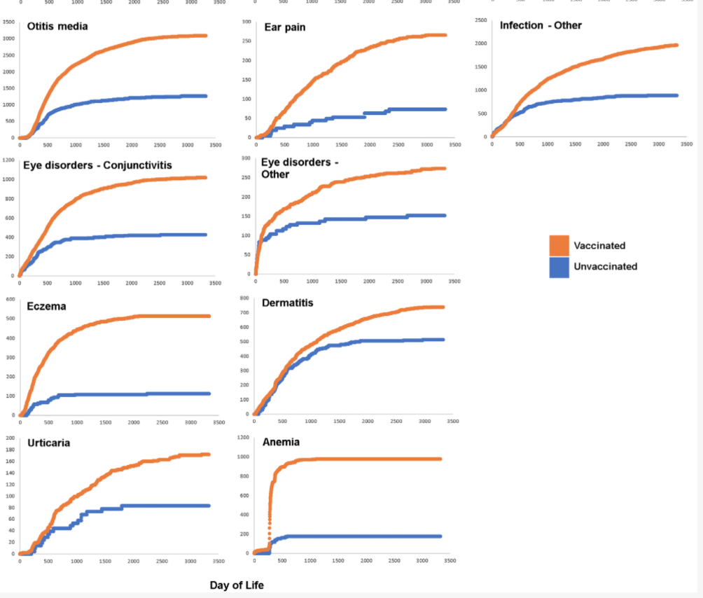

Key Conclusions

This data inspires concern for the health trajectory of vaccinated children. As a family medicine resident, I saw significant “medical trauma” whereby children were constantly receiving medical care or going to office visits for chronic health maladies that seemingly had no cure. Generally attended by well-meaning and loving parents, these kids were stuck on a ferris wheel of conventional medical care. While it is impossible to universally quantify a child’s experience of medical care, discerning on their behalf what is felt as loving care versus “medical trauma,” I cannot help but conclude, from the data presented here,that the vaccinated children were sicker and experiencing more suffering from infectious, autoimmune and neurodevelopmental disorders than the unvaccinated children. Recognizing that this suffering would also be felt to some degree in the familial units, we can expand these graphs and hypothesize that the parents and siblings not even represented in this study were likely being negatively affected as well.

Looking more closely at the cumulative office visit graphs shared previously, another fascinating trend starts to stand out. Within the unvaccinated group, it appears that many of the health conditions examined in this study reach an asymptote around a thousand days of life or 3 years old. Essentially, the unvaccinated group reached a steady state of office visits for each condition studied around 3 years of age onward. When looking at the vaccinated group, however, you see very different trends. Generally speaking, for conditions that even reach an asymptote, the “leveling out” of office visits is markedly delayed until much later in life. In some cases/health conditions, the graphs depict a persistent rise in office visits without yet reaching an asymptote. If vaccines were actually making kids generally healthier wouldn’t we see at least comparable (or opposite) trends between the groups?

Study Limitations

Science is not perfect. It is simply one tool of curious inquiry. The study was limited by the fact that it involved children from one integrative pediatric practice. Understanding this fact, I would suggest that these kids received more holistic medical care at baseline and were part of more engaged, health-conscious family units than the average child. While this is certainly a study limitation, it also raises the question: *would we see even worse health outcomes and medical care for vaccinated patients in average pediatric practices?*

Additionally, some of the key neurologic conditions such as autism and developmental challenges were not present at high enough levels in the integrative pediatric practice as a whole to be able to see any significant signal with regards to vaccines or no vaccines. Larger studies with higher numbers of these conditions would help us to better understand how vaccines may be involved in changing the health trajectory of children in connection with these neurologic conditions.

Why Hasn’t This Been Seen Before?

Studying vaccines is remarkably controversial. Most of the studies performed by pharmaceutical companies only last months. Even retrospective studies look at a relatively narrow sliver of time. This study involved 10 years worth of pediatric patient care.

In addition to its length period of analysis, the study was also remarkably unique with regard to the origins of the patients themselves. They were born into the practice! While the children obviously came from different mothers and different households with an innumerable number of confounding variables, these patients were followed from as similar a starting place AND health trajectory as one may ever find in a research study.

What Can I Do?

So what are you thinking now? Do vaccines negatively change the health trajectory of children? I can’t give you a definitive answer to this question simply from one study or ever answer this question for you. I can only invite you to incorporate this new information into your current understanding of the role of vaccines in the health of our children as I take pause to wonder if we are messing up.

To take a deeper dive into the published literature challenging the safety, efficacy, and necessity of vaccines, [download our Vaccines & Brain Health eBook](https://kellybroganmd.com/vaccines-and-brain-health-ebook/).