The DHS hiring surge in ICE & CBP: how big, did it stick, who’s leaving?
Analyst memo · data through Jul 2026 · every figure is reproduced in dhs_hiring_surge.ipynb
Bottom line. The 2025 DHS surge was overwhelmingly an ICE event, concentrated in Sept 2025–Jan 2026 and in entry immigration-enforcement officer jobs. It did put people on the payroll — ICE grew about 46% — and headcount has since slipped further (about 5% off its January peak) as those hires begin to leave. More than one in four of the ~7,200 entry-officer surge hires has already left — mostly by quitting — before their first year is even up, already past what comparable CBP law-enforcement classes shed over a full year (~10–11%).
Source. OPM/EHRI records for hires, departures, and monthly headcount, read directly from the HuggingFace dataset impactproject/opm-ehri-data. ICE = agency code HSBB, CBP = HSBD. Each record is a count of people, not one named individual — see caveats.

1. The surge was ICE, and it was big but brief · notebook §1
ICE normally hires about 700–1,350 people a year. In 2025 it hired 10,474 — roughly 8× normal — and the burst was tightly concentrated: about 10,133 hires fell in the five months Sept 2025–Jan 2026 alone, peaking in December, then falling back to normal monthly levels. It is about 99.6% genuine new hires, not transfers from other agencies (transfers = 0.4%). CBP’s increase was modest (2025 was about 1.2× its 2024 level); its ramp is smaller, later, and Border-Patrol-focused.
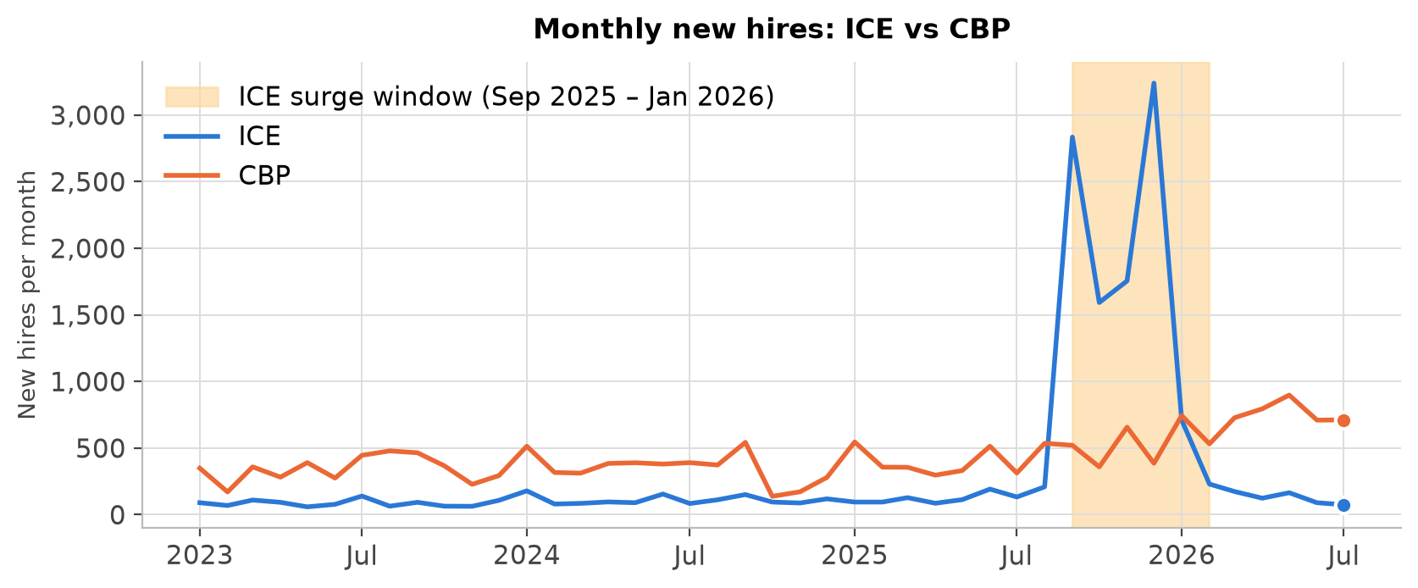
Monthly new hires, ICE vs CBP — a sharp, brief ICE burst in Sept 2025–Jan 2026 (shaded); CBP barely moves.

1b. The biggest hiring year in ICE’s history · notebook §1b
Extending the series back to 2006, ICE’s previous annual hiring record was about 1,966 (2009); 2025’s 10,474 is about 5.3× ICE’s all-time record and 8× its recent norm. The 2017 executive order directing 10,000 new ICE officers produced no visible surge — hiring stayed near 700–1,300/year. The only comparable buildup in this data is CBP in 2007–2009 (about 7,000–9,000 hires/year, the Bush-era Border Patrol expansion); and CBP’s most recent rapid entry-officer push, in 2019–21, lost nearly 30% of new hires within the first year (§4b).

2. It reached the payroll — then kept edging down · notebook §2
ICE headcount went from 20,848 (Aug 2025) to 30,461 (Jan 2026), a roughly 46% jump. It has since slipped to 28,861 (Jul 2026), down 1,600 (−5.3%) from the peak, even though some hiring continued — a larger decline than it looked a couple of months ago (−4% as of May), consistent with the surge cohort continuing to leave (§4). CBP rose gradually (67.3k→70.3k since Aug 2025) with no reversal. So the ICE workforce is still far above its pre-surge level — up roughly 8,000 since August even after the slip — but the ~5% decline from January’s peak is real, and §§3–4 show it is the surge hires themselves leaving.

3. Who the surge hires are — a job profile · notebook §3
With no person IDs, we identify the surge hires by the jobs they were hired into, comparing them with normal ICE hiring. The surge is unmistakable in job and pay plan: job series 1801 (General Inspection, Investigation, Enforcement, and Compliance — the ICE deportation / immigration-enforcement officer series) is about 64% of surge hires vs 20% normally (3.2× as common); with 1811 (Criminal Investigation) the two are about 87%. About 68% are on the GL entry law-enforcement pay plan at grades GL-05/07/09. Other markers: term (non-permanent) appointments are about 3× as common, and the age mix skews unusually older. Profile = GL pay plan + series 1801/1811. Because ICE had almost no one in these jobs before the surge, any jump in departures from them is the surge hires.

4. The leavers are the surge hires — and they’re mostly quitting, not being let go · notebook §4
Departures from these jobs ran a flat 27–46 per year (2018–2024), then jumped to 739 (2025) and 1,303 in just the first seven months of 2026 — already 76% more than all of 2025, in barely half the year — about 50–60× the prior norm, beginning the same month hiring did. Of those exits, about 69% are voluntary quits and about 27% are involuntary terminations (expired term appointments plus some probationary removals; the data lumps the two together).

4b. More than one in four is already gone — before the first year is up · notebook §4b
Watching the whole group’s exits against its own hires, 1,987 of 7,214 surge hires (27.5%) had left by Jul 2026, and still climbing because hiring stopped while exits continue. We can’t yet state an ICE first-year rate: the group’s first year isn’t over for the cohort as a whole (the earliest arrivals, from Sept 2025, have only about ten months in; later arrivals less), and annualizing a partial year would mislead. But that ~28% already exceeds what CBP’s comparable entry classes shed over a full first year — about 10–11% for Border Patrol (series 1896-GL, Border Patrol Enforcement) and CBP Officer (series 1895, Customs and Border Protection) in 2023–24 — and is closing on the roughly 29% that CBP’s own 2019–21 rapid-hire Border Patrol classes lost across a full year. ICE’s early loss is already near the high end of that range, with its first year not yet complete.
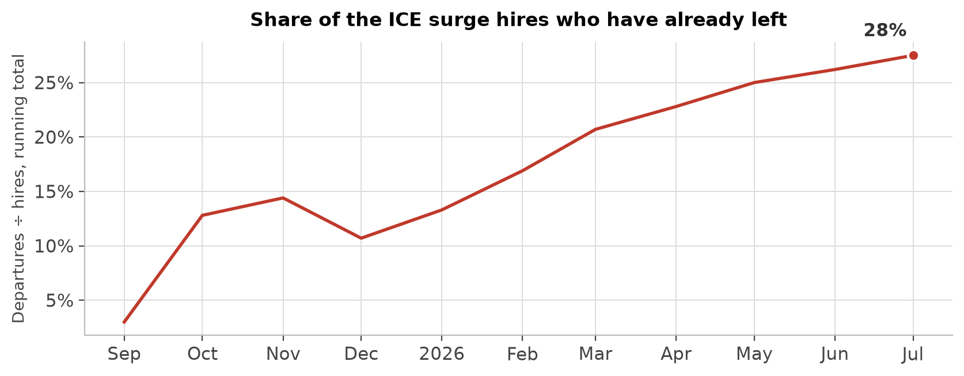
Cumulative share of the ~7,200 entry-officer surge hires who had separated, by month — more than one in four within the first year, and still climbing.

What the data can’t say (caveats) · notebook §5, checked in §0
- Counts, not people. We match departing jobs to hiring jobs; we can’t prove a specific leaver was a specific fall-2025 hire. The match is tight only because these GL entry jobs held few people before the surge (~1,500 in Aug 2025, small next to the ~7,200 hired into them). The group we track cleanly is the ~68% who are entry law-enforcement officers (GL-1801/1811); the higher-grade officers and attorneys can’t be isolated the same way.
- Length of service is not time in the job. The service figure is total federal service; about 30% of 2025 ICE new hires arrived with 3+ years of prior service — a mix of veterans (military credit) and prior federal civilians (rehires), not transfers. This is why we define the group by job and grade, not by length of service.
- Headcount and flow don’t reconcile — hires minus departures lags the headcount change by about 15–20% (timing plus provisional late reporting), so we use headcount for levels and departures for exits, never chained. The “headcount is declining” finding rests on complete point-in-time headcount snapshots, not on provisional flows.
- Involuntary exits can’t be fully split (term-appointment expiration vs. removal for cause), and the elevated departures are not a buyout-program artifact: the separations drp_indicator field flags none of the 1,987 cohort departures (and none of the ~4,100 ICE departures in the window) as deferred-resignation-program exits.
Method checked (notebook §0): ICE=HSBB / CBP=HSBD confirmed as the only ICE/CBP codes, stable 2008–2026; monthly files confirmed to add new actions, so summing across files and grouping by the effective-date field is required (a single file holds only ~30% of December’s hires, so one-file-per-month undercounts that surge month by ~70%) and does not double-count; redaction preserves totals; headcount de-duplicated to one snapshot per file.
Reproduce: python src/extract.py and python src/history.py (pull the data → data/), then run dhs_hiring_surge.ipynb. The surge-hire definition and windows are in src/surge.py.

