Learning to use f-strings and data frames in Quarto

Abigail Haddad

3/3/23

## My Specific Use Case Involves F-Strings, DataFrames, and Graphs/Figures

[Python Data Frames](https://pandas.pydata.org/docs/reference/api/pandas.DataFrame.html) are a core data structure for working in (**Python**)

[F-strings](https://realpython.com/python-f-strings/) are a way to put variables/code results in your strings

Some libraries you might want to use for making charts in Python include:

* Matplotlib
* Seaborne
* Plotly

## This is a Pandas DataFrame about meteorite landings. These are the earliest five in our data set.

|  | id | nametype | mass (g) | year |
| --- | --- | --- | --- | --- |
| 704 | 16988 | Valid | 472.0 | 860.0 |
| 679 | 16914 | Valid | NaN | 920.0 |
| 278 | 7823 | Valid | 107000.0 | 1399.0 |
| 856 | 22614 | Valid | 103.3 | 1490.0 |
| 283 | 10039 | Valid | 127000.0 | 1491.0 |

## This is a scatterplot.

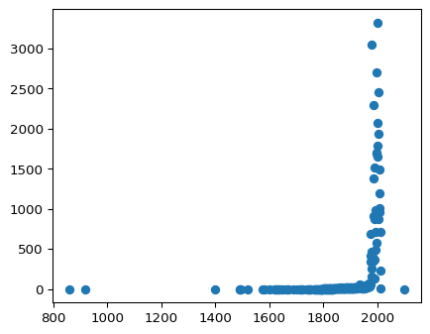

## This is an f-string

According to our data, the number of meteors between 1995 and 2000 is 8946.