Introduction:

The development of germ-free study systems has been revolutionary for many biomedical

fields, including microbiology, immunology, and infectious disease biology. However, most germ-free research has predominantly used a limited number of model organisms (e.g., mice, zebrafish) with few alternatives. Research generated using germ-free model systems has shown the microbiome influences development of the immune system and later function, but we do not yet have a germ-free (or a gnotobiotic) system optimized in amphibians that can be used to uncover the microbiome’s influence on the immune system in frogs.

The amphibian fungal pathogen *Batrachochytrium dendrobatidis* (*Bd*) causes the disease chytridiomycosis. *Bd* affects the epidermal skin layer, and has caused the decline of many amphibian species globally (Scheele et al. 2019). *Bd* has varying effects across frog species, with some species highly susceptible to infection, eventually succumbing to the disease, while others become asymptomatic carriers of the pathogen (Eskew et al. 2018). The microbiome has been previously implicated in these interspecific differences in host susceptibility to infection, as well as in overall infection intensity (Grogan et al. 2018).

Previous studies have shown a disruption to the skin microbiome can increase susceptibility to *Bd*. Specifically, researchers have depleted the skin microbiome of adult frogs with a combination of antibiotics and found increased mortality and higher pathogen loads (Becker et al. 2011; Jani et al. 2014). These studies have also led to the identification of certain microbiome members that negatively affect *Bd* growth in vitro, catalyzing research on bioaugmentation and probiotics as a potential treatment of the infection. No studies to date have looked at how an early-life disruption to the microbiome in developing tadpoles may affect later susceptibility to *Bd*, or, more broadly, the development of the amphibian immune system as a whole. My research is therefore focused on generating a gnotobiotic or “germ-reduced” system in frogs which can be used to determine the impact of the microbiome on amphibian immune system development and susceptibility to infectious disease.

Methods:

To generate “germ-reduced” tadpoles, I first treat embryos with a broad mixture of antimicrobials. Then, I rear them in sterile conditions inside a biosafety cabinet and feed them sterilized (i.e., gamma-irradiated) food and house them in sterilized (i.e., autoclaved) water. I treat my control nonsterile embryos with a sham solution of sterilized water, and house the subsequent nonsterile tadpoles outside of the biosafety cabinet so they are exposed to potential microbes in the air. Because my sterile treatment groups are held inside the biosafety cabinet while my nonsterile groups are held outside the cabinet, I need to use iButton loggers to confirm the temperature inside the cabinet is the same as outside so I can be sure my tadpoles are developing at the same temperature. I have 6 iButtons placed inside the biosafety cabinet and 6 iButtons placed outside the biosafety cabinet. I would like to write a script in Python that I can use to loop through my iButton data to calculate the average temperature both inside and outside the biosafety cabinet. I will also visualize the data from each iButton using ggplot and use statistics to confirm there is no difference in average temperature over time among my loggers.

Results:

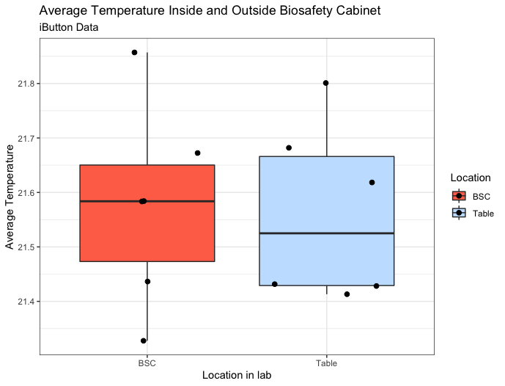

Figure 1. Boxplot showing average temperature from iButton loggers placed inside and outside of a biosafety cabinet.

For this project, I wrote two python scripts. The first took all my data files from either my iButtons placed inside the biosafety cabinet or outside the biosafety cabinet and averaged all of the temperature readings over five days. The second script took the average temperature from each iButton and added it to a new .csv file. I then imported the new .csv file to R and used ggplot to plot the average temperatures for each condition (Fig. 1). I found no difference in average temperature inside or outside the biosafety cabinet (t-test; *t*(9.84) = 0.14, *p* > 0.05).

Conclusion:

Through this project, I have confirmed my average temperatures inside the biosafety cabinet where I am rearing my germ-free tadpoles is not significantly different from my average temperatures outside of the cabinet in standard laboratory space. Previously when working with iButton data, I have gone through and averaged the temperature for each logger by hand, and so with this project I have been able to automate these processes to save me time in the future. Further, it has been helpful to work through the ggplot primer and create code to generate visualizations with better aesthetics that I can also reuse in the future.

References:

Becker, M. H., Harris, R. N., Minbiole, K. P., Schwantes, C. R., Rollins-Smith, L. A., Reinert, L. K., ... & Gratwicke, B. (2011). Towards a better understanding of the use of probiotics for preventing chytridiomycosis in Panamanian golden frogs. *Ecohealth*, *8*, 501-506.

Eskew, E. A., Shock, B. C., LaDouceur, E. E., Keel, K., Miller, M. R., Foley, J. E., & Todd, B. D. (2018). Gene expression differs in susceptible and resistant amphibians exposed to Batrachochytrium dendrobatidis. *Royal Society open science*, *5*(2), 170910.

Grogan, L. F., Robert, J., Berger, L., Skerratt, L. F., Scheele, B. C., Castley, J. G., ... & McCallum, H. I. (2018). Review of the amphibian immune response to chytridiomycosis, and future directions. *Frontiers in immunology*, *9*, 2536.

Jani, A. J., & Briggs, C. J. (2014). The pathogen Batrachochytrium dendrobatidis disturbs the frog skin microbiome during a natural epidemic and experimental infection. *Proceedings of the National Academy of Sciences*, *111*(47), E5049-E5058.

Scheele, B. C., Pasmans, F., Skerratt, L. F., Berger, L., Martel, A. N., Beukema, W., ... & Canessa, S. (2019). Amphibian fungal panzootic causes catastrophic and ongoing loss of biodiversity. *Science*, *363*(6434), 1459-1463.