Link: <https://github.com/abigailkeely6/csd-340>

Repository and README:

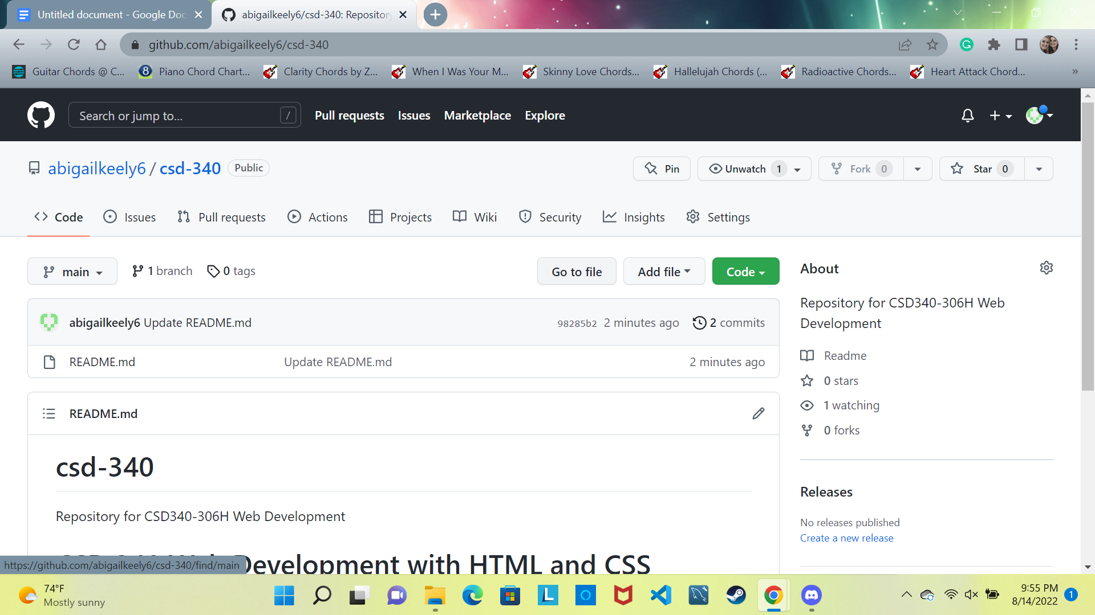

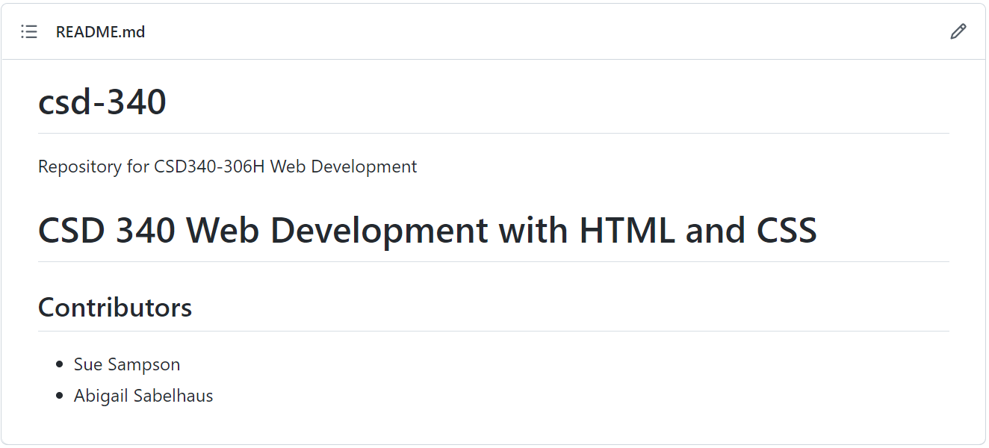

Directory: