Predicting calving likelihood for North Atlantic right whales in relation to space use and prey exposure
Abigail Kreuser
Background & Questions
North Atlantic right whales are critically endangered species of baleen whale with an estimated 384 individuals remaining. Rapid warming in the Northwest Atlantic has caused interannual variability in right whale prey across seasonal foraging habitats. These fluctuations in prey abundance have been linked to annual right whale distribution and birth rates. Foraging patterns and regional habitat use varies between individuals. This can be due to different individual nutritional needs or social interactions related to demographic characteristics. Right whales have been highly monitored since the 1980s, and individuals can be identified by unique callosities and markings which provide a noninvasive opportunity to characterize individual space use over time.
This project will use a novel right whale movement modeling framework, which applies a Brownian-bridge to estimate space use by a uniquely identified individual right whale between consecutive sightings as a unit of whale days (e.g. Fig. 1). This model provides a 5-fold increase in knowledge of individual right whale distribution across their full habitat range relative to the complete North Atlantic Right Whale Consortium Identification Database (North Atlantic Right Whale Consortium 2025). The metric of whale days allows for spatial and temporal representation of habitat-use to be quantified and compared across individuals and time (Mu et al. 2026).
I will be investigating if calving by reproductive female can be predicted relative to the space use of that individual in regional areas, latitudinal zones, or exposure to prey in the two years prior to calving. By applying this novel method to investigate reproductive success, this project will be able to illuminate how sight fidelity and prey exposure impact species recovery and distribution. A healthy right whale calving interval is expected to be 3 years, where after the calf is born the mother lactates for a year, rests, and is pregnant for over a year (Browning et al. 2010). Right whale calving intervals have increased as birth rates have declined (Pettis & Hamilton 2026). Calving right whales are in better body condition than non-calving whales, and overall decline in body condition has been related to declines in calving (Rolland et al. 2016). This suggests that foraging conditions two years prior to calving are for reproductive females to successfully reproduce. If right whale calving can be predicted from spatial distributions, that would allow for protection and further investigation of foraging areas and prepare managers for years when more whales will be traveling to the Southeast US to calve.
Methods: dataset and info
Right whales that give birth every year are identified in the North Atlantic Right Whale Consortium Identification Database as being “with calf” (North Atlantic Right Whale Consortium 2025). Reproductive females will be identified if an individual was ever seen with a calf. Those individuals’ space use distributions will be extracted from published outputs of Kreuser et al. 2026, and then for each individual, space use will be summed within regional and latitudinal zones for the 2 years prior to each calving season (Fig. 2). Prey exposure will be calculated by overlapping space use with prey distributions of Calanus finmarchicus, Calanus hyperboreous, Pseudocalanus sp., and Centropages sp.. These prey distributions were calculated by collaborators at Bigelow using Boosted Regression Trees with EcoMon and AZMP data. Prey exposure will be calculated on a monthly time scale. In addition to prey and space use, effort in the regional areas will quantified, as on-effort days within the area by platform. Effort will be considered to have occurred if survey teams recorded Beaufort sea state ≤ 4, visibility > 3.7 km (2 nautical miles), and, for aerial surveys, altitude < 366 m (12600 ft) (North Atlantic Right Whale Consortium 2024).
Summing space use with regional and latitudinal zones will reduce spatial autocorrelation of distributions, and each row of data will have spatial information about the individual’s space use and prey exposure for two years with a binary outcome of having calved of not calved. Years where a whale would be nursing will not be included in the 2 years prior, because it is not expected that the whale would be able to successfully calve in that timeline. There are some individuals that are rarely seen, yet have been seen with calves. Reproductive females that are rarely observed will be removed from the dataset.
Whale days, prey exposure, and effort in regional areas will be normalized. There will be varying days of estimated space use due to the reliance on individuals to be observed, and I would like the variance to be preserved and related to the days of effort in the region. Years where individuals were not observed is informative if they were foraging successfully or unsuccessfully elsewhere. Features will include the individual, year, time-period, time spent in regional areas for year 1 and year 2, monthly prey exposure of each species for year 1 and year 2.
Test data will be separated using a stratified approach removing all rows associated with the same individuals. There is likely behavioral and health patterns associated with individuals, and separating all observations of the test data individuals will help prevent data leakage. Cross validation data will also be grouped by ID so that all data pertaining to one individual is contained in one-fold.
The baseline model will be a logistic regression with only the year, individual ID, monitoring effort to predict calving. The primary model will be logistic regression with lasso regularization incorporate prey and regional space use, with additional models solely using regional space and prey exposure separately. Comparing these model iterations to the baseline model will show the added value of estimating space use and prey exposure. During the validation phase I will evaluate the features performance largely with sensitivity and F1 score because births will be rare. I will also evaluate ROC-AUC. After evaluation, if the regional areas are too small, I will use the broader latitudinal zones, and if the prey layers I plan on using do not perform as expected, I will use a simpler published prey layer that quantifies caloric content of prey distributions (Plourde et al. 2024).

For model interpretation I will report the coefficients to identify important features. I will calculate uncertainty through resampling of individuals. Limitations of this project is that the number of calving events may be relatively small for machine learning. Effort and estimated space use in an area will be strongly correlated. I am missing data that would very informative like body condition and age.
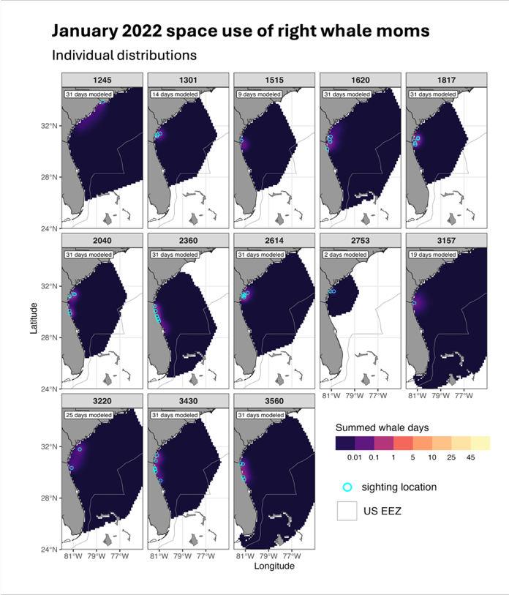

Figure 1. Example of individual Brownian bridge movement model outputs from January 2022 summed together to characterize space use of a demographic group. Space use distributions shown are adult female right whales that calved in 2022 and were sighted in the Southeast US in January. (left) Individual space use estimates labeled by their four-digit identification number (Eg #). Sightings that occurred in the month are indicated by cyan open circles. Sightings outside January 2022 inform the movement model distributions, but were not plotted (i.e., Eg #3157 was first sighted on January 13, 2022, and next sighted on February 10, 2022, so the January 13 sighting is plotted and the following 19 days modeled in January).

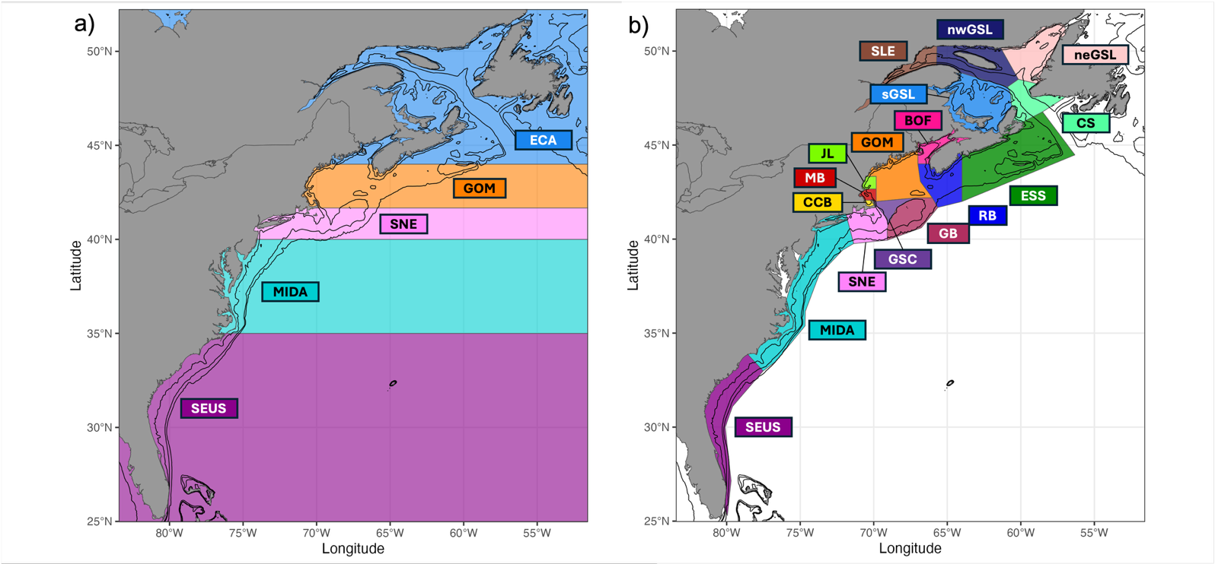
Figure 2. (a) Latitudinal zones: ECA = Eastern Canada, GOM = Gulf of Maine, SNE = Southern New England, MIDA = Mid-Atlantic, SEUS = Southeast United States. (b) Regional area polygons: SLE = St. Lawrence Estuary, nwGSL = Northwest Gulf of St. Lawrence, neGSL = Northeast Gulf of St. Lawrence, CS = Cabot Strait, sGSL = southern Gulf of St. Lawrence, ESS = East Scotian Shelf, BOF = Bay of Fundy, RB = Roseway Basin, GOM = Gulf of Maine, JL = Jeffreys Ledge, MB = Massachusetts Bay, CCB = Cape Cod Bay, GSC = Great South Channel, GB = Georges Bank, SNE = Southern New England, MIDA = Mid-Atlantic, SEUS = Southeast United States.

References
Browning, C. L., Rolland, R. M., & Kraus, S. D. (2010). Estimated calf and perinatal mortality in western North Atlantic right whales (Eubalaena glacialis). Marine Mammal Science, 26(3), 648–662. https://doi.org/10.1111/j.1748-7692.2009.00361.x
Kreuser, A. M., Pendleton, D. E., Record, N. R., & Meyer-Gutbrod, E. L. (2026). Individual movement modeling expands the power of migratory species observations: North Atlantic right whale case study. Limnology and Oceanography: Methods. https://doi.org/10.1002/lom3.70049
North Atlantic Right Whale Consortium (2024). North Atlantic Right Whale Consortium Sightings Database 04/19/2024 (Anderson Cabot Center for Ocean Life at the New England Aquarium, Boston, MA, U.S.A.).
North Atlantic Right Whale Consortium (2025). North Atlantic Right Whale Consortium Identification Database 01/30/2025 (Anderson Cabot Center for Ocean Life at the New England Aquarium, Boston, MA, U.S.A.).
Mu, T., Verhoeven, M. A., Jackson, M. V., Piersma, T., Fuller, R. A., & Wilcove, D. S. (2026). A “demand and supply” approach to monitoring habitat and population changes of migratory birds. Frontiers in Ecology and the Environment, 24(3). https://doi.org/10.1002/fee.70035
Pettis, H.M. and Hamilton, P.K. 2026. North Atlantic Right Whale Consortium 2025 Annual Report Card. Report to the North Atlantic Right Whale Consortium. www.narwc.org
Plourde, S., Lehoux, C., Roberts, J.J., Johnson, C.L., Record, N., Pepin, P., Orphanides, C., Schick, R.S., Walsh, H.J., Ross, C.H. 2024. Describing the Seasonal and Spatial Distribution of Calanus Prey and North Atlantic Right Whale Potential Foraging Habitats in Canadian Waters Using Species Distribution Models. DFO Can. Sci. Advis. Sec. Res. Doc. 2024/039. v + 71 p. https://publications.gc.ca/collections/collection_2024/mpo-dfo/fs70-5/Fs70-5-2024-039-eng.pdf

Rolland, R., Schick, R., Pettis, H., Knowlton, A., Hamilton, P., Clark, J., & Kraus, S. (2016). Health of North Atlantic right whales Eubalaena glacialis over three decades: from individual health to demographic and population health trends. Marine Ecology Progress Series, 542, 265–282. https://doi.org/10.3354/meps11547

