Obesity vs. Happiness Summary

Team: ABC

Members: Abigail Metzger and Brennan Stottlemyer

After examining the relationships between the happiness scores, obesity rates, life expectancy, and GDP on a global scale we were able to determine these factors are more closely correlated than we initially thought.

***Correlation of Obesity and Happiness by Country***

This visualization was meant to illustrate our initial question whether countries with higher obesity rates tend to be happier. Based on the article, “Overweight People More Likely To Be Happy Than Skinny Ones, Study Finds” we suspected there would be a positive correlation between the two factors. It wasn’t until we ran a linear regression analysis to determine the p-value was 2.86 e-14 that we learned obesity and happiness were more correlated than we thought.

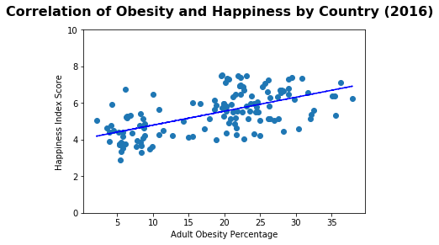

***Correlation of Obesity and Life Expectancy by Country***

After finding the strong correlation between obesity and happiness we were curious what other factors could influence happiness scores by country. We decided to explore a country’s obesity rate against its average life expectancy. These two factors ended up being more positively correlated than our original question. We found it interesting that in countries with less than 10% of their adult population being considered obese there was a wide range of life expectancies (from approximately 50-85 years). In discussing possible explanations for this trend, we wondered if a country’s economic situation could be a factor.

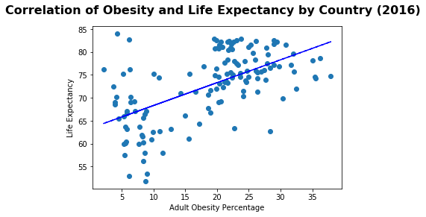

***Correlation of Life Expectancy and Happiness by Country***

Since there was a positive correlation between obesity vs. happiness and obesity vs. life expectancy, we wanted to examine the potential correlation between life expectancy and happiness. Based on our previous findings the result fell in line with what we were anticipating and was verified by a very low p-value (p-value 6.03e-29).

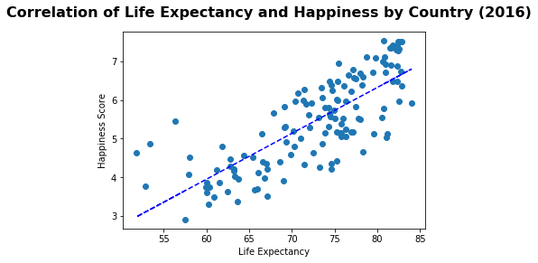

***GDP Box Plot***

The original GDP data set had many outliers that made the graphs difficult to analyze accurately. We created a box plot for the GDP data to better visualize the outliers. The first plot shows the original GDP data and the second boxplot shows the GDP data once the initial outliers were removed.

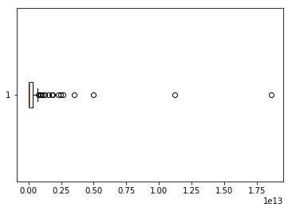

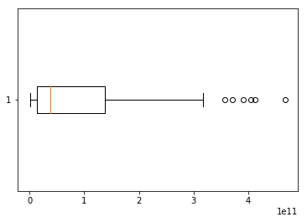

***Correlation of GDP and Obesity Percentage by Country***

As previously mentioned, while we were looking at the correlation between life expectancy and obesity, we were curious if there was an economic factor that could contribute to the trend of countries with lower obesity rates having a wide range of life expectancies. We found data from the World Bank that allowed us to take a closer look at this question by providing GDP data for the countries we were examining. Based off of the initial graph there are clear outliers that impact the readability of the scatterplot. The second graph shows the GDP data once the outliers were removed. To our surprise both original and revised data set do not show any statistical significance (p-vlaue 0.12).

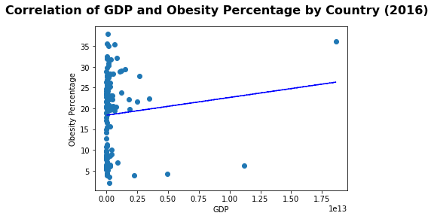

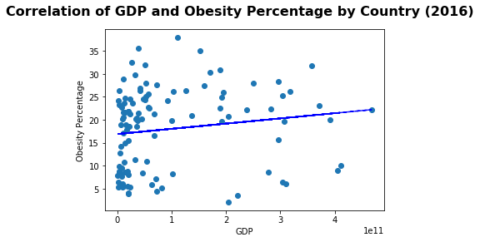

***Correlation of GDP and Happiness by Country***

With such a strong societal notion that countries with a higher GDP are happier we were in a position to examine if that idea was true. Additionally, since there was a positive correlation between obesity vs. happiness and GDP vs. obesity, we wanted to examine the potential correlation between GDP and happiness. Again, the GDP data has clear outliers which effect the readability of the graph. In the second graph those initial outliers have been removed and the result ended up being statistically significant (p-value 1.04e-08).

