
STUDENT PROJECT SUBMISSION AND PEER REVIEW WEB APPLICATION
SWE3090A FALL SEMESTER 2026
SUPERVISOR: PROF. FREDRICK OGORE
STUDENT: ABIGAIL WAIHENYA 669841

CHAPTER ONE

1.0 Project Introduction and Background
In higher education institutions, project based assessments are critical for evaluating students' practical skills, critical thinking, and domain knowledge. Universities routinely require students enrolled in technical and non technical courses to submit academic software projects, analytical reports, presentations, and design artifacts. However, managing the lifecycle of these submissions from assignment setup to final grading remains administrative work for faculty members.
Historically, higher education relies on fragmented channels such as email, instant messaging apps, shared cloud folders, and paper submissions. While these tools allow raw file transfers, they lack structured review workflows, standardized rubric applications, and automated peer allocation mechanisms. Incorporating peer review into this process further enhances pedagogical outcomes by encouraging critical evaluation and reflective learning among students. A centralized, web-based platform tailored specifically for project submissions and double blind peer reviews streamlines administrative workflows, ensures objective grading, and delivers transparent feedback to students.

1.1 Problem Statement
The current decentralized approach to managing student project submissions and peer evaluations creates operational friction for both educators and students. Handling project submissions across disjointed channels such as email attachments and public shared drives often results in lost files, version control confusion, and difficulty tracking submission deadlines. Furthermore, manual peer review allocation by faculty is prone to administrative bottlenecks, accidental exposure of student identities (compromising review objectivity), and inconsistent evaluation due to the lack of interactive rubrics.
Lecturers face significant overhead when collecting feedback from multiple peer reviewers, computing aggregate scores, and compiling readable feedback reports. Students, on the other hand, often receive delayed, non-standardized feedback, limiting their opportunity to learn from peer assessments. Without an integrated digital environment designed specifically for assignment management, file uploads, automated reviewer allocation, and rubric driven evaluation, higher education institutions struggle to maintain consistent assessment quality and administrative efficiency.

1.2 Project Objectives
A. Main Objective
To develop and deploy a web based Student Project Submission and Peer Review Web Application that centralizes assignment creation, submission file management, anonymous peer review allocation, and rubric based assessment reporting.
B. Specific Objectives
- To Develop a secure user management and authentication module utilizing Role Based Access Control (RBAC) and JSON Web Tokens (JWT) for administrators, lecturers, and students.
- To Integrate a project submission engine that enables students to submit project descriptions, code repositories, and documents via secure server file uploads.
- To Facilitate an automated, anonymous peer-allocation system that assigns submitted projects to designated student reviewers while enforcing double-blind anonymity.
- To Streamline lecturer management through an interactive dashboard featuring customizable assessment rubrics, score calculations, and downloadable PDF assessment reports.
1.3 Justification (Significance of the Project)
The implementation of the Student Project Submission and Peer Review Web Application addresses critical operational and pedagogical needs within academic institutions:
- Administrative Efficiency: Automating reviewer allocation, rubric scoring, and report generation reduces manual workload for academic staff.
- Pedagogical Enhancement: Peer review fosters critical thinking and continuous peer learning, enabling students to analyze diverse approaches to software development and academic problem-solving.
- Bias Reduction: Enforcing double blind anonymity during review cycles mitigates personal bias, ensuring fair and objective evaluation.
- Centralization & Transparency: Replacing informal submission channels (e.g., email, cloud folders) with a single centralized database minimizes data loss and provides an audit trail for grades and feedback.

CHAPTER TWO

2.0 Literature Review

2.1 Global Context
Globally, Learning Management Systems (LMS) such as Moodle and Canvas have integrated peer assessment modules. Moodle features a "Workshop Activity" module that supports peer assessment by allowing students to evaluate peer submissions based on multi-criterion assessment forms. Similarly, specialized digital tools evaluated by organizations like Jisc highlight the efficacy of automated reviewer allocation, criteria-linked reviews, and double-blind feedback management in higher education. However, enterprise LMS solutions often suffer from complex user interfaces, rigid configuration options, and heavy system overhead, making them cumbersome for targeted course level project workflows.

2.2 African and Kenyan Context
In the African continent and specifically within Kenyan higher education institutions (e.g., USIU-Africa, University of Nairobi), institutions heavily utilize platforms such as Google Workspace for Education, Blackboard, and custom student portals. While these systems excel at general assignment submission and grade recording, they frequently lack dedicated, native peer review mechanisms embedded directly into project workflows. Consequently, lecturers in Kenya resort to manually allocating peer reviews via spreadsheets and collecting feedback through Google Forms or email, leading to high administrative overhead and security risks regarding student anonymity.

2.3 Comparative Analysis & System Uniqueness
Platform / Approach | Global / Regional Availability | Key Features | Limitations | Proposed System Uniqueness
Moodle Workshop | Global | Peer allocation, multi criterion forms, grading phases | Complex setup, cluttered UI, difficult custom rubric exports. | Lightweight & Dedicated: Tailored exclusively for tech/academic projects with clean UX.
Google Classroom/ Forms | Global | File submission via Drive, form based feedback. | Manual peer assignment, non anonymous, no auto grading aggregation. | Automated Allocation & Anonymity: Automatic non self reviewer pairing and double blind isolation.
Manual/ Email Workflow | Global | Direct submission to instructor. | High administrative burden, unorganized feedback, high risk of lost files. | Centralized Dashboard & PDF Reports: Consolidated lecturer analytics and one click PDF grade summary generation.

CHAPTER THREE

3.0 Methodology
This project adopts the Agile (Scrum) software development methodology. Agile is chosen due to its iterative nature, flexibility in handling evolving system requirements, and continuous integration capabilities. The project will be executed across six 2 week sprints over a 12 week timeline.
Timeline:
Sprint 1: Authentication and Database
Sprint 2: Core API’s
Sprint 3: React UI
Sprint 4: Peer Review
Sprint 5: Dashboard
Sprint 6: Testing

3.1 Preliminary Investigation & Requirement Analysis
Elicitation Methods Used:
- User Interviews: Structured interviews with university lecturers to gather pain points regarding manual project grading and peer evaluation.
- Student Questionnaires: Online surveys distributed to undergraduate students to analyze usability preferences and issues with legacy submission platforms.
- Document & Workflow Analysis: Reviewing current assessment rubrics, peer review forms, and grading sheets to establish system data models.
Functional Requirements:
- User Management: Secure user registration, login, JWT token generation, and Role Based Access Control (Admin, Lecturer, Student).
- Assignment & Course Management: Lecturers can create courses, define project assignments, set deadlines, and configure assessment rubrics.
- Project Submission: Students can upload project files, supply project repository URLs, and write descriptions.
- Peer Allocation Engine: System automatically assigns anonymous student submissions to allocated reviewers, ensuring no student reviews their own work.
- Peer Evaluation & Rubrics: Reviewers evaluate assigned submissions using structured, customizable rubrics and provide textual feedback.
- Lecturer Dashboard & PDF Export: Lecturers can view aggregated scores, override peer marks, and export downloadable PDF evaluation reports.
Non-Functional Requirements:
- Security: Passwords hashed using bcrypt; API access governed via JWT; strict input validation to prevent SQL Injection and XSS.
- Performance: API response times under 200ms for standard requests; efficient database query indexing.
- Usability: Responsive, intuitive user interfaces built with React and Tailwind CSS/Material UI.
- Reliability & Storage: Validation on uploaded file types and file size restrictions to prevent server storage overload.

3.2 Design Phase
The application leverages a three tier software architecture:
- Presentation Layer: React.js single page application (SPA) styled with Tailwind CSS or Material UI.
- Application Layer: RESTful API server built with Node.js and Express.js handling business logic, authentication, file handling, and allocation logic.
- Data Layer: Relational MySQL database for persistent, normalized storage of user credentials, courses, rubrics, submissions, and reviews.

CHAPTER FOUR

4.0 System Analysis & Design

4.1 Data Flow Diagram (DFD) - Level 1
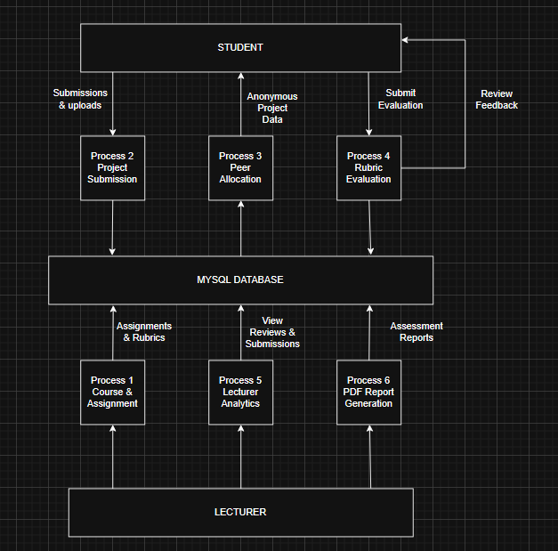

4.2 Entity Relationship (ER) Diagram
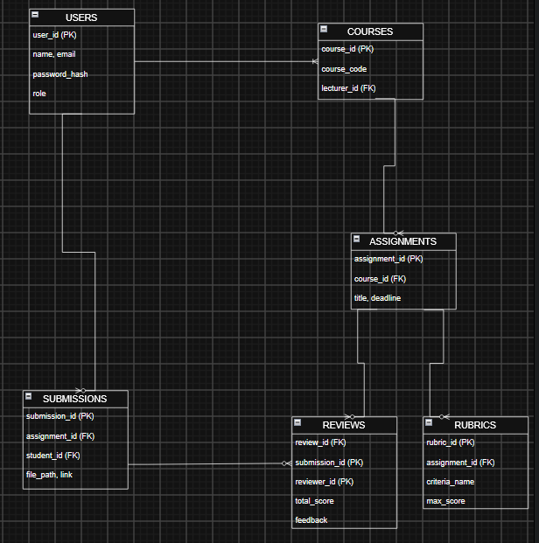

4.3 Proposed Timelines
Week | Activity
1-2 | Express backend setup, DB configuration, JWT authentication, and RBAC setup.
3-4 | Core RESTful APIs for Users, Courses, Assignments, and Submissions
5-6 | React frontend integration, authentication state, Student & Lecturer dashboards.
7-8 | Peer review module, anonymous review algorithm, interactive rubric UI.
9-10 | Lecturer assessment dashboard, score calculation engine, PDF report generation.
11-12 | End-to-end testing, security audits, deployment, and final system demonstration.

REFERENCES
- Jisc. (2022). Principles of good assessment and feedback. Jisc Reports. Retrieved from https://www.jisc.ac.uk/guides/principles-of-good-assessment-and-feedback
- Moodle. (2023). Moodle features for students and instructors. Moodle Documentation. Retrieved from https://docs.moodle.org/en/Features
- Moodle. (2023). Workshop module and peer assessment features. Moodle Documentation. Retrieved from https://docs.moodle.org/en/Workshop_activity
- Pressman, R. S., & Maxim, B. R. (2020). Software Engineering: A Practitioner's Approach (9th ed.). McGraw-Hill Education.

