Abigail Plata

CRN 40652

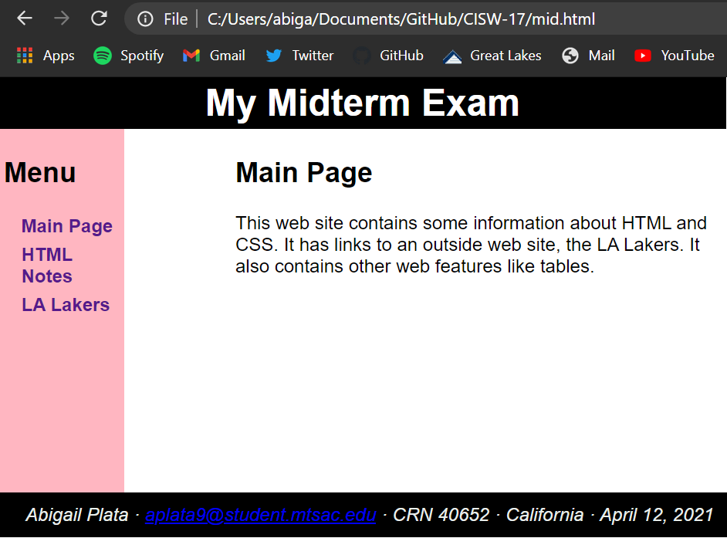

**Main Page**

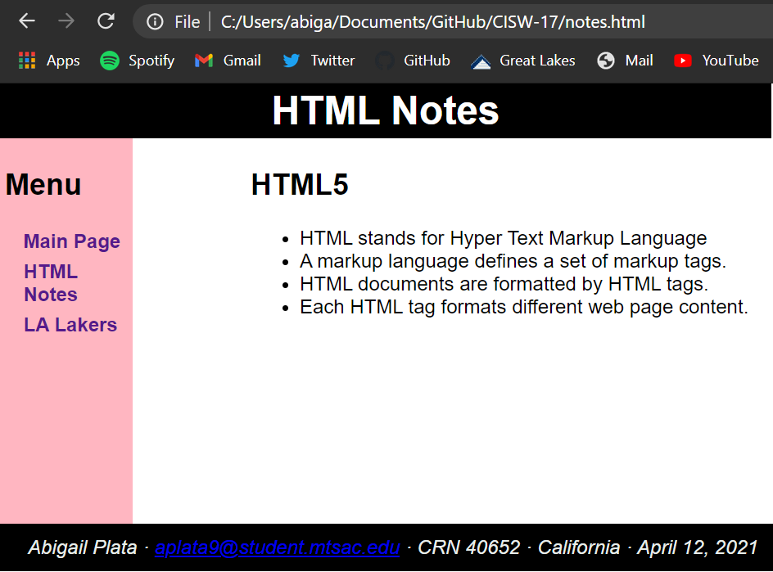

**HTML5 Page**