Abigail Plata

Lab 2

Module 2

March 15, 2022

Linux

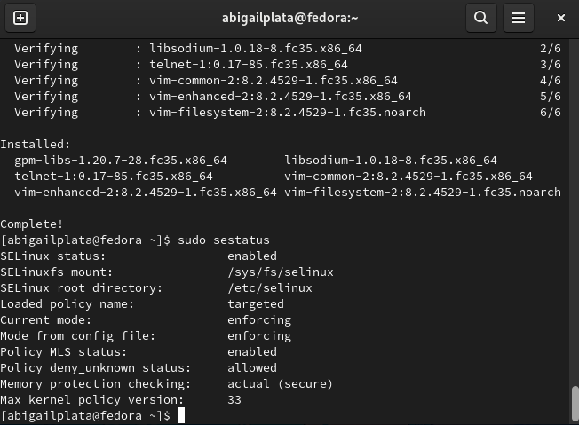

MySQL/MariaDB

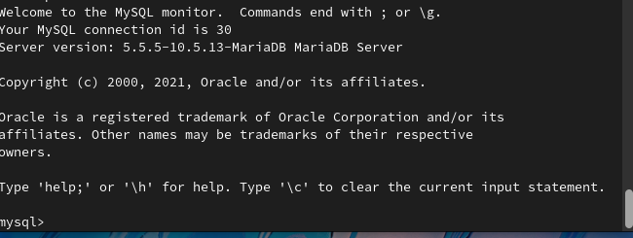

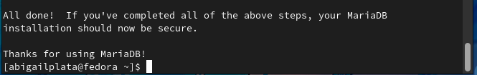

PHP

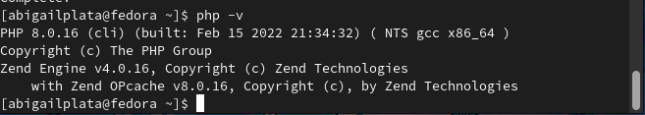

Apache

