Western European Temperature/ Dew Point Variation by Geography

by

Abigale Cole

_____________________________

GIST | GEOG | PLG 457

STATISTICAL TECHNIQUES IN GEOGRAPHY,

REGIONAL DEVELOPMENT & PLANNING

THE UNIVERSITY OF ARIZONA

Fall 2020

**ABSTRACT**

By looking at the geographic distribution of temperature and dewpoint we can make assumptions about future freeze warnings. We can the then take these analyses to know how to best prepare areas that are under a higher risk for freeze warnings and a higher risk of ice. By looking at a random sample of points and preforming Inverse Distance Weighted (IDW) interpolation we can get the averages for the entirety of Western Europe. We see a correlation between the elevation and temperature along with proximity to the coast and dew point. These results will serve as a road sign to where future resources for the winter will need to be placed, and a good starting point for mapping future extreme winter weather.

**INTEGRITY STATEMENT**

The work submitted in this project is my own work and I did not receive any unfair and/or unauthorized assistance from another person.

**TABLE OF CONTENTS**

**ABSTRACT** 2

**TABLE OF CONTENTS** 3

**LIST OF TABLES** 4

**LIST OF FIGURES** 5

**INTRODUCTION** 6

Anomalous Weather 6

**DATA**  8

**METHODS** 10

**RESULTS** 17

**CONCLUSIONS** 19

**REFERENCES** 20

**LIST OF TABLES**

Table 1. Metadata of the dataset 10

**LIST OF FIGURES**

Figure 1: Snow depth at various ECA&D stations in Western Europe, where snow data is available, 29 January 2004. 8

Figure 2: Location of Weather Stations 11

Figure 3: WorkFlow 12

Figure 4: Model that was built for IDW Interpolation in ModelBuilder 13

Figure 5: Temperature IDW based on 50 random sample points 14

Figure 6: Dew Point IDW Interpolation based on 50 Random Sample Points 15

Figure 7: Temperature IDW Interpolation based on all Weather Stations 16

Figure 8: Dew Point IDW Interpolation Based on All Weather Stations 17

Figure 9: Elevation Model 18

Figure 10:ECA&D station map of minimum temperature across Europe on 19 December 2009. 20

**INTRODUCTION**

With climate change beginning to take a toll we are seeing much more extreme weather events throughout Western Europe. By tracking certain weather parameters we can begin to see patterns in where these extreme weather events are likely to happen again. The goal is to be able to create cold-spots within Western Europe based on dew point and temperature to measure and predict future repeat extreme cold weather.

Anomalous Weather

Unlike the United States the Winters in Western Europe have been lessened in severity while summers have gained in intensity [1]. While this is the overall trend there have still been instances of extreme cold weather. Between December 2009 – February 2010 (will be referred to as Winter of 2010) “three successive cold outbreaks and unusual persistence of snow cover were observed”[2]. By providing an analysis for Western Europe we can see what areas are more than likely to be affected if anomalous weather were to strike again. We also see extreme snow in Western Europe in January 2004 [3]. Amounts that were 15cm above the regular amounts were reported see figure 1.

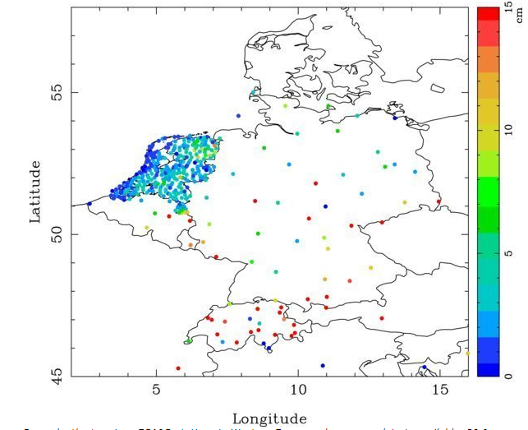

Figure : Snow depth at various ECA&D stations in Western Europe, where snow data is available, 29 January 2004.

**DATA**

This section is meant to summarize the main characteristics of your data sources. It should consist of a text introducing the data that you have used and graphical descriptions of the sources:

For every dataset used, create a table describing its basic metadata, for example:

Table 2. Metadata for Weather Station Reports

|  |  |
| --- | --- |
| Official name of data set | Weather Station Reports |
| Year of publication and/or last update |  |
| Author and/or owner | National Climatic Data Center |
| URL or FTP address of the repository |  |
| Description | This dataset contains temperature, dewpoint, and visibility data from western Europe. The temperature values are a snapshot of values for 2004. The dataset includes reporting weather station codes. The temperature data is reported in degrees Fahrenheit. This data has been modified from the original for training purposes. |
| Coordinate system | , European Datum 1950, 4230 |
| Projection system | Europe Albers Equal Area Conic |
| Type of geometry | Point |
|  |  |

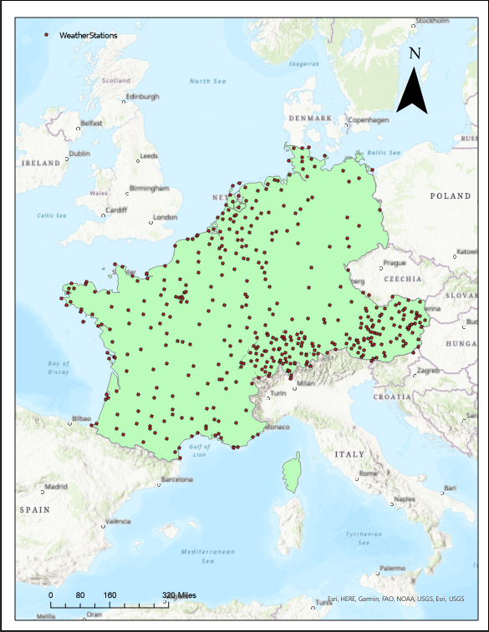

Figure : Location of Weather Stations

**METHODS**

To solve this problem, I implemented ArcGIS (ESRI ArcGIS Pro 2.6) and ModelBuilder. I first isolated the dew point and temperature variables from the Weather Stations data set (which was given). I then preformed 4 analysis. Two of which were done are each variable. I preformed IDW interpolation[4] on both a random population as well as the entire data set. I did this because I wanted to see the differences in the data (see Figures 3-7). The analysis proved fruitful however and provided me with well rounded results. IDW was the most logical choice because of the terrain of Europe along with the number of weather stations.

Figure : WorkFlow

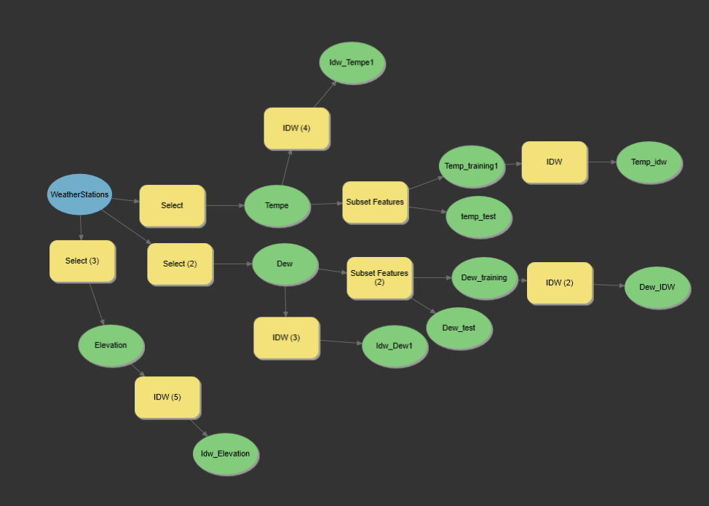

Figure : Model that was built for IDW Interpolation in ModelBuilder

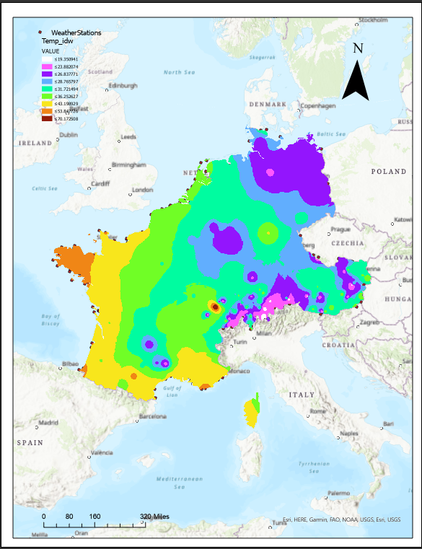

Figure : Temperature IDW based on 50 random sample points

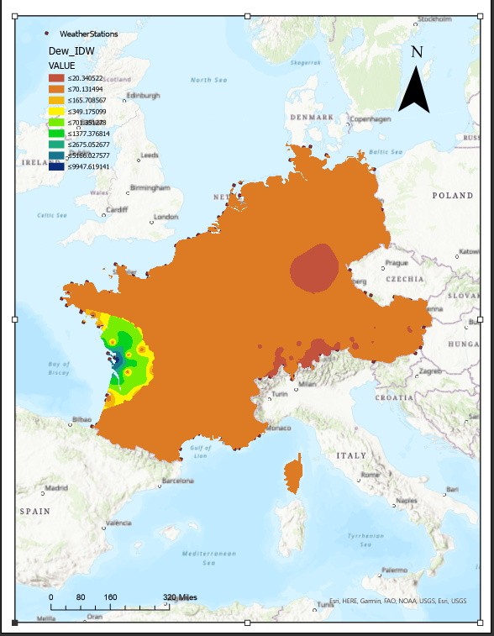

Figure : Dew Point IDW Interpolation based on 50 Random Sample Points

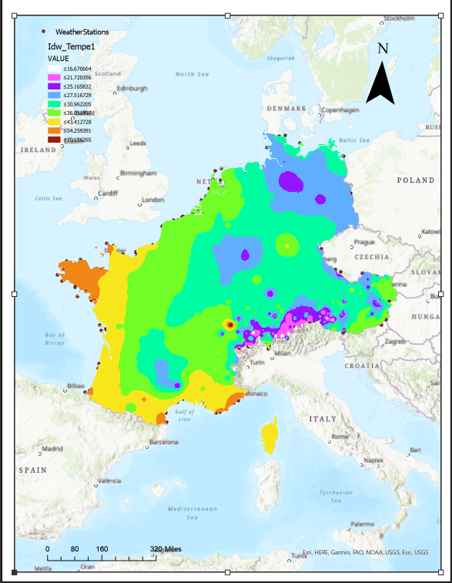

Figure : Temperature IDW Interpolation based on all Weather Stations

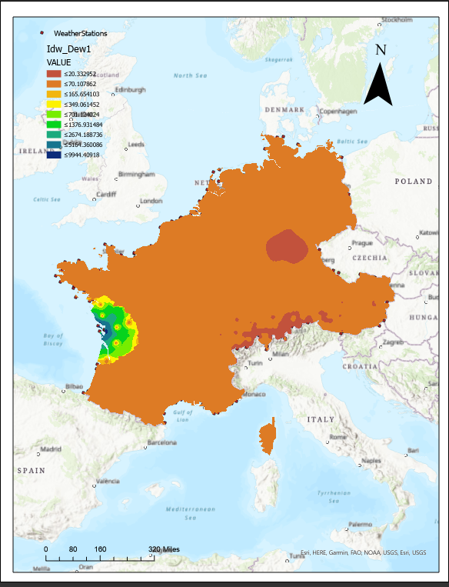

Figure : Dew Point IDW Interpolation Based on All Weather Stations

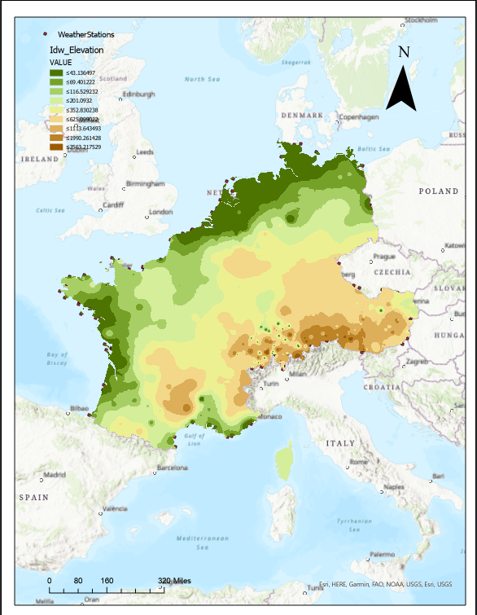

Figure : Elevation Model

**RESULTS**

After preforming IDW interpolation we can see a correlation between high elevations and low temperatures during wintertime. There is also a smaller correlation between high elevation and higher dew point event though we see the highest dew points off the Western Coast. We these correlations become ever more apparent in the Alps region where there is a high elevation, high dew point and low average winter temperature. As well as a region near Frankfurt in Germany.

**DISCUSSION**

With these results we can see that the Alps region and the area around Frankfurt may become more susceptible to harsh winter conditions. While climate change is having a more profound effect on the summers in Western Europe, we cannot ignore the implications these may have on winters. By being able to track the cold weather and dew point we can accurately track the areas that are the most susceptible to ice and the runoff that may occur in the summer months. We can also see that the Western Coast has a higher dew point this can translate to an even higher amount of rainfall during the summer months. By collecting and tracking winter data such as this we can also track the changes throughout the years (figure 5) and see where potential hotspots can be formed. Looking at the dew point in comparison with the temperature can offer a good gauge on where anomalous events are more likely to happen.

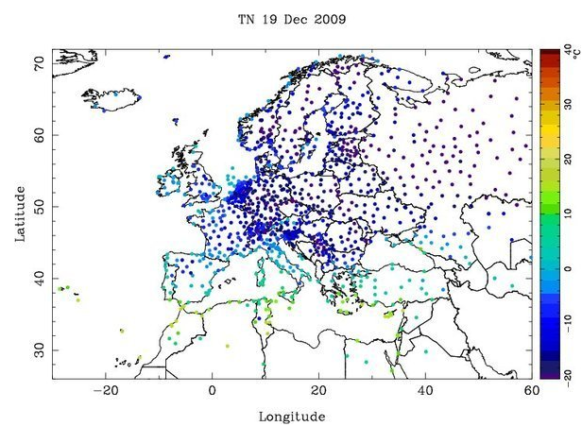

Figure :ECA&D station map of minimum temperature across Europe on 19 December 2009.[5]

**CONCLUSIONS**

My results will allow climate change scientists to be able to provide a more accurate assessment of where anomalous weather events are more likely to occur. This will be a good tool to use in further analysis.

The objective of this analysis was to provide a good steppingstone for further analysis. And provide an accurate representation of future freezing sites. I do believe this was accomplished but with temperatures rising I would be interested in seeing the comparison with future data (or more current).

Since colder winters are seeming to be become rarer this analysis will be better suited with comparison with Summer Data.

**REFERENCES**

Cattiaux, J., R. Vautard, C. Cassou, P. Yiou, V. Masson-Delmotte, and F. Codron. “Winter 2010 in Europe: A Cold Extreme in a Warming Climate.” *Geophysical Research Letters* 37, no. 20 (2010). https://doi.org/10.1029/2010gl044613.

“IDW (Geostatistical Analyst).” IDW (Geostatistical Analyst)-ArcGIS Pro | Documentation. Accessed December 17, 2020. https://pro.arcgis.com/en/pro-app/latest/tool-reference/geostatistical-analyst/idw.htm.

Kürbis, K., M. Mudelsee, G. Tetzlaff, and R. Brázdil. “Trends in Extremes of Temperature, Dew Point, and Precipitation from Long Instrumental Series from Central Europe.” *Theoretical and Applied Climatology* 98, no. 1-2 (2009): 187–95. https://doi.org/10.1007/s00704-008-0094-5.

Snow in Western Europe, Winter 2004. Accessed December 17, 2020. https://www.ecad.eu/events/displayevent.php?eventnr=5.

Snow in Western Europe, Winter 2004. Accessed December 17, 2020. https://www.ecad.eu/events/displayevent.php?eventnr=5.

1. Kürbis, K., Mudelsee, M., Tetzlaff, G. *et al.* Trends in extremes of temperature, dew point, and precipitation from long instrumental series from central Europe. *Theor Appl Climatol* **98,**187–195 (2009). https://doi.org/10.1007/s00704-008-0094-5
2. Cattiaux, J., Vautard, R., Cassou, C., Yiou, P., Masson‐Delmotte, V., and Codron, F. (2010), Winter 2010 in Europe: A cold extreme in a warming climate, *Geophys. Res. Lett.*, 37, L20704, doi:[10.1029/2010GL044613](https://doi.org/10.1029/2010GL044613).
3. Snow in Western Europe, Winter 2004, accessed December 17, 2020, https://www.ecad.eu/events/displayevent.php?eventnr=5.
4. “IDW (Geostatistical Analyst),” IDW (Geostatistical Analyst)-ArcGIS Pro | Documentation, accessed December 17, 2020, https://pro.arcgis.com/en/pro-app/latest/tool-reference/geostatistical-analyst/idw.htm.
5. Snow in Western Europe, Winter 2004, accessed December 17, 2020, https://www.ecad.eu/events/displayevent.php?eventnr=5.