DFD

(Data Flow Diagram)

Level-0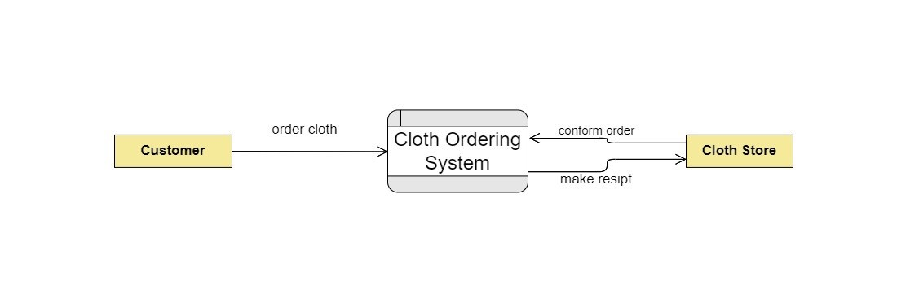

__________________________________________________________________________________

Level-1

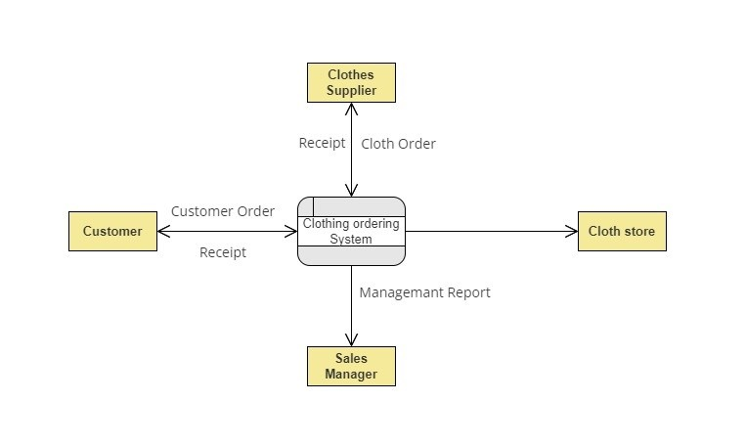

__________________________________________________________________________________

Level-2

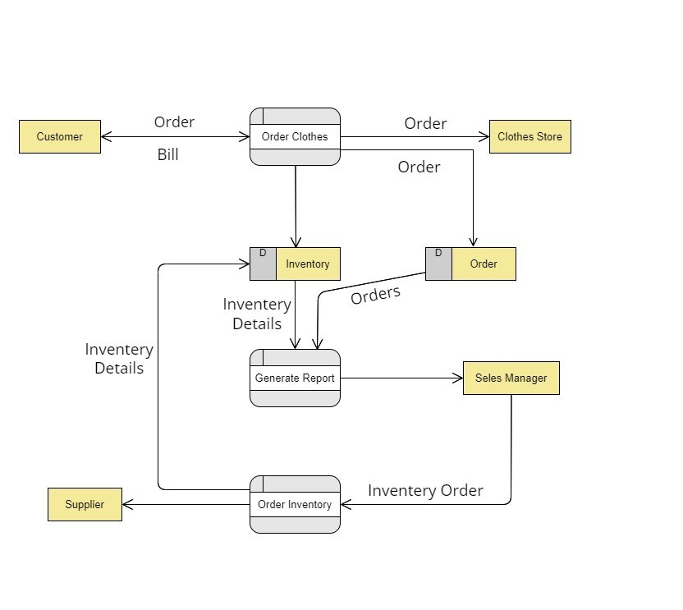

THANK YOU

__________________________________________________________________________________

Flow-Chat

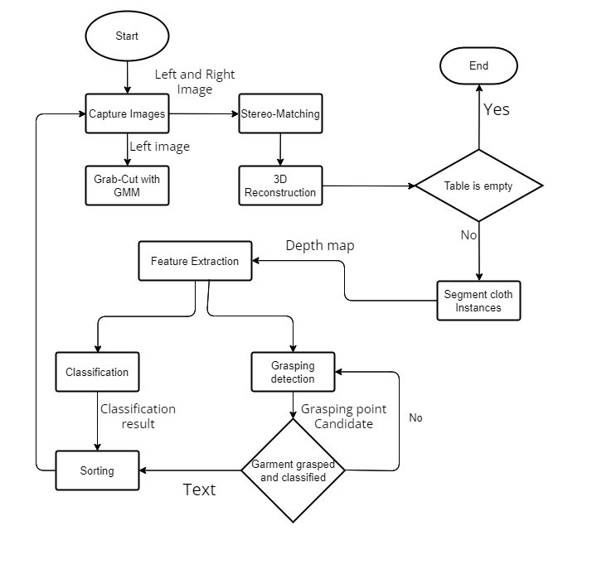

__________________________________________________________________________________

THANK YOU

__________________________________________________________________________________

Use-Case

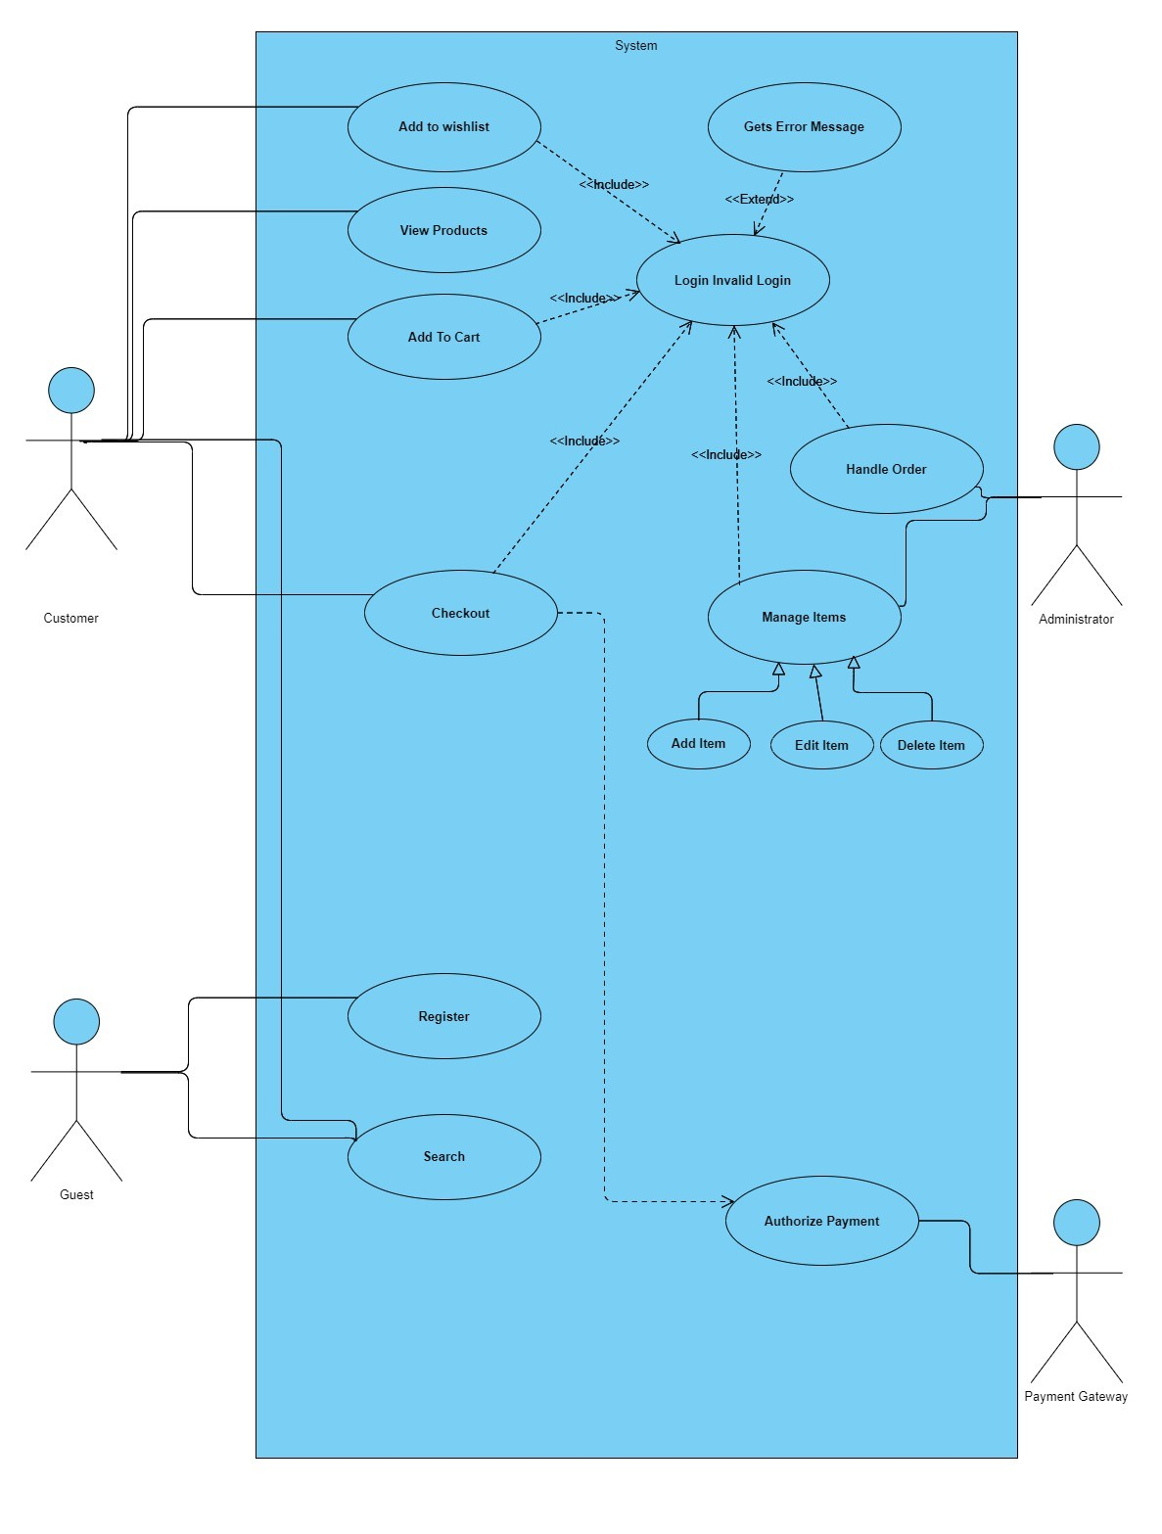

__________________________________________________________________________________

THANK YOU