Running Apps With Virtual environment

Things We Need:
a linux system & ubuntu 16.4

What We Are Creating:
we are gong to run a flask python application with the python virtual environment

What Should Do:
- update your system packages
sudo apt-get update
- we install python
sudo apt-get install python3.6 python3.6-dev python3-venv
- this might generate an error as python 3.6 is not supported by ubuntu 16.4 so for that we run
sudo add-apt-repository ppa:fkrull/deadsnakes
deadsnakes is basicaly a new python version so the statement above will add all deadsnakes repositoies to our system
- then we again perform step 2
sudo apt-get install python3.6 python3.6-dev python3-venv
this might take a while
- we than make a new directory
mkdir apps
- we then go to this newly created directory
cd apps
- we then create a python virtual environment
python -m venv myenv *here myenv is my virtual machine's name assigned by me
- then we activate our virtal machine
source myenv/bin/activate
there will be (myenv)written at the start of command line indicating that the vitual machine is activated
- then install flask
pip install flask
- we then create a requirements text file
pip freeze requirements.txt
this requiremnts.txt file contains flask and its dependencies
- to write our code we create a python file
cat > app.py* here app is my python file name
- we will write our code in this executable file
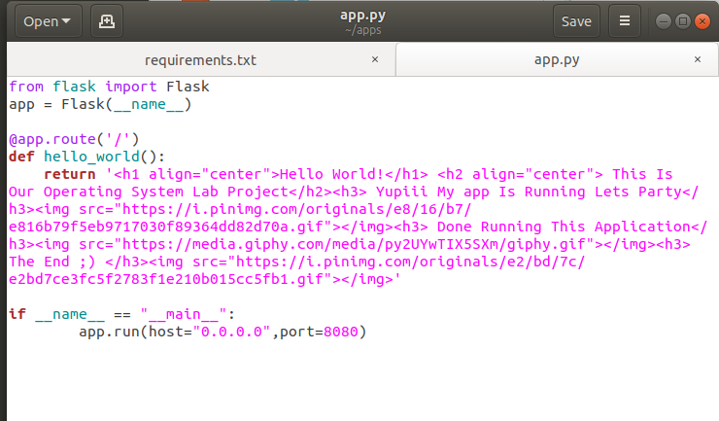
for this we have using python as well as html
- we assign it some local hosting to run it on
I have assigned http://0.0.0.0:8080/
- for running this application we type
python app.py
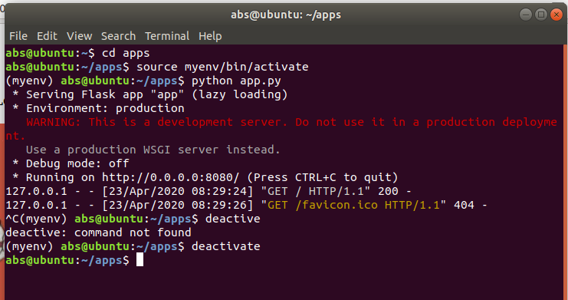
- after you are done running this app make sure you deactivate your vitual environment for that type
deactivate
