Mini Project

***AMP – The Online Furniture Store***

*Abstract*

For this project, we developed an online furniture store. The website displays items which can be bought based on item description, price and quantity. The user can place and order and it will be delivered to his/her address. Our online store consists of 3 main modules such as sign up/login for customers, ease of searching & selecting for required products & add to cart option for order summary. Payment module is implemented by using Cash On Delivery [COD] option only. The website runs its frontend developed using languages such as HTML5, CSS3. Bootstrap is used for framework & JQuery used for validation along with JavaScript. Backend development includes languages such as PHP, SQL & database used is MySQL. Xampp setup is used for server & database connectivity.

*Introduction*

*1.1*  *Need*

An online furniture store simplifies the process of choosing, ordering and receiving different items of furniture. Variety of items are available at the click of the mouse. The idea is also useful for people who do not wish to travel to stores and can instead order furniture from the comfort of their homes.

*1.2 Scope*

This project includes user sign in, two pages to view the following categories – Furniture and Décor, tiles to display each item, pop up for item description from where you can also add the product to cart. The functionality of the cart is created so that the user can add more than one items and make payment for the combined order.

The project doesn’t include but can include the following – a system for coupon codes for discounts, to be able to view order history and check if order can be delivered to given zip code.

*1.3 Problem Statement*

To create an attractive online portal to buy furniture and décor. This is because various traditional businesses which used to have a lot of sales and major business by offline stores are having a difficult time generating revenue. People or customers always look for buying and shopping in a less difficult way. Due to this digital shift in technologies and products which can be bought right from home with a finger tap has created a problem for offline businesses.

*Requirements*

* 1. *Hardware*

*1. 500 GB hard disk*

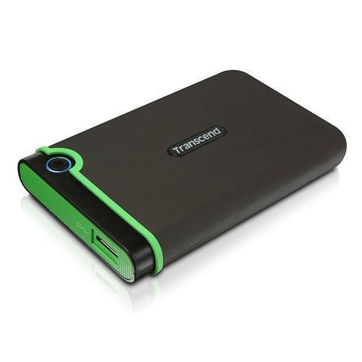

As we run the project on local server using xampp, it takes atleast a desktop or laptop with 500 GB disk space in order to store the entire online store including its data, customer information, forms, reviews, etc.

*2. 4 GB RAM*

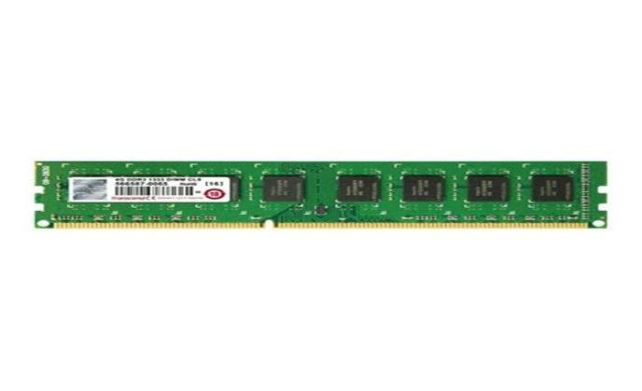

As the e-commerce website handles a lot of data requests from people accessing the website, high processing capabilities are to be needed by the machine hosting the website. Hence, 4 GB RAM is the minimum requirement of the system for normal working condition.

*3. Intel i3/i5/i7 processor*

**In order to work efficiently with RAM for more processing power, these processors are a must. These processors help users to smoothly browse through to the website reducing friction and ease of use.

*2.2 Software*

1. *HTML5*



HTML5 is the latest evolution of the standard that defines [HTML.](https://developer.mozilla.org/en-US/docs/HTML) The term represents two different concepts. It is a new version of the language, with new elements, attributes, and behaviors, and a larger set of technologies that allows the building of more diverse and powerful Web sites.

*2. CSS3:*

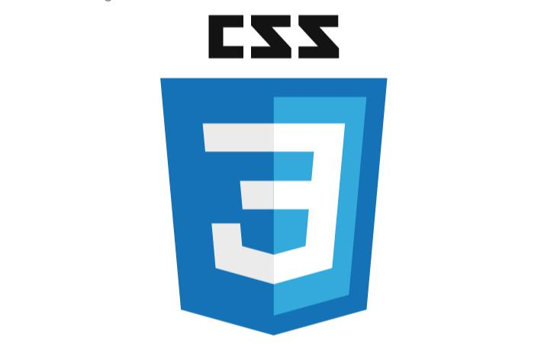

Cascading Style Sheets (CSS) is a style sheet language used for describing the look and formatting of a document written in a markup language. CSS3 is a latest standard of css earlier versions(CSS2).

*3. JavaScript*



JavaScript is a lightweight, interpreted programming language. It is designed for creating network-centric applications. It is complimentary to and integrated with Java. JavaScript is very easy to implement because it is integrated with HTML.

*4. PHP*



The PHP Hypertext Preprocessor (PHP) is a programming language that allows web developers to create dynamic content that interacts with databases. PHP is basically used for developing web based software applications.

*Methodology*

1. Homepage displays 2 sections. A vertical navbar on the left and a display of trending items on the right.
2. The furniture tab displays various furniture items in a tile like view – emphasising the clean design and craft work of the pieces. Each tile has a pop up – click on it to read about the product details and then add to cart.
3. The décor tab is similar to the furniture tab and contains décor items in a similar tile like view.
4. The cart tab leads you to the cart page. The cart page has a list of all the items currently in your cart. On the right there is section to choose payment mode and proceed to payment.

*Screenshots*

1. Home page

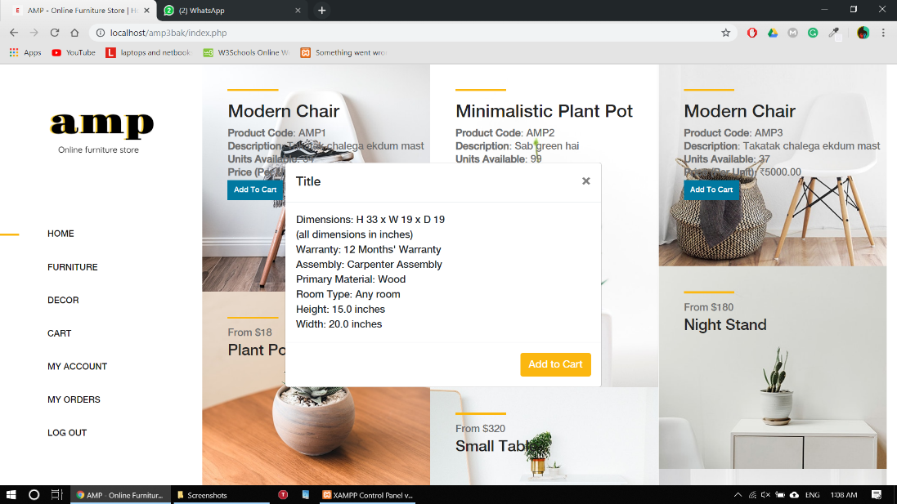

1. Products page

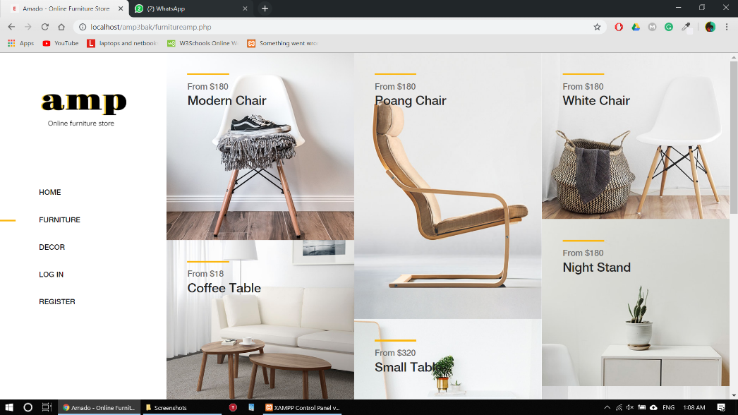

1. Orders page

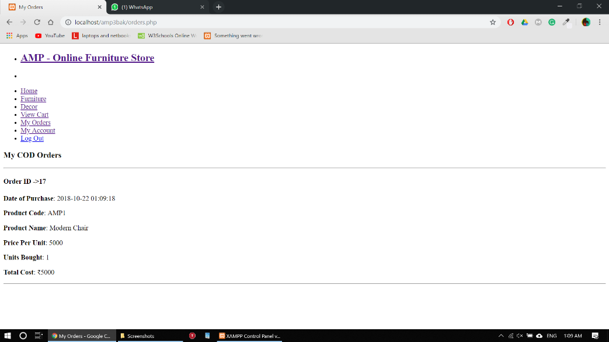

1. Register page

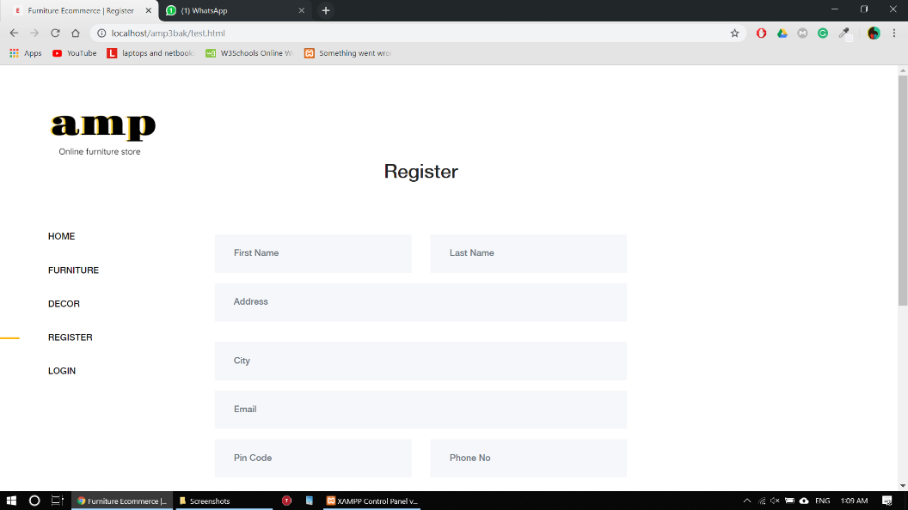

1. Login page

