Assignment 2 - Machine Learning Application
Insurance Cost Prediction using Ridge and Lasso Regression
Name: ____________________ Roll No: ____________ Date: ____________

1. Problem Statement
Health insurers must estimate the yearly medical charges of a person from a few personal attributes so premiums can be priced fairly. The goal of this project is to build a regression model that predicts individual medical insurance charges (a continuous value) from age, sex, BMI, number of children, smoking status and region. Ridge (L2) and Lasso (L1) regression are used because they add regularisation, which reduces overfitting and handles correlated features; Lasso can also perform feature selection.

2. Dataset Description
The dataset follows the structure of the popular "Medical Cost Personal Dataset" (Kaggle, mirichoi0218/insurance): 1338 records, 6 input features and 1 target.
- age (numeric), bmi (numeric), children (numeric count)
- sex (male/female), smoker (yes/no), region (4 US regions) - categorical
- charges (target) - yearly medical cost in USD
Important note: the sandbox used to build this project had no internet access, so the CSV in the zip is a synthetic dataset with the same columns, size and similar relationships (smokers pay far more, charges rise with age and BMI). The code runs unchanged on the original Kaggle file; replace data/insurance.csv and re-run, and the numbers in this report will change accordingly.

3. Data Preprocessing
- Checked for missing values (none) and duplicate rows (none removed).
- Explored the data: charges are right-skewed, and smokers form a clearly separate, higher-cost group.
- Feature engineering: added smoker x BMI (BMI affects cost much more for smokers) and age squared (non-linear ageing effect).
- One-hot encoding of sex, smoker and region (first category dropped to avoid the dummy-variable trap).
- Standardisation (StandardScaler) of numeric features - essential because Ridge/Lasso penalties depend on coefficient size.
- 80/20 train-test split (random_state=42); all preprocessing is inside a scikit-learn Pipeline so no test data leaks into training.
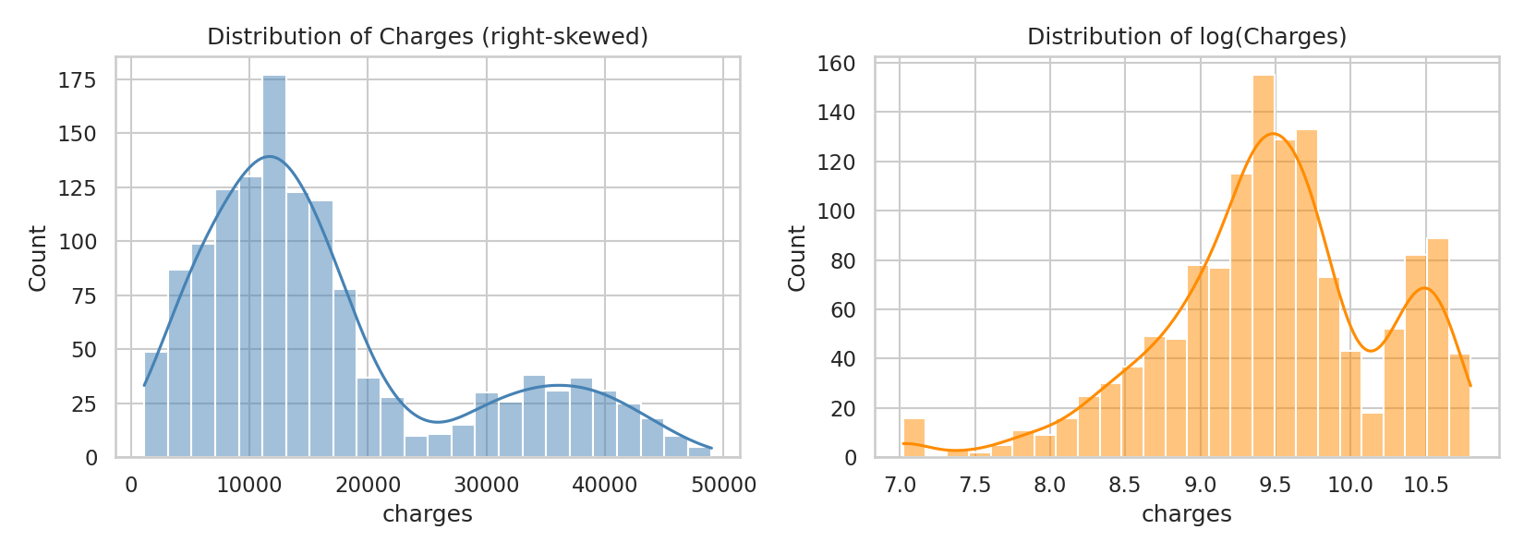
Figure 1: Distribution of charges and log(charges)
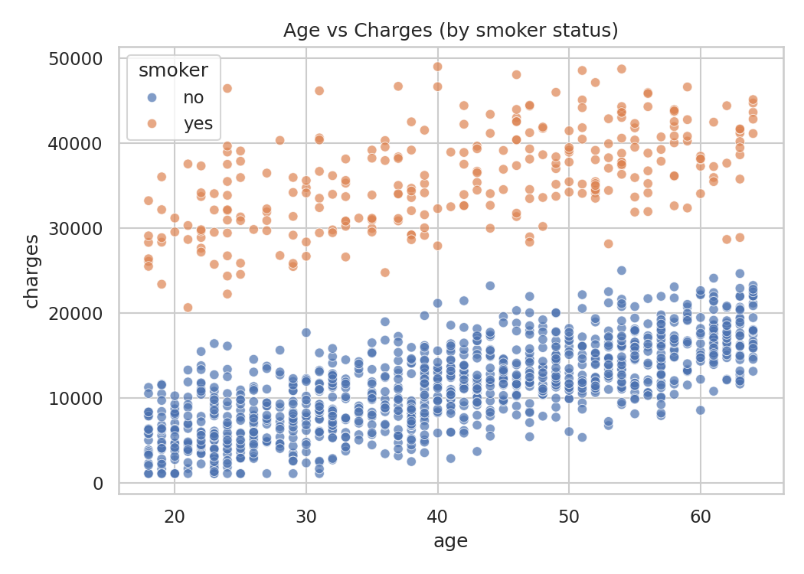
Figure 2: Age vs charges, coloured by smoker status

4. Algorithm Selection
Ridge minimises squared error + alpha * sum(w^2): it shrinks all coefficients but keeps them non-zero. Lasso minimises squared error + alpha * sum(|w|): it can shrink some coefficients exactly to zero. Ordinary Linear Regression is trained as a baseline. The regularisation strength alpha was tuned for both models with GridSearchCV (5-fold cross-validation, 30 values from 0.001 to 1000, scoring by R2).

5. Training and Testing
Each model was fitted on the training set (1070 rows) and evaluated on the unseen test set (268 rows). 5-fold cross-validated R2 on the training set was also calculated to check stability.

6. Evaluation Metrics and Results
MAE (average absolute error in USD), RMSE (error in USD, penalises large mistakes) and R2 (share of variance explained) were used.
Model | Best alpha | MAE | RMSE | R2 (test) | R2 (train) | CV R2
Linear Regression | - | 2984 | 3673 | 0.8971 | 0.9129 | 0.9092
Ridge | 0.788 | 2990 | 3675 | 0.8969 | 0.9129 | 0.9093
Lasso | 3.290 | 2989 | 3675 | 0.8969 | 0.9129 | 0.9093

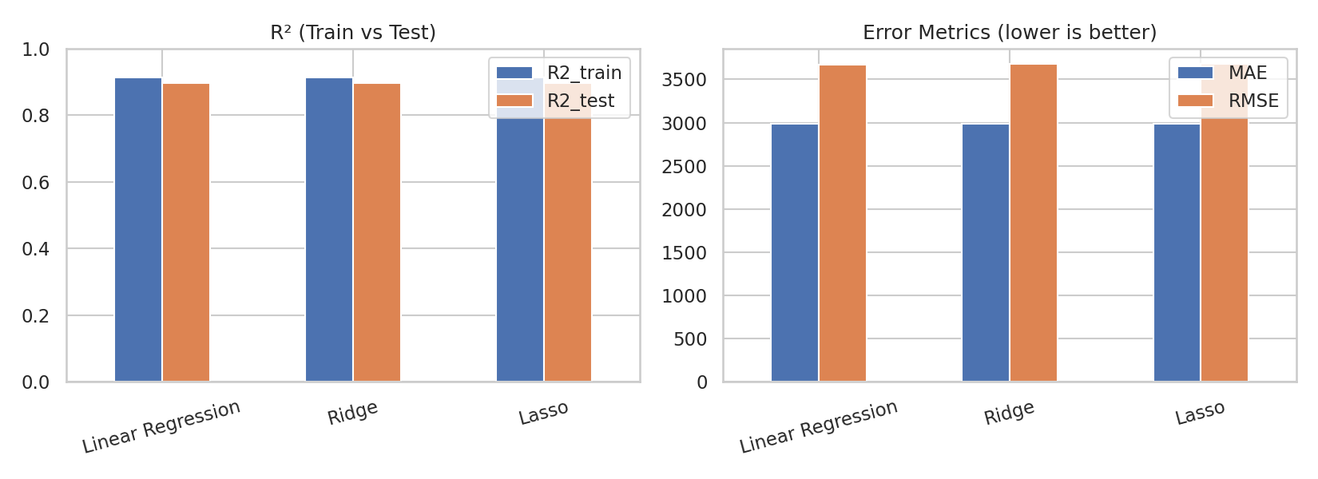
Figure 3: R2 and error comparison of the three models
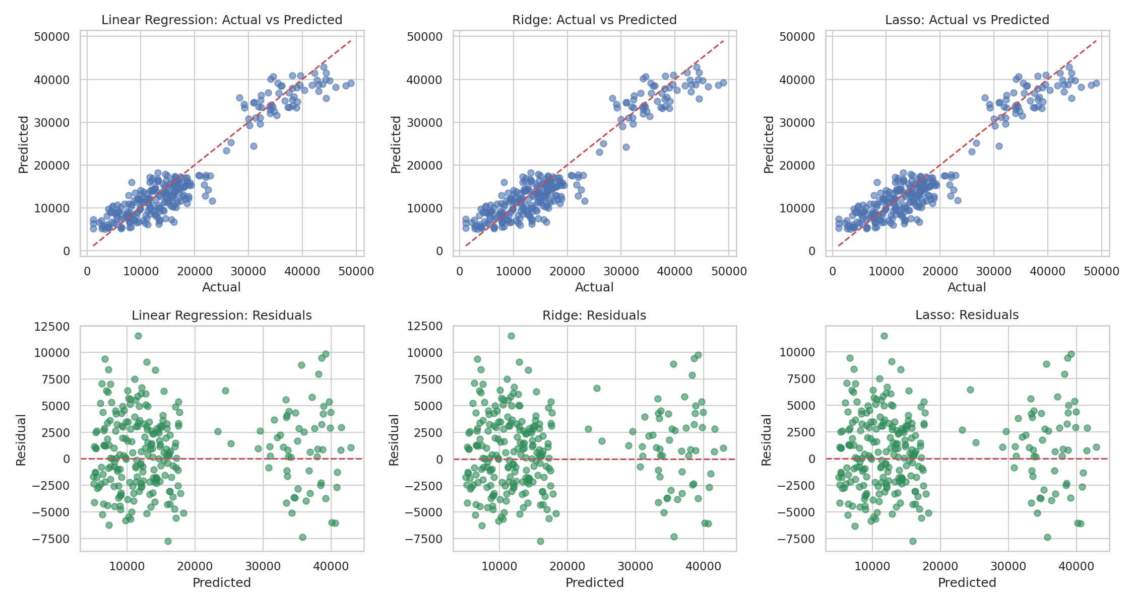
Figure 4: Actual vs predicted values and residuals
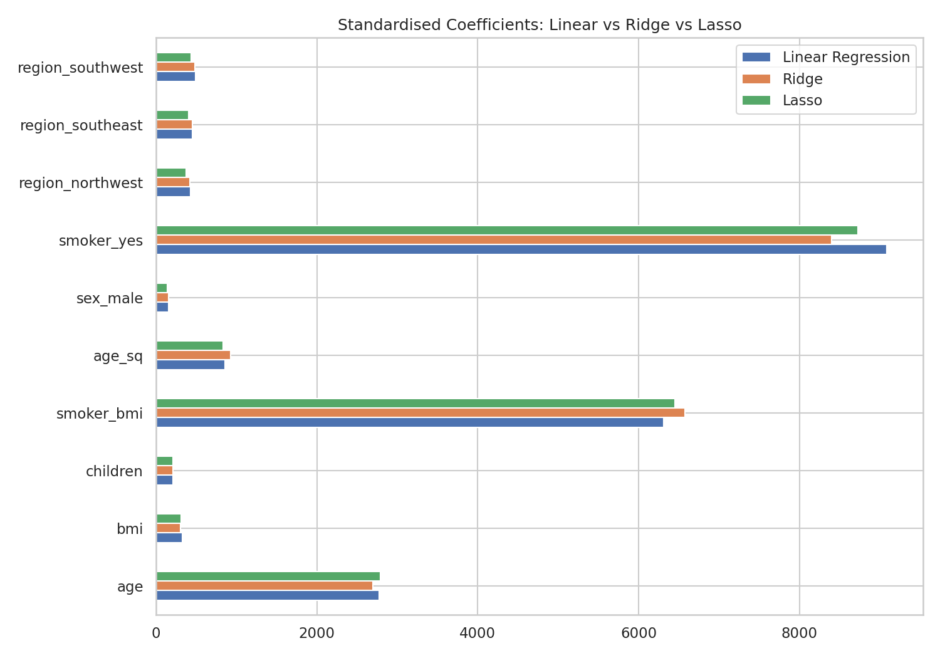
Figure 5: Standardised coefficients of Linear, Ridge and Lasso
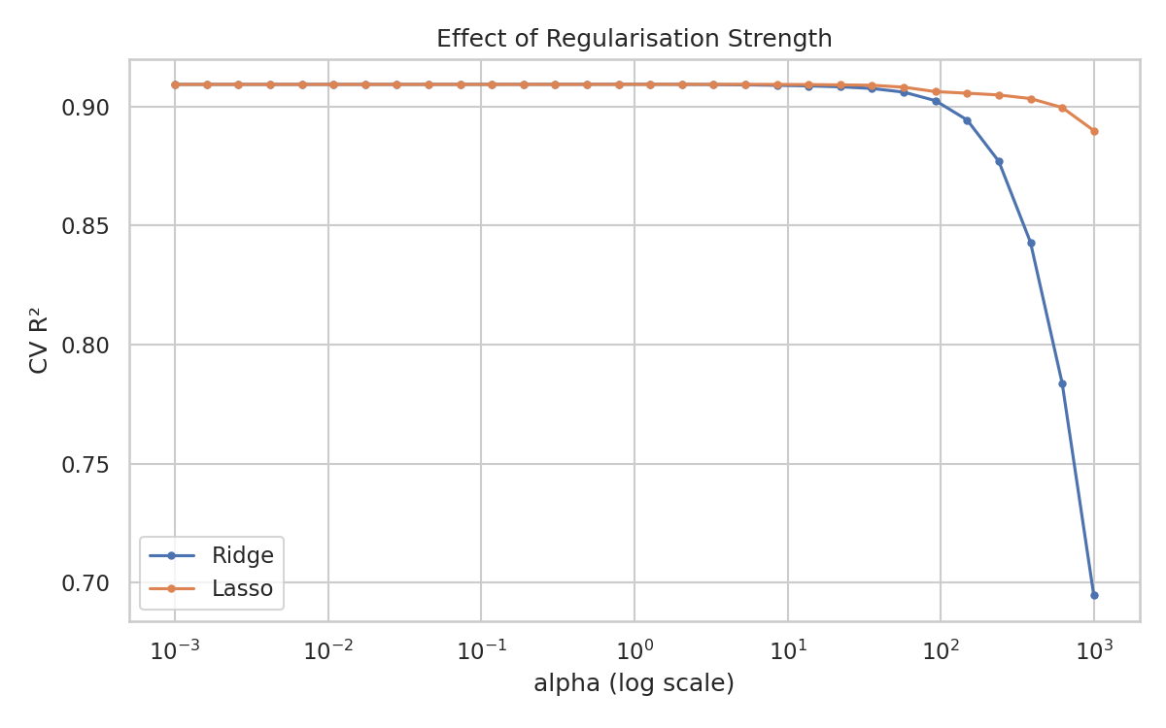
Figure 6: Effect of alpha on cross-validated R2

7. Analysis of Results
- All three models reach about 0.90 R2 on the test set (RMSE about 3,675 USD, MAE about 2,990 USD), so roughly 90% of the variation in charges is explained.
- Train R2 (0.913) is close to test R2 (0.897) and CV R2 (0.909): the models are not overfitting.
- Ridge and Lasso performed essentially the same as plain Linear Regression. With only a handful of features and 1000+ rows, overfitting is not a real problem here, so regularisation gives little benefit. This is an honest finding, not a failure: the best alpha values are small (Ridge about 0.79, Lasso about 3.3), and Figure 6 shows the score staying flat until alpha becomes large.
- Lasso did not drive any coefficient to exactly zero because all features carry some signal; with a larger alpha it would begin removing weak features such as sex.
- The most influential features are smoking status (smoker, smoker x BMI), then age; children and region have small effects.
- Limitations: the residual plot shows larger errors for high-cost patients (heteroscedasticity), and a linear model cannot capture every interaction. A tree-based model (Random Forest / Gradient Boosting) or a log-transformed target could improve accuracy.

8. Streamlit Interface (Optional Extension)
app.py loads the saved model and lets the user enter age, BMI, children, sex, smoker status and region, then displays the predicted yearly charge. Run with: streamlit run app.py

9. Conclusion
A regularised linear model can predict insurance charges with about 0.90 R2 and an average error of about 3,000 USD. Smoking status is the dominant cost driver. Ridge and Lasso are stable and interpretable choices, though on this small, clean dataset they match ordinary regression.

