DATA 601 Final Project Report
Prediction of a Country’s GDP per Capita
Group 2: Abijeet Dhillon - 30153872, Noor Fatima - 30305229, Tam Nguyen - 30305986
1. Ask a Question
ML Question: Can Current-Year Energy, Economic, Infrastructure, Urbanization, Environmental, and Country-Level Information Predict a Country’s GDP per Capita in the Following Year?
Ideal Outcome: Develop a model with low prediction error (MAE < 1,000), high R^2 (R^2 ≥ 0.95), and similar performance across training, validation, and test data. This indicates accurate next-year GDP per capita predictions and strong generalization to unseen observations.
Data Source: https://databank.worldbank.org/source/world-development-indicators#advancedDownloadOptions
Data Reliability: The World Development Indicators (WDI) data is collected and compiled by the World Bank from officially recognized national and international sources as part of the WDI database from 1960 to the present. We downloaded this data directly from the WDI DataBank portal as a country-by-indicator-by-year panel dataset. The data collection was “based on data originally collected, compiled and published by other sources, including other international organizations such as UN specialized agencies (sometimes in cooperation with the World Bank), national statistical offices, organizations with a specific research or monitoring focus, the private sector, and academic studies” (World Bank).
Permission/Accessibility: The World Development Indicators data is classified as Public under the Access to Information Classification Policy. Therefore, we require no special permission or additional accessibility requests to access and utilize this dataset in our project, provided that we credit and cite the World Bank as the data source.
Sample Selection:
- Countries: 193 unique countries (of the ~217 available in WDI), after removing entities with no usable GDP data
- Indicators: 22 variables selected from the full WDI pool of ~1,498 series, covering energy, economic development, population, technology, trade, and environmental indicators
- Time coverage: 2006–2021 (16 years), narrowed down from the full ~ 1960–2025 range after finding that missingness stays roughly stable (~10%) through 2021 but rises sharply (>20%) afterward.
- Format: Panel data — one row per country-year, reshaped from the original wide country-indicator-year layout into a long/tidy format for analysis
- Resulting shape: ~3,400 country-year observations × 22 variables
Dataset Limitations: This dataset has missing values for some indicators and countries, particularly for energy-related variables. The original World Bank dataset was not analysis-ready, so we reformatted it from multiple-year columns to a country-year format. During this process, we also limited the analysis to 2006–2021, as data availability decreased significantly after 2021. These factors may reduce the number of observations in certain analyses.
ML Problem Type and Model Choice: This is a supervised regression problem because the target variable, next-year GDP per capita, is continuous. We tested several models, including linear regression, Decision Trees, Random Forests, and XGBoost.
- Linear Regression served as a simple baseline to assess how well a linear relationship could explain next-year GDP per capita.
- Decision Tree was tested because it can capture nonlinear relationships and interactions between variables.
- Random Forest combines many decision trees, which usually gives more stable predictions and reduces the overfitting of a single tree.
- XGBoost builds trees sequentially. This makes it useful for capturing complex nonlinear relationships in the data.
Metrics: We will use MAE, RMSE, and R² to evaluate model performance. However, we will use MAE as the primary metric for selecting the best hyperparameter combination. - MAE: Main tuning metric because it gives the average prediction error in the original GDP-per-capita units and is easy to interpret. - RMSE: Useful as a secondary metric because it gives more weight to large prediction errors. - R²: Shows how much of the variation in next-year GDP per capita is explained by the model.
Selection Rule: Choose the parameter combination with the lowest cross-validation MAE. Then use RMSE and R² as supporting metrics to confirm that the model also performs well overall.
2. Data Understanding, Exploration, and Visualization
EDA: For the EDA, I selected several key variables to explore patterns in economic development and energy consumption. GDP per capita represents economic development, while energy use and electric power consumption measure energy consumption. Access to electricity represents energy infrastructure, CO₂ emissions capture the environmental aspect of energy use, and urban population represents the level of urbanization. These variables provide an initial view of the main economic, energy, infrastructure, environmental, and demographic factors in the project.
GDP Per Capita  GDP per capita varies substantially across countries. GDP per capita has a mean of ~24,156 international dollars and a median of 14,854. The large difference between the mean and median, together with the histograms, indicates a strongly right-skewed distribution in which a relatively small number of countries have very high GDP per capita.  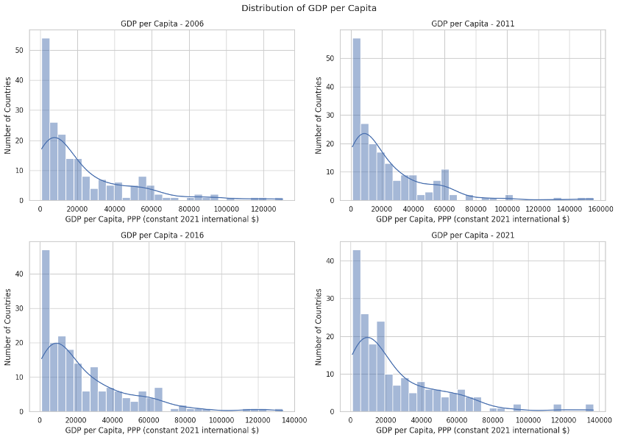 | Energy Use  On average, energy use is about 2,455 kg of oil equivalent per person, while the median is about 1,441. The large standard deviation (~2,966) and wide range (from ~9.7 to ~21,456) show that energy consumption varies greatly across countries. The mean being lower than the median also indicates a right-skewed distribution in which a relatively small number of high-energy-consuming countries increase the overall average.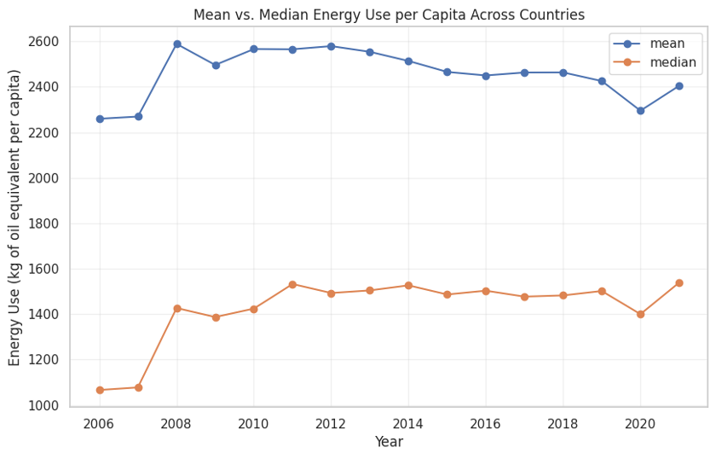
Access to Electricity  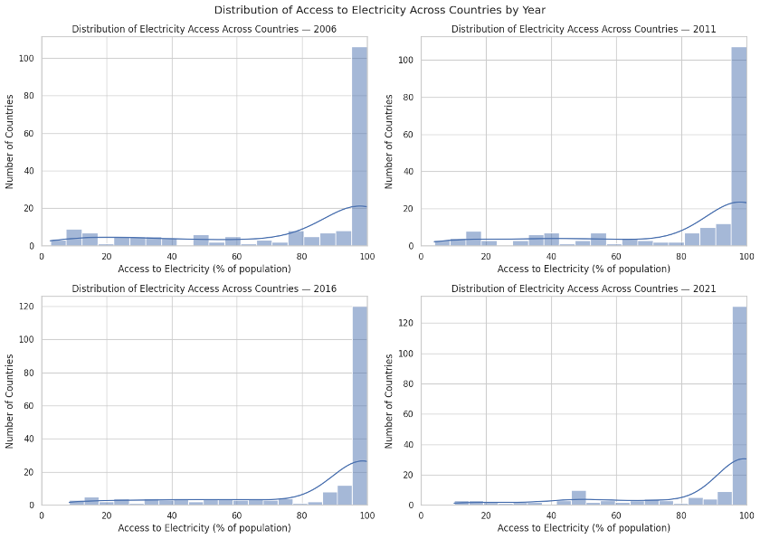  Access to electricity varies substantially across countries, ranging from 1.3% to 100%. The histograms show a left-skewed distribution concentrated near 100%, with a median of 99%. This suggests that many countries have near-universal electricity access, while a smaller number of countries with low access pull the average downward. The yearly trend also shows steady improvement over time, with average electricity access increasing from below 75% in 2006 to about 87% by 2021. | CO₂ Emissions  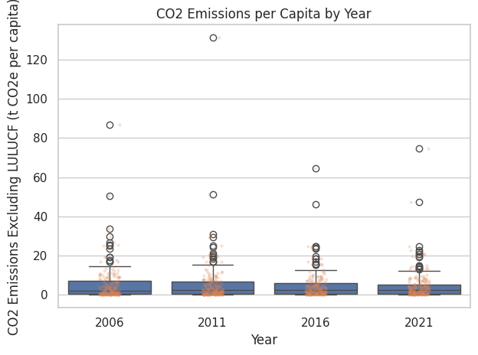  CO₂ emissions per capita vary substantially across countries and show a strongly right-skewed distribution. The mean emission level is about 5.05 tonnes of CO₂e per person, while the median is only 2.44, indicating that some countries have much higher CO₂ emissions than others. The boxplots also show many high-value outliers across the selected years, while most countries remain concentrated at relatively low emission levels.
Electric Power Consumption  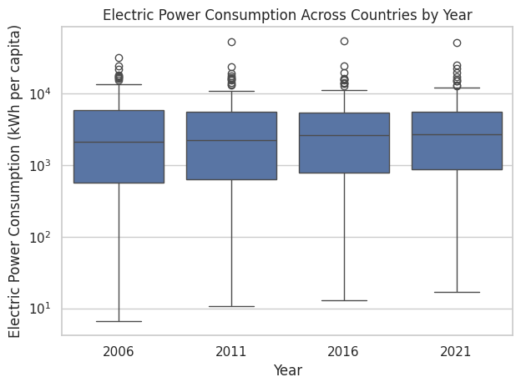  The boxplots show many high-consumption outliers across the selected years, while the median gradually increases from 2006 to 2021, suggesting a moderate increase in typical electricity consumption over time. | Urban Population  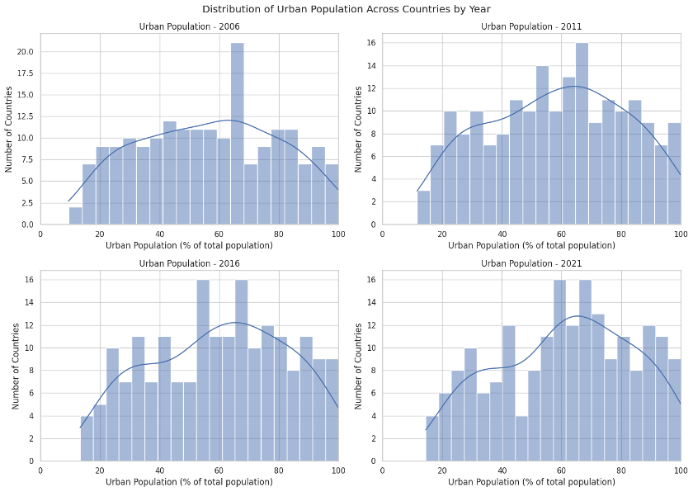  The histograms show that the distribution gradually shifts toward higher urbanization levels over time, with more countries concentrated around 60–80% by 2021. Overall, this suggests a general increase in urbanization across countries during the study period.

3. Data Wrangling and Preprocessing
Our data range from 2006 to 2020, covering 15 years. The goal of this project is to predict future GDP per capita. Therefore, we use a chronological split so that the model is trained on earlier years and evaluated on later, unseen years. This prevents information from later years from being used to predict earlier years, which could occur with a random split. The data are divided into training, validation, and test sets. The validation set tunes model parameters, while the test set remains separate for final model evaluation.

- Train: 2006–2015 = 10 years → 66.7%
- Validation: 2016–2017 = 2 years → 13.3%
- Test: 2018–2020 = 3 years → 20%

This results in an approximately 67/13/20 chronological split. Our method for filling missing values in X is forward fill + median + missing indicator. Before filling missing values, we record which observations were originally missing. A value of 0 means the original value was available, while 1 means the value was originally missing and had to be filled. This preserves information that would otherwise be lost after imputation and allows the model to determine whether missing-data patterns contain useful predictive information. If a value is missing, we use the most recent available value from the same country. We don't do backward fill to prevent future information from leaking into earlier observations. After forward fill, we replace any remaining missing values with the median calculated from the training data. We calculate the median only from the training data to avoid data leakage.

To select the features in the training set, we used the following four methods.
- Correlation
  - We will create a heatmap of the original predictors to identify linear relationships and potentially redundant information. We explicitly remove rural population (% of total population) because its share is complementary to urban population (% of total population). We will consider high correlation a diagnostic value because tree models may use correlated values differently.
- Permutation Importance
  - We will fit a fixed random-forest model on the earlier portion of the training data and measure how much MAE increases when we randomly shuffle each predictor in the later portion of the training data.
- Chronological Verification
  - We will retrain the same fixed random-forest model on the full training set. Then, we will compare the 2016/17 validation MAE to select the feature count and report the RMSE and R^2 as well.
- One-Hot Encode Country Names
  - We will use one-hot encoding instead of label encoding because Country Name has no natural order. Label encoding could introduce an artificial numerical ranking between
  - countries.
4. Build and Test a Model
We chose regression because GDP per capita is a continuous numerical variable, so the prediction requires regression rather than classification. We will compare four regression models on the same features and training data: linear regression, a decision tree regressor, a random forest regressor, and an XGBoost regressor. Linear regression is highly interpretable and will give us a baseline for model comparison. The decision forest is still interpretable but may produce higher variance/overfitting. The random forest may reduce variance by averaging predictions across multiple trees but may be harder to interpret. XGBoost builds multiple trees sequentially, with each new tree minimizing the errors of previous trees, which improves performance but makes the model harder to interpret. We will compare the MAE, RMSE, and R^2 of each model.
The four baseline models showed strong initial predictive performance, all with R^2 values over 0.99, but they differed in MAE and RMSE. The decision tree overfit, while linear regression had lower MAE and RMSE. Our best-performing model was random forest, with the lowest MAE (560.61), lowest RMSE (1,228.36), and highest R^2 (0.9977). XGBoost also performed strongly, with a validation MAE of 693.83 and R^2 of 0.9965, although it showed a larger gap between training and validation performance. Therefore, we selected Random Forest and XGBoost for further analysis because they showed the strongest predictive performance among the four models.
For fine-tuning, we did the following.
- XGBoost Tuning
  - Selected tuning parameters: - n_estimators: Number of trees built by XGBoost. More trees allow the model to learn more patterns. - max_depth: Maximum depth of each tree. Smaller depths help control model complexity and reduce overfitting. - learning_rate: Controls how much each new tree contributes to the model. Smaller values make learning more gradual. - subsample: Percentage of training observations used to build each tree.
  - Overall purpose: These parameters balance model complexity and predictive performance while reducing overfitting.
  - The best XGBoost model used 200 trees (n_estimators = 200), a maximum tree depth of 5 (max_depth = 5), a learning rate of 0.05, and 100% of the training observations for each tree (subsample = 1.0). The model achieved an average chronological cross-validation MAE of 1070.70, meaning that across the time-based validation folds, its predictions differed from the actual GDP per capita values by approximately 1,071 units on average.
  - After hyperparameter tuning, XGBoost showed improved validation performance. Validation MAE decreased from 693.83 to 601.22, RMSE decreased from 1518.44 to 1245.98, and R² increased from 0.9965 to 0.9977. Training error increased after tuning, indicating the model fit the training data less tightly. Although a train-validation gap remains, the tuned XGBoost generalizes better than the baseline model.
- Random Forest Tuning
  - Selected tuning parameters:
    - n_estimators: Number of trees in the Random Forest. More trees can improve stability and predictive performance, but also increase computation time.
    - max_depth: Maximum depth of each tree. Smaller depths help control model complexity and reduce overfitting.
    - min_samples_split: Minimum number of observations required to split a node. Larger values make the trees more conservative and can reduce overfitting.
    - min_samples_leaf: Minimum number of observations required in each leaf. Larger values prevent very small leaves and can improve generalization.
  - Overall purpose: These parameters are tuned to balance model complexity and predictive performance while reducing overfitting
  - The best Random Forest model used 100 trees, with no maximum depth, a minimum of 2 samples to split a node, and 1 sample per leaf. This parameter combination produced the lowest cross-validation MAE among the tested combinations. The optimal parameters identified through hyperparameter tuning matched the baseline Random Forest settings. Therefore, the tuned model produced identical performance, indicating that tuning did not improve the baseline model.
- Log Transformation: As shown in the EDA, GDP per capita is highly right-skewed, with some countries having extremely high values. Therefore, we apply a log transformation to the target variable to compress large GDP values, reducing the influence of extreme observations during model training.
  - Random Forest Log Transformation Results: The log transformation did not improve Random Forest performance. Validation MAE increased from 582.57 to 604.34, RMSE increased from 1174.52 to 1257.66, and R² decreased slightly from 0.9979 to 0.9976. Therefore, we retained the original target for Random Forest.
  - XGBoost Log Transformation Results: The log transformation improved XGBoost’s validation performance. Validation MAE decreased from 627.76 to 598.53, RMSE decreased from 1284.08 to 1213.23, and R² increased slightly from 0.9975 to 0.9978. Although training error increased, this suggests better generalization. Therefore, XGBoost + Log Target was retained.
After comparing our tuned models, we selected XGBoost with a log-transformed target as the final model. Although Random Forest achieved a slightly lower validation MAE, XGBoost showed a much smaller train-validation gap, indicating better generalization and lower overfitting.
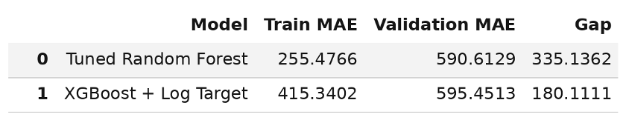
The final XGBoost model’s results are below.
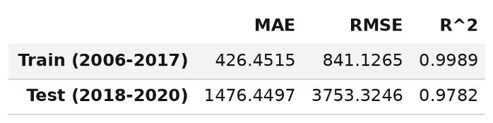
Because the test set covers 2018–2020 (predictor years), it includes 2019 - 2020, the years COVID-19 caused an economic shock globally.
An error analysis was also conducted. We broke test errors down by year, GDP level, and the size of the year-to-year GDP change, and checked whether a few countries account for most of the error. We do not remove extreme observations; if they drive the error, we report that as a model limitation.
- By Year: Error is much larger for predictor year 2019 (MAE 2,350, RMSE 5,758, median error 6.9%, R² 0.943) than for 2018 (MAE 520, median error 1.6%, R² 0.998). The 2019 predictions target 2020, the year of the COVID-19 shock. 2020 sits in between (MAE 1,559, median error 4.0%), which is consistent with an uneven rebound in 2021. The 2018 MAE of about 520 is similar to the validation MAE of roughly 600, so the model generalizes well in a normal year. The train-test gap in Section VI is therefore driven mainly by the 2019 and 2020 shock years.
- By Size of GDP Change: Error grows sharply with the size of the actual year-to-year change. The largest-change group has an MAE of 3,449 and a median error of 11.0%, compared with 532 and 1.6% for the smallest-change group. The model behaves like a "continue the recent trend" forecaster and cannot anticipate sudden changes.
- By GDP Level: Absolute error increases with GDP (MAE from 136 in the lowest quartile to 3,373 in the highest). The median percentage error stays in a narrow 2.5–5.2% band across all quartiles. Richer countries therefore have larger dollar errors mostly because their GDP values are larger, not because the model is much less accurate for them in relative terms.
- Concentration: The top 10 countries account for 29.2% of total absolute error (out of 193 countries), and the top 5% of observations account for 33.9%. The error is somewhat concentrated but not dominated by a few cases. The single largest error is Macao SAR in 2019: GDP actually fell 55.3%, but the model predicted about 128,800 against an actual 59,700, an error of 69,169. That one observation is about 8% of the total test error and likely drives the high 2019 RMSE. The other large errors are mostly small, high-income or tourism- and finance-dependent economies (Singapore, Ireland, Luxembourg, San Marino, Bermuda, Aruba, Maldives) in 2019 and 2020.
The conclusion we came to from the error analysis was that the generalization gap is best described as a limitation in predicting economic shocks, especially the 2020 COVID downturn and rebound in small, open economies, rather than a general failure of the model.
5. Interpret Your Model
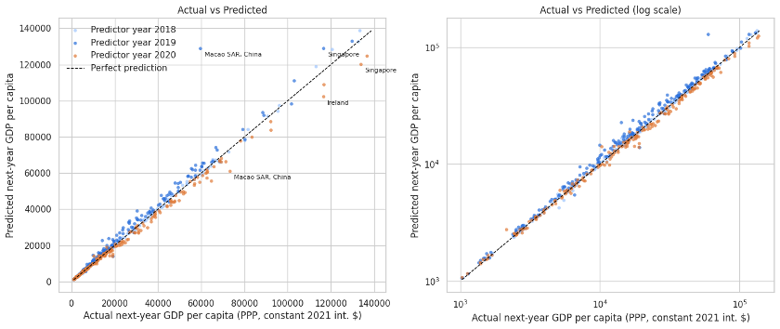
Looking at the plots above, we can see that the predictions lie very close to the diagonal across the full range of GDP, including the log-scale view, which shows the model also predicts low- and middle-income countries well. The visible departures are a few high-GDP points, such as Macao SAR (2019), Singapore, and Ireland.
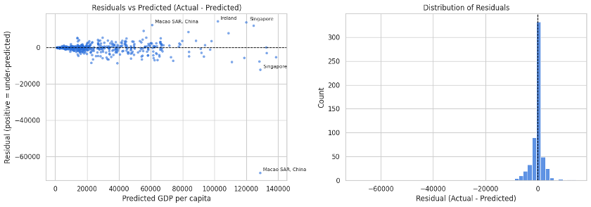
Residuals are centered on zero, so there is no systematic bias. The histogram is sharply peaked at zero with a few long tails. The spread widens at higher predicted GDP, so the model is less precise in dollar terms for rich economies. Macao SAR (about −69,000) is an extreme outlier in the over-prediction direction. Singapore and Ireland in 2020 are the clearest under-predictions (about +14,000), consistent with a strong 2020 to 2021 rebound (+15% in both cases).
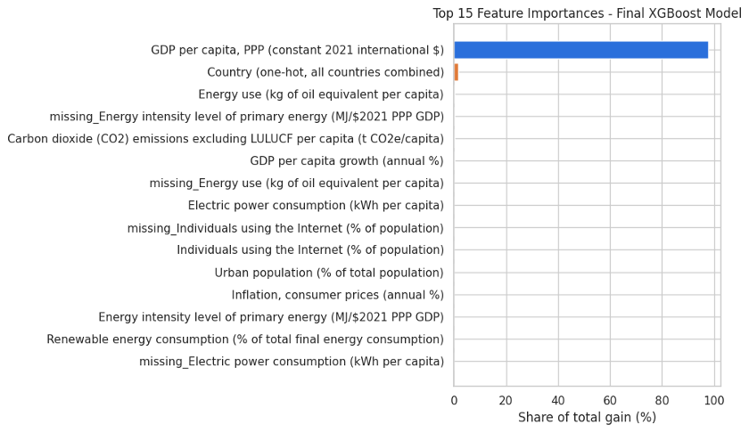
From the plot above, we can see that current year GDP per capita is accounting for 97% of the model’s total performance. The second most important feature for our model was country name, and the rest of the indicators contributed little towards our model’s predictive ability. Other than the top 2 important predictors, the other predictors add little additional predictive contribution. This result is accurate with our naive benchmark of assuming this model learns that “next year = this year”, with minor adjustments.
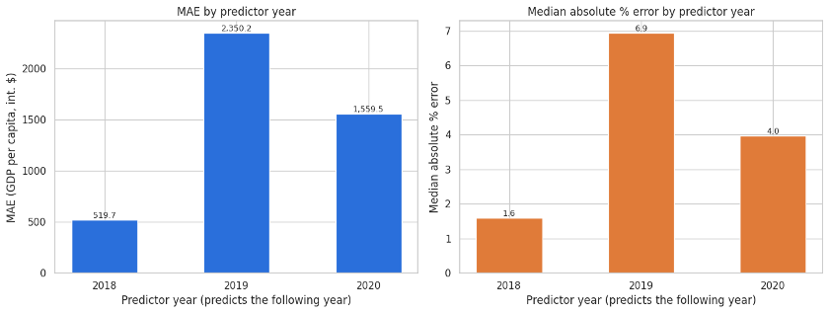
Both MAE and median percentage error are lowest in 2018 and highest in 2019, then partly fall back in 2020. This confirms that accuracy is tied to economic conditions, with shock years being hardest.
Predictive Ability: The selected XGBoost + log-transformed target model showed strong predictive ability on the validation data, achieving an MAE of 598.53, RMSE of 1,213.23, and R^2 of 0.9978. The very high R^2 indicates that the model explains most of the variation in next-year GDP per capita. However, the training MAE (300.54) is noticeably lower than the validation MAE, suggesting some generalization gap.
Variable Interpretation: Our final XGBoost model showed that current-year GDP per capita is the most important predictor, accounting for roughly 97% of the model's total gain. The country's one-hot encoded indicators contribute the second-most importance to predictions; however, their importance is much lower than that of current-year GDP per capita. The remaining predictor variables have little importance compared with current-year GDP per capita and country name. This doesn't mean these predictor variables are unrelated to GDP; rather, they provide little additional predictive contribution.
Since our final model is an XGBoost model, we cannot report the coefficients/feature importance for itself other than determining that the model's predictive performance is driven by GDP per capita over time rather than a set of economic, energy, or infrastructure predictors. However, we can discuss the feature importance/coefficients from our random forest model. Based on our ranking above in the feature selection section of features by their averaged mean absolute error increase during our permutation importance test, we say that GDP per capita was the predictor with the largest increase in mean absolute error, followed by inflation, electric power consumption, carbon dioxide, emissions, and energy use.
The final XGBoost model generalizes well in normal years but less well in shock years. Trained in 2006–2017 predictor years, it reached a training MAE of 426 and R² of 0.9989. On the unseen 2018–2020 test set, the MAE was 1,476 and the R² was 0.9782. The test MAE is about 3.5× the training MAE and the test RMSE about 4.5× the training RMSE. There is a clear generalization gap in dollar terms, although the R² drops by only about 0.02.
The gap is not spread evenly across the test period. The 2018 predictor year (predicting 2019) has an MAE of about 520 and a median error of 1.6%, close to the roughly 600 validation MAE from tuning. The 2019 predictor year, which predicts 2020, has an MAE of 2,350 and a median error of 6.9%. The 2020 predictor year is in between (MAE 1,559). This pattern points to the COVID-19 shock and its rebound as the main driver of the gap rather than general overfitting. Error also increases with the size of the actual GDP change: the largest-change group has a median error of 11.0%, versus 1.6% for the smallest. Macao SAR in 2019 is the largest single error (its GDP fell 55.3%, but the model predicted a value close to the previous year's). It accounts for about 8% of the total test error. More broadly, the top 10 countries account for 29.2% of the total error and the top 5% of observations for 33.9%, so the error is somewhat concentrated but not dominated by a few countries. We did not remove these observations and treat them as a model limitation.
The model's predictive value over a simple baseline is limited. A naive "next year equals this year" forecast scores an MAE of 1,399, RMSE of 3,837, and R² of 0.9772 on the test set. The model's MAE (1,476) is slightly worse, its RMSE (3,753) slightly better, and its R² (0.9782) slightly higher. Current-year GDP per capita accounts for about 97% of the model's feature importance, so most of the predictive power comes from persistence in GDP rather than from the energy, technology, or other indicators. The other predictors add little beyond current GDP, and the model cannot anticipate sudden economic shocks.
Because high-GDP countries have the largest dollar errors (test MAE of about 3,373 in the top GDP quartile versus 136 in the bottom quartile, although median percentage errors are similar across quartiles at roughly 2.5 -- 5%), we tested whether the model was under-fitting these countries. Training the same model with sample weights that give more influence to higher-GDP observations changed the results very little: overall MAE was slightly lower (1,459 vs 1,476), but RMSE (3,846 vs 3,753) and R² (0.9771 vs 0.9782) were slightly worse, and the top-quartile MAE improved by only about 1%. This suggests the larger errors in high-GDP countries mostly stem from their larger GDP values and shock years, rather than something more weighting can fix, so we kept the original model.
Overall, the model predicts next-year GDP per capita reliably in stable years but does not generalize well to sudden economic shocks, and it performs about as well as carrying this year's GDP forward.
6. Answer Your Question
Our analysis answered our question of interest: “Can Current-Year Energy, Economic, Infrastructure, Urbanization, Environmental, and Country-Level Information Predict a Country’s GDP per Capita in the Following Year?” Given a country’s current-year information, we can predict its next-year GDP per capita well, especially when economic conditions are stable. Most of the model’s predictive power came from current-year GDP per capita, while the other economic, energy, infrastructure, and environmental indicators added little predictive value.
Compared with our ideal outcome, the final XGBoost model had a test R^2 of 0.9782, exceeding our goal of 0.95, but its test MAE of 1,476 did not meet our goal of less than 1,000. The training and test performance was also different, with the test MAE around 3 times higher than our training MAE. According to our error analysis, this could be largely attributed to economic shocks rather than overfitting. Also, our model did not do better when compared to the naive assumption that next year’s GDP per capita equals this year’s GDP per capita in terms of MAE.
Our next steps should focus on improving prediction ability beyond the simple baseline established in this project. This could be done by investigating yearly changes and looking more closely at other predictors that predict GDP growth. We could test additional predictors that capture changing economic conditions (e.g., recessions, COVID-19), look more closely at how our model performs during stable and shock years, and identify them in our data. Another potential way to improve our model would be to recreate the permutation importance and chronological verification sections using an XGBoost model, since that was the model we decided to go with. These differences could help our model predict sudden changes rather than a steady GDP level. Although our model didn’t meet the target MAE, it still provides a useful benchmark for predicting a country’s next year's GDP.

