DATA 602 Final Project Report

Energy Consumption and Economic
Development Across Countries

Group Members
Abijeet Dhillon - UCID: 30153872
Noor Fatima - UCID: 30305229
Tam Nguyen - UCID: 30305986

Table of Contents
- Overview 3
- Does Change in Energy Consumption per Capita Differ Between Lower- and Higher-Income Countries? 3
  - Research Question 3
  - Purpose 3
  - Statistical Approach 3
  - Exploring the Data 4
  - Statistical Results 5
  - Sensitivity Analysis: 2010-2019 5
  - Discussion 6
- The Relationship Between Energy Consumption per capita and GDP per capita 6
  - Research Question 6
  - Purpose 6
  - Statistical Approach 6
  - Exploring the Data 6
  - Initial Regression Model 7
  - Log Transformation 8
  - Discussion 10
- Overall Discussion 10
- References 11
- Appendix 12

Overview
This project investigates how energy consumption and economic development are connected across countries through two complementary perspectives. First, we examine changes in energy consumption per capita from 2010 to 2021 across 142 countries to determine whether countries with different initial levels of economic development followed different energy-use patterns. Second, we focus on 2021 to assess how strongly energy consumption per capita is associated with GDP per capita. Together, these analyses provide insight into how energy-use patterns differ across levels of economic development and how closely energy consumption relates to economic performance across countries. However, the results represent associations and should not be interpreted as proof of causation or as certain predictions of future economic performance.
Does the Change in Energy Consumption per Capita Differ Between Lower- and Higher-Developed Countries?
    - Research Question
Did the change in energy consumption per capita from 2010 to 2021 differ between countries with lower and higher initial levels of economic development?
    - Purpose
The purpose of this analysis is to test whether the average change in energy use per capita between 2010 and 2021 differs between countries with varying levels of economic development. Economic development is closely related to energy use; studies have found relations where “a number of rich countries have managed to decouple economic growth from energy use: GDP has increased while energy use has stayed the same, or even declined” (Ritchie, 2021). Identifying this change can help predict whether other countries will follow the same pattern at different levels of economic development.
    - Statistical Approach
Variables: For each country, we calculated the change in energy use per capita (kg of oil equivalent per capita), Δ = Energy Use₂₀₂₁ − Energy Use₂₀₁₀. Countries were then split into two groups using the median 2010 GDP per capita (PPP, constant 2021 international dollars): those below the median form the lower initial development group, and those at or above it form the higher group. Each country contributes one change value and belongs to exactly one group.
Hypotheses: Let μ_Δ, Higher and μ_Δ, Lower be the population mean changes in the two groups. We use a significance level of α = 0.05; our statistical hypothesis is below.
H₀: μ_Δ,Higher = μ_Δ,Lower
Hₐ: μ_Δ,Higher ≠ μ_Δ,Lower
Methods: Because we compare the means of two independent groups, our primary test is the Welch independent-samples t-test. We chose it over the pooled t-test because it does not assume equal variances, and the two groups clearly differ in spread (see Section 4). Before running it, we checked three assumptions: independence, approximate normality (histograms and normal probability plots), and outliers (computation of the upper and lower fences and box plots). Since normality is questionable, we also ran a permutation test for the difference in means, which makes no distributional assumption, and compared its conclusion with the t-test. Finally, we calculated a 95% confidence interval for the difference in mean changes. As a sensitivity analysis, we repeated the whole analysis using the change from 2010 to 2019, keeping the same 2010 GDP groups, to check that the conclusion is not driven by the 2020–2021 pandemic years.
    - Exploring the Data
The data comes from the World Bank's World Development Indicators. After keeping the countries with complete energy use and GDP per capita values for both 2010 and 2021, the analysis uses 142 countries, 71 in each group. The analysis data had no missing values. The table below summarizes the change in energy use per capita in each group:
Group | n | Mean Change (X̄_Δ ) | Standard Deviation (S_Δ)
Higher Initial Development | 71 | -445.83 | 1,115.30
Lower Initial Development | 71 | 121.66 | 230.93

On average, countries in the higher development group used less energy per person in 2021 than in 2010 (a decrease of ~446 kg of oil equivalent per capita), while countries in the lower group used more (an increase of ~122 kg). The observed difference in means (higher − lower) is −567.49kg. The higher group also varies far more from country to country, with a standard deviation nearly five times that of the lower group, which supports using the Welch test.

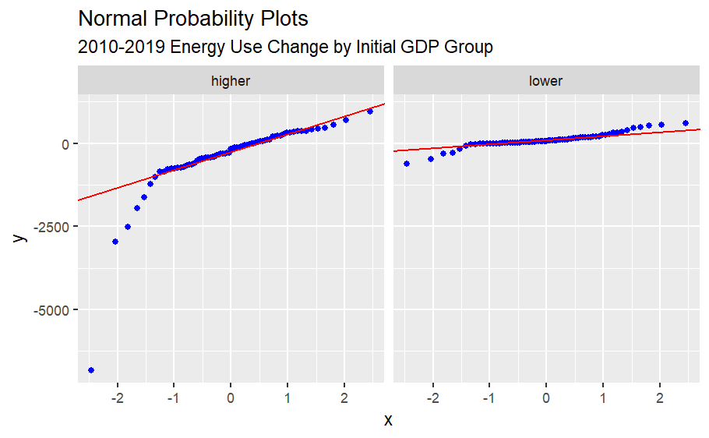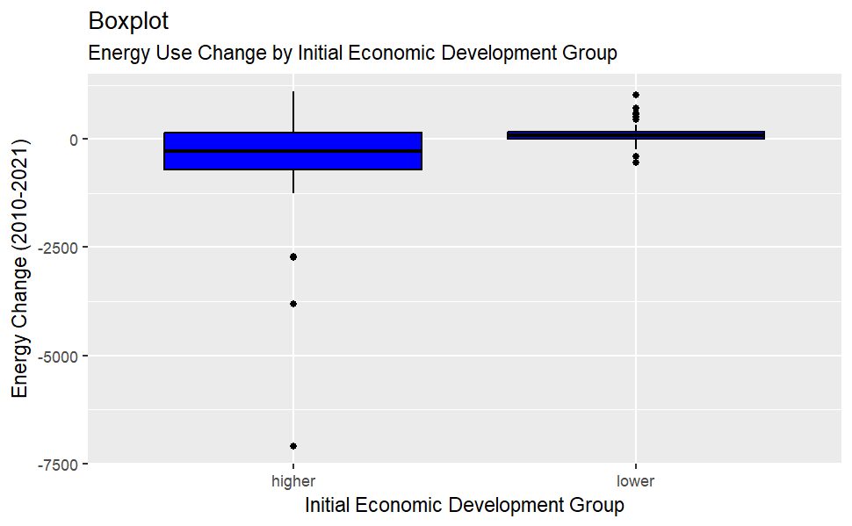
The normal probability plots above place most of the observations close to the reference line; therefore, we can infer that the distribution of the energy difference data for both higher and lower initial economic development groups is approximately modeled by the Normal Distribution. However, this condition can be relaxed since the sample sizes are large enough (n ≥ 25). From the boxplot above, we can see that each group has some outliers. To further analyze these outliers, we computed the upper and lower fences using the outlier-determination criteria and identified which countries are outliers. We identified 4 outliers in the higher group: {Curacao: -7104.499, Kuwait: -2740.052, Luxembourg: -2704.748, Trinidad and Tobago: -3806.902}. In the lower group, we have {Armenia: 455.9001, Bosnia and Herzegovina: 566.7772, China: 723.9996, Georgia: 601.3628, Iran, Islamic Rep.: 717.4335, Mongolia: 504.9392, South Africa: -393.8189, Syrian Arab Republic: -545.4488, Turkmenistan: 1031.5927}.
Given the computations in this section, we can assume our mean sample data approximately follow a Normal distribution, but we recognize some extreme outliers.
    - Statistical Results
The Welch independent-samples t-test provided a test statistic of t = -4.1984 with 76 degrees of freedom and a P-value of p = 0.00007228768. The permutation test gave an empirical P-value of p = 0.0005. These small P-values mean that, if the null hypothesis is true, there is a small probability that another n=71 countries within the higher initial economic development group and n=71 countries within the lower initial economic development group would produce statistical evidence as strong as, if not stronger, against the null hypothesis than the current data/sample. Given the small P-value from both the t-test and the permutation test, we reject the null hypothesis in favor of the alternative hypothesis for both statistical tests.
The 95% confidence interval for the population difference in mean energy changes (μ_Δ, Higher - μ_Δ, Lower) was computed to be between -836.7039 and -298.2768 kg of oil equivalent per capita. Since this interval is below zero, we can infer with 95% confidence that the mean change in energy consumption was smaller for the higher initial development group than for the lower initial development group.
Together, these tests provide statistically significant evidence that the mean change in energy consumption per capita from 2010 to 2021 differed between the two initial economic development groups. In our computations, it was found that on average, countries in the higher initial economic development group used about 446 kg of oil equivalent per capita less in 2021 than in 2010, while countries in the lower initial economic development group used about 122 kg of oil equivalent per capita more in 2021 than in 2010.
    - Sensitivity Analysis: 2010-2019
Due to the worldwide disruption of energy use (and many other sectors) that was brought about by the COVID-19 pandemic, this analysis was repeated using the change from 2010 to 2019 while keeping the same GDP groups. This sensitivity analysis checks whether our conclusion depends on 2020 and 2021. We define the new country-level change as Δ₂₀₁₉ = Energy Use₂₀₁₉ − Energy Use₂₀₁₀. Otherwise, our hypothesis and methods remain the same as defined above. This yields the same results when exploring the data, and we conducted the Welch independent-samples t-test and permutation test on this sample.
The differences among groups were similar to our original analysis. The higher initial development group had a mean decrease in energy use per capita of 377.28 kg of oil equivalent, while the lower group had a mean increase of 95.99, giving a difference of −473.26 (compared with −567.49 for 2010–2021).
For our 2010-2019 sensitivity analysis, the results were the same as our original 2010-2021 analysis. The Welch t-test (t = −3.83, p ≈ 0.0003) and the permutation test (p = 0.0005) both reject the null hypothesis at α = 0.05, and the 95% confidence interval for the difference in means is between -719.1063 and -227.4233, which also does not contain 0. The difference is somewhat smaller than for the full period, which could suggest that 2020 and 2021 widened the gap between the groups; however, the pattern exists without those years. Our conclusion for research question 1 is therefore not driven by the pandemic period.
    - Discussion
Overall, these data provide sufficient statistical evidence to conclude that the population means for the higher initial economic development group and the lower initial economic development group are not equal.
The Relationship Between Energy Consumption per capita and GDP per capita

Research Question
What is the relationship between energy consumption per capita and GDP per capita across countries in 2021, and how much of the variation in GDP per capita is explained by differences in energy consumption per capita?

Purpose
Building on Part A’s findings, we further examine the relationship between energy consumption and economic development. We will examine the relationship between these variables and determine whether energy consumption per capita can predict GDP per capita.

Statistical Approach
To examine the relationship between energy consumption per capita and GDP per capita, we use simple linear regression, with energy consumption per capita as the explanatory variable ($X$) and GDP per capita as the response variable ($Y$). The initial model is:
$GDP_{i}=β_{0}+β_{1}(Energy_{i})+ϵ_{i}$
We test whether there is a statistically significant linear relationship between the two variables:
$H_{0}:{ β}_{1}=0$ $H_{A}: β_{1}≠0$
at a significance level of $α=0.05$

Exploring the Data
Before building the regression model, we first examined the distributions of energy consumption per capita and GDP per capita across the 142 countries. In 2021, mean energy consumption was 2,404.13 kg of oil equivalent per capita, while the median was 1,538.36. Mean GDP per capita was $28,584.44, compared with a median of $18,372.45.
For both variables, the mean was considerably higher than the median, and the histograms below showed long right tails, suggesting a right-skewed distribution. This indicates most countries have relatively low values, while only a few have very high values.
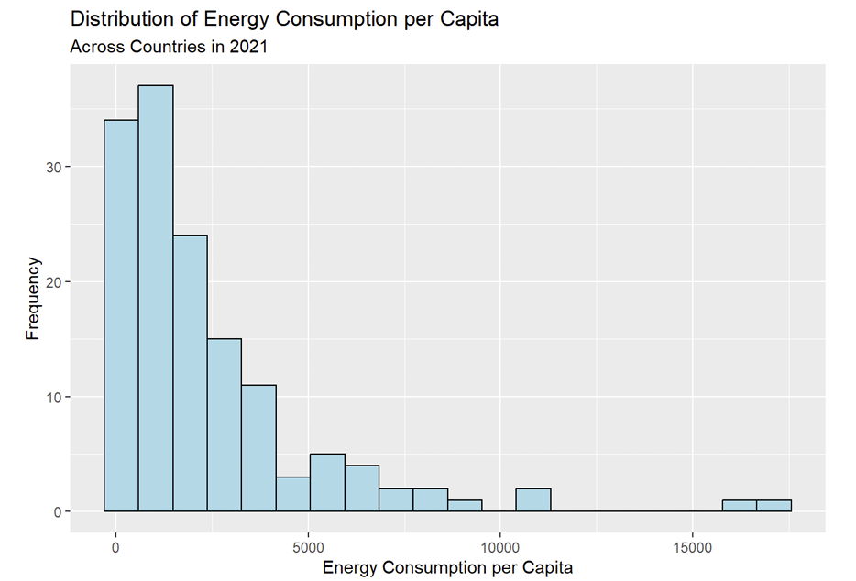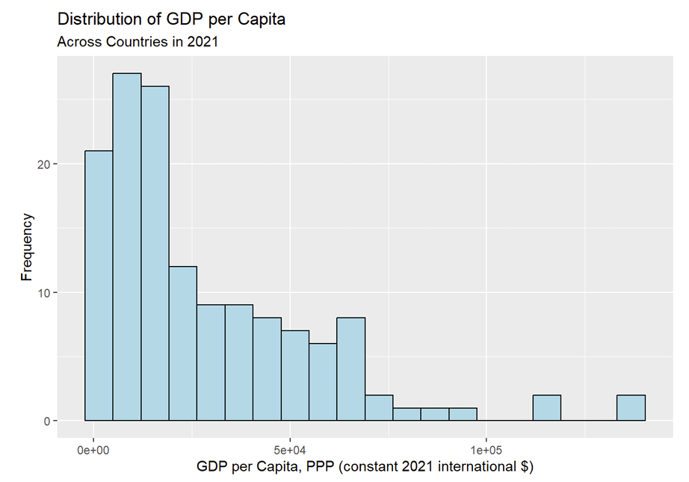
The scatterplot suggests a positive relationship between energy consumption per capita and GDP per capita, as indicated by the upward slope of the fitted regression line. However, the data do not lie close to the fitted regression line, and several extreme outliers exist.
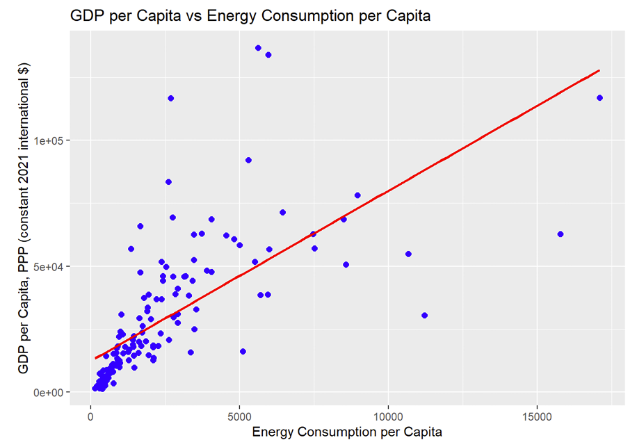
This pattern suggested a positive relationship, but the skewness and extreme values indicated that the original linear regression model needed careful evaluation before being used for inference.

Initial Regression Model
Based on the positive trend observed in the scatterplot, we first fitted a simple linear regression model using the original variables. The estimated model was:
$\hat{GDP per capita}=12,333.20+6.7597(Energy Consumption)$
The estimated intercept is 12,333.20, and the estimated slope is 6.7597. For each 1 kg increase in energy use per capita, the model predicts a 6.7597 PPP increase in GDP per capita, measured in constant 2021 international dollars. The intercept has limited practical meaning because zero energy consumption is outside the observed data range.
Before using this regression model, we examined it and found that it did not meet the regression assumptions. The QQ plot shows that the residuals do not closely follow the reference line, with substantial deviations in both tails. The residual plot shows a funnel-like pattern, with residual spread increasing as fitted values increase. Therefore, the original model did not reasonably satisfy the normality and homoscedasticity conditions.
Since the original model did not reasonably satisfy the regression assumptions, we will transform the variables and assess whether this improves the model and better satisfies those assumptions.
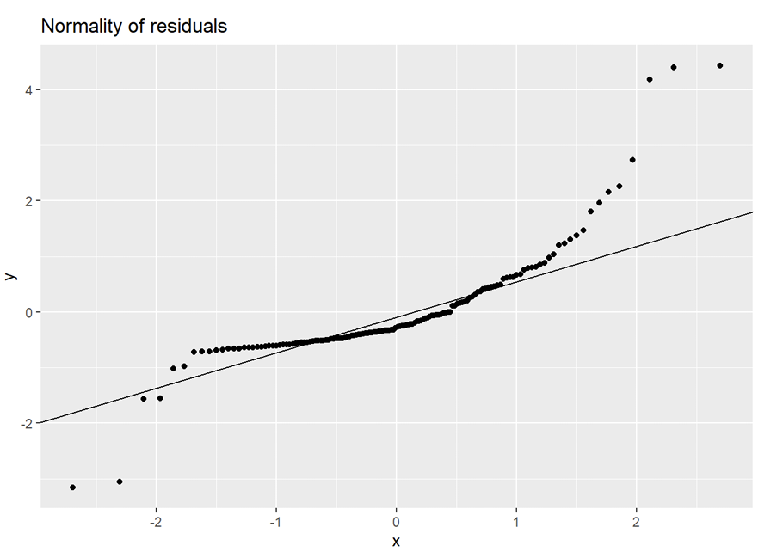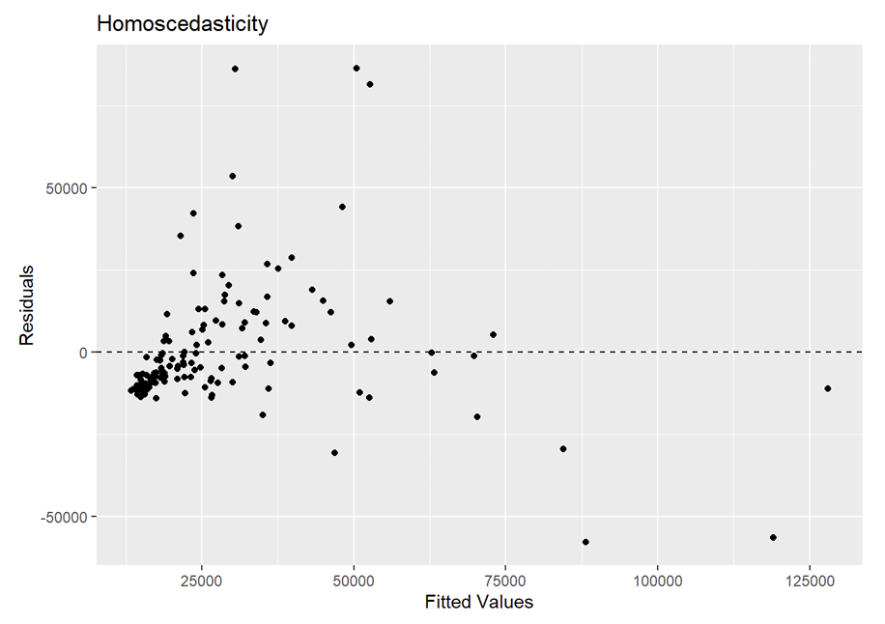

Log Transformation
While exploring the data, we found that energy consumption per capita and GDP per capita were both strongly right-skewed. A log transformation can help by compressing large values to reduce the effect of extreme observations. Therefore, we log-transformed both variables and fitted a new regression model to assess whether the transformation improved linearity and better satisfied the regression assumptions.
Log-Transformed Model Diagnostics
After applying the log transformation, the relationship between energy consumption per capita and GDP per capita became more linear. Compared with the original scale, the observations follow the fitted regression line more closely, and the influence of extremely high values is reduced.
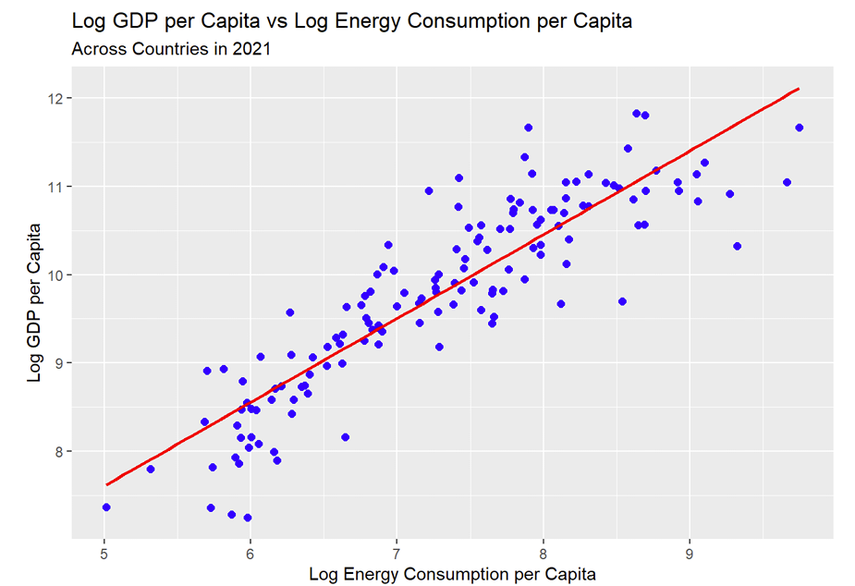
The regression diagnostics also improved clearly. The residuals followed the QQ reference line more closely, with only minor deviations in the tails. The residual plot showed a more consistent spread around zero and no clear funnel-shaped pattern. Therefore, the normality and homoscedasticity assumptions were reasonably satisfied, making the log-transformed model more appropriate for the final analysis.
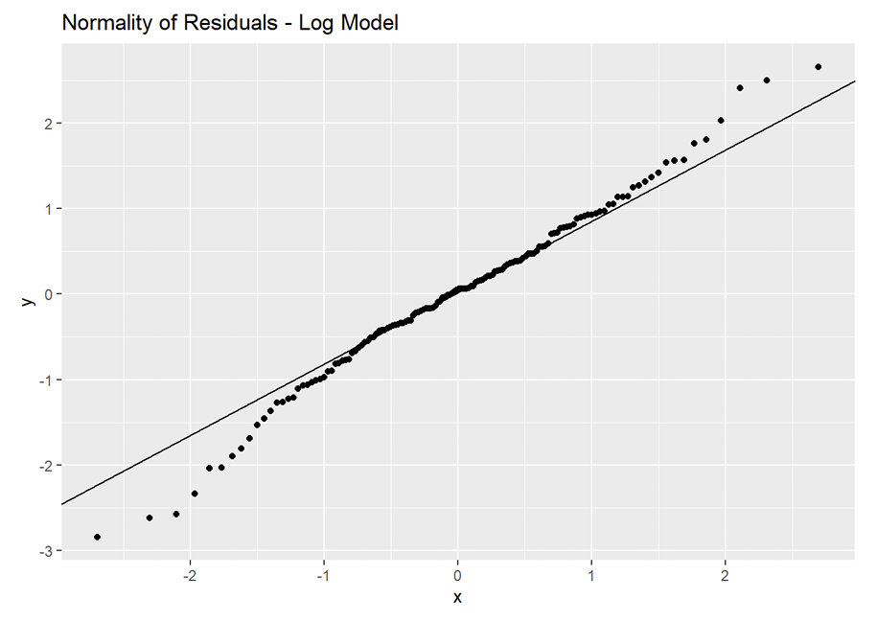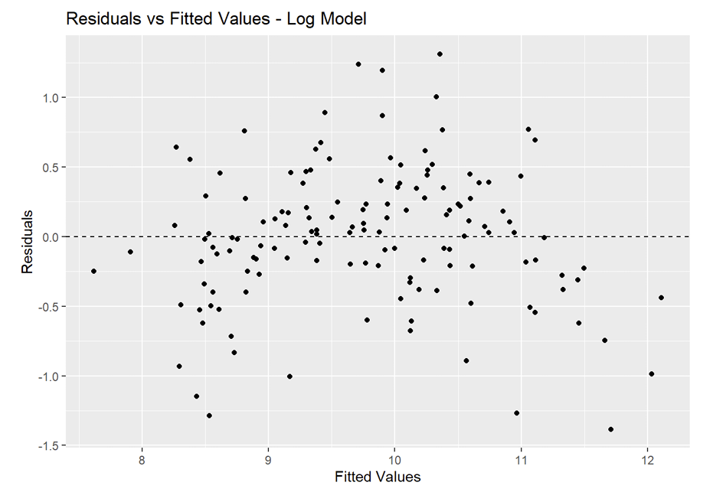
Building Final Estimated Model
The final estimated model was:
$\hat{log(GDP per capita)}=2.8695+0.9479log(Energy Consumption)$
Because both variables are log-transformed, the slope describes the relationship in terms of proportional (percentage) changes rather than changes in the original units. Therefore, the estimated slope of 0.9479 means that a 1% increase in energy consumption per capita is associated with approximately a 0.95% increase in GDP per capita, on average across countries in 2021.
Statistical Significance and Strength of the Relationship
After selecting the log-transformed model, we tested whether the relationship between energy consumption per capita and GDP per capita was statistically significant. The estimated slope was 0.9479, with a test statistic of $t=22.75$ and a p-value of approximately $7.04×10^{-49}$. Because the p-value is much smaller than the 0.05 significance level, we reject the null hypothesis. There is sufficient statistical evidence that a significant linear relationship exists between log energy consumption per capita and log GDP per capita across countries in 2021.
The 95% confidence interval for the population slope β1 is [0.8656, 1.0303]. From this sample, we can be 95% confident that for every 1% increase in energy consumption per capita, GDP per capita increases by somewhere between approximately 0.87% and 1.03%, on average across countries in 2021. The estimated increase in GDP per capita is approximately 0.95%. Since the confidence interval does not contain 0, this provides further evidence of a statistically significant positive relationship between energy consumption per capita and GDP per capita.
The Pearson correlation coefficient was $r=0.8872$, indicating a strong positive linear relationship between the two log-transformed variables.
In addition, the model had an $R^{2}=0.7871$. This means that approximately 78.71% of the variation in log GDP per capita across countries in 2021 is explained by its linear relationship with log energy consumption per capita. The remaining 21.29% of the variation is not explained by this model.

Discussion
Overall, there is sufficient statistical evidence to conclude that a strong, positive relationship exists between energy consumption per capita and GDP per capita. The log-transformed model indicates that for every 1% increase in energy consumption per capita, GDP per capita is predicted to increase by approximately 0.95%, on average.
The model explained approximately 78.71% of the variation in log GDP per capita, suggesting that energy consumption is strongly associated with differences in economic development across countries.
Overall Discussion
Together, the two research questions show that energy consumption and economic development are strongly connected, but the relationship changes across stages of development. The first research question found that higher-development countries generally decreased their energy consumption from 2010 to 2021, while lower-development countries generally increased it, with a significant difference between the two groups ($p<0.001$). The sensitivity analysis using 2010-2019 produced the same overall conclusion, suggesting that the observed pattern was not driven by the COVID-19 pandemic years.
At the same time, the second research question showed that countries with higher energy consumption in 2021 generally had higher GDP per capita. The regression model’s slope of 0.9479 means that a 1% increase in energy consumption corresponds to a 0.9479% increase in GDP per capita. Upon log-transforming both variables to better fit the regression assumptions, the model found a strong positive relationship between GDP per capita and energy consumption (Pearson correlation coefficient r = 0.8872), and energy consumption explained approximately 78.7% of the variation in log GDP per capita.
Overall, it was found that a country’s energy use is closely associated with its economic development, and that the patterns of energy consumption may change with a country’s level of economic development.

References
Ritchie, H. (2021, November 30). A number of countries have decoupled economic growth from energy use, even if we take offshored production into account. Our World in Data. https://ourworldindata.org/energy-gdp-decoupling

