**ELEMENTS OF COMPUTING SYSTEMS -1**

## 19AIE101

### Topic: Representing 0-15 numbers using two seven segment display decoders.

DONE BY:

AADITYA JAIN

ABIJITH PRADEEP

ADHITHAN PUSHPARAJ

ADITHYAN SUKUMAR

# AIM: To Representing 0-15 numbers using two seven segment display decoders.

## MATERIALS REQUIRED: 4 Breadboards, Jumper wires, 1 dip switch, ADALM1000(Source), 2 seven segment display decoders, 6 IC-7408 chips, 6 IC-7432 chips, 1 IC-7486 chips, 1 IC-7404 chips.

# K-Map

a

|  |  |  |  |  |
| --- | --- | --- | --- | --- |
|  | C’.D’ | C’.D | C.D | C.D’ |
| A’.B’ | 1 | 0 | 1 | 1 |
| A’.B | 0 | 1 | 1 | 1 |
| A.B | 1 | 1 | 1 | 0 |
| A.B’ | 1 | 1 | 0 | 1 |

b

|  |  |  |  |  |
| --- | --- | --- | --- | --- |
|  | C’.D’ | C’.D | C.D | C.D’ |
| A’.B’ | 1 | 1 | 1 | 1 |
| A’.B | 1 | 0 | 1 | 0 |
| A.B | 1 | 1 | 0 | 1 |
| A.B’ | 1 | 1 | 1 | 1 |

c

|  |  |  |  |  |
| --- | --- | --- | --- | --- |
|  | C’.D’ | C’.D | C.D | C.D’ |
| A’.B’ | 1 | 1 | 1 | 0 |
| A’.B | 1 | 1 | 0 | 1 |
| A.B | 0 | 1 | 1 | 1 |
| A.B’ | 1 | 1 | 1 | 1 |

d

|  |  |  |  |  |
| --- | --- | --- | --- | --- |
|  | C’.D’ | C’.D | C.D | C.D’ |
| A’.B’ | 1 | 0 | 1 | 1 |
| A’.B | 0 | 1 | 0 | 1 |
| A.B | 1 | 1 | 1 | 0 |
| A.B’ | 1 | 0 | 0 | 1 |

e

|  |  |  |  |  |
| --- | --- | --- | --- | --- |
|  | C’.D’ | C’.D | C.D | C.D’ |
| A’.B’ | 1 | 0 | 0 | 1 |
| A’.B | 0 | 0 | 0 | 1 |
| A.B | 1 | 0 | 0 | 0 |
| A.B’ | 1 | 0 | 0 | 1 |

f

|  |  |  |  |  |
| --- | --- | --- | --- | --- |
|  | C’.D’ | C’.D | C.D | C.D’ |
| A’.B’ | 1 | 0 | 0 | 0 |
| A’.B | 1 | 1 | 0 | 1 |
| A.B | 0 | 0 | 1 | 1 |
| A.B’ | 1 | 1 | 0 | 1 |

g

|  |  |  |  |  |
| --- | --- | --- | --- | --- |
|  | C’.D’ | C’.D | C.D | C.D’ |
| A’.B’ | 0 | 0 | 1 | 1 |
| A’.B | 1 | 1 | 0 | 1 |
| A.B | 1 | 1 | 1 | 1 |
| A.B’ | 1 | 1 | 0 | 0 |

a’

|  |  |  |  |  |
| --- | --- | --- | --- | --- |
|  | C’.D’ | C’.D | C.D | C.D’ |
| A’.B’ | 1 | 1 | 1 | 1 |
| A’.B | 1 | 1 | 1 | 1 |
| A.B | 0 | 0 | 0 | 0 |
| A.B’ | 1 | 1 | 0 | 0 |

b’

|  |  |  |  |  |
| --- | --- | --- | --- | --- |
|  | C’.D’ | C’.D | C.D | C.D’ |
| A’.B’ | 1 | 1 | 1 | 1 |
| A’.B | 1 | 1 | 1 | 1 |
| A.B | 1 | 1 | 1 | 1 |
| A.B’ | 1 | 1 | 1 | 1 |

c’

|  |  |  |  |  |
| --- | --- | --- | --- | --- |
|  | C’.D’ | C’.D | C.D | C.D’ |
| A’.B’ | 1 | 1 | 1 | 1 |
| A’.B | 1 | 1 | 1 | 1 |
| A.B | 1 | 1 | 1 | 1 |
| A.B’ | 1 | 1 | 1 | 1 |

d’

|  |  |  |  |  |
| --- | --- | --- | --- | --- |
|  | C’.D’ | C’.D | C.D | C.D’ |
| A’.B’ | 1 | 1 | 1 | 1 |
| A’.B | 1 | 1 | 1 | 1 |
| A.B | 0 | 0 | 0 | 0 |
| A.B’ | 1 | 1 | 0 | 0 |

e’

|  |  |  |  |  |
| --- | --- | --- | --- | --- |
|  | C’.D’ | C’.D | C.D | C.D’ |
| A’.B’ | 1 | 1 | 1 | 1 |
| A’.B | 1 | 1 | 1 | 1 |
| A.B | 0 | 0 | 0 | 0 |
| A.B’ | 1 | 1 | 0 | 0 |

f’

|  |  |  |  |  |
| --- | --- | --- | --- | --- |
|  | C’.D’ | C’.D | C.D | C.D’ |
| A’.B’ | 1 | 1 | 1 | 1 |
| A’.B | 1 | 1 | 1 | 1 |
| A.B | 0 | 0 | 0 | 0 |
| A.B’ | 1 | 1 | 0 | 0 |

g’

|  |  |  |  |  |
| --- | --- | --- | --- | --- |
|  | C’.D’ | C’.D | C.D | C.D’ |
| A’.B’ | 0 | 0 | 0 | 0 |
| A’.B | 0 | 0 | 0 | 0 |
| A.B | 0 | 0 | 0 | 0 |
| A.B’ | 0 | 0 | 0 | 0 |

# CIRCUIT DIAGRAM:

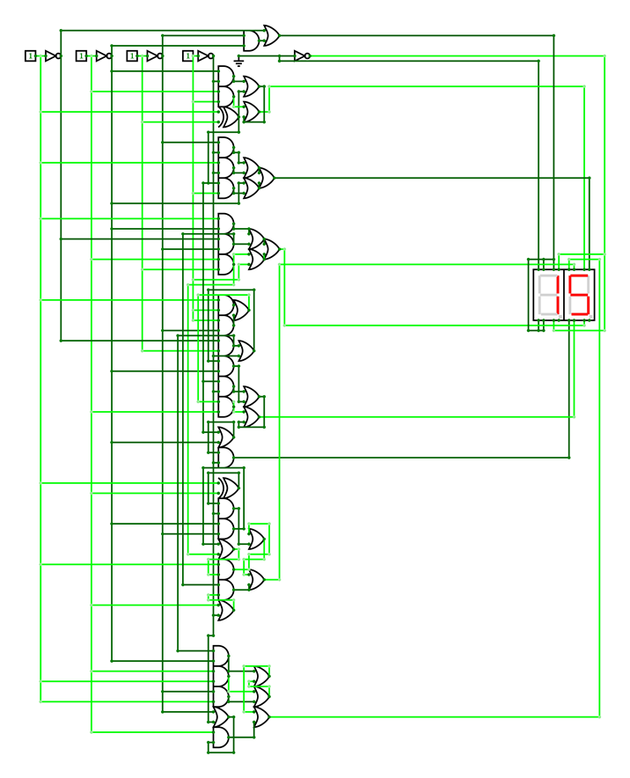

## PIN DIAGRAMS:

AND Gate IC 7408:

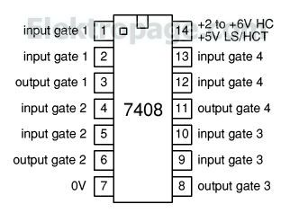

OR Gate IC 7432

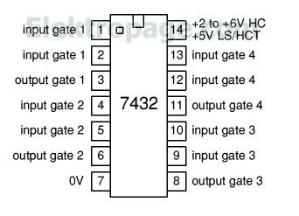

XOR Gate IC 7486

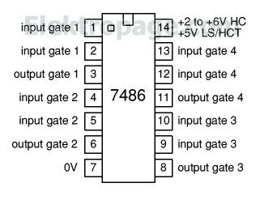

NOT Gate IC 7404

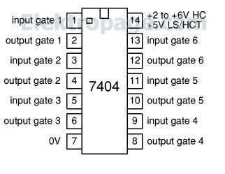

# TRUTH TABLE:







# BOOLEAN EXPRESSIONS:

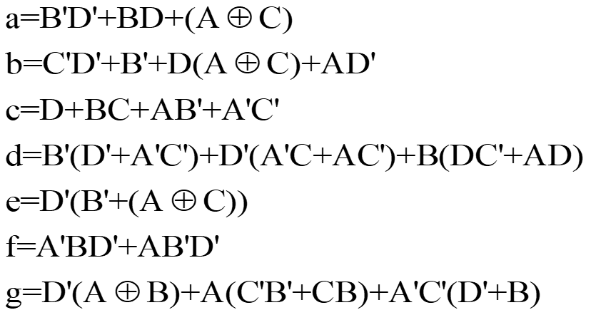



# PROCEDURE:

* Arrange the breadboards to fit all the connections as per the given circuit diagram.
* Fix the connections as per the respective pin diagram of each chip.
* After all the connections are done, keep the breadboard aside and assign a source to the given circuit.
* ADALM1000 is taken as the main voltage source and ground supply. Check the source with an LED for a test.
* Henceforth, connect the source and the ground to the respective vacant pins of each chip.