

Gesture Control Using PIR Sensor To Help People In Crisis

**Project done by:**

1. **Abijith Pradeep CB.EN.U4AIE19002**
2. **Rohith G CB.EN.U4AIE19026**
3. **Kaushik M CB.EN.U4AIE19036**
4. **Tarun Sanjeev S CB.EN.U4AIE19064**

**ACKNOWLEDGEMENT:**

We would like to extend our deepest gratitude to our professor, prof. Sajith Variyar, who gave us the golden opportunity to work on this project, which has also helped us in doing lot of research and analysis of the topic sensors and measurements.

We additionally express our gratitude towards Amrita University for agreeing to incorporate copyrighted pictures as a piece of our paper without which the design and working of the virtual simulation could not have been explained.

**AIM:**

The prime motive of this project is to create a gesture controlled drone for emergency circumstances using a PIR sensor. The drone also has a temperature sensor – useful in the case of fire accidents and ultrasonic sensors for its movement. Buzzer and LEDs are used for audible and visual alerts respectively.

**SOFTWARE REQUIREMENTS:**

1. Access to TinkerCad

**VIRTUAL HARDWARE COMPONENTS:**

1. Arduino Uno
2. 2 – mini breadboards
3. 3 – LED lights – Red, Yellow and Green
4. TMP-36 Temperature Sensor
5. Ultrasonic Sensor
6. PIR Sensor
7. Servo Motor
8. Buzzer
9. 3 – 1 k ohms resistor
10. Jumper Wires

**THEORY:**

1. **Ultrasonic Sensor**

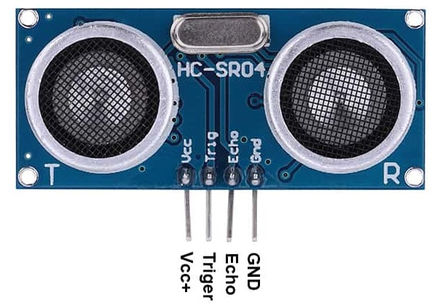

The Ultrasonic Sensor sends out a high-frequency sound pulse and then times how long it takes for the echo of the sound to reflect back. The sensor has 2 openings on its front. One opening transmits ultrasonic waves, (like a tiny speaker), the other receives them, (like a tiny microphone).  
  
The speed of sound is approximately 341 meters (1100 feet) per second in air. The ultrasonic sensor uses this information along with the time difference between sending and receiving the sound pulse to determine the distance to an object. It uses the following mathematical equation:  
  
Distance = Time x Speed of Sound divided by 2   
Distance= (time x speed)/2.  
Speed of sound at Air = 341 m/s or 34100 cm/s  
Thus, **Distance = 17050 * Time (unit cm)**Here we have divided the product of speed and time by 2 because the time is the total time it took to reach the obstacle and return back. Thus the time to reach obstacle is just half the total time taken.  
The ultrasonic sensor emits a high-frequency sound pulse and calculates the distance depending upon the time taken by the echo signal to travel back after reflecting from the desired target. The speed of sound is 341 meters per second in air.

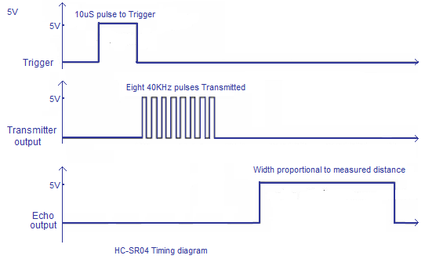

1. **TMP-36 Temperature Sensor**

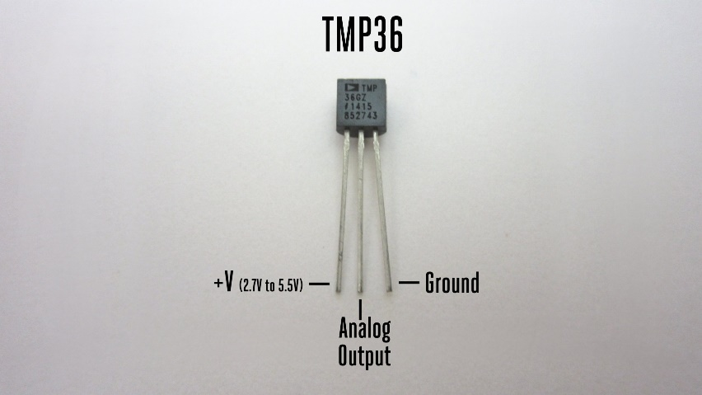

The TMP36 is a low voltage, precision centigrade temperature sensor. It provides a voltage output that is linearly proportional to the Celsius temperature. It also doesn't require any external calibration to provide typical accuracies of ±1°C at +25°C and ±2°C over the −40°C to +125°C temperature range. We read the voltage on the Vout pin. The output voltage can be converted to temperature easily using the scale factor of 10 mV/°C.

1. **PIR Sensor**

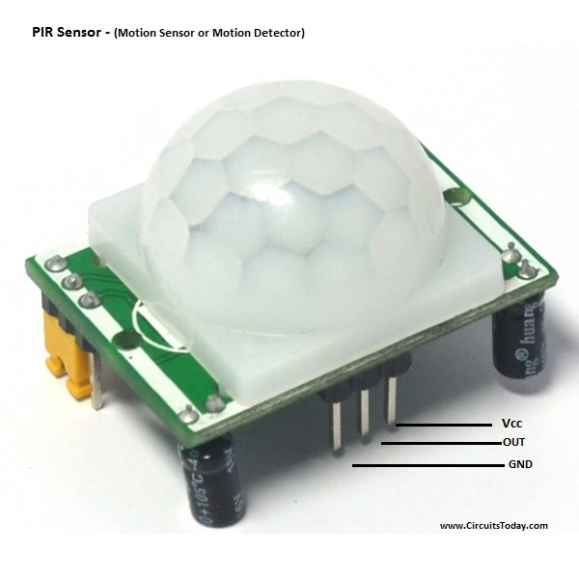

The term PIR is the short form of the Passive Infra-Red. The term **passive** indicates that the sensor does not actively take part in the process, which means, it does not emit the referred IR signals itself, rather passively detects the infrared radiations coming from the human body in the surrounding area.

The detected radiations are converted into an electrical charge, which is proportional to the detected level of the radiation. Then this charge is further improved by a built in FET and fed to the output pin of the device which becomes applicable to an external circuit for further triggering and amplification of the alarm stages. The PIR sensor range is up to 10 meters at an angle of +150 or -150.   
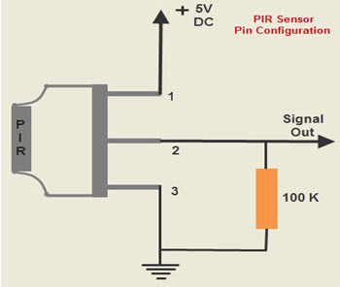  
The Fresnel lens is used to see that the two slots of the PIR can see out past some distance. When the sensor is inactive, then the two slots sense the same amount of IR.   
The ambient amount radiates from the outdoors, walls or room, etc.  
  
When a human body or any animal passes by, then it intercepts the first slot of the PIR sensor.   
This causes a positive differential change between the two bisects.   
  
When a human body leaves the sensing area, the sensor generates a negative differential change between the two bisects. The infrared sensor itself is housed in a hermetically sealed metal to improve humidity/temperature/noise/immunity.   
There is a window which is made of typically coated silicon material to protect the sensing element.  
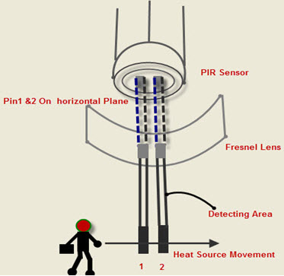

**CIRCUIT DIAGRAM:**

**ARDUINO CODING:**

**PROCEDURE:**

1. On the Tinkercad platform, bring down the following materials – Arduino uno R3 board, two mini breadboards, 3 leds,3- 1 k ohms resistors, TMP-36 temperature sensor, Ultrasonic Sensor, Servo motor, PIR Sensor and Buzzer.
2. Connect these materials as shown in the circuit diagram.
   * The TMP-36 sensor has its output connected to A0 analog pin.
   * The PIR sensor has its signal pin connected to digital pin 9.
   * From the digital pins 5,6,7 make a connection to the three led bulbs.
   * From the digital pin 2, make a connection to the buzzer.
   * Make connections for the ultrasonic sensor.
3. Use the code mentioned for the simulation.
4. Enter start simulation button to virtually give power supply to the Arduino Uno.
5. Now, change the positions present in front of the PIR sensor, by clicking on the sensor.
6. Also, change the temperature around the sensor.

**ANALYSIS:**

The PIR sensor gives out the digital values of 0’s and 1’s based on the movement of the marked position. Therefore upon movement, the PIR sensor gives the value of 1. These one’s are added up using a global variable which enables us to identify which gesture has been indicated.   
  
There are three thresholds set up – sum variable equals to 3, 4 and 5. The buzzer sound frequency changes with corresponding gesture and thus the person controlling the drone can understand or pass through a message in case of help.

The ultrasonic sensor enables the drone’s movement. If an obstacle is close to the drone, the servo motors would slow down and when an object is far off from the drone, the drone motors speed up. It is the forward and the sideward movements of the drone which is being monitored.

The temperature sensor on the other hand is used to sense the temperature. If the temperature is very high, the red light glows up and if its moderate then the yellow light glows up. When the temperature is low, the green light glows up. These LEDs give the visual alert for the temperature.   
The application of the temperature sensor is that, this drone can be used in case of fire accidents to aid the people to evacuate the hostages provided, the drone is made of good quality to sustain the heat.