Smart Campus
ERP stands for Enterprise Resource Planning. This software designed to support and automates the business process of medium and large Organization. This may include HRM, Attendance, Payroll, Inventory, Marketing and Managements.
The purpose of ERP is to facilitate the flow of information between all business functions inside the boundaries of the organization and manage the connections to outside customers.
Outlook Diagram
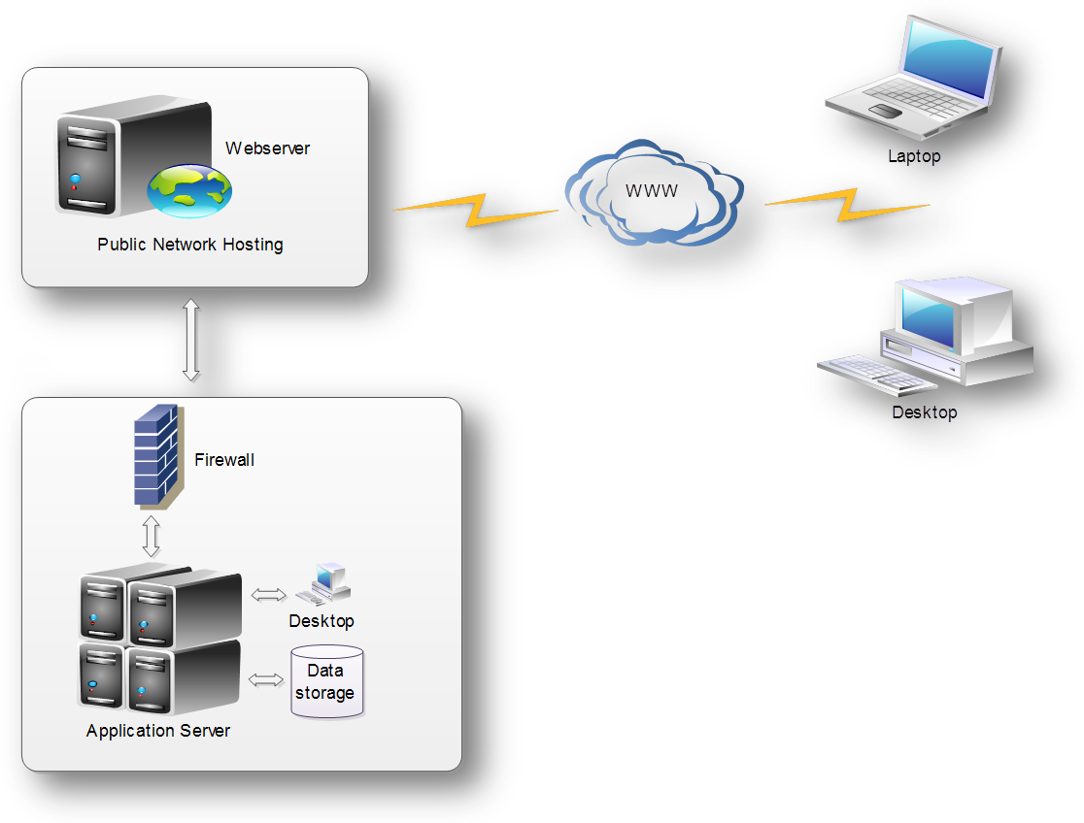

Login page.

Open a browser such as IE, Firefox and Chrome. Type http://connect.careind.net the login screen comes

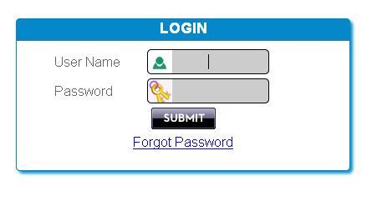
You type last 6 digit of your employee id as a username and care1234 is a default password.

Forget Password.
If you forget your password then go to login screen and click the forget password link.
You will select which email receives the password either personal or official.
Type the email and your date of birth [According to service card] then submit the go button.
Your details are matching our database the password will send to your email otherwise you will make a call to your reporting head and said to reset my password.
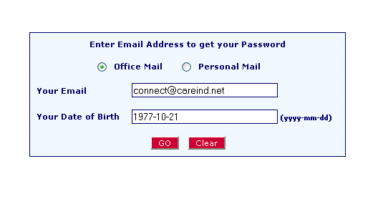

Home screen:
After submitting the login page the home screen comes. You can get a information like attendance, pay slip, leave information’s, conveyance, company profile, password change, ISD, STD, PIN codes and change the themes.
The login screen divided in to two frames. Left side is menus and right side is display.
Always the birth day wishes and anniversary of the employee lists are scrolled in display frame.
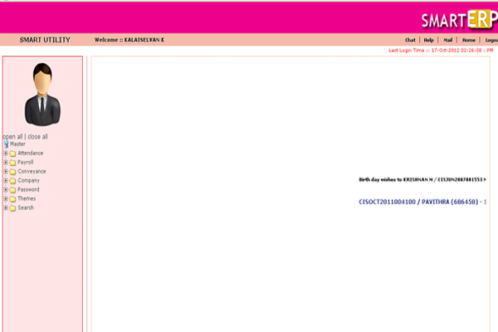

Attendance :
In right side frame is view the menus of your information. You would like to view the attendance, just click the attendance menu. The attendance screen comes.
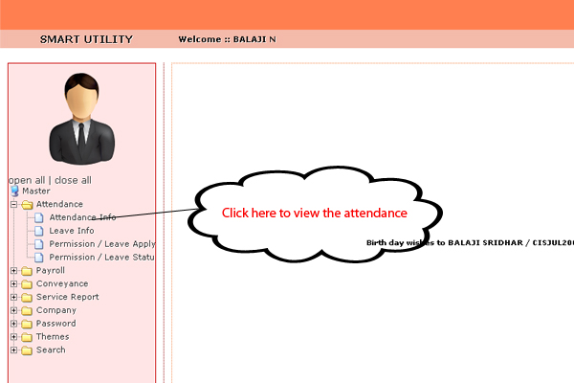

After you select month and year then submit the button.
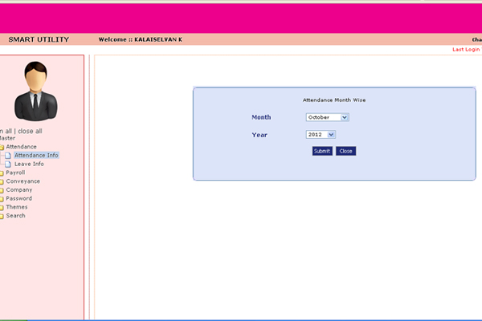

- The output is displaying of your selected month and year.
- This gives the details of present, absent, leave, late, permission, on duty , holiday and Sunday.
- You can view the attendance for your login.
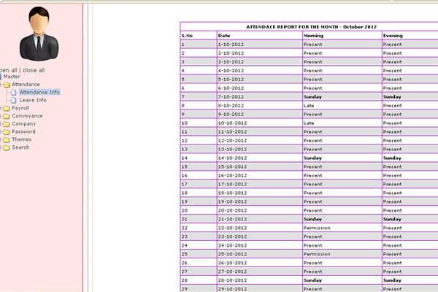

Leave :
- You would like to view your leave details. Just click the leave info menus then right side of the frame will show the leave information
- This clearly displayed the leave type, eligibility, leave taken and available balance.
- You can change the month and year then immediately you gets your leave information’s.
- The screen looks like this
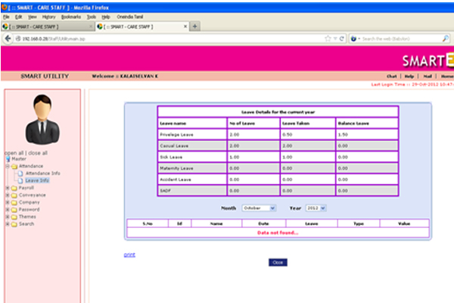

Advance:
- You got advance from our organization that also you can viewed your login.
- Just you click the advance menu of payroll icon
- The advance screen shows the advance amount and detection amount with balance amount and also you take a print out.
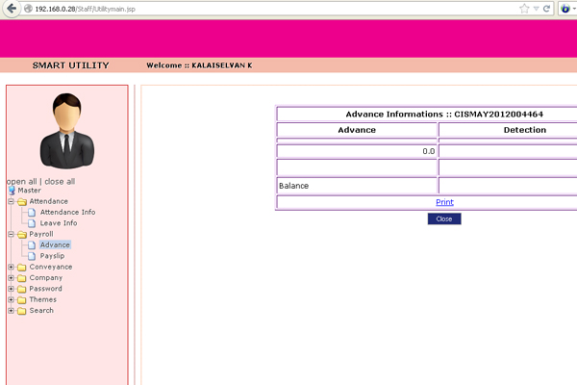

Pay slip :
- Click the pay slip menu in payroll menu
- The screen comes like this.
- You select the month and year after you submit the button then get the pay slip
- For an e.g. you would like to view your pay slip of the month October -2012 and get the pay slip.
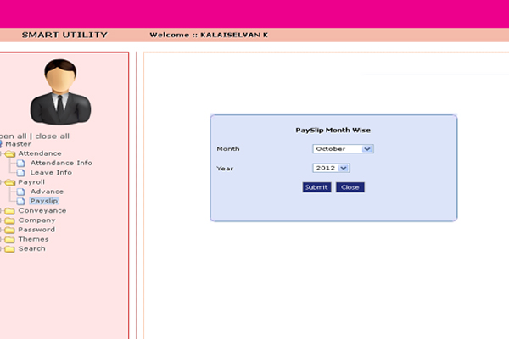

You want to take a print out of your payslip then click the print option.
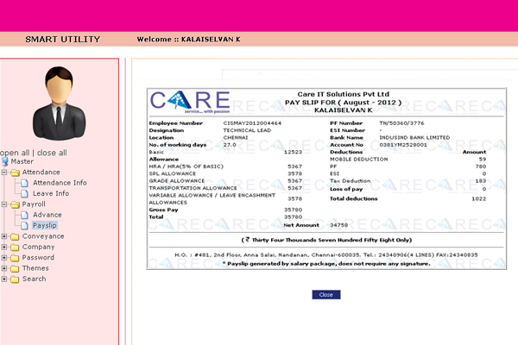

Conveyance:
- You meet the customer for official purpose that expenses also claimed. So you go to conveyance entry menu in conveyance icon.
- The claim date should be accept within 15 days. After the conveyance cleared only manual.
- You select the claim date.
- Then you click the add button
- A dynamic row inserted then types your data such as from, to, call number, kilometer, train, bus fare and etc...
- Note * you visit 4 customer per day, put 4 entry of the screen at a time. that means all entry should be entered at one time.
- Then submit the button.
- Your entries are alerted to your reporting head.

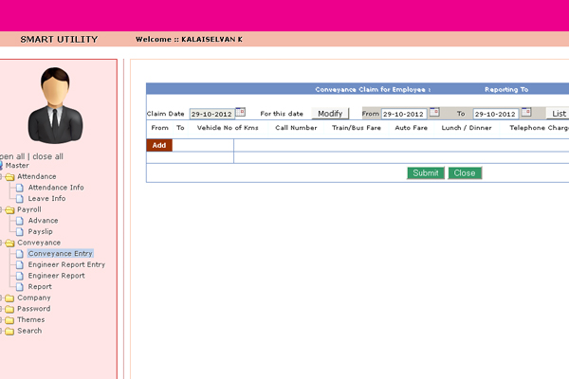

All entry is done through single submit

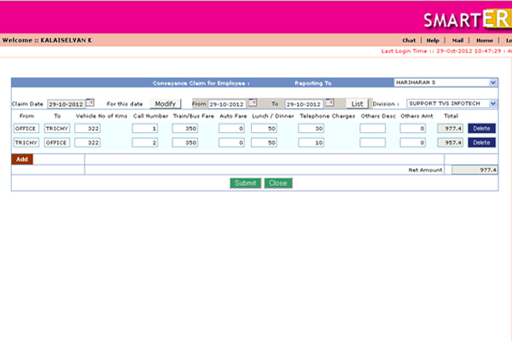

- If any change in your entry then you select the claim date and click the modify button.
- The conveyance entries are listing with edit and delete option.
- Reporting head accept your entries you could not change.
- Reporting head reject your entries, you will change.
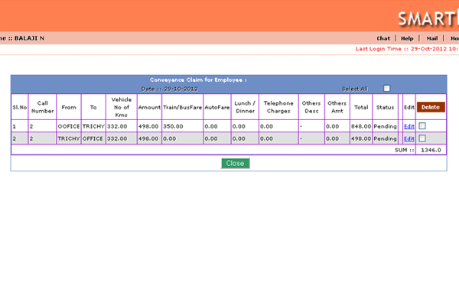

You can edit your entry through edit option.
Then submit the button.
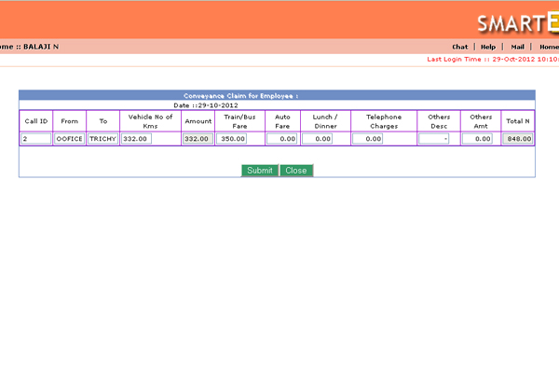

- You view the status of the conveyance entries select the from date and to date of the conveyance entry screen and click the list button.
- The screen displayed your entries are accept / reject/pending.
- Once your entries are accepted it automatically goes to the accounts department.
- The accounts department only cleared your entries.
- These statuses are viewing in your login.
- If you would like to export in excel the option is available or take a print.

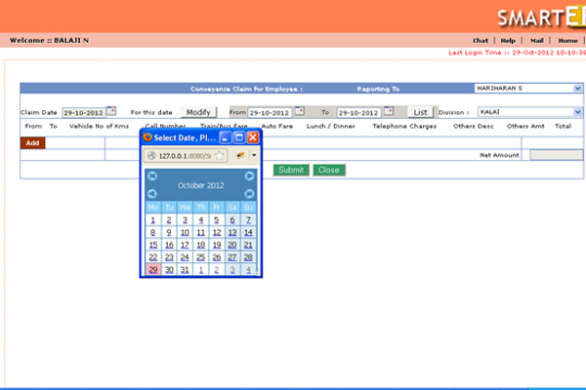

The status of the conveyance entries are displayed.
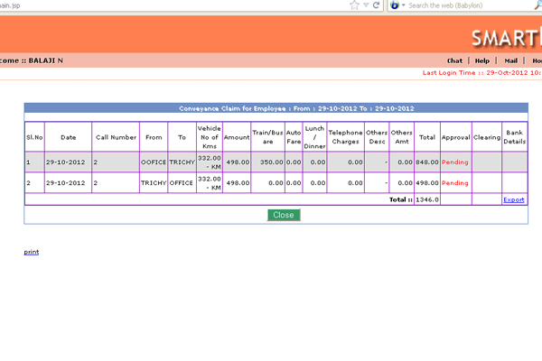

Conveyance Approval :
- The reporting head only use this link.
- You click the conveyance approval screen then select the employee then submit.
- The screen displayed with conveyance entries.
- You check and give the Approval or Reject one by one or select all.
- If you reject the entries then give to description.
- Then the approval entries are going to accounts department.
- They can cleared the conveyance amount.

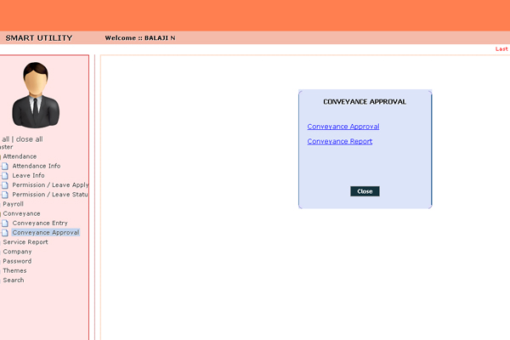

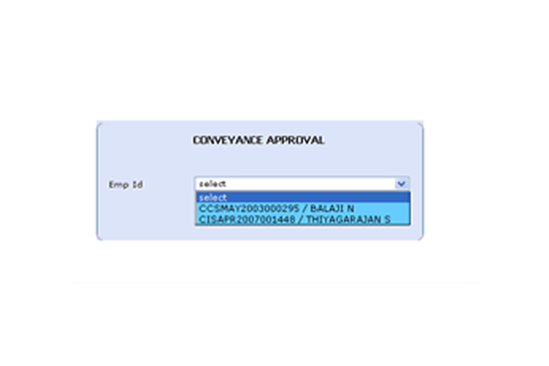

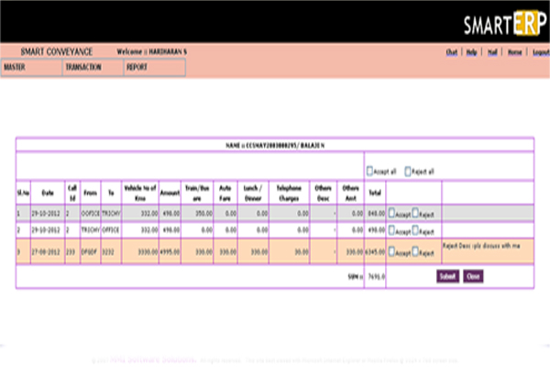

Password change:
- You would like to change your password
- Click the password change link in password icon.
- Enter your old password , new password and confirm password
- Password maximum character is 8.
- It is not accept more than 8 characters.
- Then submit the button.

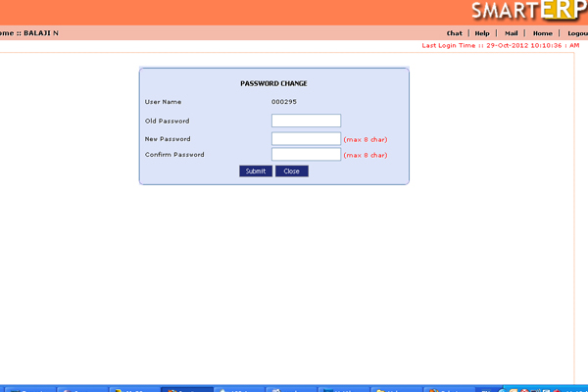

Themes :
- You would like to change your themes kindly click the themes.
- Its automatically changed.

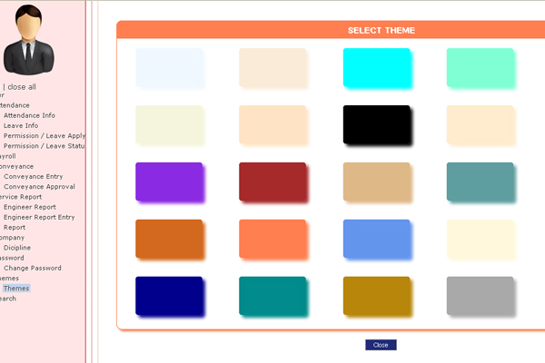

ISD:

You also view the ISD codes through this screen.

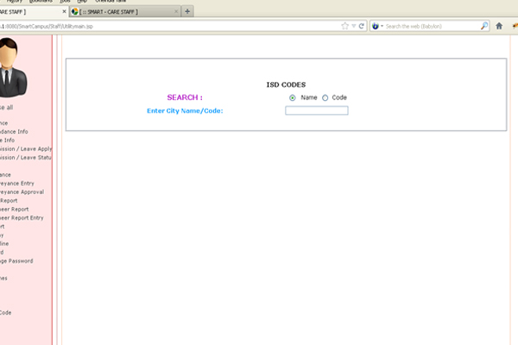

STD :

You also view the STD codes of our country.

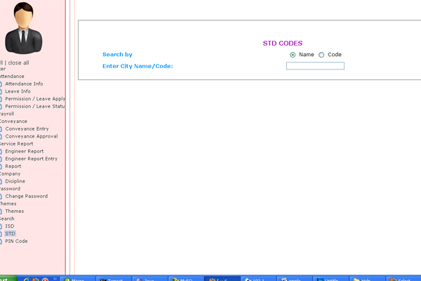

PIN CODES:

You can able to search the pin codes list of our country

