**HOW I USED DESIGN SCIENCE IN THIS STUDY**

**By**

**Patrick E. Muinda**

**Research Design for this Study**

This section outlines the research design for this study, detailing how each research question was addressed. A research design is a strategic plan guiding data collection and analysis, specifying the types of information to be gathered, their sources, and the procedures for collecting them (Otieno, 2023).

The research questions are:

i) What are the requirements for a model for digitization in TVETs?

ii) What model design best supports digitization in Ugandan TVETs?

iii) To what extent can the effectiveness of the designed digitization model be evaluated?

To achieve the objectives, the following activities were conducted:

i) A field study to identify factors for a digitization model in Ugandan TVETs.

ii) Proposing a model for digitization in Ugandan TVETs.

iii) Evaluating the proposed model.

A pragmatic philosophical approach was adopted for its flexibility in reconciling different types of knowledge and contextual experiences. Pragmatism, which does not adhere to a single reality or research paradigm, allows researchers to choose methods best suited to their research questions (Saunders et al., 2007; Creswell, 2012). An abductive approach, or argument, combining deductive and inductive elements, was used to gather comprehensive information for developing the model (Saunders, 2007).

A deductive approach tested hypotheses and validated the model through quantitative data analysis, integrating concepts from the DeLone & McLean Information Systems Success Model and Agency Theory. Qualitative data from the field study were used to refine the conceptual model through a concurrent triangulation design.

The research strategy, guided by philosophical assumptions, employed a Concurrent Triangulation Mixed Method approach, combining quantitative and qualitative methods for a richer understanding of factors influencing digitization project success (Johnson et al., 2007; Myers, 1997) to enhance and validate the model. Primary data collection involved structured surveys and semi-structured interviews with 177 participants from 11 TVET institutions, including principals, instructors, ICT heads, administrators, and students. Quantitative data were analyzed using SPSS, while qualitative data from purposive interviews with strategic individuals provided nuanced insights (Conger & Toegel, 2012; Mahaney & Lederer, 2003). The concurrent triangulation design integrated these data sources, enhancing the understanding of digitization in Ugandan TVET institutions (Patton, 1999; Creswell & Clark, 2017; Rupani & Vyas, 2023).

Design Science was adopted as the guiding methodology, aligning with the study's objective of developing a model for successful digitization projects in TVETs. Design Science addresses digitization problems by creating and evaluating useful models (Hevner & Chatterjee, 2021; Hevner et al., 2004). The research steps included:

a) Comparing Design Science Research with other methodologies.

b) Elaborating on the philosophy of Design Science Research.

c) Demonstrating how Design Science Research meets the study's objectives.

d) Concluding and communicating research outcomes.

The Figure 3.4 below shows how Design Science Research in this study was conducted. The study involved three cycles: relevance, rigor, and design (Hevner, 2007; Vom Brocke et al., 2020). The relevance cycle involved input requirements for design and evaluation. The rigor cycle applied literature, underpinning theories and methodologies, contributing new knowledge, including Agency Theory, the DeLone and McLean Theory, and aspects of the Dynamic Capabilities Theory (Mahaney & Lederer, 2003; Takahashi et al., 2016).

**Environment IS Research Knowledge Base** 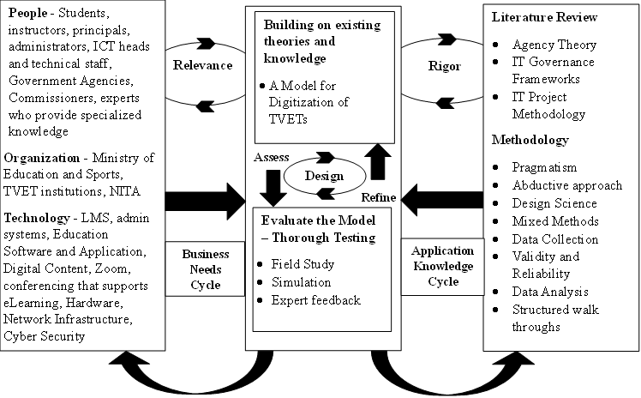

*Figure 3.4: The Design science research model adopted from (Hevner et al., 2003; Hevner et al.,2004)*

The left compartment signifies the problem domain (the environment) of the study. It is comprised of the individuals affected by the problem articulated in chapter two of this thesis. The issue at hand in this environment is the process of interest – improved success of digitization projects.

The middle section represents the two major phases in Information systems research, i.e., build and evaluate (Hevner et al.,2004). These two processes are essential for the design of the model for improved success of digitization and the evaluation of the model through the field study and structured walkthrough techniques.

The section on the right represents the knowledge base from which the study obtained its theoretical foundation, the concepts, and methodologies that were used to execute the Information Systems research processes to build and evaluate an artefact in design science (A. Hevner & Chatterjee, 2021). This study contributes to knowledge in the area of Information System Project research.

**3.7 The Descriptive Field Study**

In design science research, the seven guidelines shown in the table above were followed. Design Science research as a process was achieved by, 1) reviewing existing theories and methodologies, 2) designing and evaluating the artifact that solves the problem of increasing failure of digitization projects. For this study, a descriptive field study was conducted as described in subsection 3.7.1.

**3.7.1** **Design Science Research**

The field research method used in this study aimed at accurately and systematically describing interactions between behavioral and environmental events (Bijou et al, (1968); Kpebo et al., 2022). This field survey employed both qualitative and quantitative research methods for data collection (Bijou et al., 1968; Saunders et al., 2019a). This field study was conducted using observations and administering questionnaires as survey techniques (Saunders et al., 2009). Specifically, survey research was done using techniques to collect data from the population and yet the anonymity of the respondents was maintained (Saunders et al., 2009).

Prior to conducting this field survey, clearance for research was obtained from the Research Ethics Committee. Specifically, the following was done: 1) considering the sample size, 2) confirming the target audience, and 3) fine tuning the data collection instruments for both the quantitative and qualitative data collection. 4) pretesting the data collection tools by going through them with both peers and potential respondents to collect feedback on whether or not the questions in the tools were not ambiguous, unclear or difficult to answer.

**Design Science Cycles and Objectives of Field Study**

The first objective of the field survey was to determine the factors for digitization of Ugandan TVETs. The design science cycle applied here is the Relevance cycle. The key activities executed in this cycle were i) the establishment of factors for the model for digitization and the evaluation of the model. The techniques used during this cycle were i) administration of questionnaires, ii) conducting of interviews, iii) structured walkthroughs and, iii) experimenting with a prototype. This was achieved by testing the interactions among variables in the conceptual model and by assessing their relationships within the conceptual model designed for Digitization Projects in TVETs. This investigation focused on specific variables, namely goal conflict, contract type, communication, originally labeled as "privately held information", and task programmability. These variables were initially identified in the research conducted by Mahaney and Lederer in 2003. Additionally, this study introduced an innovative element, process quality, following an extensive literature review.

The second objective of this field study was to design the Model for digitization of TVETs. The design science cycle applied at this stage was the rigor cycle. The key activities involved here were the development of the conceptual model for TVET digitization, testing of the conceptual model, refining the model for digitization and deriving the model for digitization of TVETs. The techniques used during the rigor cycle were, i) Review of literature on existing theories such as Agency Theory, IT Governance frameworks, and the National IT Project Methodology; ii) A field study was conducted, data was collected and analyzed.

The third objective was to evaluate the Model. The design science cycle applied at this stage was the design cycle. The key activities involved here was, i) carry out other field studies with small user groups to test the prototype derived from the Model; ii) Simulate the Model while establishing Expert feedback. This process was done to assess the model. The findings of the assessment were used to refine the Model for digitization of TVETs. This was an iterative process that went on until saturation was achieved.