Biostatistics 140.654
Fourth Term, 2021
April 12, 2021
Quiz 1

The purpose of this quiz is to assess your knowledge of the course materials covered during the first two weeks of class and covered in Problem Set 1.

Instructions:

- This is an open book quiz; you may consult your course notes and handouts.
- You should not discuss this quiz with any other student during Monday April 12th.
- This quiz is designed to be completed in 20-30 minutes.
- You can use calculators or R on your computer for arithmetic. But you should NOT use the 'glm' function in R to compute estimates of logistic regression coefficients.
- You may provide your solution by editing the word version of this quiz, annotating the pdf version of this quiz or writing your solution on paper and submitting a picture of your solution.

By signing my name, I enter agree to abide by the instructions above and the Johns Hopkins University School of Public Health Academic Code:

Name (Print): _________________________________________

Signature: ____________________________________________

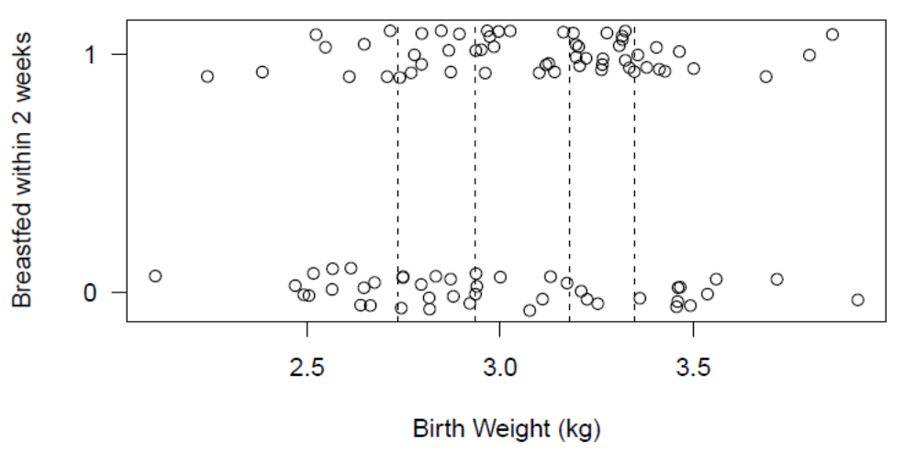

- In the figure above, you will find a display of data from a set of 100 Nepali infants showing whether each infant began breastfeedling within the first 2 weeks (1 – yes, 0 – no; jittered) against the child’s birth weight (kg). Vertical lines are drawn at roughly the quintiles of birth weight (assume 20 data points in each bin). Use these data to estimate the coefficients in a simple logistic regression model.

Report:

  - The logistic regression equation and your approximate estimates of the coefficients in your model.

  - The approximate predicted probability of breast feeding within 2 weeks for a child with birth weight of 2 kg

  - Your findings in a sentence or two for a public health journal. Be numerate, eliminate jargon to the extent possible.

- Below find two 2x2 tables showing: whether or not a person spent more than $1000 on medical services (Y), whether the person has a major smoking cause disease (mscd=1) or not (mscd=0), and age group.

Age < 65 |  |  | Age ≥ 65
 | MSCD |  |  | MSCD
Y | 0 | 1 | Y | 0 | 1
0 | 5436 | 119 | 0 | 2647 | 280
1 | 2028 | 323 | 1 | 1878 | 881

The scientific question is whether the mscd effect on risk of an expenditure above $1,000 is the same for persons younger than 65 vs. 65 and older.

- Conduct an analysis to answer this question.

- Write a sentence or two to report your findings to a public health audience. Be numerate. Avoid jargon!

