June 04, 2019

AWS Udemy Course Note!

EC2

What is EC2?

Is a web service that provides resizable compute capacity in the cloud

Length 2hrs and 29 minutes.

it reduces the time that it takes to obtain and boot new server instances two minutes allowing you to quickly scale capacity both up and down as your computing requirements change.

EC2 instance types

F1, I3, G3,H1, T3 ...A1, U-6tb1

FP GA

**EC2 Exam Tips for prices**

1. On Demand: allows you to pay a fixed rate by the hour or by a seconds with no commitment
2. Reserved provides you with a capacity reservation and offer a significant discount on the hourly charges for an instance. Contract terms are one year or 3 years.
3. Spot: enables you to bid whatever price you want for instance capacity, providing for even greater savings if your application have flexible start and end times.
4. Dedicated hosts: physical EC2 sever dedicated for your use

Can help you reduce costs by allowing you to use your existing server-bound software licenses.

EC2 part1

Command line setup and Config

Afer you created your key pair

Get your IPv4 Public IP

Open terminal ls

Mkdir NewFolder

Mv your keypair here then

Move to NewFolder

Ls

Change permission

CHMOD 400 NewFolder

Ssh ec2-user@ your IPv4 Public IP -I Your key pair file name.

Ask if you want to connect, then hit yes

You will see 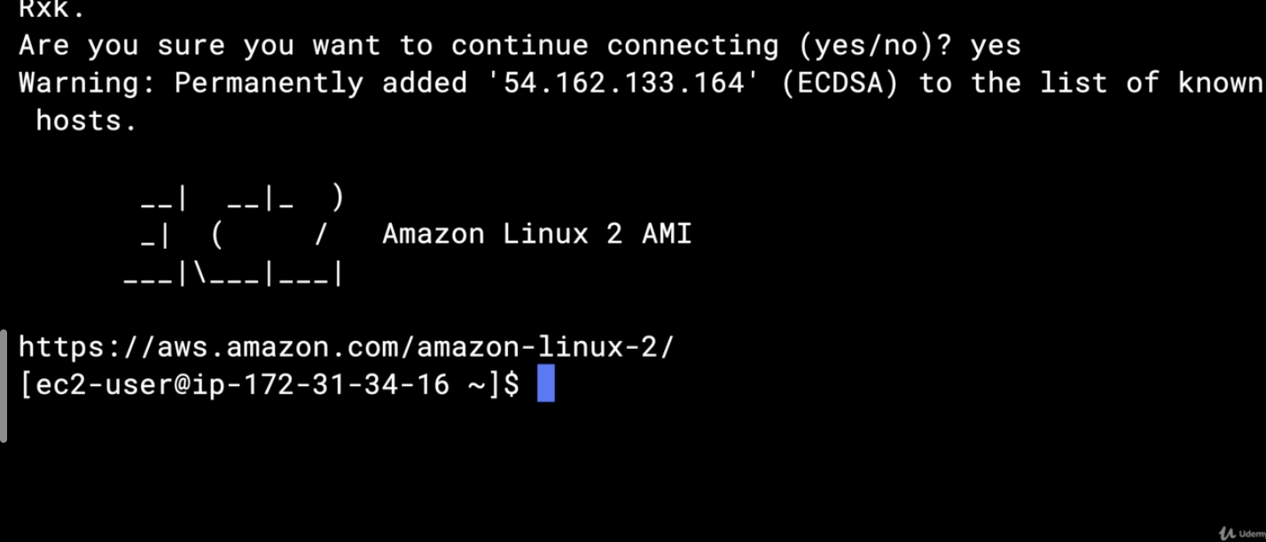

Sudo Su

Yum update -y

To install Appache ~ yum install httpd -y

Cd /var /www/html

Nano index.html

Create a file

Hit ctrl + X, Yes, enter

Service httpd start

Chkconfig on

Go to browser and paste your ip address

Let's get our Hands Dirty with EC2 part-2

Security Groups Basics

EBS 101

Volumes & Snapshot

AMI types (EBS vs instances store)

**AWS command line**

**Go to EC2 user on the terminal and**

**Aws ec2/s3/ ls**

**Sudo su**

**[root@ip-172-31-43-227 ec2-user]# aws ec2**

**Boot strap Scripting**

#!/bin/bash

yum update -y

yum install httpd -y

service httpd start

chkconfig httpd on

cd /var/www/html

echo "<html><h1>Hello Cloud Gurus Welcome To My Webpage</h1></html>" > index.html

aws s3 mb s3://YOURBUCKETNAMEHERE

aws s3 cp index.html s3://YOURBUCKETNAMEHERE

yum install -y amazon-efs-tool is to EFS system

**instance meta data and user data**

used to get the information about an instance (such as public ip address)

curl <http://169.254.169.254/latest/meta-data/>

curl <http://169.254.169.254/latest/user-data/>

**EBS**

=>termination protection is turned off by default, you must turn it on.

=> on an EBS-back-end instance, the default action is for the root **EBS** volume to be deleted when the instance is terminated.

* EBS root volumes of your default AMI’s can’t be encrypted. You can also use a 3rd party tools such as bit locker to encrypt the root the root volume, this can be done when creating AMI’s in the AWS console or using API’s.
* Additional volumes can be encrypted.
  + Volumes exist on EBS. Think EBS as a virtual hard disk.
  + Snapshots exist on S3. Think of snapshots as a photograph of the disk.
  + Snapshots are point in time copes of volume.
  + Snapshots are incremental: this means that only blocks that have changed since your last snapshots are moved to S3
  + If you created snapshot for first time it may take some time.
  + To create a snapshot for Amazon EBS volumes that serve as a root device, you should stop the instance before taking the snapshot
  + However, you can take a snap while the instance is running.
  + You can create AMI from both volumes and snapshots
  + You =can change a EBS volume size on the fly including size and storage type.
  + Volumes will be always In the same availability zone as EC2 instance.

**Migrating EBS**

* To move an EC2 to volume from one Az to another:

1. Take a snapshot of it
2. Create AMI from the snapshot
3. Then use AMI to launch the EC2 instance in a new AZ

=>To create EC2 volume from one region to another:

i. take the snapshot of it

ii. create AMI from the snapshot

1. Then copy the AMI from one region to another.
2. Then use the copied AMI to launch the new ED2 instance in the new region.

EBS Encryption

Snapshots of encrypted volumes are encrypted automatically

volumes stored from the encrypted snapshots are encrypted automatically

you can share snapshots, but only if they are unencrypted.

These snapshots can be shared with other AWS accounts or made public

EBS vs instance store

|  |  |
| --- | --- |
| EBS backed instances can be stopped. You will not lose the data on this instance if it is stopped | Instance store volume  Called ephemeral  Can’t be stopped if they are underlying host fails, you will loss your data |

You can reboot both, and you won’t lose the data

By default, both root volumes will be deleted on termination. However, with EBS volumes, you can tell AWS to keep the root device volume.

**Security groups**

All inbound is blocked by default

All outbound traffic is allowed

Changes to security group takes effect immediately.

You can have any number of EC2 to instances with in a security group.

Security group are stateful (port becomes open for in/outbound)

If you create an inbound rule allowing traffic in, that traffic is automatically allowed to back out again.

You can’t block specific Ip addresses using security groups Instead use a Network access control lists

You can specify allow rules, but not deny rules.

***Exam Tip from EFS(06/15/19)***

Amazon elastic file system is a file storage service for Amazon EC2 instances.

Is easy to use and provide a simple interface that allows you to create and configure file system quickly and easily

With AEFS, storage capacity is elastic, growing and shirking automatically as you add and remove files, so your applications have the storage they, when they need it.

* It supports the network file system version4(NFSv4) protocol.
* You only pay for the storage you use (No pre-provisioning required)
* Can scale up to per terabytes.
* Can support thousands of concurrent NFS connections  
  data is stored across multiple AZ’s with in a region
* Read after write consistency.

EC2 placement groups (they opposite to each other)

1. Clustered Placement group: is a group of instances within a single availability zone.

Are recommended for applications that needs low network latency, high network throughout, or both.

Only certain instances can be launched into a clustered placement group.

1. Spread placement group is a group of instances that are each placed on distinct underlaying hardware. Compute optimized, CPU, memory optimized, storage optimized.

Are also recommended for application that have a small number of critical instances that should be kept separate from each other.

* The name you specify for a placement group must be unique with in your AWS account.
* AWS recommends homogenous instance with placement groups.
* You can’t merge placement groups.
* You can’t move existing instances int a placement group.
* But you can create an AMI from your existing instance, and then you can launch a new instance from the AMI into a placement group.

Cloud Watch vs Cloud trail

Roles of EC2

June 04, 2019

AWS Udemy Course Note!

EC2

What is EC2?

Is a web service that provides resizable compute capacity in the cloud

Length 2hrs and 29 minutes.

it reducesthe time that it takes to obtain and boot new server instances two minutes allowing you to quickly scale

capacity both up and down as your computing requirements change.

EC2 instance types

F1, I3, G3,H1, T3 ...A1, U-6tb1

FP GA

EC2 Exam Tips for prices

On Demand:allows you to pay a fixed rate by the hour or by a seconds with no commitment

Reserved provides you with a capacity reservation and offer a significant discount on the hourly charges for an instance. Contract terms are one year or 3 years.

Spot

Dedicated hosts

EC2 101

Let's get our Hands Dirty with EC2 part-2

Security Groups Basics

EBS 101

Volumes & Snapshot

AMI types (EBS vs instances store)

ssh -i "/Users/abiken/Downloads/AWSKey4Clink/Captivlink.pem" [ubuntu@ec2-54-193-29-161.us-west-1.compute.amazonaws.com\](mailto:ubuntu@ec2-54-193-29-161.us-west-1.compute.amazonaws.com\)

06/26/19

***Route53***

DNS 101

Route 53 throughout the rest of this section of the course.

Now first of all you might be wondering where did they get the name Route 53 from.

Well if you know a little bit about US history the very first interstate was Route 66 was the very first

road that went from one side of the country to the other.

And with DNS DNS is actually on the port 53 So that's where Route 53 gets its name.

What is DNS?

DNS iS a way of looking up a domain name and getting an IP address just like you

Is use to convert human friendly domain names into an internet protocol address such as http://82.124.53.1.

IP address are used by computers to identify each other on the network. Ip addresses are commonly come in 2 different forms IPv$ /6.

IP4 address is a 32 bit field over 4 Billion different addresses (4,294,967,296)

We created IPTV six to solve this problem of running out of IP V for addresses and IP these six has

an address space of 128 bits.

IPv6 was created to solve the depletion issue and has an address space of 128bits 340 Undecillion addressees.

Top level domain names are governed by https://www.iana.org/about

**Summary of Route53/Tip**

ELBs do not have a pre-defined IPv4 addresses, you resolve to them using a DNS name.

Know the difference between an Alias record and a CNAME

Common DNS Type

SOA Records

NS Records

A Records

CNAMES

MX Records which we use for mail

***Register a Domain Name***

* On AWS console/Networking & Content Delivery
* Route 53

Domain Registration

You will be promted to select

1. New domain register
2. Transfer

|  |  |  |  |  |
| --- | --- | --- | --- | --- |
| |  | | --- | | abinetkenore.com can be transferred to Route 53 ($12.00)  To transfer the domain to Route 53 please ensure the following:   * Disable domain privacy for the domain so we can get your contact information. * Ensure the domain's registrant email at WHOIS is valid and reachable. * Get an authorization code for the domain *(Not required for certain TLDs).*   Add to Cart | | abinetkenore.com cannot be transferred to Route 53  **Reason**: Your current registrar is preventing the domain from being transferred. Confirm that the domain is unlocked. If so, contact your registrar for more information.  To transfer the domain to Route 53 please ensure the following:   * Unlock the domain so it can be transferred. * Disable domain privacy for the domain so we can get your contact information. * Ensure the registrant contact for the domain has a valid email address. * Get an authorization code for the domain *(Not required for certain TLDs)*. * If you have done the above already, please note that it may take some time for the changes to propagate. | | abinetkenore.com cannot be transferred to Route 53  **Reason**: Your current registrar is preventing the domain from being transferred. Confirm that the domain is unlocked. If so, contact your registrar for more information.  To transfer the domain to Route 53 please ensure the following:   * Unlock the domain so it can be transferred. * Disable domain privacy for the domain so we can get your contact information. * Ensure the registrant contact for the domain has a valid email address. * Get an authorization code for the domain *(Not required for certain TLDs)*. * If you have done the above already, please note that it may take some time for the changes to propagate. |   CancelContinue |  |