Abinet Kenore

CS390P

Fall 2018

This is a continuation of HW1 and in this homework I was asked to implement a many to many relationship between the students, and sections in order to get a full functionality of the registration banner by either creating a enrollment class which joins sections and students or or by creating a joint table between students and sections. For me the easy was creating a joint table us the rails g model SectionsStudents section:references student:references --force-plural. Adding a validation to the project.

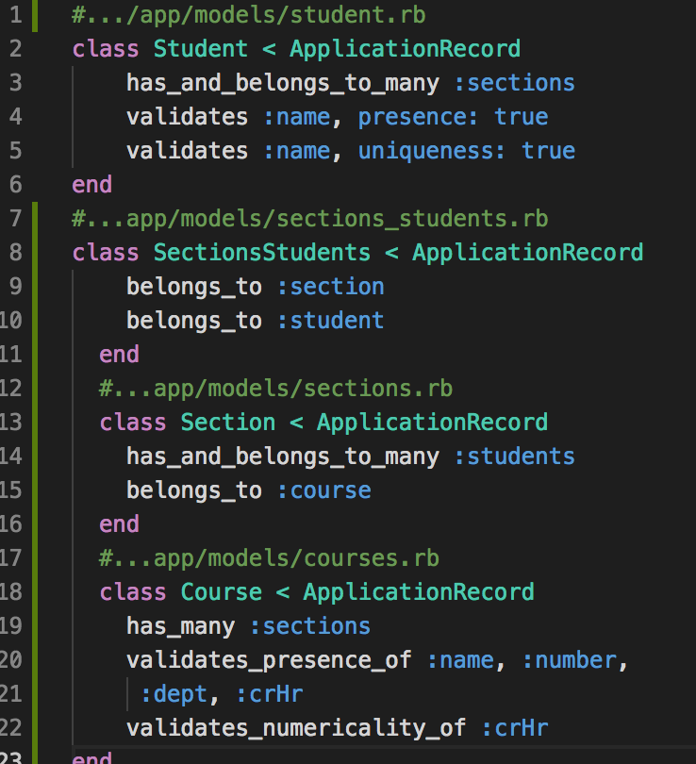

*The Many to Many Relationship and Adding a validation*

ruby -v ==🡺 ruby 2.5.1p57 (2018-03-29) and rails -v Rails 5.2.1.

Adding a search bar and autocompletion was a part of the project in order to make a search more effiecent and fast. And the following screenshot’s will show how to add a code to the controllers, views, and routes of the application. Before that knowing where to add the methods is a key. For Example if you are adding a search bar to the students

1. Go to …/app/controllers/students_controller.rb =====> create a new def search and then add search function/code

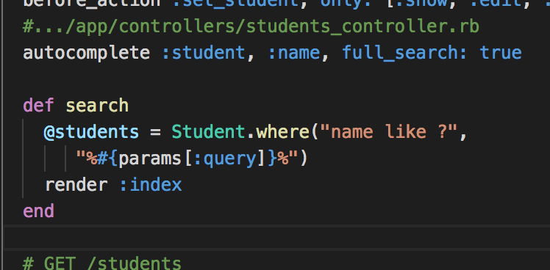

1. Under the … app/views/students/index.html.erb add the following code

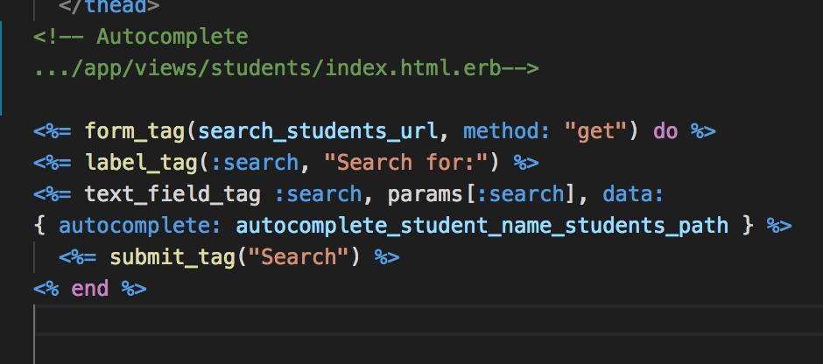

1. Under …. /config/routes.rb

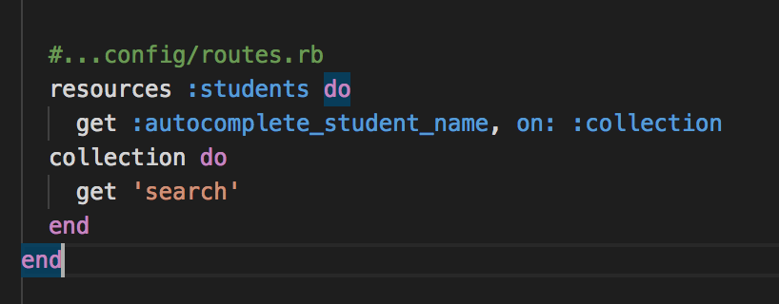

Here you need to make sure adding a key word search to call the method and autocompletion.

You do the same thing for sections or courses.

The following is a demo of validation for course and search and autocompletion for student

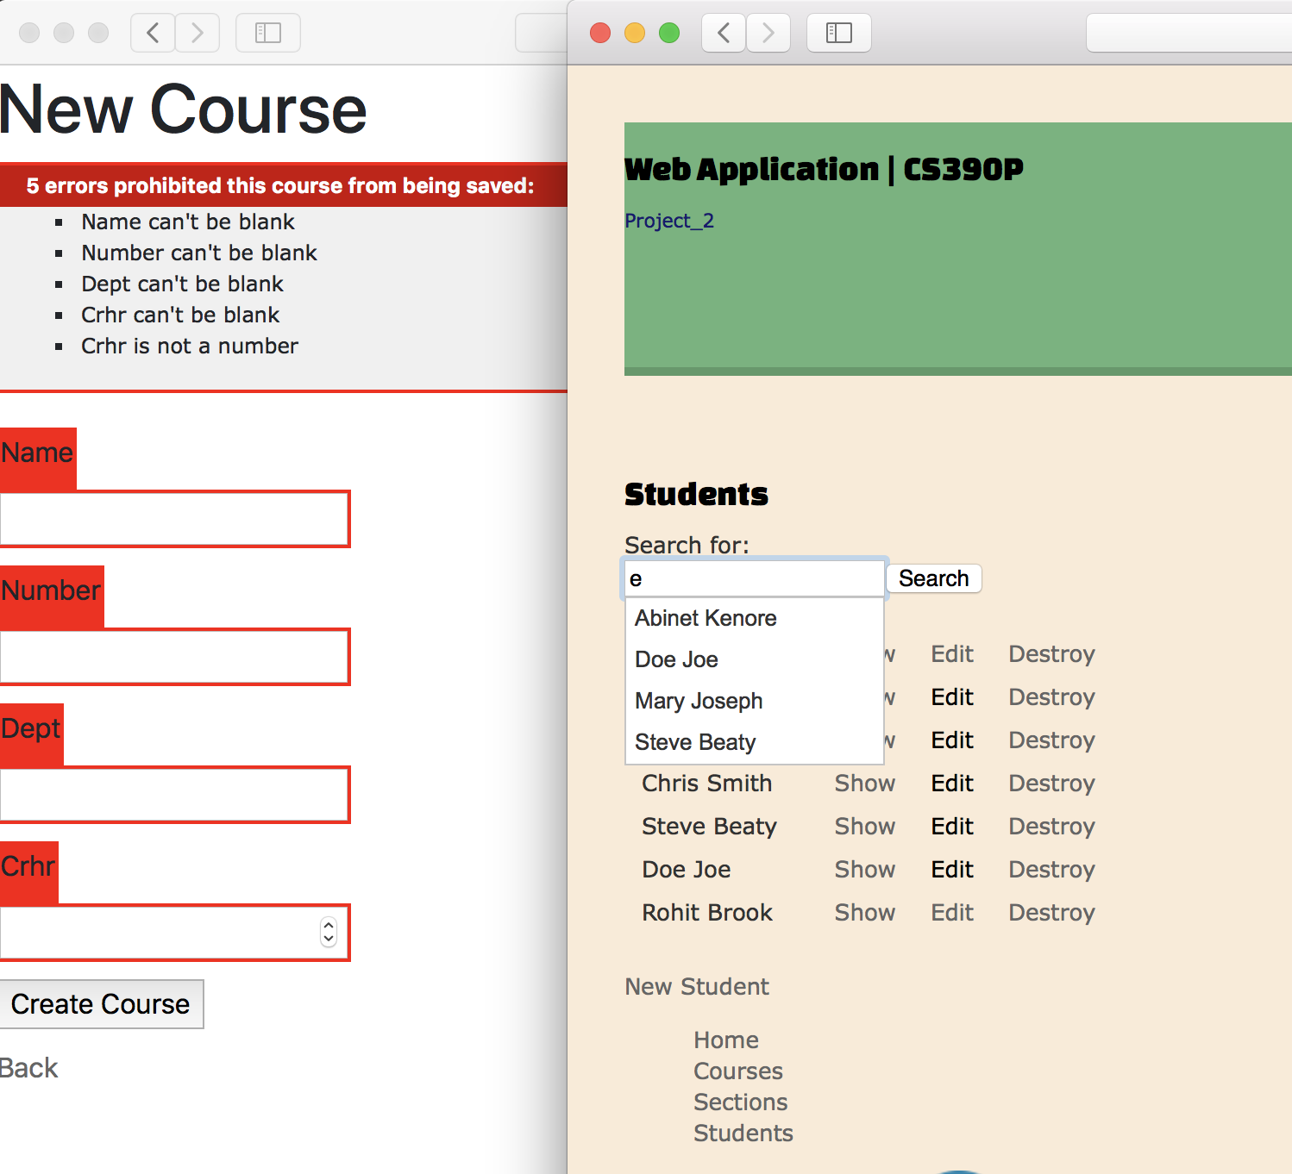

The left side screenshot is to show that in order to create a course you must fill the required fields with the appropriate information and the picture on the right is to show you that how it is try to fill the form automatically.

The following picture is a git difference before and after Adding a JavaScript for autocompletion.

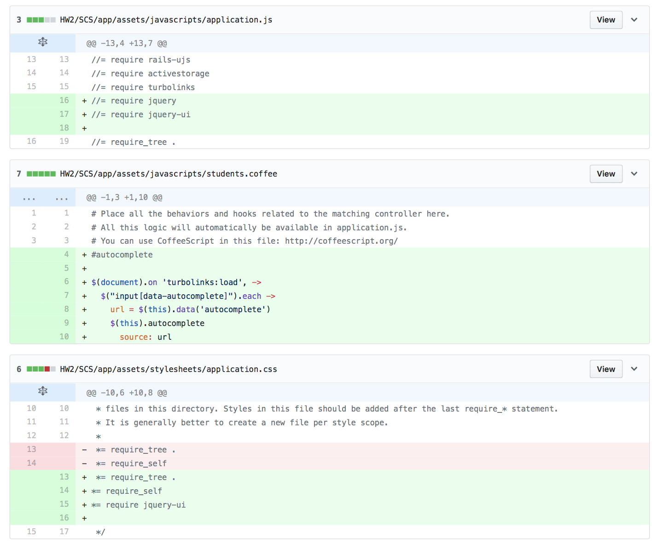

Writing unit testing

Knowing how to a GemFile