Abinet Kenore

CS390P

HW5

Fall 2018

The purpose of this homework was about to create a single page application (SPA) in which the user can interact dynamically with the website without even loading the whole web page. Because SPA avoids interruption of the user experience between successive pages by reducing the loading time from the server.

Hence this homework is about creating SPA, I will explain how I implemented it and how cool it is to a SPA in the web applications. Hence this HW is a continuation and adding of SPA, the following are the steps I took.

For me the easiest way was taking the copy of HW#2 and adding the SPA index to the view.

In order to add a spa index

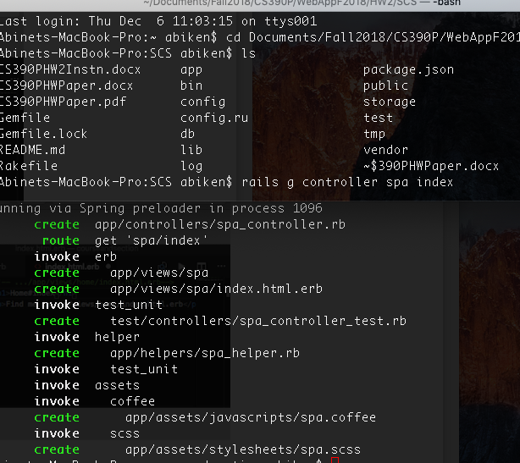

The rails scaffolds adds the spa controller, spa view, and route to the appropriate folders and files. Those are the folders we are interested in.



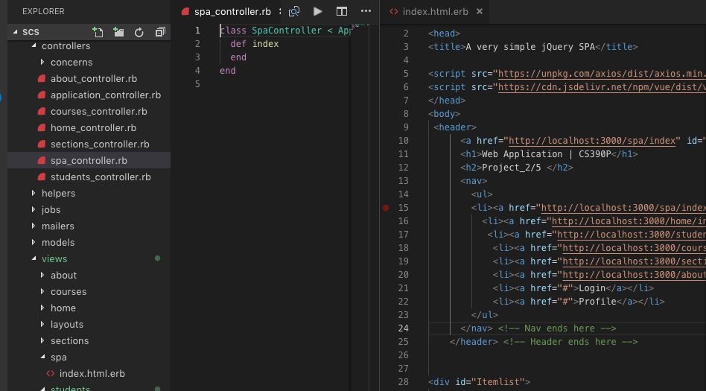



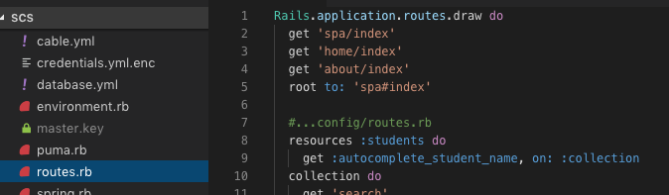



Hence the purpose is to make it easily accessible to the use, now I have to change the route from localhost:3000/whatever was routing to the spa page. ***HOW?***

Go to the .. /SCS/config/routes.rb file and change to route to root to: ’spa#index’

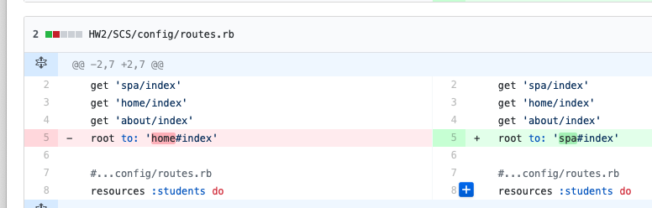

Once you change the route spa#index now the landing page changes.

Then under the …/app/views/spa/index.html.erb add the JavaScript code and modify the HTML snippets in the way you are displaying the information.

If you have followed the steps correctly you will get the following result when you fire up the rails server.

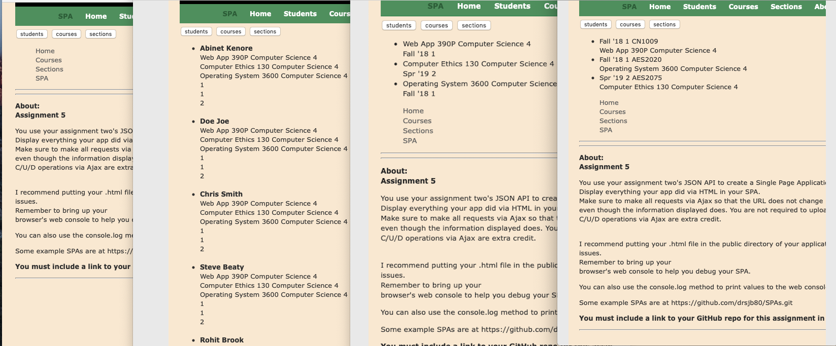

In the above picture you can see spa/landing page, students, course, and sections respectively from left to right.

**References**

Dr. Beaty’s PowerPoints

<https://github.com/drsjb80/SPAs/blob/master/vueaxiosspa1toM.html> Decmber 10, 2018