**Abinet Kenore**

**CS390P**

**HW3**

**Fall 2018**

This is the last part of the continuation on building up a “registration banner” and this time the primary goals are to add a navigation bar and an authentication via using a devise gem. In this part of the project I liked to go further, and I added a home page and footer for the all the views, and I also modified a default CSS to give the page nicer look and adjusted what it looks like in a different screen sizes using a bootstrap.

In this paper I will show you how you can add a home/static page/s on ruby on rails app. I mean when you start a server and route to <http://localhost:xxxx> instead of seeing a ruby on rails home page how you can see the home/landing page you created. I believe you already have some app and you are wondering to add a home page to it.

So in order to add a home page to the app you just need to create a controller index under the application you created as follow.

Rails g controller Home index

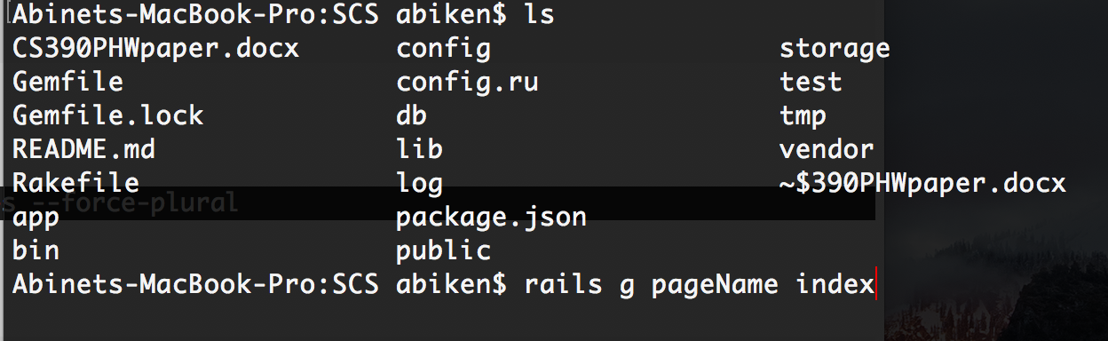

Next Go to .. /config/routes.rb and add root to: "home#index"

Then the landing page …localhost:3000 looks like default on (left) after modified (middle ) what the code looks in view before making or adding any additional information to the landing page

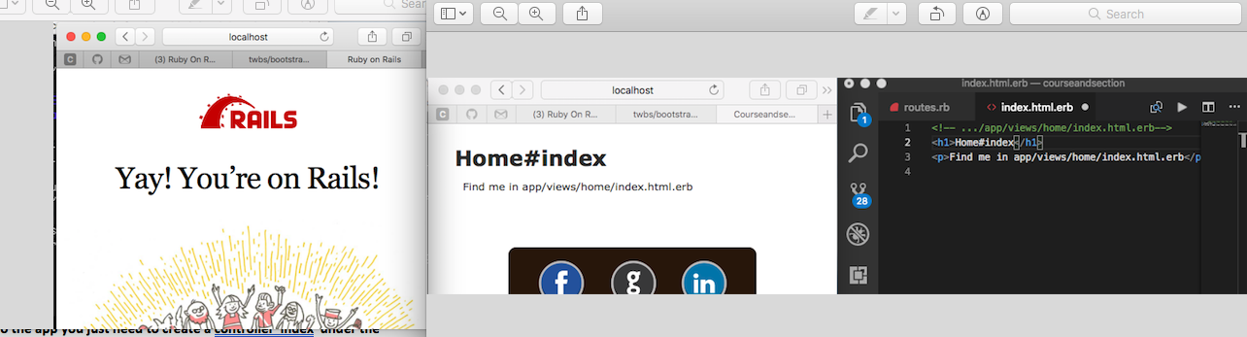

Then visit the website start bootstrap(<https://startbootstrap.com>) and pick the them you liked and click view live and then inspect it on the on the browser and pick the part you are looking for OR view source code on GitHub and see the index.html file(I believe this would be the easiest way to get the snippet you are looking for (<https://github.com/BlackrockDigital/startbootstrap-grayscale> ) . Also the alternative way would be just to visit the Bootstrap home page and see what’s out there for you (<http://getbootstrap.com/docs/4.1/getting-started/introduction/>). After you copied a snippet which liked to add in to you app go to your …app/views/layouts/application.html.erb past it before the <%= yield %> then you are good modify the href’s to the urls like:

<ul class="navbar-nav">

<li class="nav-item active">

<a class="navbar navbar-light" style="background-color: #2e8b57;"

href="http://localhost:3000/home/index">Home <span class="sr-only">(current)</span></a>

</li>

Good thing about adding a navbar and other features to the layout/application.html.erb is it can be accessed by all the views you have and it makes your code DRY as well.

Hence I said, I added footer to the view let me explain you how you can do it. Under application.html.erb <%= yield %>

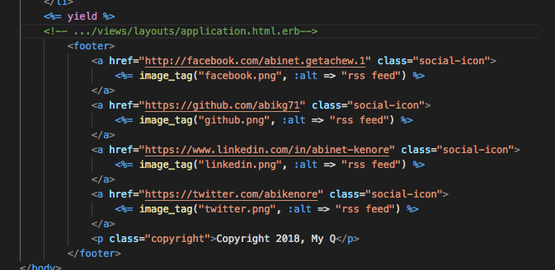

The footer also applies to all the views you have.

Next I will explain to you how it is easy to add an authentication to your ror app using devise gem. At this point I am not going to explain you how you add the gems to the GemFile. You need how to add gems to your ror app read my HW2 paper.

However, when you are installing a devise gem (* <https://www.youtube.com/watch?v=zJYuLebl-Js>)

After you install devise gem you will see a success message

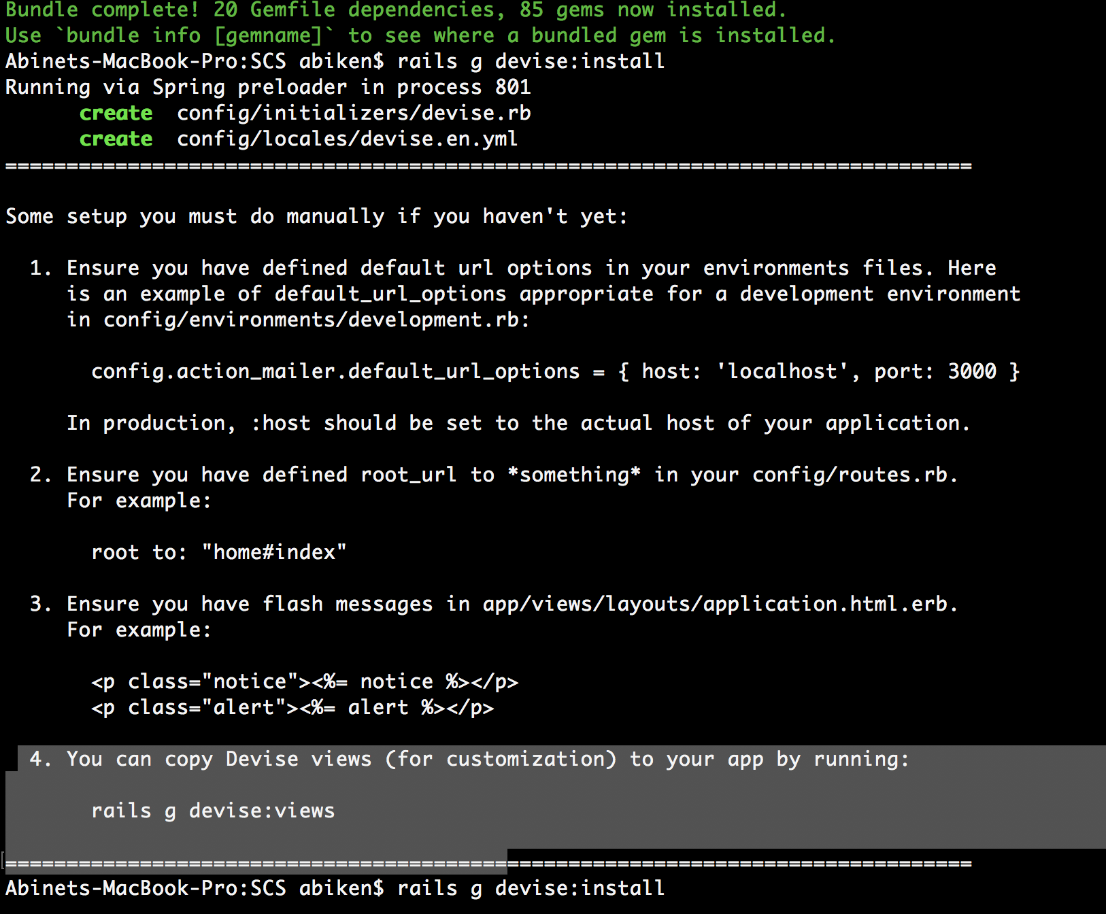

Then go to … /views/layouts/application.html.erb add

<!-- Added -->

<p class="notice">

<%= notice %>

</p>

<p class="alert">

<%= alert %>

</p>

<li>

<%= link_to 'Log out', destroy_user_session_path, method: :delete %>

</li>

<%= yield %>

Rails.application.routes.draw do

devise_for :users

get 'user/sign_up'

get 'user/sign_in'

root to: "home#index"

Add the following code to the contollers you are authenticating

before_action :authenticate_user!

… /app/views/students/index.html.erb

<li>

<%= link_to 'Log out', destroy_user_session_path, method: :delete %>

</li>

You can appy the same process the other files you are authenticating

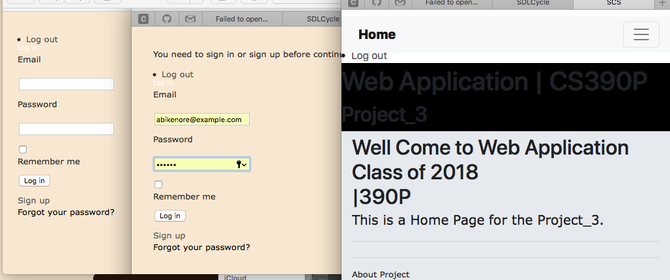

If you are interested to know how many users created go to your terminal or CMD

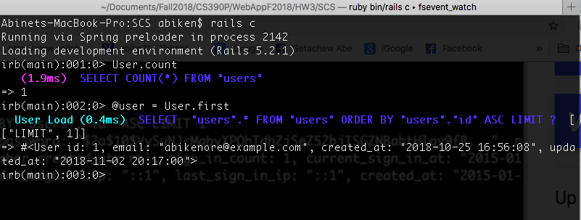

The above screenshot show you that there is one user created and when it was created and the last time user logged in and out and more.

When you are signing up and if you don’t fill the form correctly the devise gem will complain you and here is what it looks like.

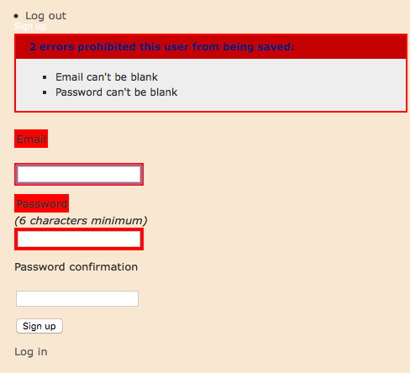

Methods/Measurements

I cloned my HW2 project and started modifying the project by adding the requirements for HW3.

As stated above adding the navbar and devise gem were the main ones. Hence I already learned how to add a new gem’s to the project it wasn’t too bad to do the same thing. Also by watching few YouTube videos I was able to add a landing page to the views .

The big point which I leaned on this part of the project was how cool it to use a devise gem to add authentication instead of creating my own credentials.

**Bibliography**

**Fomal**

Dr. Beaty’s PowerPoint slides, 08Authentication.pptx

**Online**

<https://slackredir.net/link?url=https%3A%2F%2Fwww.youtube.com%2Fwatch%3Fv%3DNf_Si8_szmM>

<https://www.youtube.com/watch?v=idgRXCLDWG8>

<https://github.com/twbs/bootstrap-sass>

<https://blog.teamtreehouse.com/static-pages-ruby-rails#setup>

<https://www.youtube.com/watch?v=Nf_Si8_szmM>

<https://github.com/rails/rails/issues/22584>

<https://rubygems.org/gems/devise/versions/>

<https://www.youtube.com/watch?v=zJYuLebl-Js>