Abinet Kenore

CS390P

Fall 2018

HW4

**Abstraction/Executive Summary**

**T**his assignment was all about how to break into the vulnerable web applications using a Web Goat from OWASP.

In order to break the sites we need three things.

1. Docker
2. OWASPZAP
3. WebGoat vulnerable site via Firefox.

**Steps I took**: hence I don’t have all of the above in my machine I have to install all of them.

**F**irst I installed docker in my machine using Homebrew.

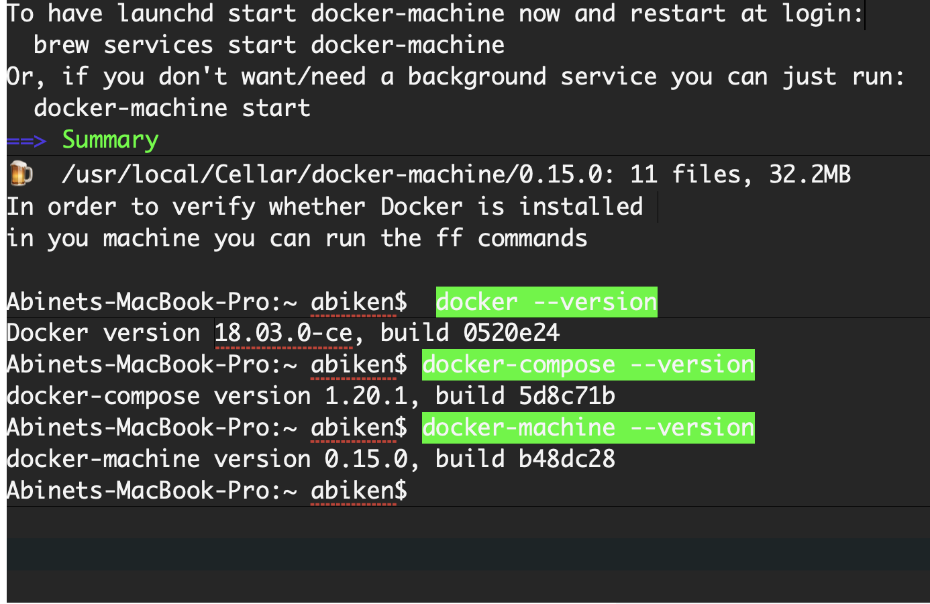

Second I installed OWASP ZAP the OWASP Zed Attack Proxy Project website and I followed the download instruction. I also downloaded Firefox as well.

**Method**

To run webgoat, I needed a container in which it would be put and thus why docker was needed to be installed first. Then

docker run -p 8080:8080 webgoat/webgoat-7.1

Then after I opened up fire fox configured the proxy as instructed in the PowerPoint from class Lecture

A screenshot of a cell phone


After I configured up the proxy, I fired up zap configured the proxies too. The following screenshot shows what it looks like when you fire up zap.

A screenshot of a cell phone


With all configurations done I ran webgoat server and it listened to <http://localhost:8080/WebGoat> logged in as a guest went to the numeric SQL injection executed the SQL command selecting local weather station as Columbia. Navigated through ZAP got the post broke it and ran it again. And as expected ZAP stopped the submission

A screenshot of a social media post


**Result**

As for the result I edited and submitted the SQL command in ZAP and hit play twice, then I got the required results.

A screenshot of a social media post


The take away from this Homework for me is that how to get around to mess around with the vulnerable sites using necessary tools.

**My concern:**

If this how easy it is to break into a web sites in realty, then I have to learn a lot as computer programmers in order to keep the sites not breakable easily or the other way around. More needs to be Done to make the world Better.

**References**

**Online**

<https://docs.docker.com/docker-for-mac/#proxies>

<https://www.owasp.org/index.php/OWASP_Zed_Attack_Proxy_Project>

<https://store.docker.com/editions/community/docker-ce-desktop-mac>

Dr Beaty’s PowerPoints.,