**ASSIGNMENT-42**

**Task-1**

**SourceCode: In Github with filename “Fibonacci.scala”**

A Fibonacci series (starting from 1) written in order without any spaces in between, thus

producing a sequence of digits.

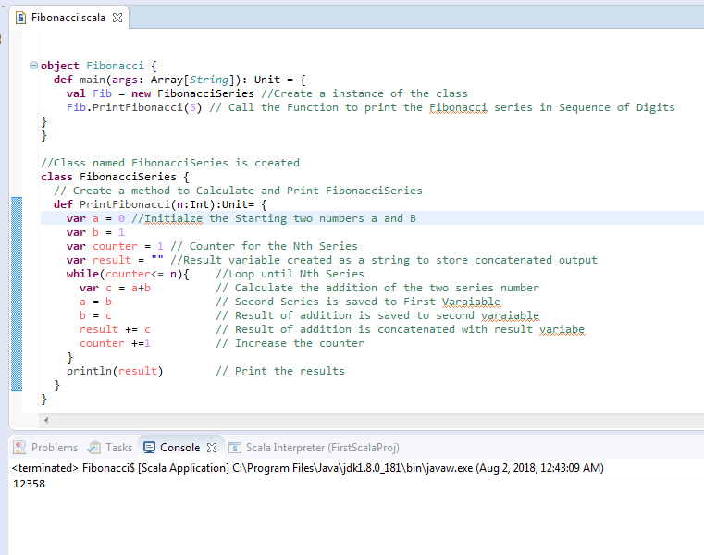

**For the Nth Series Input as 5, the result printed above is “12358”**

Write a Scala application to find the Nth digit in the sequence.

➢ Write the function using standard for loop

➢ Write the function using recursion

**Here Two Methods “FibNormalLoop” and “FibRecursion” is created to get the results for the above questions.**

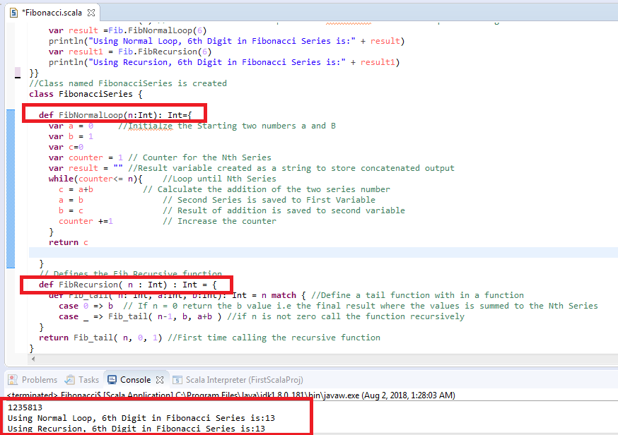

**Task 2**

**SourceCode in Github with file name:** “**Rational.scala”**

Create a calculator to work with rational numbers.

Requirements:

➢ It should provide capability to add, subtract, divide and multiply rational

numbers

➢ Create a method to compute GCD (this will come in handy during operations on

rational)

Add option to work with whole numbers which are also rational numbers i.e. (n/1)

- achieve the above using auxiliary constructors

- enable method overloading to enable each function to work with numbers and rational.

**Class Creation:**

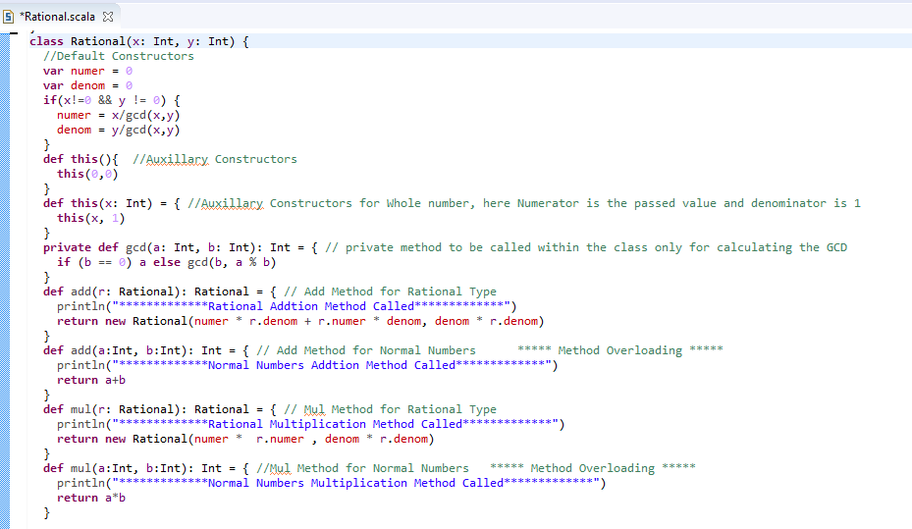

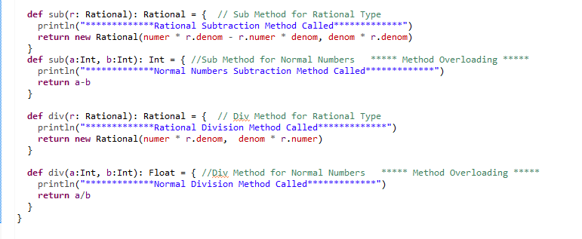

**MAIN METHOD:**

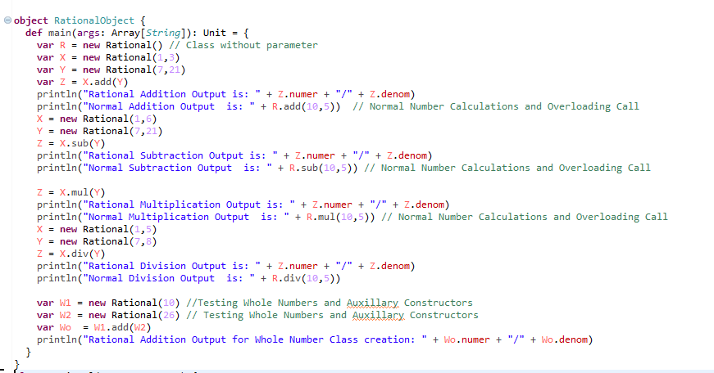

**Output:**

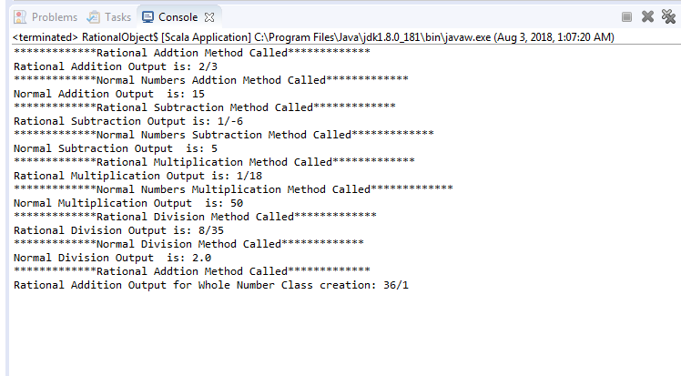

**Task 3**

1 .Write a simple program to show inheritance in scala.

2. Write a simple program to show multiple inheritances in scala.

**SourceCode: In Github with filename “Inheritance.scala”**

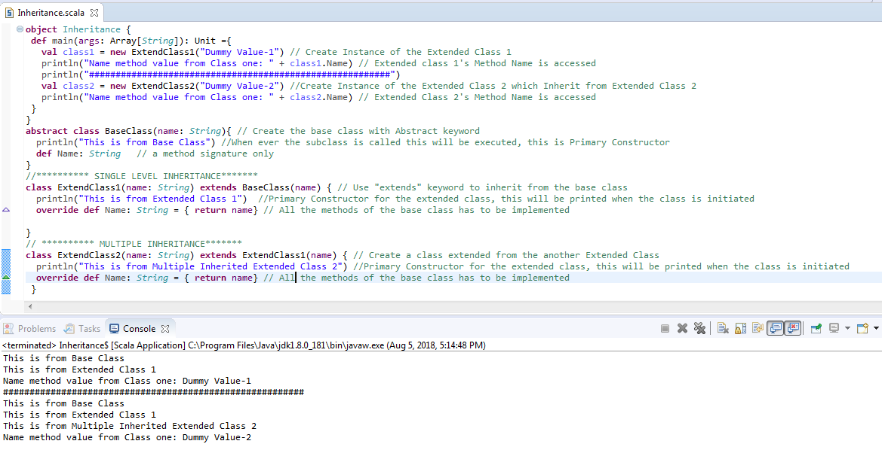

3.Write a partial function to add three numbers in which one number is constant and two numbers can be passed as inputs and define another method which can take the partial

function as input and squares the result.

4.Write a program to print the prices of 4 courses of Acadgild : Android-12999,Big Data

Development-17999, Big Data Development-17999, Spark-19999 using match and add a

default condition if the user enters any other course

**SourceCode: In Github with filename “PartialFunctionMatch.scala”**

