**ASSIGNMENT - 47**

1. Task-1 – Code saved in **Task1.scala** file within Github

What are the total numbers of gold medal winners every year?

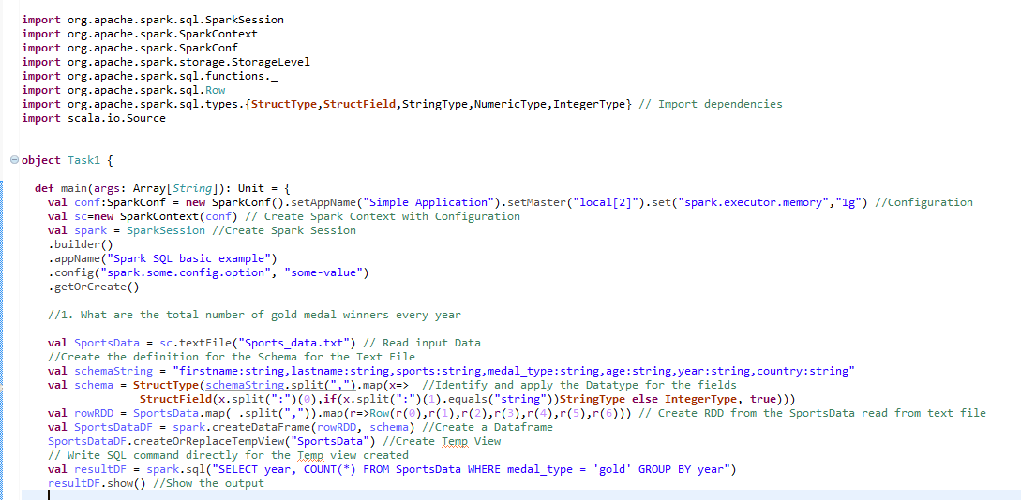

**Output**

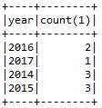

How many silver medals have been won by USA in each sport



**Output**

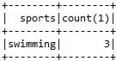

1. Task-2 – Code saved in **Task2.scala** file within Github

**Change firstname, lastname columns into**

**Mr.first_two_letters_of_firstname<space>lastname**

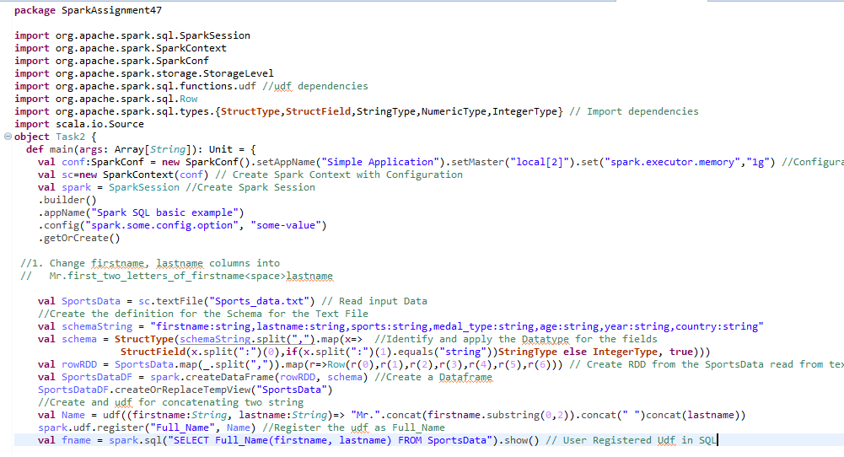

**Output**

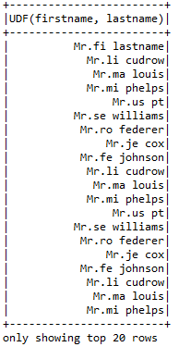

Add a new column called ranking using udfs on dataframe, where :

gold medalist, with age >= 32 are ranked as pro

gold medalists, with age <= 31 are ranked amateur

silver medalist, with age >= 32 are ranked as expert

silver medalists, with age <= 31 are ranked rookie

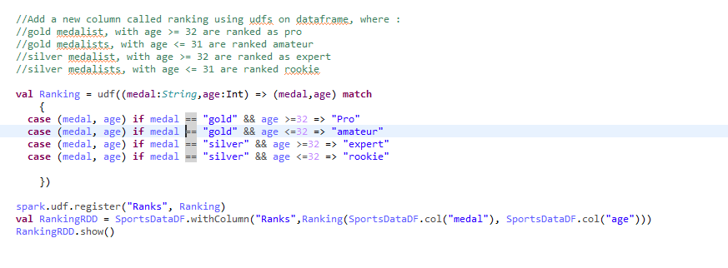

**Output**



