## **SUPPLEMENT: First Do No Harm? Modeling risks and benefits of challenge trials for hepatitis C vaccine development**

Alyssa Bilinski1, Rachel Slimovitch2, Andrew Mendlowitz3, Jordan Feld3, Joshua A. Salomon4

1 Department of Health Services, Policy, and Practice and Department of Biostatistics, Brown School of Public Health, Providence, RI, USA

2 Department of Epidemiology, Brown School of Public Health, Providence, RI, USA

3 Toronto Center for Liver Disease, University of Toronto, Toronto, Canada

4 Department of Health Policy, Stanford University School of Medicine, Stanford, California

### Table of Contents

Methods

Equations

Tables

Figures

### 

### Methods

**Methods S1. Challenge and traditional trial pathways**

Our model assumes that vaccine candidates would be trialed in the same order in both challenge and traditional approaches. If trial candidates are run simultaneously by different researchers, a conservative approach to incorporating this would be to assume such simultaneous trials occur in both challenge and traditional approaches and adjust *p* to represent the joint probability of at least one success. A less conservative interpretation, if multiple challenge trials are more likely to be run simultaneously than traditional trials due to reduced logistical burden, would be to increase the expected difference in duration between challenge and traditional trials. (For example, if two challenge trials would be run for each traditional trial, the expected time difference between trials, *y*, could be doubled.) Similarly, if traditional trials are likely to be delayed relative to challenge trials due to implementation challenges, this could likewise be modeled by increasing *y*.

**Methods S2. Vaccine uptake**

We estimated global vaccine uptake for comparator vaccines, both weighted and unweighted by disease burden (Tables S2-3). We divided this into two terms for ease of calculation. First, we estimated percentage of countries that include a vaccine in their national program:

,

where *pi*  is the population of country i, and *C* indicates the set of countries that covers a given vaccine. We then estimate uptake among countries that cover a particular vaccine.

,

where *vi* is vaccination uptake in country *i*. Total uptake is . To adjust by disease burden, we weight by a measure of disease burden in each country (*di*):

,,

**Methods S3. Steady-state uptake**

We assume that after a vaccine is developed, uptake will follow identical trajectories whether it was developed through a traditional or challenge approach. Historically, many vaccines have achieved a “steady state” of uptake around 5-10 years after roll-out.

Assume a vaccine has undiscounted benefits *Xt*  for during years 0,...,T-1 followed by benefits *X* each year thereafter. Further assume that a challenge approach saves *y\** years. Suppose a challenge trial produced a vaccine that has been available for *n* years:

Assuming n-y > T-1, a traditional approach will have accrued:

Without discounting, subtracting the two, the first terms cancel, and we are left with *Xy\** benefits, i.e. annual benefits at steady state multiplied by total years saved by a challenge approach. With discounting, the terms do not entirely cancel due to later timing of benefits in a traditional approach. However, uptake and therefore benefits are low during roll-out, discounting on this time scale is generally small relative to other model variation, and error in this regard makes our estimates conservative with regard to challenge approach benefits. We therefore adopt the steady state estimate as a reasonable approximation.

**Methods S4. Monetary costs**

Our monetary cost estimates are conservative, as we assume minimal health costs incurred prior to treatment and do not include trial costs. We exclude the latter because while challenge trials are often less expensive compared to traditional trials, data are limited, the running of additional challenge trials due to logistical ease may reduce the cost difference, and ethicists have expressed concern about conducting challenge trials “merely because it offers an inexpensive research design” [[1]](https://www.zotero.org/google-docs/?0usTue).

### Equations

**Equation S1. Expected years saved**

The first term of discounts all benefits to start being received *R* years into the future. We then sum over trials from 1 to T, where there is a of achieving success on trial *t.* Assuming that trial *t* is successful, years saved are , which is the sum of the first *ty* entries of a geometric series with common ratio *1-d*. This assumes an exponential discounting rate of *d*, such that given an annual benefit *X*, we value it at *X* in year 1, *(1-d)X* in year 2, and so on. When the discount rate is set to 0, the last term is instead *ty,* reflecting that each challenge trial saves *y* years.

**Equation S2. Expected years saved (generous)**

We assume years saved include *E(Y)* but also add benefits even in the case that all trials fail. In the second term, discounts all benefits to start being received *R* years into the future, and is the probability that all trials fail. The last term adds the minimum of 10 years and the number of years saved by conducting *T* trials, each of which saves 10 years.

**Equation S3. Expected infections incurred during challenge trial**

In the first term, is the probability that all trials fail, in which case individuals are infected. In the second term, is the probability of success on trial *t*, in which case *n(t-1)* individuals are infected in the first *t-1* trials, *1/2n* placebo recipients in trial *t*, and *1/2n(1-e)* treatment recipients in trial *t*, which sums to .

**Equation S4. Probability of successful vaccine**

If a trial is successful with probability *p* and trials are independent, the probability of obtaining a successful vaccine after *T* trials is the complement of the probability that all trials fail.

### 

### Tables

**Table S1. Model parameters**

| **Parameter** | **Description** | **Value** | **Source** |
| --- | --- | --- | --- |
| ***Years saved by challenge trial approach*** | | | |
| Probability of success of each trial (p) | As a base case, we take the average probability of approval of non-industry- sponsored Phase 2 vaccine candidates. To reflect Phase 1 candidates (e.g. a combined Phase 1/2 trial like [[2]](https://www.zotero.org/google-docs/?8Ey7Mr)) or a lower probability of success given a more challenging target, we also present results for 6%. | 11% (6%, up to 40% presented in Supplement) | [[3]](https://www.zotero.org/google-docs/?7oBWvU) |
| Difference in length between traditional and challenge trial (y) | [[2]](https://www.zotero.org/google-docs/?UhY9W9) lasted 6 years in duration. Our base case estimate assumes a challenge trial could be conducted in a year. The lower bound estimate assumes additional regulatory requirements for a challenge trial increasing duration; the upper bound more interest in research (and e.g., simultaneous trials) when faster paths are available. | 5 (2.5-10) | [[2]](https://www.zotero.org/google-docs/?QOGqUY) |
| Number of vaccine candidates (T) | We estimate the number of candidates available for a challenge trial approach at 3, per expert opinion. | 3 (1-5) | Expert opinion (Feld) |
| Years until benefits accrue (R) | For a successful trial, we assume 5-10 years trial duration, 5-10 years of scale-up, and 10-15 years from vaccination to averted infection. | 30 | [[4,5]](https://www.zotero.org/google-docs/?0tPlIL) |
| ***Deployment*** | | | |
| Vaccine uptake | We model vaccine uptake based on comparable vaccines (HPV, rotavirus, HPV). | 20-90% | See Table S3 |
| ***Vaccine efficacy/waning*** | | | |
| Vaccine efficacy | We assume that vaccines below 50% efficacy would not be approved. Because an HCV vaccine has been hard to develop, experts anticipate a lower efficacy and/or waning. | 70% (50%-90%) |  |
| ***Projected HCV cases*** | | | |
| 2055 HCV incidence | We use estimates of global HCV incidence from a previously published model. | .02/100 | [[6]](https://www.zotero.org/google-docs/?P2bz7O) |
| 2055 population | We use World Bank population estimates. | 9.67 billion | [[7]](https://www.zotero.org/google-docs/?tmTPBh) |
| ***Risks*** | | | |
| Sample size (n) | Challenge trials usually run from 10-100 participants; we assume a larger trial is needed for regulatory approval. | 100 | [[8,9]](https://www.zotero.org/google-docs/?TAZOPE) |

**Table S2. Parameters for estimating vaccine uptake**

| **Parameter** | **Description** | **Citation** |
| --- | --- | --- |
| Presence of an HPV vaccination campaign | Whether countries had an HPV vaccination campaign | [[10]](https://www.zotero.org/google-docs/?58hAwk) |
| HPV vaccination coverage | Percent of girls aged 15 years old that received the recommended doses of the HPV vaccine | [[11]](https://www.zotero.org/google-docs/?1mODCO) |
| Cervical cancer incidence rate | Crude incidence rate per 100,000 for cervical cancer | [[12]](https://www.zotero.org/google-docs/?dRP6mw) |
| Cervical cancer mortality rate | Crude mortality rate per 100,000 for cervical cancer | [[12]](https://www.zotero.org/google-docs/?u4YWKb) |
| Hepatitis B vaccination coverage | Percentage of one-year-olds who have received three doses of the Hepatitis B vaccine | [[13]](https://www.zotero.org/google-docs/?5VEIlq) |
| Hepatitis B incidence rate | Crude incidence rate per 100,000 of Hepatitis B | [[14]](https://www.zotero.org/google-docs/?nFQhkU) |
| Rotavirus vaccination coverage | Percentage of surviving one-year-olds who received the final recommended dose of the rotavirus vaccine (which can be either the 2nd or 3rd dose depending on the vaccine) | [[15]](https://www.zotero.org/google-docs/?GodY0h) |
| Rotavirus incidence rate | Incidence rate per 1,000 of rotavirus among children under 5 years old | [[16]](https://www.zotero.org/google-docs/?myd3Xa) |
| Incident cases of rotavirus | Number of cases of rotavirus among children under 5 in 2016 | [[16]](https://www.zotero.org/google-docs/?ESSqO6) |
| Presence of a rotavirus vaccination program | Whether countries had a rotavirus vaccination program in 2016 | [[17]](https://www.zotero.org/google-docs/?QP6UkN) |
| Population | Population of each country | [[18,19]](https://www.zotero.org/google-docs/?EaBfa8) |

**Table S3. Vaccine global uptake estimates**

|  | | ***Unweighted*** | | | ***Weighted*** | | |
| --- | --- | --- | --- | --- | --- | --- | --- |
| **Disease** | **Measure of disease burden** | ***Coverage*** | ***Uptake in covered countries*** | **Uptake** | ***Weighted coverage*** | ***Weighted uptake in covered countries*** | **Weighted uptake** |
| HPV | Cervical cancer (2019) | 0.29 | 0.49 | 0.14 | 0.32 | 0.44 | 0.14 |
| Rotavirus | Rotavirus infections (2016) | 0.23 | 0.77 | 0.17 | 0.29 | 0.77 | 0.23 |
| HBV | HBV incidence (2019) | 1 | 0.9 | 0.9 | 1 | 0.9 | 0.9 |

**Table S4. Tiers of ethical considerations for challenge trial approval**

| **Question** | **Approach** | **Limitations** |
| --- | --- | --- |
| 1. Do risks to participants reach an unacceptable level? | Quantify harms and benchmark against other activities | No universal threshold for acceptable risk |
| 2. How do benefits compare to risks? | Estimate ratio of benefits to risks | Sensitive to small risk denominators, choice of unit |
| 3. Do risks exceed the cost of obtaining benefits otherwise? | Benchmark against cost of obtaining comparable benefits through other approaches | Sensitive to set of alternatives deemed ‘plausible’ |

**Table S5. Health costs of challenge trial participation**

| **Parameter** | **Value** | **Reference** |
| --- | --- | --- |
| DAA treatment success rate | 0.9998 | [[20–22]](https://www.zotero.org/google-docs/?X8pppj)  We assume a 2% failure rate on first treatment and 1% failure rate on retreatment: 0.98+0.99*0.02. |
| Risk of fulminant acute hepatitis | 1/500 | [[23,24]](https://www.zotero.org/google-docs/?LSX5ZE), expert opinion (Feld)  The risk of severe acute infection is low, and treatable. |
| QALY cost of acute hepatitis C | 0.02 | [[25–29]](https://www.zotero.org/google-docs/?HxOMnN)  We assume that participants would be treated after a period of acute infection, in which it is determined whether the vaccine increases the probability of clearing the virus (Feld).  This QALY cost is low, comparable, for example, to moderate-to-severe influenza. |
| QALY cost of untreated hepatitis C | 4 (range: 3-5) | [[30–34]](https://www.zotero.org/google-docs/?hgUyuy) |
| Treatment rate (2050) | 50% | Assumed, intended to be conservative with respect to challenge trial benefit. Current treatment rates are around 10%, but scale-up is in-progress. |

**Table S6. Cost of diagnosis and treatment (India as example)** We approximate total cost to detect and treat an infection based on parameters below as: $100 + $119 + $89 + $2.60*200 ~ $500.

| **Parameter** | **Value** | **Reference** |
| --- | --- | --- |
| 4-week DAA regimen | $100 | [[30–33]](https://www.zotero.org/google-docs/?CiNPMa) |
| Diagnosis of chronic HCV | $119 | [[30–33]](https://www.zotero.org/google-docs/?nODFus) |
| Assessment of HCV treatment response | $89 | [[30–33]](https://www.zotero.org/google-docs/?aWwJwR) |
| Screening diagnostic tests | $2 | [[35]](https://www.zotero.org/google-docs/?CGsrcW)  Assumes ELISA + rapid diagnostic test, 50% of cost added for overhead |
| Number needed to screen to detect a case | 100 | [[35,36]](https://www.zotero.org/google-docs/?Ha11Y8)  Assumes 0.5-1% prevalence and moderately-targeted testing |
| Conversion factor (Indian rupee to dollar) | 0.012 | [[37]](https://www.zotero.org/google-docs/?vgkSVM)  Used to adjust costs in this paper: [[35]](https://www.zotero.org/google-docs/?9vEUqr) |

### Figures

**Figure S1. Model diagram** 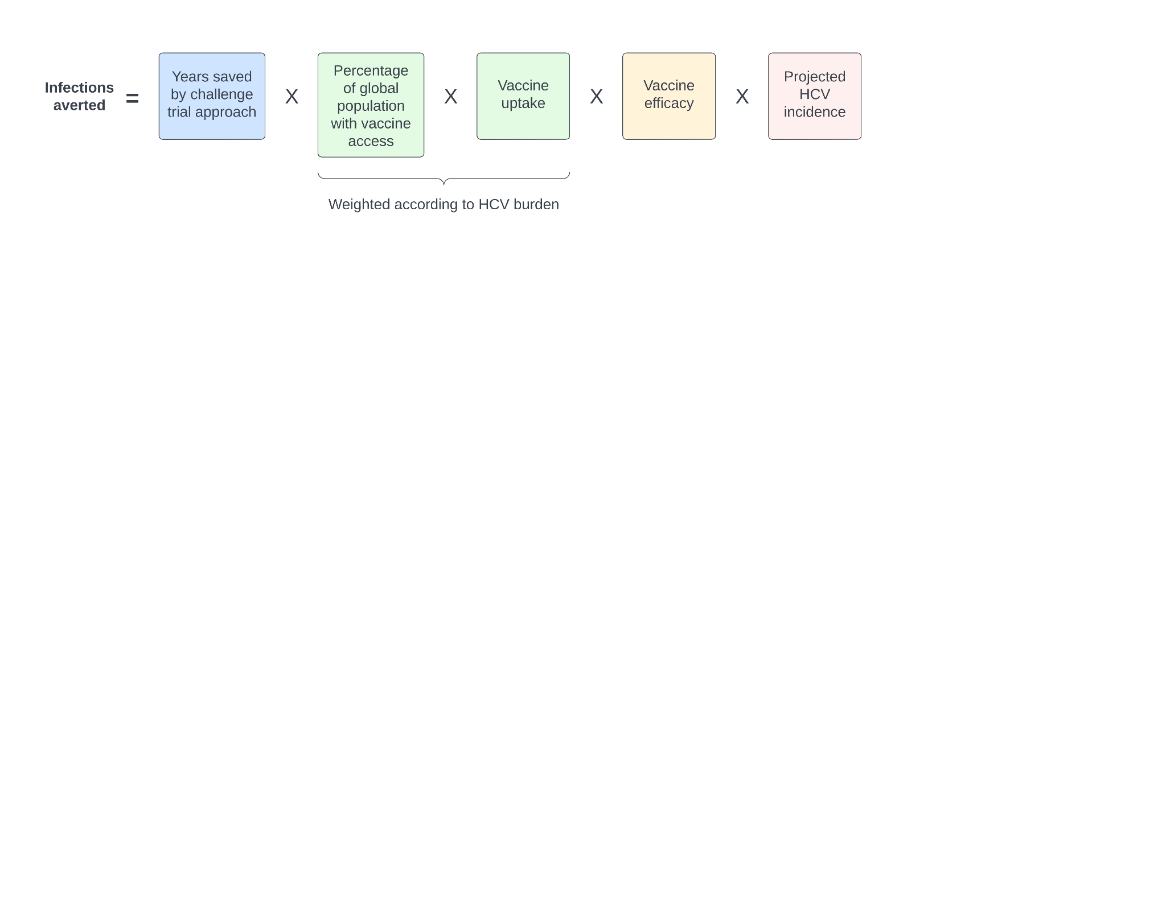

**Figure S2. Probability of trial success.** The x-axis varies the probability of success in each trial (*p*), and colors indicate the maximum number of trials (*T*).

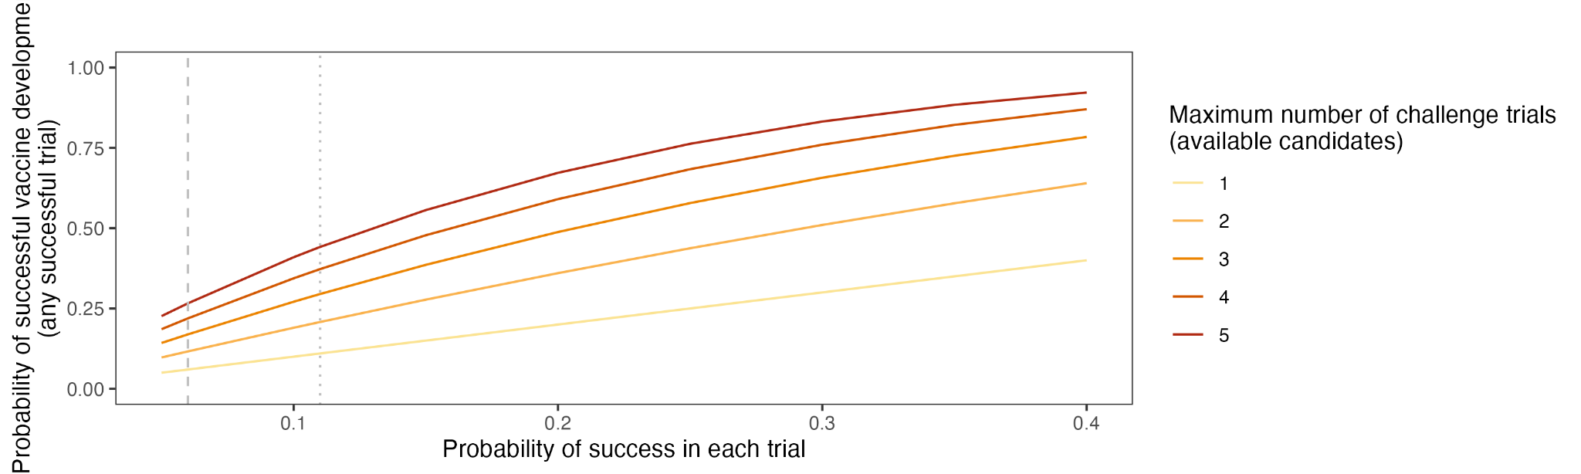

**Figure S3. Estimates of years saved by a challenge trial model compared to a traditional trial model.** The x-axis varies the probability of success in each trial (*p*), columns indicate differential length between a challenge and a traditional trial (*y*), and colors indicate the maximum number of trials (*T*). We apply an annual discount rate of 3%.

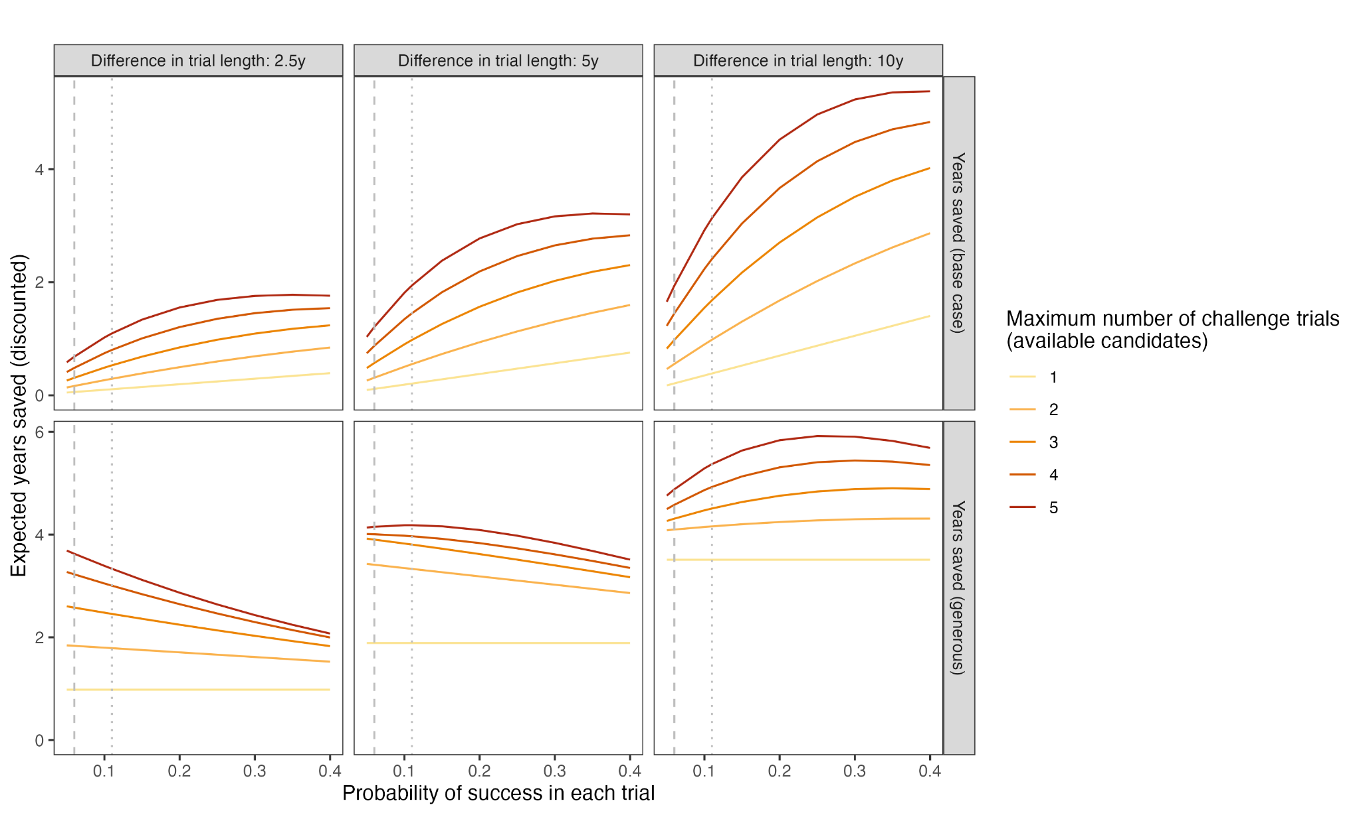

**Figure S4. QALY benefit-risk frontiers across different parameter values.** Each line shows frontier for a given level of the infection benefit-risk ratio (BRR): expected incremental future QALYs averted by a challenge trial, discounted to present value (benefits) vs. incremental additional QALYs incurred by a challenge trial (risks). In other words, all points above a line have a BRR above that indicated by the line. We vary global vaccine uptake across the x-axis and the difference in trial length (years) between each traditional and challenge trial on the y-axis. The number of available vaccine candidates is varied across columns, and the per-trial success probability is varied across rows. 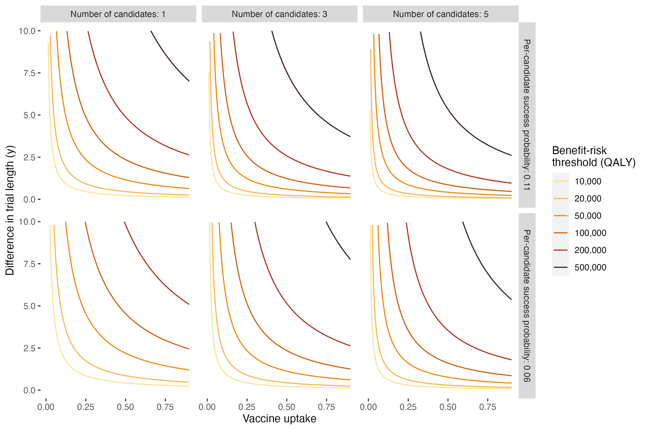

**Figure S5. Cost of achieving incremental benefits through treatment.** The x-axis displays vaccine uptake and the y-axis displays the cost of achieving incremental benefits through treatment. We vary the number of vaccine candidates across columns and per trial success probability across rows. Colors correspond to the difference in length (years) between a traditional and challenge trial.

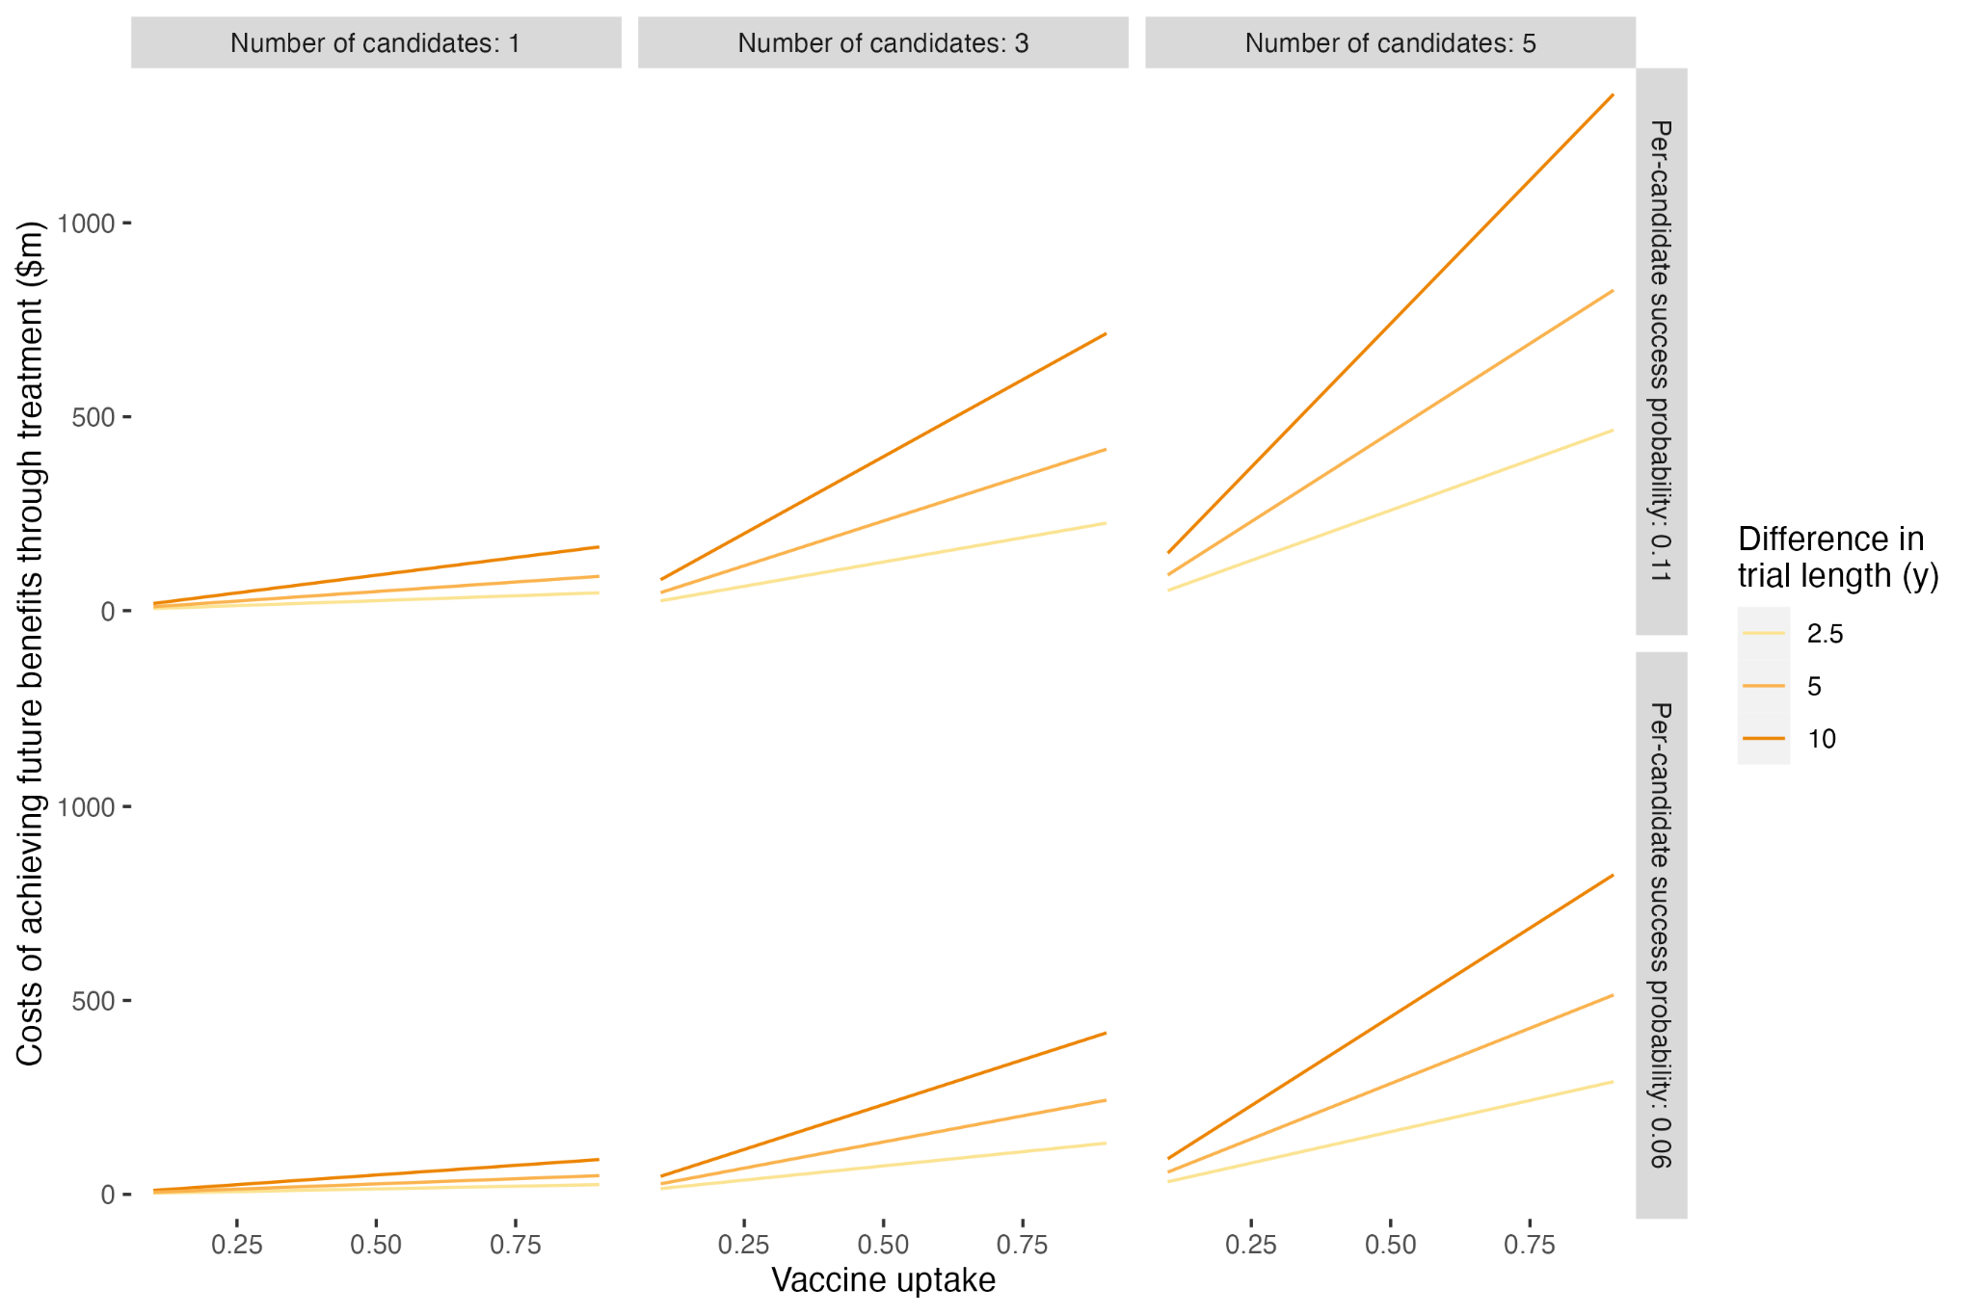

**Figure S6. Infection benefit-risk frontiers across different parameter values (SENSITIVITY ANALYSIS – vaccine efficacy 90% vs. 70% base case).** Each line shows frontier for a given level of the benefit-risk ratio (BRR): expected incremental future infections averted by a challenge trial, discounted to present value (benefits) vs. incremental additional infections incurred by a challenge trial (risks). In other words, all points above a line have a BRR above that indicated by the line. We vary global vaccine uptake across the x-axis and the difference in trial length (years) between each traditional and challenge trial on the y-axis. The number of available vaccine candidates is varied across columns, and the per-trial success probability is varied across rows. 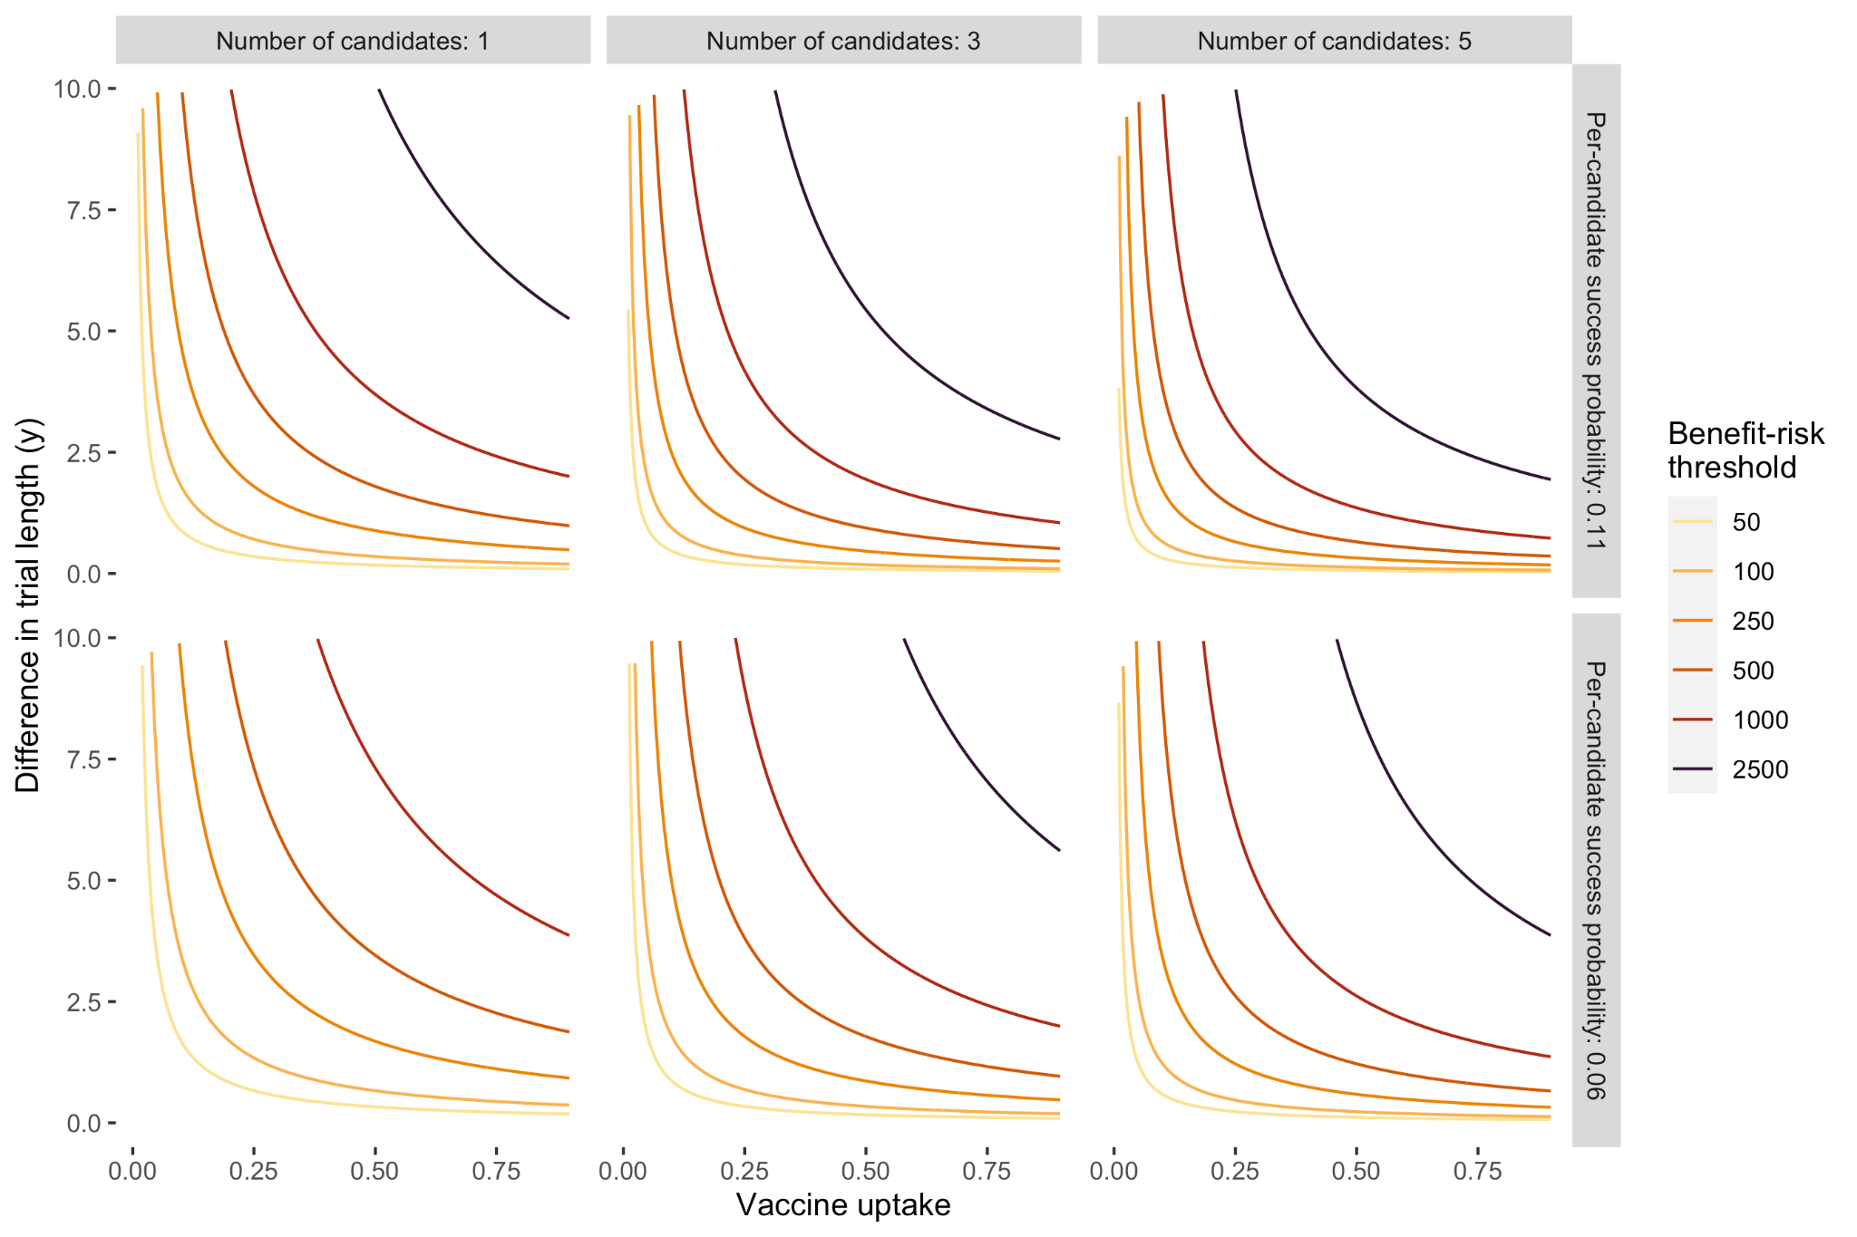

**Figure S7. Infection benefit-risk frontiers across different parameter values (SENSITIVITY ANALYSIS – incidence halved from base case).** Each line shows frontier for a given level of the benefit-risk ratio (BRR): expected incremental future infections averted by a challenge trial, discounted to present value (benefits) vs. incremental additional infections incurred by a challenge trial (risks). In other words, all points above a line have a BRR above that indicated by the line. We vary global vaccine uptake across the x-axis and the difference in trial length (years) between each traditional and challenge trial on the y-axis. The number of available vaccine candidates is varied across columns, and the per-trial success probability is varied across rows.

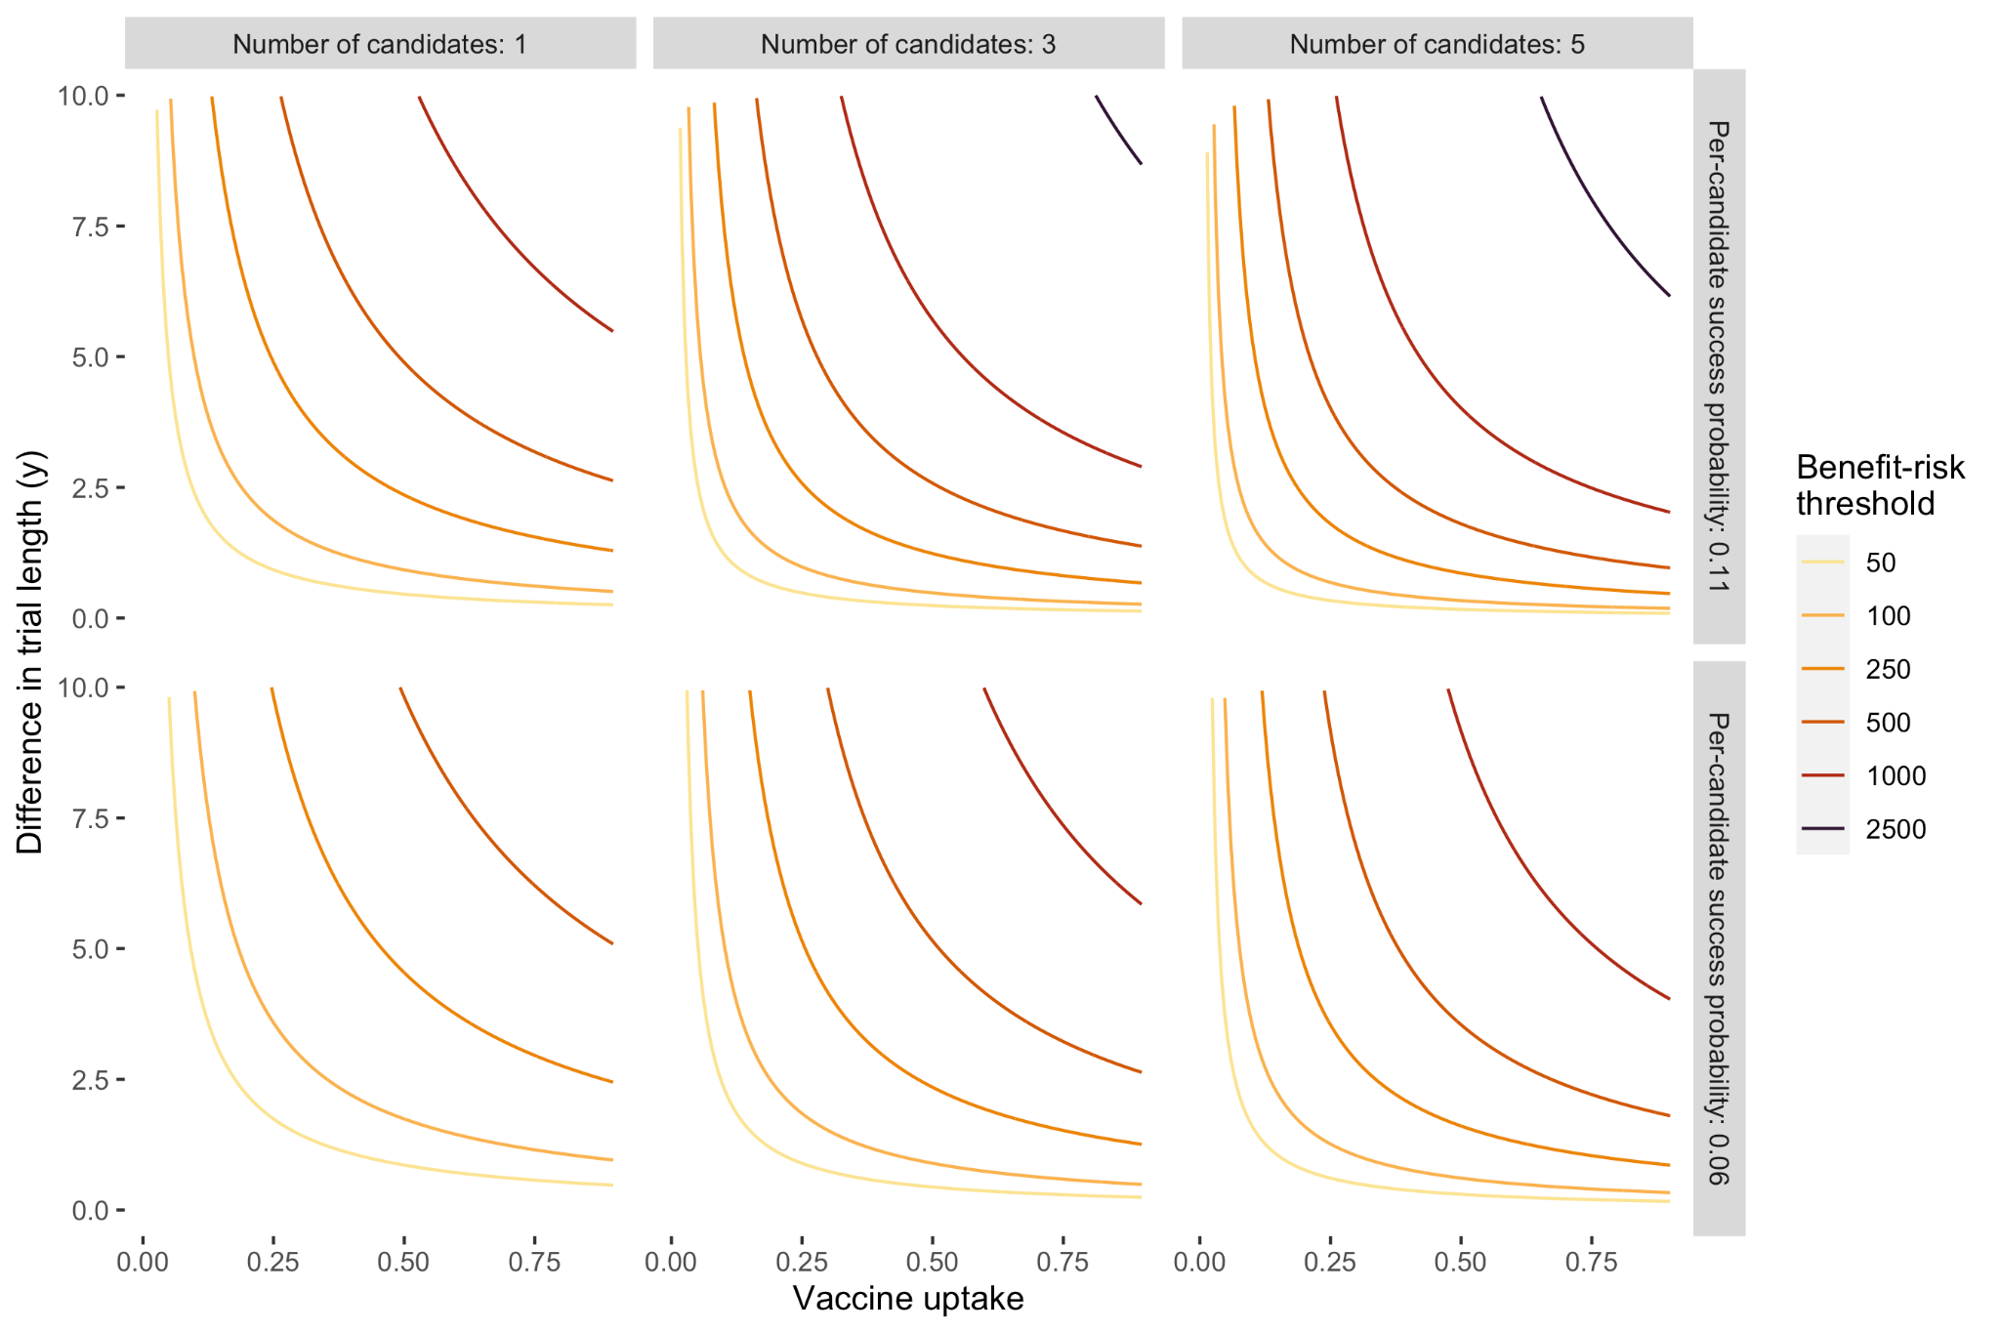

**Figure S8. Infection benefit-risk frontiers across different parameter values (SENSITIVITY ANALYSIS – no discounting vs. 3% base case).** Each line shows frontier for a given level of the benefit-risk ratio (BRR): expected incremental future infections averted by a challenge trial, discounted to present value (benefits) vs. incremental additional infections incurred by a challenge trial (risks). In other words, all points above a line have a BRR above that indicated by the line. We vary global vaccine uptake across the x-axis and the difference in trial length (years) between each traditional and challenge trial on the y-axis. The number of available vaccine candidates is varied across columns, and the per-trial success probability is varied across rows.

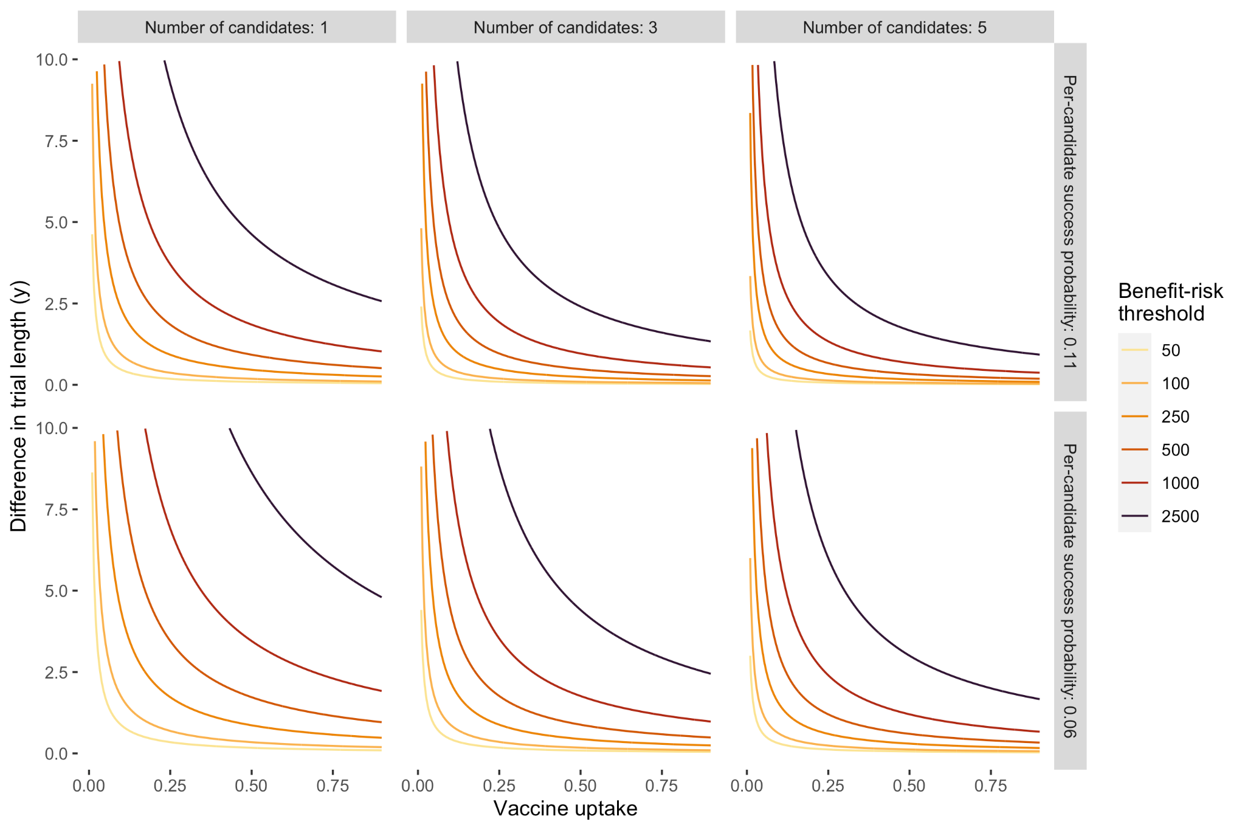

**Figure S9. Infection benefit-risk frontiers across different parameter values (SENSITIVITY ANALYSIS – “generous” estimate of years saved, which allows up to 10 years of time saved even if no effective vaccine candidate is identified).** Each line shows frontier for a given level of the benefit-risk ratio (BRR): expected incremental future infections averted by a challenge trial, discounted to present value (benefits) vs. incremental additional infections incurred by a challenge trial (risks). In other words, all points above a line have a BRR above that indicated by the line. We vary global vaccine uptake across the x-axis and the difference in trial length (years) between each traditional and challenge trial on the y-axis. The number of available vaccine candidates is varied across columns, and the per-trial success probability is varied across rows.

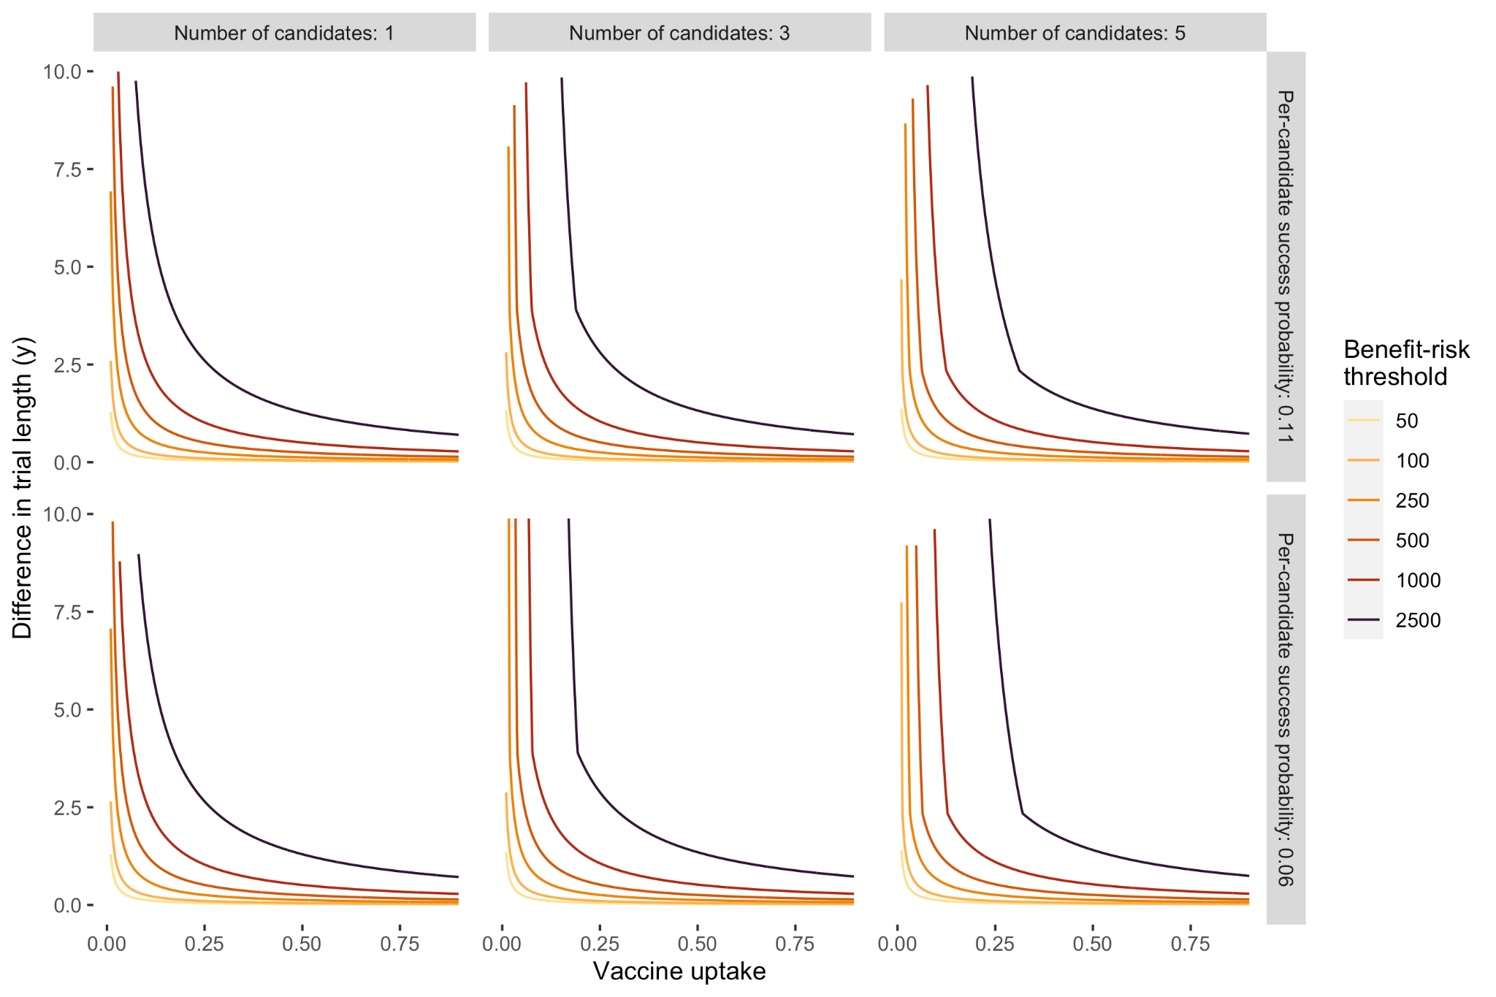

References

[1. Sulmasy DP. Are SARS-CoV-2 Human Challenge Trials Ethical? JAMA Intern Med **2021**; 181:1031–1032.](https://www.zotero.org/google-docs/?UHJPRI)

[2. Page K, Melia MT, Veenhuis RT, et al. Randomized Trial of a Vaccine Regimen to Prevent Chronic HCV Infection. N Engl J Med **2021**; 384:541–549.](https://www.zotero.org/google-docs/?UHJPRI)

[3. Lo AW, Siah KW, Wong CH. Estimating Probabilities of Success of Vaccine and Other Anti-Infective Therapeutic Development Programs. Harv Data Sci Rev **2020**; Available at: https://hdsr.mitpress.mit.edu/pub/pnp0pr4j/release/3. Accessed 24 December 2022.](https://www.zotero.org/google-docs/?UHJPRI)

[4. Vaccine Research & Development. Available at: https://coronavirus.jhu.edu/vaccines/timeline. Accessed 11 January 2023.](https://www.zotero.org/google-docs/?UHJPRI)

[5. 2020 Hepatitis C | Viral Hepatitis Surveillance Report | CDC. 2022. Available at: https://www.cdc.gov/hepatitis/statistics/2020surveillance/hepatitis-c.htm. Accessed 1 March 2023.](https://www.zotero.org/google-docs/?UHJPRI)

[6. Heffernan A, Cooke GS, Nayagam S, Thursz M, Hallett TB. Scaling up prevention and treatment towards the elimination of hepatitis C: a global mathematical model. The Lancet **2019**; 393:1319–1329.](https://www.zotero.org/google-docs/?UHJPRI)

[7. Population estimates and projections | DataBank. Available at: https://databank.worldbank.org/source/population-estimates-and-projections. Accessed 8 January 2023.](https://www.zotero.org/google-docs/?UHJPRI)

[8. Roestenberg M, Hoogerwerf M-A, Ferreira DM, Mordmüller B, Yazdanbakhsh M. Experimental infection of human volunteers. Lancet Infect Dis **2018**; 18:e312–e322.](https://www.zotero.org/google-docs/?UHJPRI)

[9. Rid A, Roestenberg M. Judging the social value of controlled human infection studies. Bioethics **2020**; 34:749–763.](https://www.zotero.org/google-docs/?UHJPRI)

[10. World Health Organization. Existence of national HPV vaccination programme. 2020. Available at: https://www.who.int/data/gho/data/indicators/indicator-details/GHO/existence-of-national-hpv-vaccination-programme.](https://www.zotero.org/google-docs/?UHJPRI)

[11. Girls aged 15 years old that received the recommended doses of HPV vaccine. Available at: https://www.who.int/data/gho/data/indicators/indicator-details/GHO/girls-aged-15-years-old-that-received-the-recommended-doses-of-hpv-vaccine. Accessed 20 December 2022.](https://www.zotero.org/google-docs/?UHJPRI)

[12. International Agency for Research on Cancer. Cervix Uteri, 2020. Available at: http://gco.iarc.fr/today/home. Accessed 16 December 2022.](https://www.zotero.org/google-docs/?UHJPRI)

[13. Hepatitis B (HepB3) immunization coverage among 1-year-olds (%). Available at: https://www.who.int/data/gho/data/indicators/indicator-details/GHO/hepatitis-b-(hepb3)-immunization-coverage-among-1-year-olds-(-). Accessed 14 December 2022.](https://www.zotero.org/google-docs/?UHJPRI)

[14. Global Burden of Disease Collaborative Network. Incidence of Acute Hepatitis B. Available at: https://vizhub.healthdata.org/gbd-results. Accessed 14 December 2022.](https://www.zotero.org/google-docs/?UHJPRI)

[15. Rotavirus vaccines completed dose (RotaC) immunization coverage among 1-year-olds (%). Available at: https://www.who.int/data/gho/data/indicators/indicator-details/GHO/rotavirus-vaccines-completed-dose-(rotac)-immunization-coverage-among-1-year-olds-(-). Accessed 20 December 2022.](https://www.zotero.org/google-docs/?UHJPRI)

[16. Troeger C, Khalil IA, Rao PC, et al. Rotavirus Vaccination and the Global Burden of Rotavirus Diarrhea Among Children Younger Than 5 Years. JAMA Pediatr **2018**; 172:958–965.](https://www.zotero.org/google-docs/?UHJPRI)

[17. Abou-Nader AJ, Sauer MA, Steele AD, et al. Global rotavirus vaccine introductions and coverage: 2006 – 2016. Hum Vaccines Immunother **2018**; 14:2281–2296.](https://www.zotero.org/google-docs/?UHJPRI)

[18. Population, total | Data. Available at: https://data.worldbank.org/indicator/SP.POP.TOTL?end=2021&start=2000. Accessed 20 December 2022.](https://www.zotero.org/google-docs/?UHJPRI)

[19. United Nations- Data Portal Population Division. Total population by sex. Available at: https://population.un.org/dataportal/data/indicators/49/locations/232,158/start/2000/end/2022/table/pivotbylocation. Accessed 20 December 2022.](https://www.zotero.org/google-docs/?UHJPRI)

[20. Feld JJ, Jacobson IM, Hézode C, et al. Sofosbuvir and Velpatasvir for HCV Genotype 1, 2, 4, 5, and 6 Infection. N Engl J Med **2015**; 373:2599–2607.](https://www.zotero.org/google-docs/?UHJPRI)

[21. Zeuzem S, Foster GR, Wang S, et al. Glecaprevir-Pibrentasvir for 8 or 12 Weeks in HCV Genotype 1 or 3 Infection. N Engl J Med **2018**; 378:354–369.](https://www.zotero.org/google-docs/?UHJPRI)

[22. Bourlière M, Gordon SC, Flamm SL, et al. Sofosbuvir, Velpatasvir, and Voxilaprevir for Previously Treated HCV Infection. N Engl J Med **2017**; 376:2134–2146.](https://www.zotero.org/google-docs/?UHJPRI)

[23. Farci P, Alter HJ, Shimoda A, et al. Hepatitis C virus-associated fulminant hepatic failure. N Engl J Med **1996**; 335:631–634.](https://www.zotero.org/google-docs/?UHJPRI)

[24. Rao A, Rule JA, Cerro-Chiang G, et al. Role of Hepatitis C Infection in Acute Liver Injury/Acute Liver Failure in North America. Dig Dis Sci **2023**; 68:304–311.](https://www.zotero.org/google-docs/?UHJPRI)

[25. Bethea ED, Chen Q, Hur C, Chung RT, Chhatwal J. Should we treat acute hepatitis C? A decision and cost-effectiveness analysis. Hepatol Baltim Md **2018**; 67:837–846.](https://www.zotero.org/google-docs/?UHJPRI)

[26. Chong CAKY, Gulamhussein A, Heathcote EJ, et al. Health-state utilities and quality of life in hepatitis C patients. Am J Gastroenterol **2003**; 98:630–638.](https://www.zotero.org/google-docs/?UHJPRI)

[27. Whitehead SJ, Ali S. Health outcomes in economic evaluation: the QALY and utilities. Br Med Bull **2010**; 96:5–21.](https://www.zotero.org/google-docs/?UHJPRI)

[28. Hollmann M, Garin O, Galante M, Ferrer M, Dominguez A, Alonso J. Impact of Influenza on Health-Related Quality of Life among Confirmed (H1N1)2009 Patients. PLoS ONE **2013**; 8:e60477.](https://www.zotero.org/google-docs/?UHJPRI)

[29. Fragaszy EB, Warren-Gash C, White PJ, et al. Effects of seasonal and pandemic influenza on health-related quality of life, work and school absence in England: Results from the Flu Watch cohort study. Influenza Other Respir Viruses **2018**; 12:171–182.](https://www.zotero.org/google-docs/?UHJPRI)

[30. About Hep C Treatment Calculator. Available at: https://www.hepccalculator.org/about-the-calculators/calculator. Accessed 1 March 2023.](https://www.zotero.org/google-docs/?UHJPRI)

[31. Global Cost-Effectiveness of Hepatitis C Treatment. 2020. Available at: https://www.hepccalculator.org/hepccalc. Accessed 1 March 2023.](https://www.zotero.org/google-docs/?UHJPRI)

[32. Aggarwal R, Chen Q, Goel A, et al. Cost-effectiveness of hepatitis C treatment using generic direct-acting antivirals available in India. PLoS ONE **2017**; 12:e0176503.](https://www.zotero.org/google-docs/?UHJPRI)

[33. Chhatwal J, Kanwal F, Roberts MS, Dunn MA. Cost-Effectiveness and Budget Impact of Hepatitis C Virus Treatment With Sofosbuvir and Ledipasvir in the United States. Ann Intern Med **2015**; 162:397–406.](https://www.zotero.org/google-docs/?UHJPRI)

[34. Gubay F, Staunton R, Metzig C, Abubakar I, White PJ. Assessing uncertainty in the burden of hepatitis C virus: Comparison of estimated disease burden and treatment costs in the UK. J Viral Hepat **2018**; 25:514–523.](https://www.zotero.org/google-docs/?UHJPRI)

[35. Chugh Y, Premkumar M, Grover GS, Dhiman RK, Teerawattananon Y, Prinja S. Cost-effectiveness and budget impact analysis of facility-based screening and treatment of hepatitis C in Punjab state of India. BMJ Open **2021**; 11:e042280.](https://www.zotero.org/google-docs/?UHJPRI)

[36. Puri P, Anand AC, Saraswat VA, et al. Consensus Statement of HCV Task Force of the Indian National Association for Study of the Liver (INASL). Part I: Status Report of HCV Infection in India. J Clin Exp Hepatol **2014**; 4:106–116.](https://www.zotero.org/google-docs/?UHJPRI)

[37. INR/USD Currency Exchange Rate & News. Available at: https://www.google.com/finance/quote/INR-USD. Accessed 1 March 2023.](https://www.zotero.org/google-docs/?UHJPRI)