Abilio Esteves Calegario de Oliveira – 999550263

James Dryden - 993063613

ECS 170 – Part 1, 1st Programming Assignment

**1st Heuristics – Exponential**

To calculate the heuristic value to go from a tile **T1** to another tile **T2** we need to keep track of 2 variables: minimal number of Horizontal Transitions (**HT**) and minimal number of Vertical Transitions (**VT**); These variables are deterministic, as shown below:

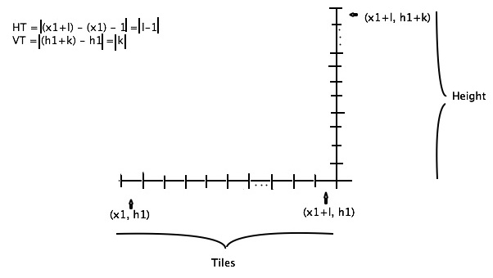

To find the better path between T1 and T2, we have to make the least number of “huge” steps; in other words, we have to keep a “constant” progression of heights. The most reasonable choice for the change in heights would be . Considering that VT and HT are integers, we should use a special case of the Euclidean division to figure out the best step, where the quotient must be the lowest value and the divisor **MUST NOT** be greater than HT. We will have ().

Suppose T1 height is 3, T2 height is 29 and HT is 5. From that, we have VT equals 26 and . This result means that the best path consists of going up 4 times a difference of 6 in height, and going up 1 time a difference of 2. To make this possible we need some values:

Giving us the following equation for the heuristic (h):

Those equations are only related to the number of steps necessary to get to the same height of the end tile, they do not include extra steps “walking” in the same height neither include end heights being lower than initial height. We need also take in consideration the following variables:

That said, our final heuristic equation would be:

;

**2nd Heuristics – Division**