# 2-Design

## 2.1-High Level Overview

These flowcharts describe the general overview of how my website will work

### Main Menu

### Login

### Staff Main Menu Actions

### Non-Staff Main Menu Actions

## Logout

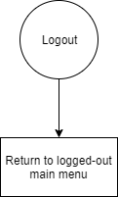

### All Music

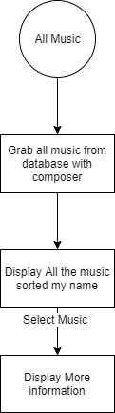

### All Composers

### All Borrowed

### All Reserved

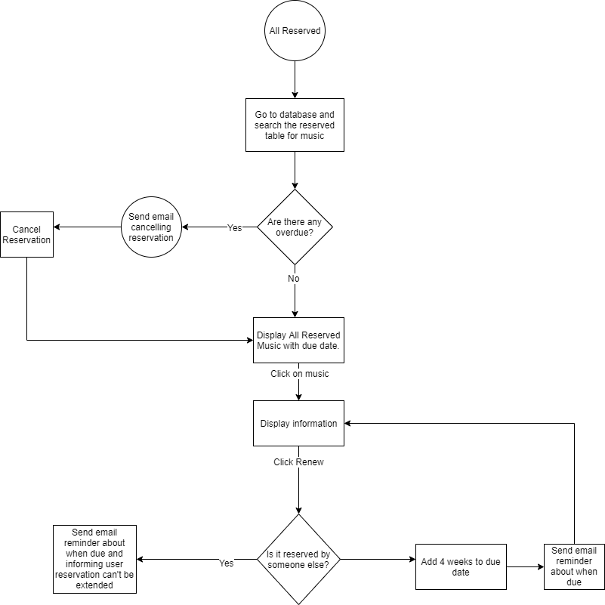

### My Borrowed

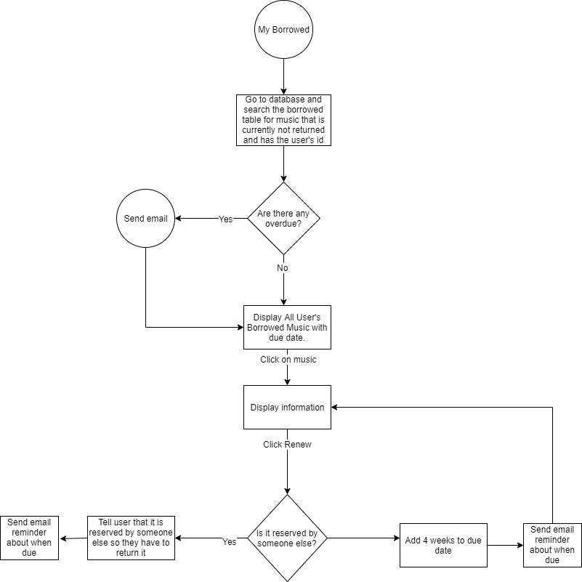

My Reserved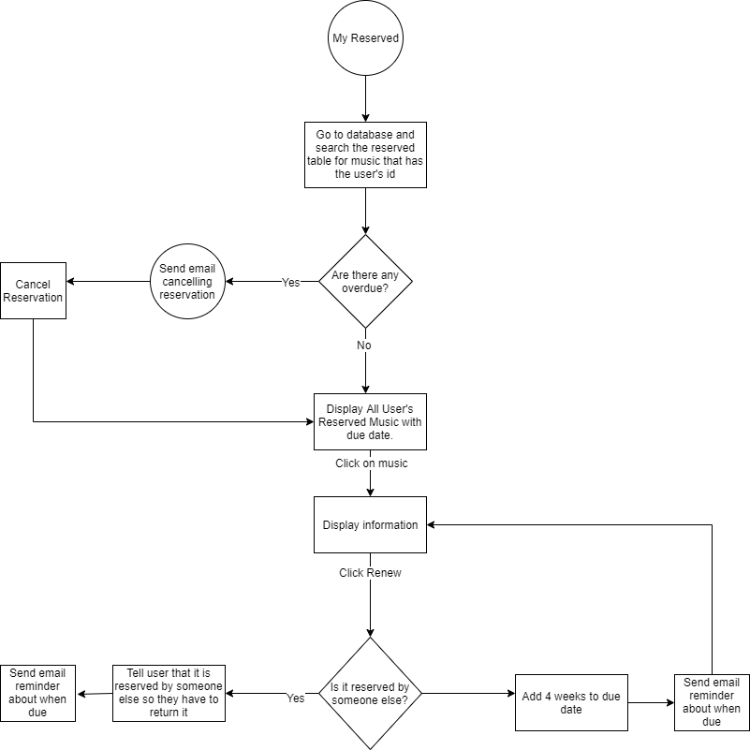

### Borrow

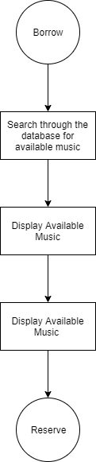

### Reserve

### Overview of Chatbot

### Training

### Chat

## 2.2-Data Dictionary

I will be storing data such as user details, bookings, reservations, composers, music, music instances and past bookings in an SQLite3 database as this data needs to be stored long-term

User table:

|  |  |  |  |  |  |
| --- | --- | --- | --- | --- | --- |
| Field name | Field Type | Field size | Purpose | Example data | Validation |
| id | Integer | Infinite | Giving each user a unique key | 01 | Auto-increment |
| password | varchar | 128 | Holding the hashed password | fafaffarrea | Password Management |
| last_login | Datetime | 8 bytes | Holding the last_login time of the user | YYYY-MM-DD HH:MM:SS | Datetime checker |
| is_superuser | Bool | 1 | Checking whether they are the admin | True | Null |
| username | varchar | 150 | Holding the username of the user | Abilkus | Not empty between 3 and 15 characters |
| first_name | Varchar | 30 | Holding the first name of the user | Adam | Not empty between 2 and 30 characters |
| email | Varchar | 254 | Holding email address of user | [adam@Bilkus.com](mailto:adam@Bilkus.com) | N/A |
| is_staff | Bool | 1 | Tells you whether they can access parts of the admin page | True/False | n/a |
| is_active | Bool | 1 | Tells you whether a user is active | True/False | n/a |
| date_joined | Datetime | 8 | Date user joined | YYYY-MM-DD HH:MM:SS | Date |
| last_name | Varchar | 150 | Last name of user | Bilkus | Between 2 and 150 characters |

### Composers

|  |  |  |  |  |  |
| --- | --- | --- | --- | --- | --- |
| Field name | Field Type | Field size | Purpose | Example data | Validation |
| id | integer |  | Unique id for each composer | 01 | Is integer |
| first_name | varchar | 100 | First name of the composer |  |  |
| last_name | varchar | 100 | Last name of composer |  |  |
| date_of_birth | date |  | Date of birth of user |  |  |
| date_of_death | date |  | Date of death of the user |  |  |

### Genre

|  |  |  |  |  |  |
| --- | --- | --- | --- | --- | --- |
| Field name | Field Type | Field size | Purpose | Example data | Validation |
| id | integer |  | Unique id to each genre | 01 | Is numerical |
| name | varchar | 200 | Name of each genre | film | Minimum 1 letter |

### Language

|  |  |  |  |  |  |
| --- | --- | --- | --- | --- | --- |
| Field name | Field Type | Field size | Purpose | Example data | Validation |
| id | integer |  | Unique id to each language | 01 | Is numerical |
| name | varchar | 200 | Name of each language | French | Minimum 1 letter or not applicable |

### Music

|  |  |  |  |  |  |
| --- | --- | --- | --- | --- | --- |
| Field name | Field Type | Field size | Purpose | Example data | Validation |
| id | integer |  | Unique id to each set of music | 01 | Is numerical |
| title | varchar | 200 | Title of each set of music | Watermelon man | Minimum 1 letter |
| Summary | Text |  | Lets you give a short summary of the song |  |  |
| Composer_id | Integer |  | Foreign Key to link to composer table | 01 | Numerical |
| Language_id | Integer |  | Foreign key to link to language table | 01 | Numerical |
| Genre_id | Integer |  | Foreign key to link to genre table | 01 | Numerical |

### musicinstance

|  |  |  |  |  |  |
| --- | --- | --- | --- | --- | --- |
| Field name | Field Type | Field size | Purpose | Example data | Validation |
| id | char |  | Unique id to each music instance (UUID) |  | Is numerical |
| due_back | Date |  | Due back date | YYYY-MM-DD | Correct Date Format |
| status | varchar | 1 | Stores whether it is reserved/on loan/out for maintenance/available | R | Checks it is only 1 of 4 characters |
| Booking_id | integer |  | Foreign Key to Reservation/Booking Table |  |  |
| music_id | Integer |  | Foreign Key to Music Table | 01 |  |

### Borrowed

|  |  |  |  |  |  |
| --- | --- | --- | --- | --- | --- |
| Field name | Field Type | Field size | Purpose | Example data | Validation |
| id | char |  | Unique id to each music instance (UUID) | 01 | Is numerical |
| Borrowed id | Char | 16 | It’s the reservation id that is emailed | aaaaaaaaaaaaaaaa | Definitely 16 characters |
| takenoutdate | Date | 1 | Gives you the date it was originally reserved/taken out | R |  |
| Musicinstance_id | integer |  | Foreign Key to music instance table | 01 |  |
| borrower_id | Integer |  | Foreign Key to user table | 01 |  |
| Collected | Bool | 1 | Checks that the reservation was picked up | T |  |
| Returned | Bool | 1 | Checks that it has been returned |  |  |

## Database Entity Relationship Diagram

This image shows my original idea for my database

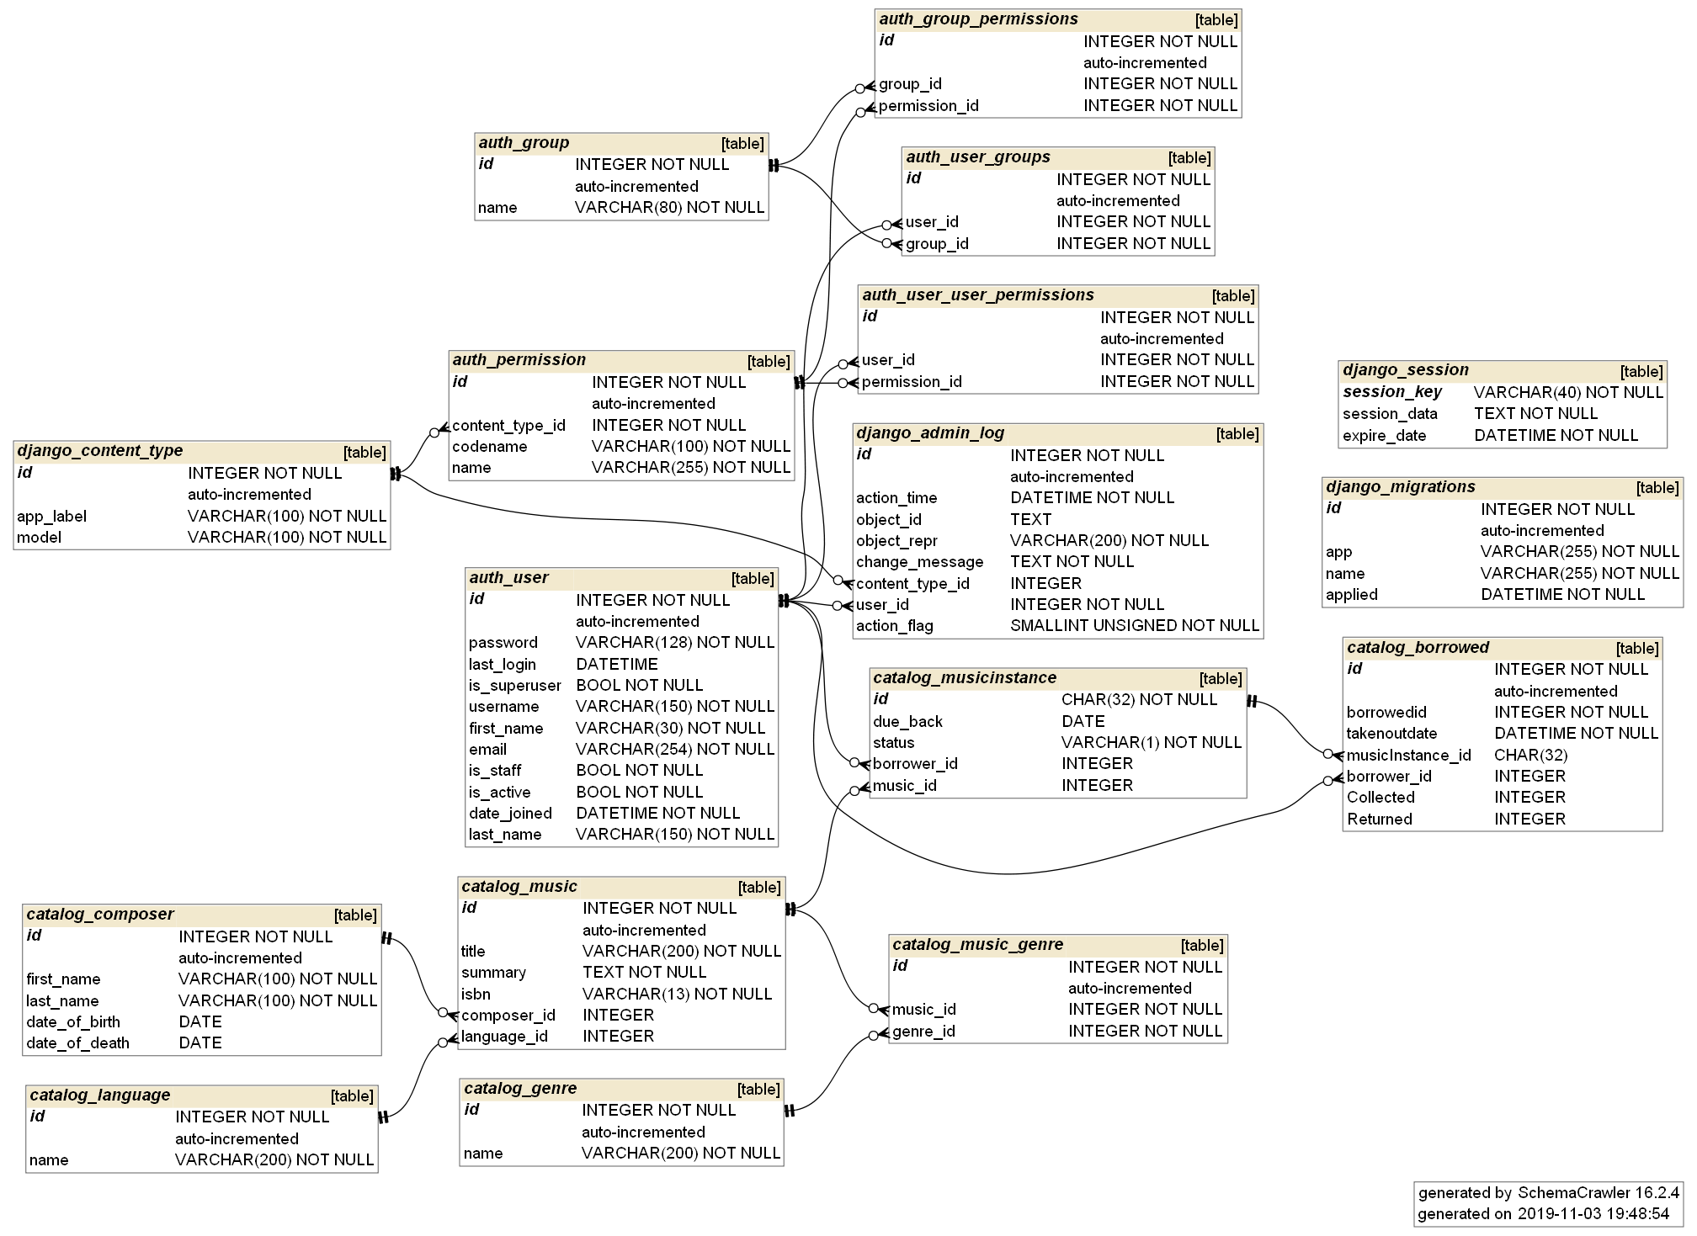

## SQLite3

This is the SQLite that creates my tables in their original form

## Auth_Group

CREATE TABLE "auth_group" (

"id" integer NOT NULL PRIMARY KEY AUTOINCREMENT,

"name" varchar(80) NOT NULL UNIQUE

);

## auth_group_permissions

CREATE TABLE "auth_group_permissions" (

"id" integer NOT NULL PRIMARY KEY AUTOINCREMENT,

"group_id" integer NOT NULL,

"permission_id" integer NOT NULL,

FOREIGN KEY("group_id") REFERENCES "auth_group"("id") DEFERRABLE INITIALLY DEFERRED,

FOREIGN KEY("permission_id") REFERENCES "auth_permission"("id") DEFERRABLE INITIALLY DEFERRED

);

## auth_permissions

CREATE TABLE "auth_permission" (

"id" integer NOT NULL PRIMARY KEY AUTOINCREMENT,

"content_type_id" integer NOT NULL,

"codename" varchar(100) NOT NULL,

"name" varchar(255) NOT NULL,

FOREIGN KEY("content_type_id") REFERENCES "django_content_type"("id") DEFERRABLE INITIALLY DEFERRED

);

## auth_user

CREATE TABLE "auth_user" (

"id" integer NOT NULL PRIMARY KEY AUTOINCREMENT,

"password" varchar(128) NOT NULL,

"last_login" datetime,

"is_superuser" bool NOT NULL,

"username" varchar(150) NOT NULL UNIQUE,

"first_name" varchar(30) NOT NULL,

"email" varchar(254) NOT NULL,

"is_staff" bool NOT NULL,

"is_active" bool NOT NULL,

"date_joined" datetime NOT NULL,

"last_name" varchar(150) NOT NULL

);

## auth_user_groups

CREATE TABLE "auth_user_groups" (

"id" integer NOT NULL PRIMARY KEY AUTOINCREMENT,

"user_id" integer NOT NULL,

"group_id" integer NOT NULL,

FOREIGN KEY("group_id") REFERENCES "auth_group"("id") DEFERRABLE INITIALLY DEFERRED,

FOREIGN KEY("user_id") REFERENCES "auth_user"("id") DEFERRABLE INITIALLY DEFERRED

);

## auth_user_user_permissions

CREATE TABLE "auth_user_user_permissions" (

"id" integer NOT NULL PRIMARY KEY AUTOINCREMENT,

"user_id" integer NOT NULL,

"permission_id" integer NOT NULL,

FOREIGN KEY("permission_id") REFERENCES "auth_permission"("id") DEFERRABLE INITIALLY DEFERRED,

FOREIGN KEY("user_id") REFERENCES "auth_user"("id") DEFERRABLE INITIALLY DEFERRED

);

## catalog_borrowed

CREATE TABLE "catalog_borrowed" (

"id" integer NOT NULL PRIMARY KEY AUTOINCREMENT,

"borrowedid" INTEGER NOT NULL,

"takenoutdate" datetime NOT NULL,

"musicInstance_id" char(32),

"borrower_id" INTEGER,

"Collected" INTEGER DEFAULT 0,

"Returned" INTEGER DEFAULT 0,

FOREIGN KEY("borrower_id") REFERENCES "auth_user"("id") DEFERRABLE INITIALLY DEFERRED,

FOREIGN KEY("musicInstance_id") REFERENCES "catalog_musicinstance"("id") DEFERRABLE INITIALLY DEFERRED

);

## catalog_composer

CREATE TABLE "catalog_composer" (

"id" integer NOT NULL PRIMARY KEY AUTOINCREMENT,

"first_name" varchar(100) NOT NULL,

"last_name" varchar(100) NOT NULL,

"date_of_birth" date,

"date_of_death" date

);

## catalog_genre

CREATE TABLE "catalog_genre" (

"id" integer NOT NULL PRIMARY KEY AUTOINCREMENT,

"name" varchar(200) NOT NULL

);

## catalog_language

CREATE TABLE "catalog_genre" (

"id" integer NOT NULL PRIMARY KEY AUTOINCREMENT,

"name" varchar(200) NOT NULL

);

## catalog_music

CREATE TABLE "catalog_music" (

"id" integer NOT NULL PRIMARY KEY AUTOINCREMENT,

"title" varchar(200) NOT NULL,

"summary" text NOT NULL,

"isbn" varchar(13) NOT NULL,

"composer_id" integer,

"language_id" integer,

FOREIGN KEY("composer_id") REFERENCES "catalog_composer"("id") DEFERRABLE INITIALLY DEFERRED,

FOREIGN KEY("language_id") REFERENCES "catalog_language"("id") DEFERRABLE INITIALLY DEFERRED

);

## catalog_music_genre

CREATE TABLE "catalog_music_genre" (

"id" integer NOT NULL PRIMARY KEY AUTOINCREMENT,

"music_id" integer NOT NULL,

"genre_id" integer NOT NULL,

FOREIGN KEY("music_id") REFERENCES "catalog_music"("id") DEFERRABLE INITIALLY DEFERRED,

FOREIGN KEY("genre_id") REFERENCES "catalog_genre"("id") DEFERRABLE INITIALLY DEFERRED

);

## catalog_musicinstance

CREATE TABLE "catalog_musicinstance" (

"id" char(32) NOT NULL,

"due_back" date,

"status" varchar(1) NOT NULL,

"borrower_id" integer,

"music_id" integer,

PRIMARY KEY("id"),

FOREIGN KEY("borrower_id") REFERENCES "auth_user"("id") DEFERRABLE INITIALLY DEFERRED,

FOREIGN KEY("music_id") REFERENCES "catalog_music"("id") DEFERRABLE INITIALLY DEFERRED

);

## django_admin_log

CREATE TABLE "django_admin_log" (

"id" integer NOT NULL PRIMARY KEY AUTOINCREMENT,

"action_time" datetime NOT NULL,

"object_id" text,

"object_repr" varchar(200) NOT NULL,

"change_message" text NOT NULL,

"content_type_id" integer,

"user_id" integer NOT NULL,

"action_flag" smallint unsigned NOT NULL,

FOREIGN KEY("content_type_id") REFERENCES "django_content_type"("id") DEFERRABLE INITIALLY DEFERRED,

FOREIGN KEY("user_id") REFERENCES "auth_user"("id") DEFERRABLE INITIALLY DEFERRED

);

## django_content_type

CREATE TABLE "django_content_type" (

"id" integer NOT NULL PRIMARY KEY AUTOINCREMENT,

"app_label" varchar(100) NOT NULL,

"model" varchar(100) NOT NULL

);

## django_migrations

CREATE TABLE "django_migrations" (

"id" integer NOT NULL PRIMARY KEY AUTOINCREMENT,

"app" varchar(255) NOT NULL,

"name" varchar(255) NOT NULL,

"applied" datetime NOT NULL

);

## django_session

CREATE TABLE "django_session" (

"session_key" varchar(40) NOT NULL,

"session_data" text NOT NULL,

"expire_date" datetime NOT NULL,

PRIMARY KEY("session_key")

);

## sqlite_sequence

CREATE TABLE "sqlite_sequence" (

"name" TEXT,

"seq" TEXT

);

## Planned SQLite Queries

With Django I create queries and it will translate them into sqlite queries.

I only have a few queries and they mostly look like this:

*def get_queryset(self):*

*return MusicInstance.objects.filter(borrower=self.request.user).filter(status__exact='o').order_by('due_back')*

*This grabs the musicinstances, filters by user, filters by onloan and then orders by when they are due back.*

All of them just change whether the borrower is the user or all and the status.

# Class Diagrams

## Admin

## Forms

## A screenshot of a computer screen Description automatically generatedModels

# Main Algorithms

## Training()

This takes the information from the json file and shortens the questions down to the main words. It then will learn these questions and link them to the tag. It then links the tags with the answers. It will then save all of this information into 2 files. 1 pickle (serialized file) and 1 tflearn file for the neural network to use. This part at the moment will take seconds but as you add more questions and answers will take longer. This also can’t learn new questions and answers by itself it will have to email me to receive an appropriate answer.

Here is the code:

*words = []*

*labels = []*

*docs_x = []*

*docs_y = []*

*for intent in data["intents"]:*

*for pattern in intent["patterns"]:*

*wrds = nltk.word_tokenize(pattern)*

*words.extend(wrds)*

*docs_x.append(wrds)*

*docs_y.append(intent["tag"])*

*if intent["tag"] not in labels:*

*labels.append(intent["tag"])*

*words = [stemmer.stem(w.lower()) for w in words if w != "?"]*

*words = sorted(list(set(words)))*

*labels = sorted(labels)*

*training = []*

*output = []*

*out_empty = [0 for _ in range(len(labels))]*

*for x, doc in enumerate(docs_x):*

*bag = []*

*wrds = [stemmer.stem(w.lower()) for w in doc]*

*for w in words:*

*if w in wrds:*

*bag.append(1)*

*else:*

*bag.append(0)*

*output_row = out_empty[:]*

*output_row[labels.index(docs_y[x])] = 1*

*training.append(bag)*

*output.append(output_row)*

*training = numpy.array(training)*

*output = numpy.array(output)*

*with open("data.pickle", "wb") as f:*

*pickle.dump((words, labels, training, output), f)*

## Chat()

This takes the model and uses it to chat with the user. It checks the questions and checks if it knows any similar questions above 90% accuracy. If it knows the question then it will respond with a random answer from the tag. If not it will tell the user that it doesn’t understand the question and then will send me (the admin) the question to add to the json file.

Here is the code:

*ef bag_of_words(s, words):*

*bag = [0 for _ in range(len(words))]*

*s_words = nltk.word_tokenize(s)*

*s_words = [stemmer.stem(word.lower()) for word in s_words]*

*for se in s_words:*

*for i, w in enumerate(words):*

*if w == se:*

*bag[i] = 1*

*return numpy.array(bag)*

*def chat():*

*print("Start talking with the bot (type quit to stop)!")*

*while True:*

*inp = input("You: ")*

*if inp.lower() == "quit":*

*break*

*results = model.predict([bag_of_words(inp, words)])*

*results_index = numpy.argmax(results)*

*tag = labels[results_index]*

*for tg in data["intents"]:*

*if tg['tag'] == tag:*

*responses = tg['responses']*

*print(random.choice(responses))*

## Suggestions()

# Data Structures

I only have 1 main type of data structure. For the chatbot I am using dictionaries as it makes it easier for the neural network to learn what questions are linked to what answers to make it easier to output answers.

Here it is:

*{"intents": [*

*{"tag": "greeting",*

*"patterns": ["Hi", "Is anyone there?", "Hello", "Good day", "Whats up"],*

*"responses": ["Hello!", "Good to see you again!", "Hi there, how can I help?"],*

*"context_set": ""*

*},*

*{"tag": "goodbye",*

*"patterns": ["cya", "See you later", "Goodbye", "I am Leaving", "Have a Good day"],*

*"responses": ["Sad to see you go :(", "Talk to you later", "Goodbye!"],*

*"context_set": ""*

*},*

*{"tag": "age",*

*"patterns": ["how old", "how old is tim", "what is your age", "how old are you", "age?"],*

*"responses": ["I am 18 years old!", "18 years young!"],*

*"context_set": ""*

*},*

*{"tag": "name",*

*"patterns": ["what is your name", "what should I call you", "whats your name?"],*

*"responses": ["You can call me Postel.", "I'm Jon Postel but you can call me Postel!", "I'm Postel aka The "God" of the Internet."],*

*"context_set": ""*

*},*

*{"tag": "work",*

*"patterns": ["How does it work", "How do you work", "What can I do?"],*

*"responses": ["I have a set of preprogrammed questions that I have learnt! If I don't know an answer I ask my creator.", "You can just ask me questions."],*

*"context_set": ""*

*},*

*{"tag": "robot",*

*"patterns": ["are you a bot", "are you a chatbot", "are you real"],*

*"responses": ["I am a chatbot hear to help you. I can answer some questions and if I don't know it I will email the admin and they will get back to you with a response"],*

*"context_set": ""*

*},*

*{"tag": "emotions",*

*"patterns": ["how's yur day been", "how are you", "how you doing", "whats up"],*

*"responses": ["I'm good", "I'm freezing start playing some games with me. ;}", "Sad as noone plays games with me :(", "Happy to see a new face. :)"],*

*"context_set":""*

*}*

*]*

*}*

This is just a general AI at the moment but once I have spoken to my client I will update it to make it more specific to the system.

# Planned Security Measures

Client-side, the information stored on the user’s side is just their username and password and only if they want it to. Cookies are unavoidable. The web browser used will store the information in a secure way.

Server side, I will be using Django security which hashes password before putting them in the database. Django also stops SQL injection by taking whatever the user enters and turning it into a query of its own.