Exfoliation

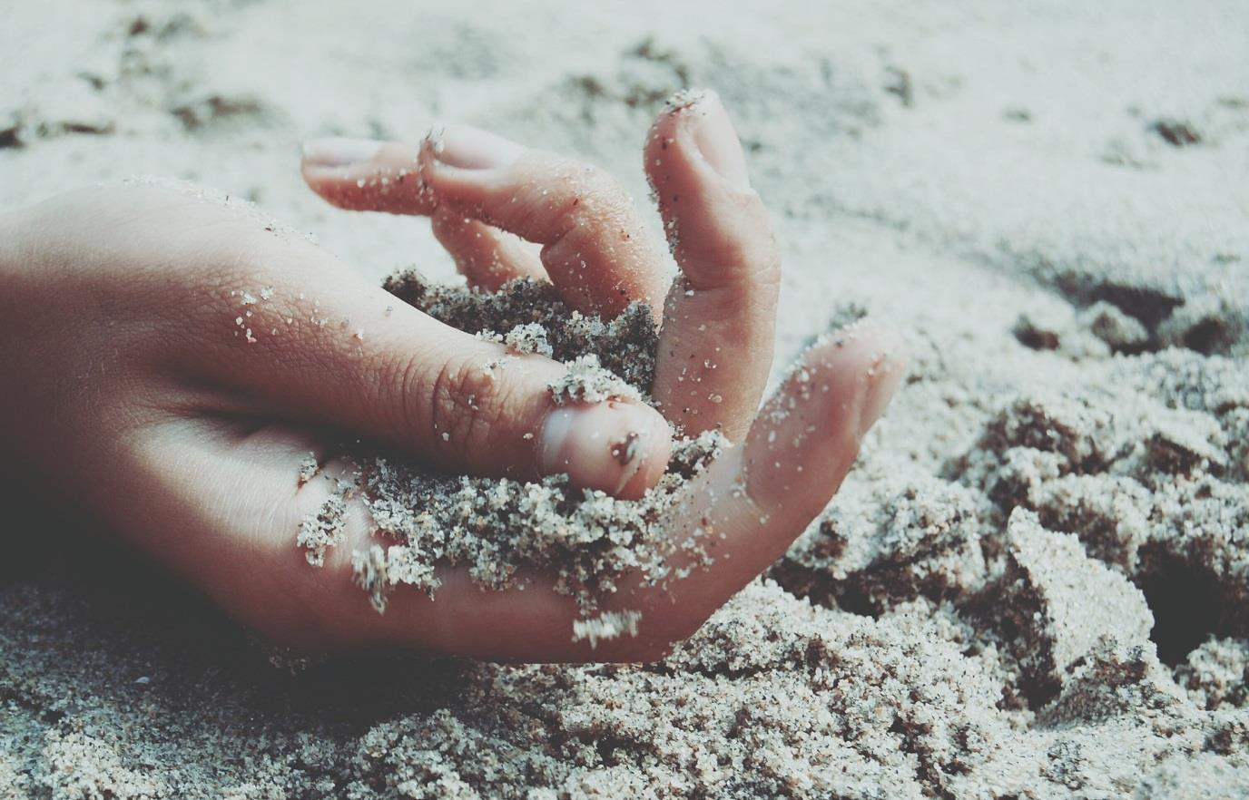

Introduction  
•  
•  
•  
•  
•  
© Lab Muffin 2021 2

Skincare Foundations  
© Lab Muffin 2021 3

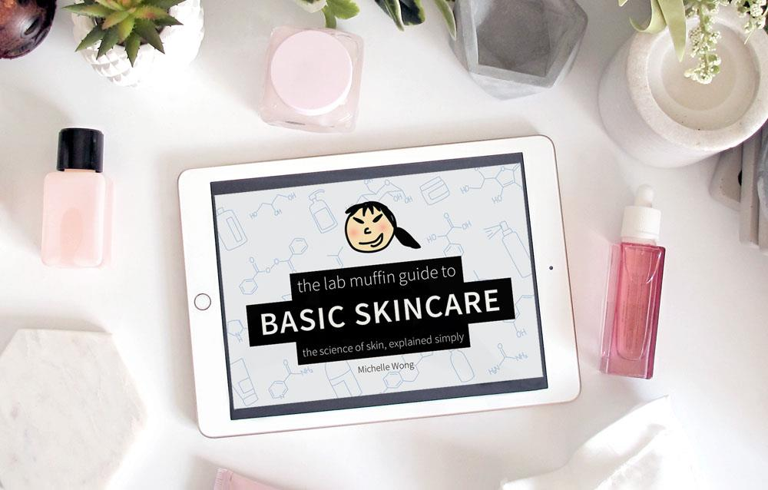

Why Do I Need to Exfoliate?  
© Lab Muffin 2021 4

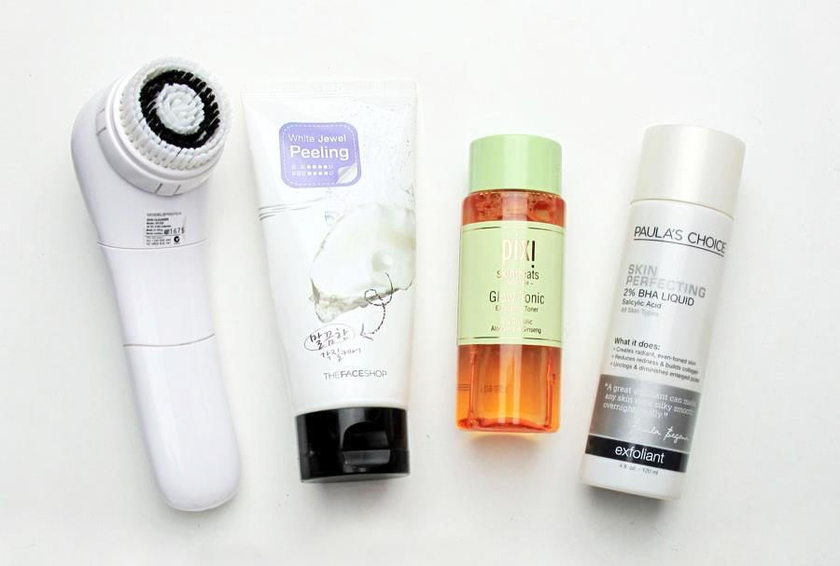

Physical Exfoliation  
✓ ✗  
✓  
✗  
✓  
✗  
© Lab Muffin 2021 5

Types of Physical Exfoliation  
© Lab Muffin 2021 6

© Lab Muffin 2021 7

© Lab Muffin 2021 8

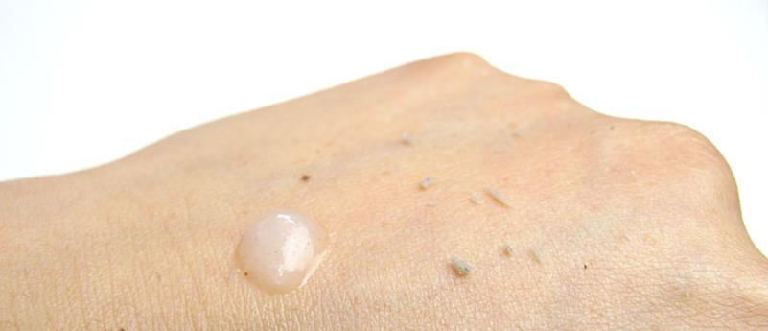

© Lab Muffin 2021 9

© Lab Muffin 2021 10

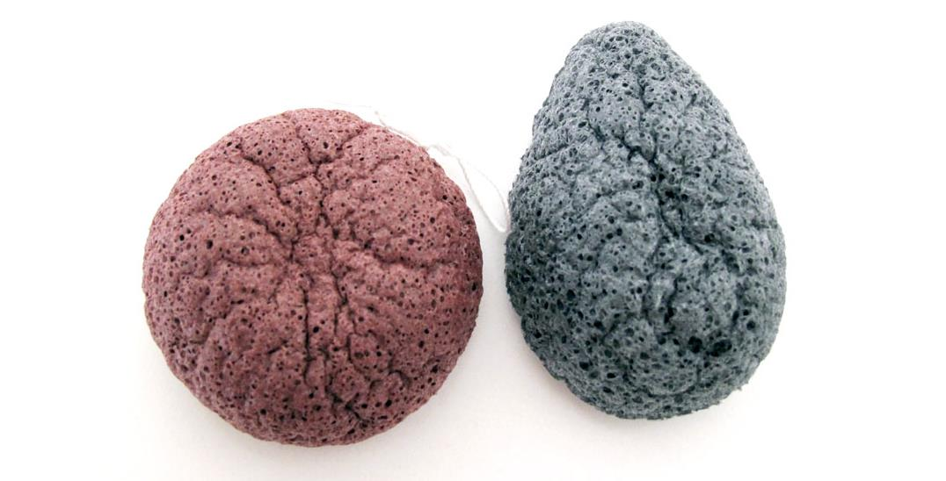

Physical Exfoliant Comparison  
© Lab Muffin 2021 11

Chemical Exfoliation  
✓ ✗  
✗  
✓  
✓ ✗  
✗  
© Lab Muffin 2021 12

© Lab Muffin 2021 13

•  
•  
•  
© Lab Muffin 2021 14

© Lab Muffin 2021 15

© Lab Muffin 2021 16

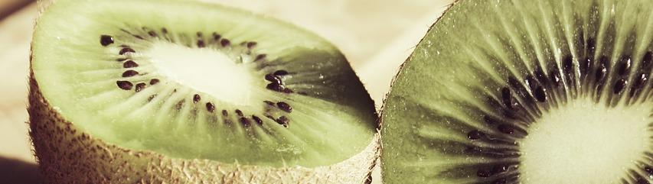

Recommendations  
•  
•  
•  
•  
•  
© Lab Muffin 2021 17

© Lab Muffin 2021 18

© Lab Muffin 2021 19

Further Reading  
• •  
• •  
•  
•  
•  
•  
•  
•  
• •  
© Lab Muffin 2021 20

© Lab Muffin 2021 21



Thank You for Reading!  
© Lab Muffin 2021 22

