**Google Document AI**

Method of operation of Google Document AI

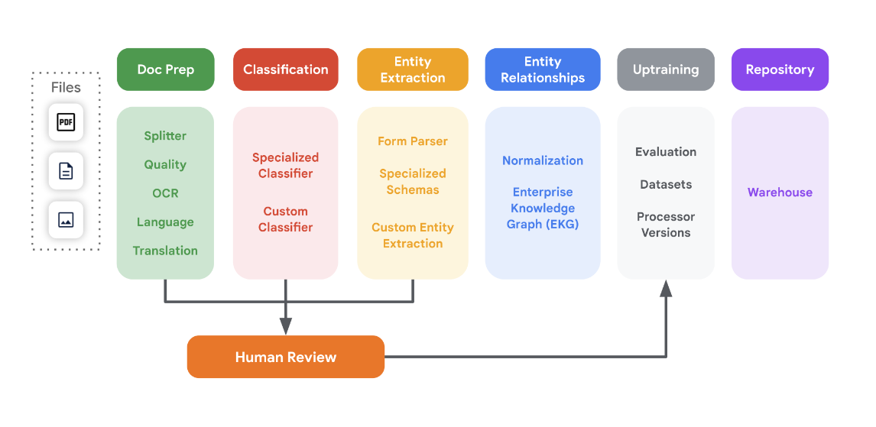

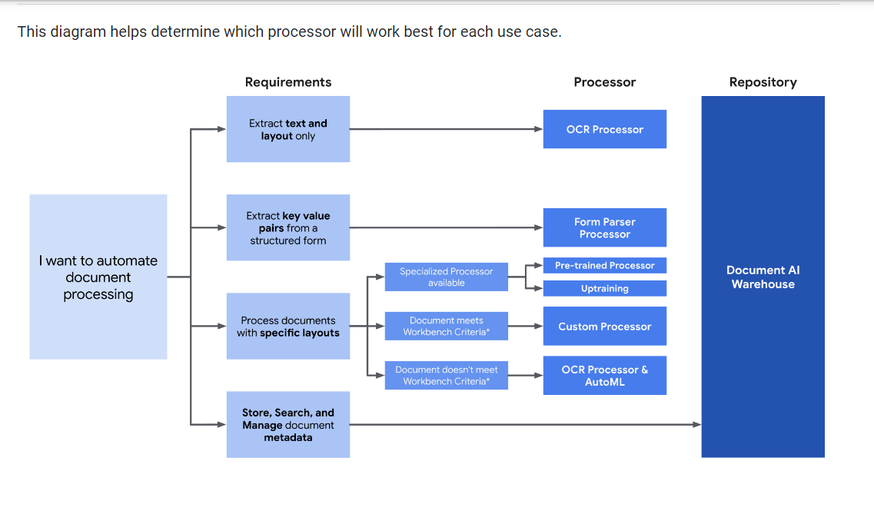

Demo Document Recognition using Google Document AI:

Key value pairs are detected accurately and extracted from PDF. AI modules detect key values from text and identify various data types including Phone number. No training was given to this particular data set.

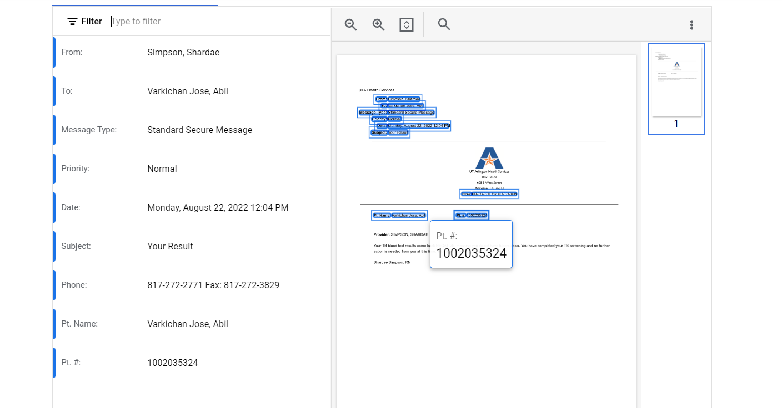

Sample existing schema for Driving License Extraction.

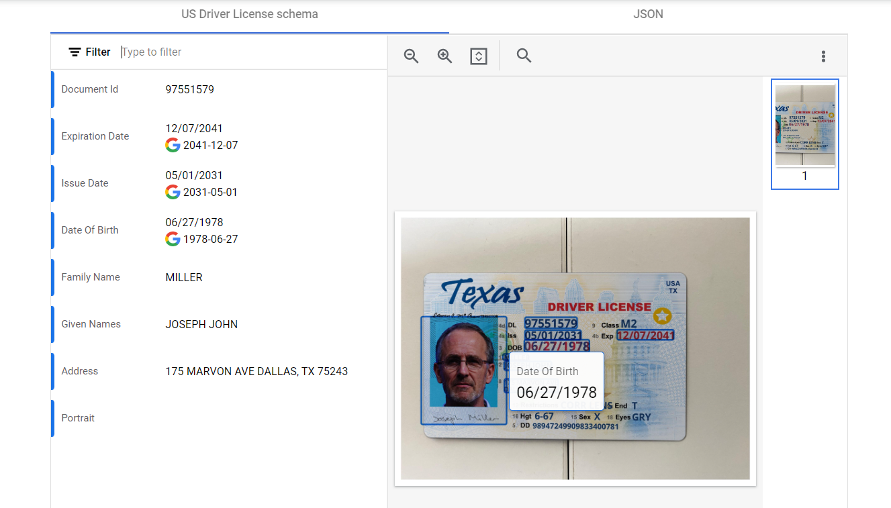

**AWS Textract**

AWS Textract needs test samples to extract key value pairs. It also shows bounding boxes and does basic OCR recognition only,

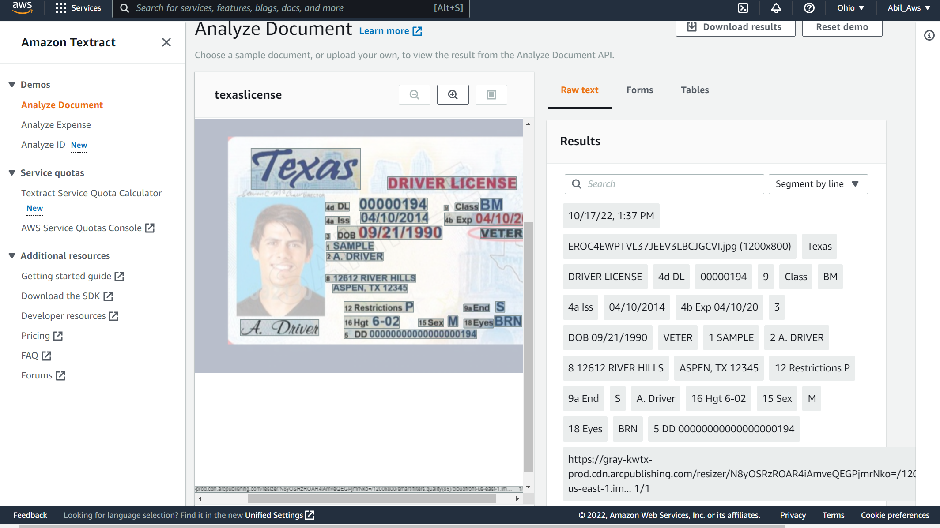

But AWS has the analyze ID document specific section, but it is too overfitting to detect licenses specified outside of the training data. For example, in the case tried below, the model recognizes license number to be the postal code which might be due to the positional change of the trained data with the supplied data. Such inaccuracies make the Textract model least dependable on high accuracy application needs.

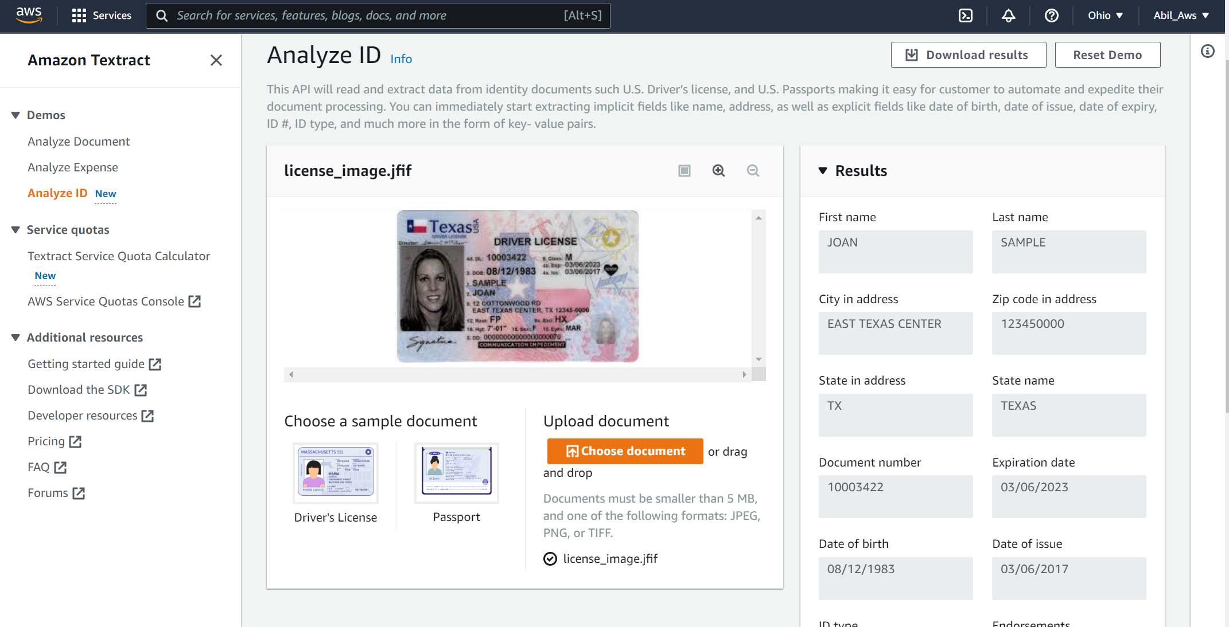

**Azure Form Recognizer**

Form Recognizer basically needed some training on image recognition. It detected text with pairs on Electronic PDFs. But, was only efficient in detecting text as bounding box in image PDFs. It required some extensive training to generate key value pairs for this specific example.

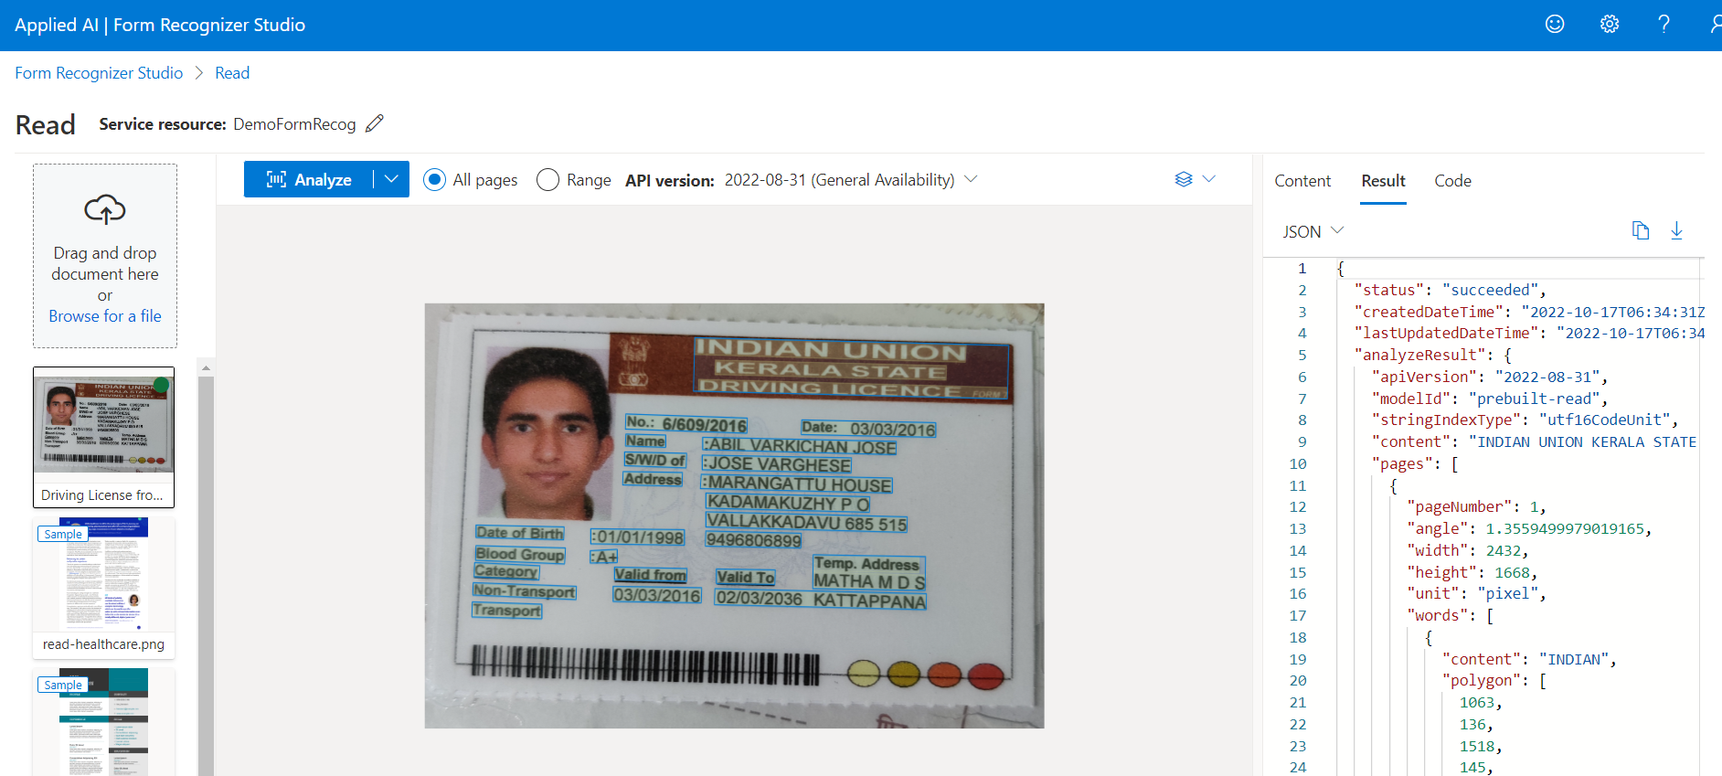

The pricing comparison reveals that for multiple general purposes, it is similarly priced, but varies based on conditional requirements. Of all google charges less for specific existing models compared to AWS and Azure

For a general document

Google Document AI pricing plan varies as per requirement, for our basic use case of id card extraction below cost model follows.

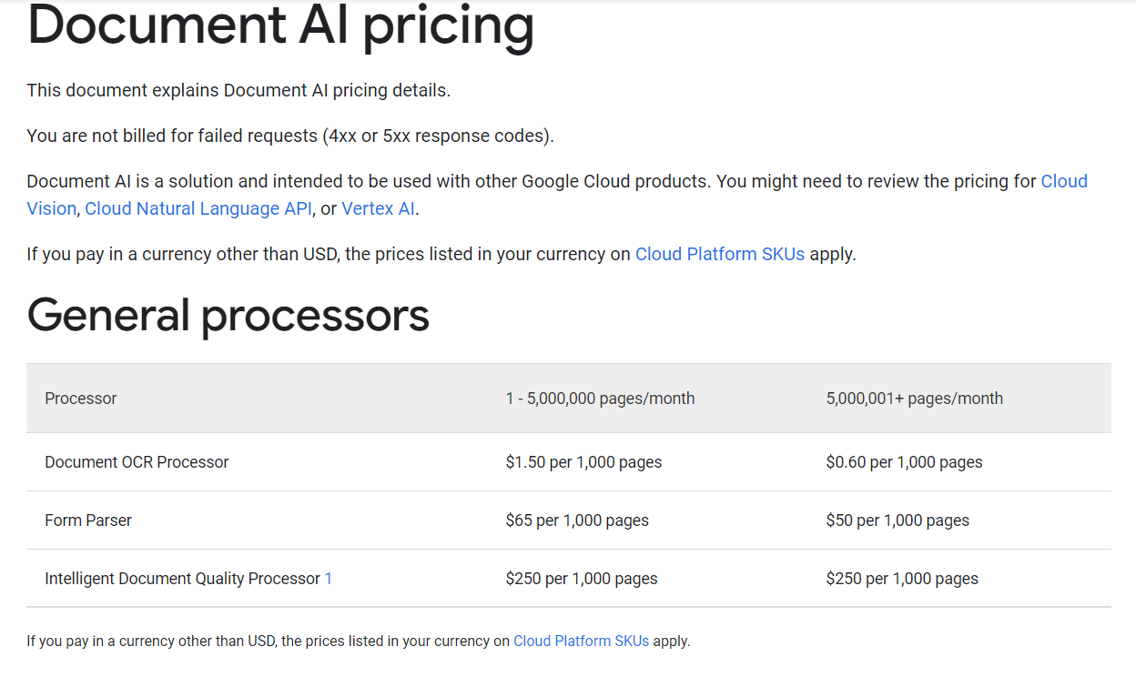

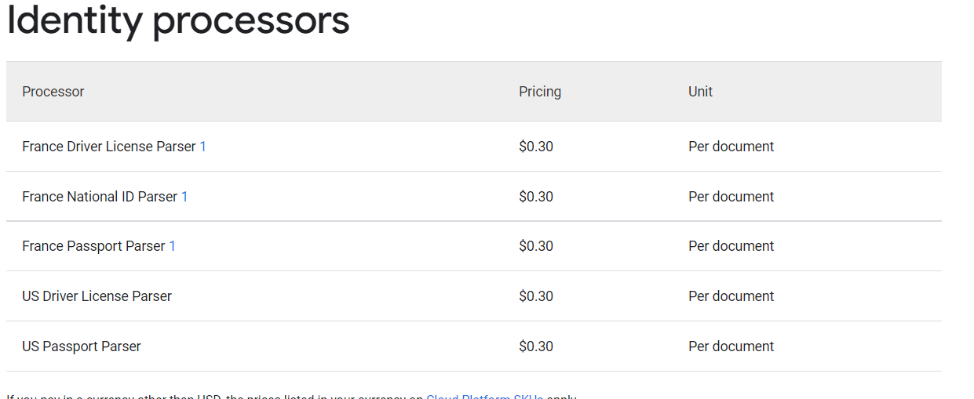

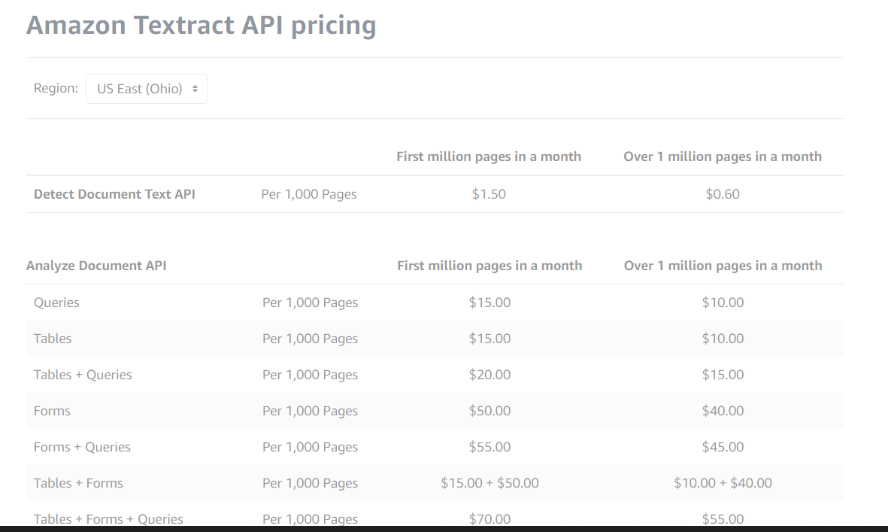

**Form Recognizer API Pricing**

