1.Average of 3 floating point numbers
#include <iostream>
using namespace std;
int main() {
float a,b,c;
float avg;
cout << "the three numbers";
cin>>a>>b>>c;
avg=(a+b+c)/3;
cout<<"the avg";
cout<<avg;

return 0;
}

Output:
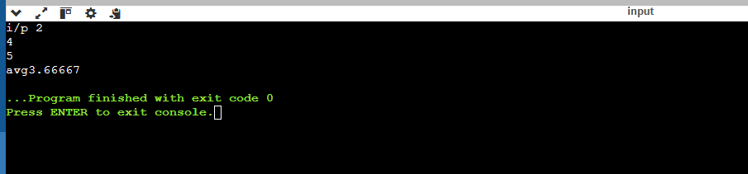
2.Area of a rectangle
#include <iostream>
using namespace std;
int main() {
int l,w;
int area;
cout << "l and w";
cin>>l>>w;
area =l*w;
cout<<"area of triangle ";
cout<<area ;

return 0;
}
Output:
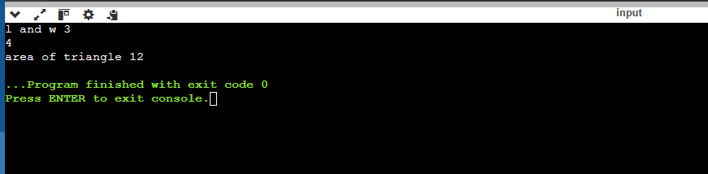
3.convert temperature in Celsius to Fahrenheit
#include <iostream>
using namespace std;
int main() {
float c,f;

cout << "temp in celsius";
cin>>c;
f=c*(1.8+32);
cout<<"fahrenheit:";
cout<<f;

return 0;
}

Output
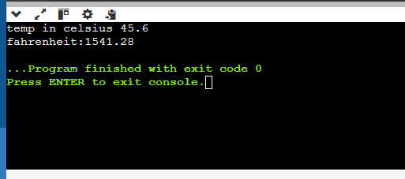
4.swapping two numers
#include <iostream>
using namespace std;
int main() {
int n1,n2,t;

cout << "n1 & n2:";
cin>>n1>>n2;
t=n1;
n1=n2;
n2=t;
cout<<"after swap\t";

cout<<n1<<"\t"<<n2;

return 0;
}
Output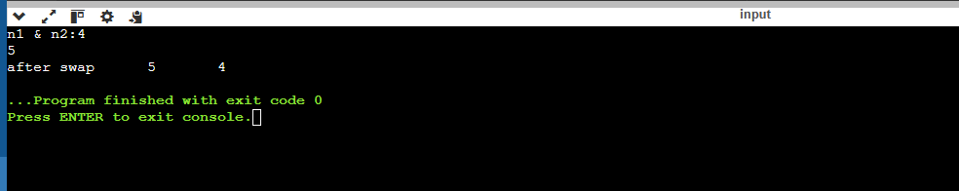
5. Greatest of three numbers
#include <iostream>
using namespace std;
int main() {
int m,n,o;
cout << "three numbers ";
cin>>m>>n>>o;
if(m>=n && m>=o)
{ cout<<"large number"<<m;
}
else if(n>=m && n>=o)
{ cout<<"large no"<<n;
}
else{cout<<"large no"<<o;}
return 0;
}
Output
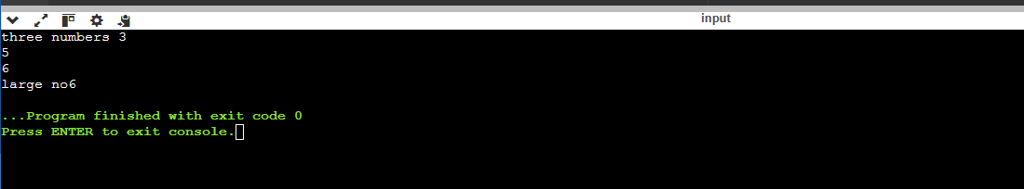
6.given number is +ve or -ve or 0
#include <iostream>
using namespace std;
int main() {
int m;
cout << "n";
cin>>m;
if(m>0)
{ cout<<"positive"<<m;
}
else if(m<0)
{ cout<<"negative"<<m;
}
else{cout<<"zero"<<m;
return 0;
}
}
Output
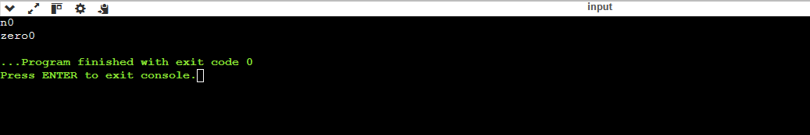

7.simple interest
#include <iostream>
using namespace std;
int main() {
int p,r,t,s;
cout << "p,r,t";
cin>>p>>r>>t;
s=(p*r*t)/100;
cout<<"si"<<s;
return 0;

}
output
