Simulation
Desciption of Procedure
1. Run motor from 0 to full speed and graph in order to find K and sigma (1.3804 and 11) and then plug into the transfer function in Simulink. (Code and graph)
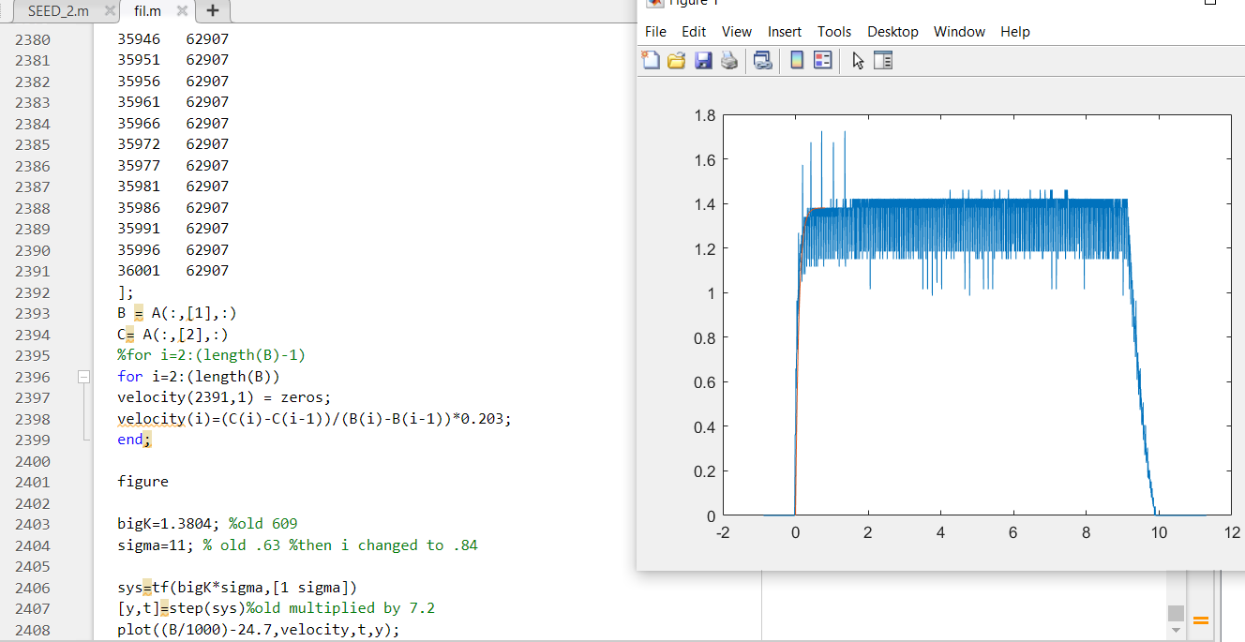
2. Use PI controller tune function in order to get Kp and Ki (4.1146 and .37071)
3. Using the pseudocode from the PID controller lecture handout program to get feedback loop.(Code is in the final project Arduino program)
4. Graph actual vs simulated(Code and graphs below)
%variables
bigK=1.3804;
sigma=11;
%get simulink
open_system('miniProject')
% run the simulation
out=sim('miniProject');
%plot the physical experiment
a=[2 0
7 2
12 7
16 14
21 24
26 33
31 43
35 56
40 70
46 86
51 102
56 120
61 139
66 158
71 178
75 200
80 222
86 245
91 269
96 293
101 317
106 343
111 369
116 395
121 422
126 449
132 477
137 505
142 533
147 562
152 592
157 621
162 651
167 680
173 710
178 740
183 770
188 801
193 832
198 862
203 893
208 924
214 955
219 987
224 1018
229 1050
234 1082
239 1114
244 1146
249 1179
254 1211
260 1244
265 1276
270 1309
276 1341
281 1374
286 1406
291 1439
296 1472
302 1505
307 1537
312 1570
317 1603
322 1636
]
c = a(:,[1],:)
b= a(:,[2],:)
for i=2:(length(b))
vel(7,1) = zeros;
vel(i)=(c(i)-c(i-1))/(b(i)-b(i-1))*0.203;
end;
%plot(B,abs(C));
%plot(B,velocity);
figure
plot((b/20),30*vel);
a =
2 0
7 2
12 7
16 14
21 24
26 33
31 43
35 56
40 70
46 86
51 102
56 120
61 139
66 158
71 178
75 200
80 222
86 245
91 269
96 293
101 317
106 343
111 369
116 395
121 422
126 449
132 477
137 505
142 533
147 562
152 592
157 621
162 651
167 680
173 710
178 740
183 770
188 801
193 832
198 862
203 893
208 924
214 955
219 987
224 1018
229 1050
234 1082
239 1114
244 1146
249 1179
254 1211
260 1244
265 1276
270 1309
276 1341
281 1374
286 1406
291 1439
296 1472
302 1505
307 1537
312 1570
317 1603
322 1636
c =
2
7
12
16
21
26
31
35
40
46
51
56
61
66
71
75
80
86
91
96
101
106
111
116
121
126
132
137
142
147
152
157
162
167
173
178
183
188
193
198
203
208
214
219
224
229
234
239
244
249
254
260
265
270
276
281
286
291
296
302
307
312
317
322
b =
0
2
7
14
24
33
43
56
70
86
102
120
139
158
178
200
222
245
269
293
317
343
369
395
422
449
477
505
533
562
592
621
651
680
710
740
770
801
832
862
893
924
955
987
1018
1050
1082
1114
1146
1179
1211
1244
1276
1309
1341
1374
1406
1439
1472
1505
1537
1570
1603
1636
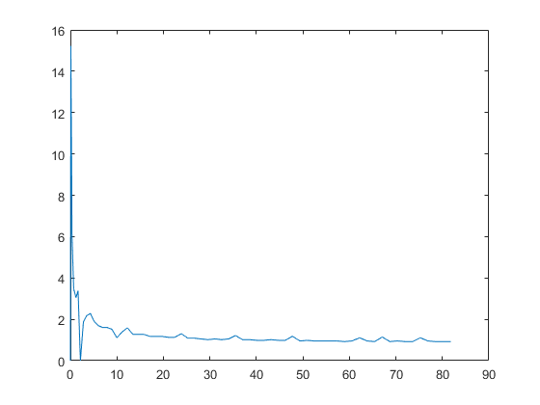

A Plot of the results
hold on
plot(out.simout)
hold off
function u = fcn(e,t)

Define Variables
Control Gains
Kp=1;
Ki=1;
umax = 10;
% Memory variables
persistent I_past;
persistent t_past;
if isempty(I_past), I_past=0; end;
if isempty(t_past), t_past=0; end;

Calculate Controller output
sample time
Ts = t - t_past;
% Integrator
I = I_past+e*Ts;
% PI control calculation
u = Kp*e+Ki*I;
% anti-windup
if abs(u)>umax,
u = sign(u)*umax;
e = sign(e)*min(umax/Kp, abs(e));
I = (u-Kp*e)/Ki;
end;
I_past=I;
t_past=t;
end
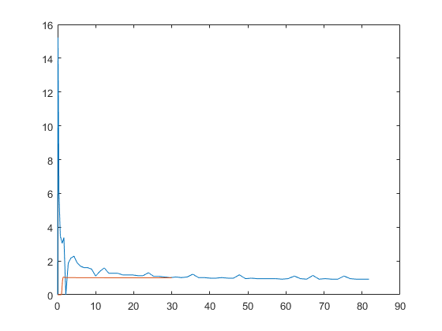
Published with MATLAB® R2021b

