# Urine Analysis Report

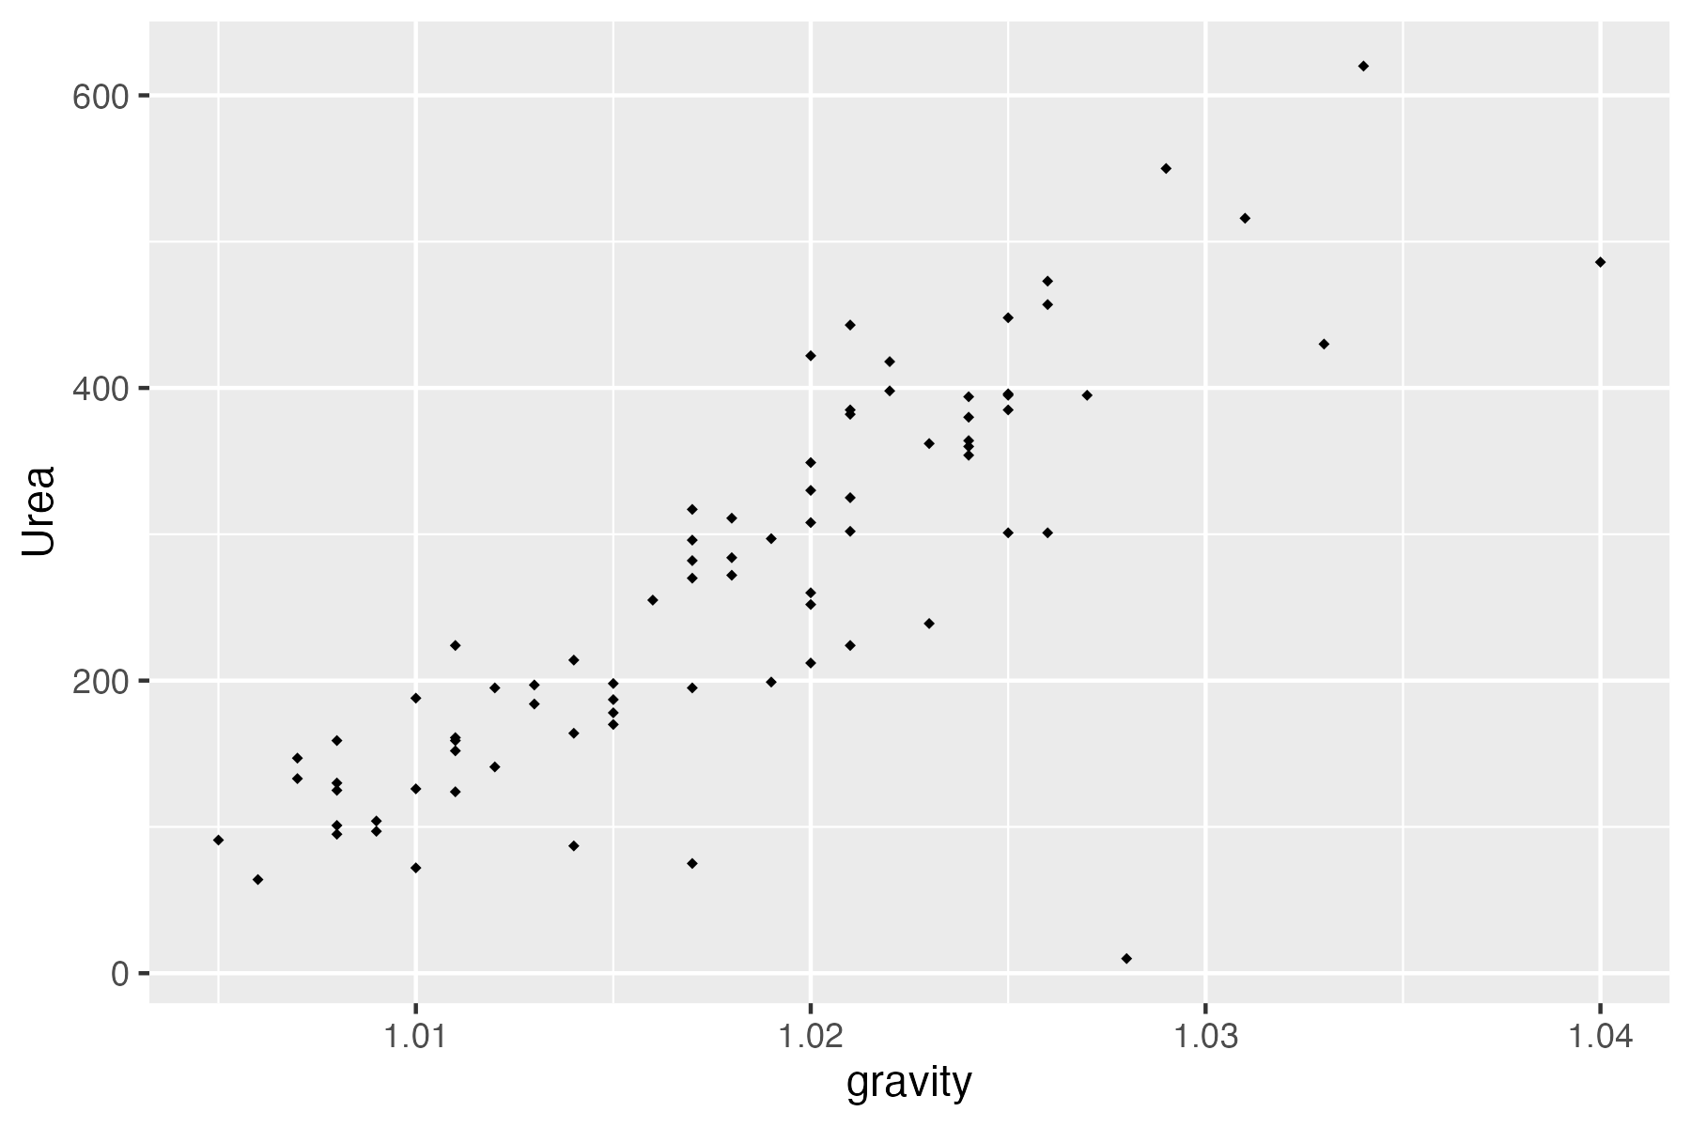

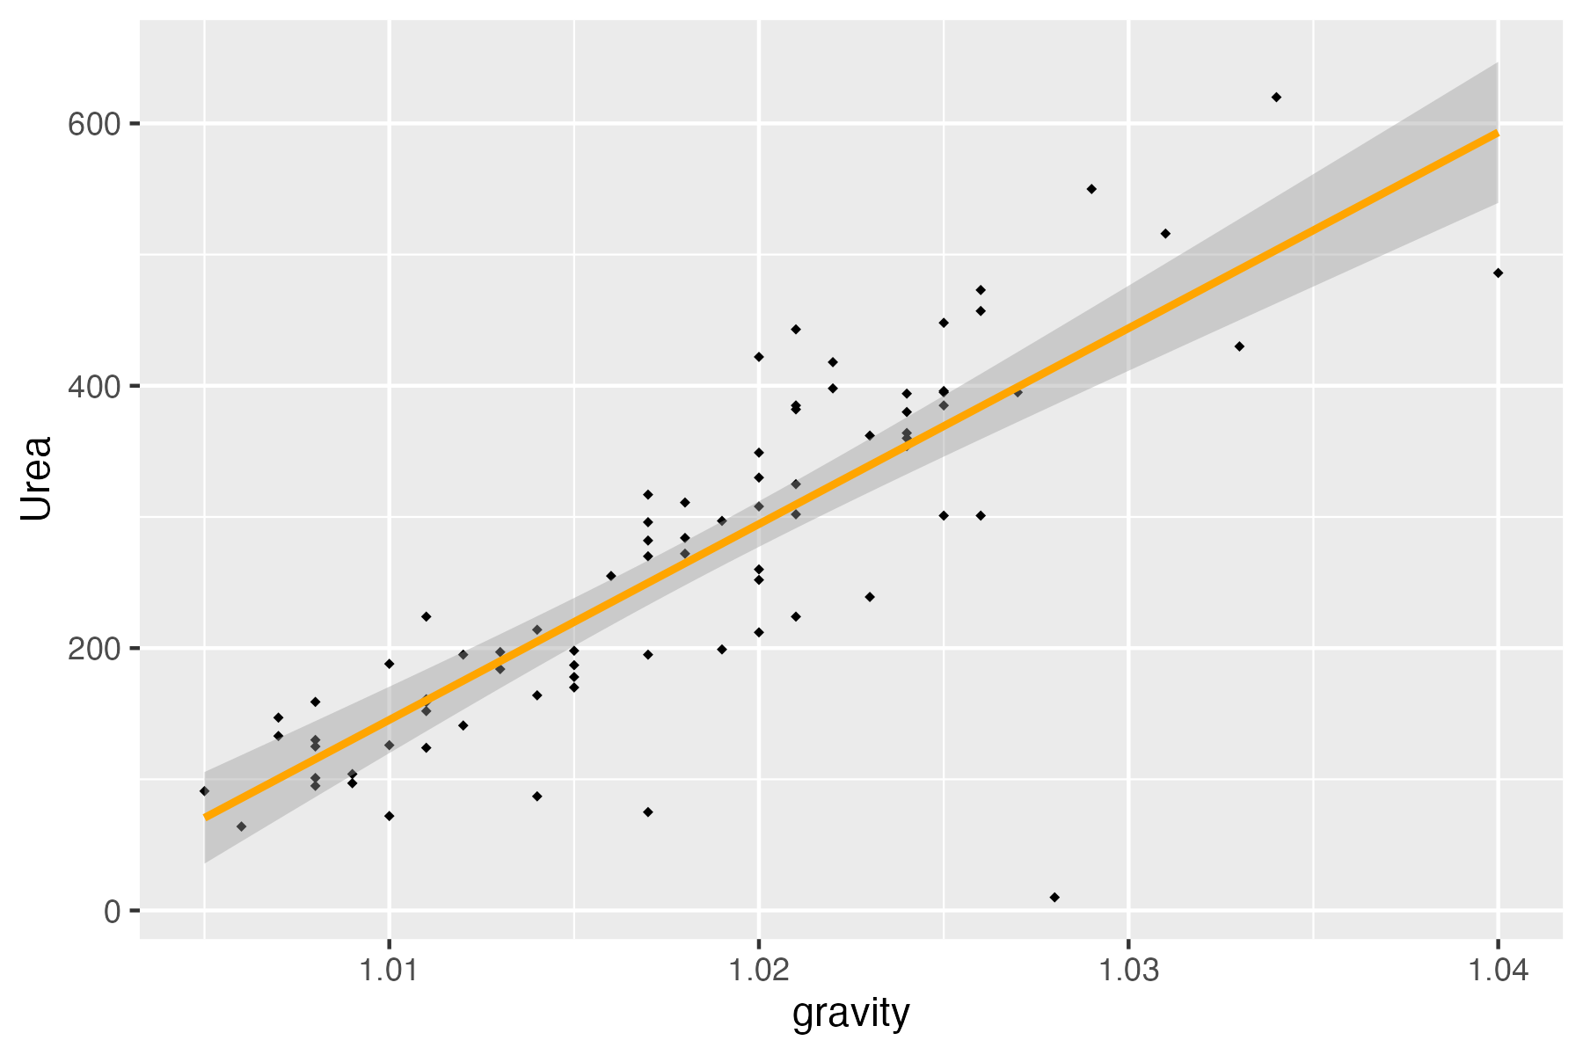

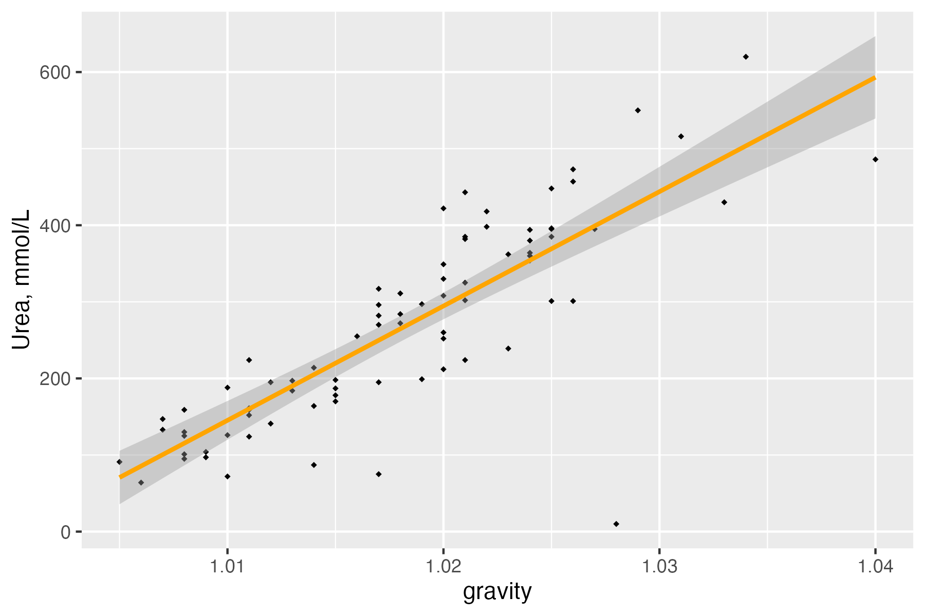

| vars | n | mean | sd | median | trimmed | mad | min | max | range | skew | kurtosis | se |
| --- | --- | --- | --- | --- | --- | --- | --- | --- | --- | --- | --- | --- |
| 1 | 79 | 0.4303797 | 0.49829309 | 0.000 | 0.4153846 | 0.0000000 | 0.000 | 1.00 | 1.000 | 0.27589780 | -1.9480607 | 0.0560623531 |
| 2 | 79 | 1.0181139 | 0.00723947 | 1.018 | 1.0178462 | 0.0088956 | 1.005 | 1.04 | 0.035 | 0.32080022 | -0.1909104 | 0.0008145041 |
| 3 | 79 | 6.0284810 | 0.72430708 | 5.940 | 5.9755385 | 0.6375180 | 4.760 | 7.94 | 3.180 | 0.71096724 | 0.1448953 | 0.0814909128 |
| 4 | 78 | 615.0384615 | 238.24768528 | 612.500 | 611.3281250 | 295.7787000 | 187.000 | 1,236.00 | 1,049.000 | 0.12434677 | -0.7759451 | 26.9762382479 |
| 5 | 78 | 20.9012821 | 7.95207224 | 21.400 | 20.8843750 | 9.4145100 | 5.100 | 38.00 | 32.900 | -0.05637007 | -0.8780210 | 0.9003948769 |
| 6 | 79 | 266.4050633 | 131.25455001 | 260.000 | 261.5692308 | 151.2252000 | 10.000 | 620.00 | 610.000 | 0.31335761 | -0.6475002 | 14.7672906153 |
| 7 | 79 | 4.1389873 | 3.26005136 | 3.160 | 3.7432308 | 2.8762440 | 0.170 | 14.34 | 14.170 | 1.09908555 | 0.6797081 | 0.3667844340 |

| Correlation.Coefficient |
| --- |
| 0.823477 |
| Number.of.people.with.urea...100.mmol.L | Median.pH.in.this.subset |
| 8 | 6.745 |