LLaMA3 Fine Tuning
Revision 1.0

 | Author By | Reviewed By | Approved By
Name
Designation
Date

Table of Contents
1 Introduction 3
2 Steps for Fine-tuning a LLaMA3 model 3
3 Dataset Preparation Methods 4
3.1 Data Generation 4
3.2 Skills / tools required 4
3.3 Dataset Format Example 5
3.4 Parquet Dataset Format on Huggingface 5
4 Memory and Cost computations for LLM fine tuning / training 6
4.1 Estimation of Memory Requirement 6
4.2 Estimation of Training Cost 9
5 Infrastructure for Fine Tuning 10
5.1 Infrastructure Requirements 10
5.2 Availed Resources 10
5.3 Google Colab Free Tier Resource Limitations 11
5.4 GPU Runtime Limitations on Kaggle 12
6 Example done for LLaMA3 fine tuning 13
6.1 Changes done for running the code on GPU locally 13
6.2 Significance of parameters changed for fine tuning 14
7 Reference Links 15

Introduction
Fine-tuning is the process of taking a pre-trained language model and adapting it to a specific task by training it further on a smaller dataset. Llama 3 (LLaMA 3), an advanced language model, is excellent for tasks like text generation, summarization, and even natural language understanding. By fine-tuning, one can align the model’s outputs to any domain specific business needs.
Domain specific LLMs can be helpful in scenarios such as support ticket resolution, querying document base or code repository to adapt into new system etc. There is a high demand for domain specific LLMs due to data privacy and pricing concerns. The stake holder’s dataset can stay on premise as the LLMs are also present on premise. Fine-tuned LLMs provide quality and custom feel to the stake holder and also has low latency in displaying the results. On the other hand, fine tuning becomes challenging with respect to the infrastructure needed, time required and overall memory needs

Steps for Fine-tuning a LLaMA3 model

Following are the steps to be followed for LLaMA3 fine-tuning with a custom-made dataset using proprietary documents and code files
- Selection of right dataset format
- Preparing the proprietary dataset for fine tuning
- Estimate the compute capability and memory needed
- Preprocessing steps for datasets
  - Document datasets - forming paragraph chunks, forming question and answer pairs and forming keyword and paragraph chunk pairs
  - Code datasets - forming summary and function pairs
- Choosing optimal configurations for fine tuning
- Fine tuning the pre trained LLaMA model using enterprise proprietary dataset
- Evaluation

Dataset Preparation Methods

Data Generation

  - Manual data generation:
    - Write (instruction, response) pairs of customer domain of interest
    - QA collection from customer Community Forum
    - DocX, pdf, text, etc – Divide the topics (Eg. Instruction Manual, Coding, Technical specification, Product knowledge, etc.)
    - API collected instruction prompts using ChatGPT, etc and writing responses manually

  - Synthesized data
    - Query response generation using API data collection (RAG pipeline) from the DocX, pdf, text documents
    - Cleaning / validation of generated data manually

  - Data augmentation - Rewriting the same (query, response) pairs to add diversity (without creating new pairs of the topics)

Skills / tools required

  - Code reviewer, domain knowledge expert
  - Use of ChatGPT, etc. for generating multiple queries of various sub-topics within domain of interest
  - Use of methods for text-data and code-data preprocessing mentioned in following slides
  - Use of a RAG pipeline to generate responses from documents of the above generated queries
  - Document format conversion (Eg. Pdf conversion to JSON file) for using in RAG pipeline
  - Final integration of manual and synthesized data into sing required format

Dataset Format Example

- Format – CSV or JSON
- Example dataset row
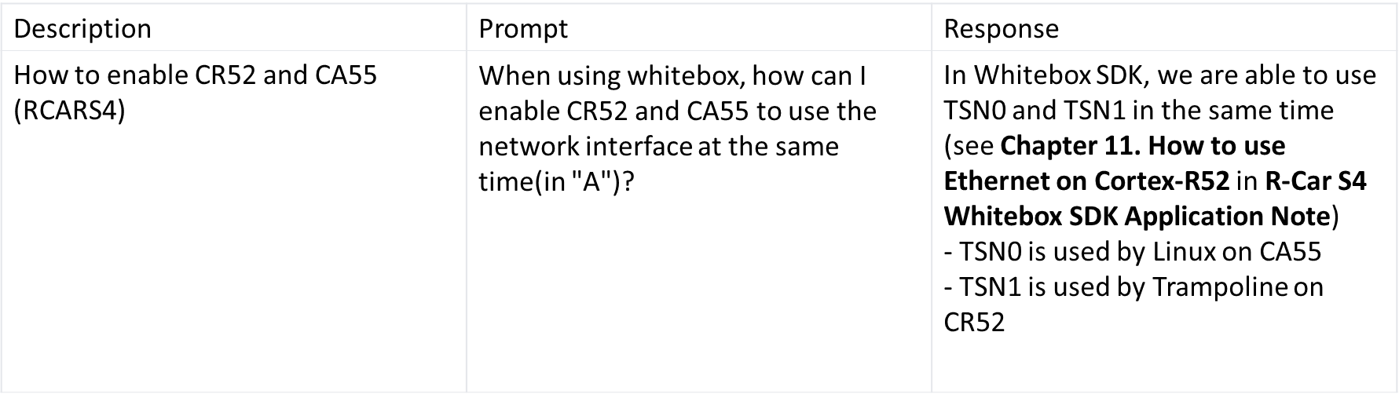

Parquet Dataset Format on Huggingface

- Apache Parquet is an open source, column-oriented data file format designed for efficient data storage and retrieval.
- It provides efficient data compression and encoding schemes with enhanced performance to handle complex data in bulk.
- Apache Parquet is designed to be a common interchange format for both batch and interactive workloads.
- It is similar to other columnar-storage file formats available in Hadoop, namely RCFile and ORC.

Memory and Cost computations for LLM fine tuning / training

Estimation of Memory Requirement

(Ref: Can You Run It? LLM version - a Hugging Face Space by Vokturz)

GPU used : NVIDIA GeForce RTX 3080 12 GB
Model used for Fine-tuning : Meta-Llama-3-8B-Instruct
No. of trainable parameters : 1% (~70Million)
Memory_{Inference} ​≈ Model Size×1.2
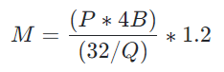
M, GPU memory expressed in Gigabyte
P, The amount of parameters in the model. E.g. a 7B model has 7 billion parameters.
4B, 4 bytes, expressing the bytes used for each parameter
32, There are 32 bits in 4 bytes
Q, The amount of bits that should be used for loading the model. E.g. 16 bits, 8 bits or 4 bits.
1.2, Represents a 20% overhead of loading additional things in GPU memory.

Following graph shows no. of GPUs required for
- Inference
- Full training (Adam)
- LoRA fine tuning

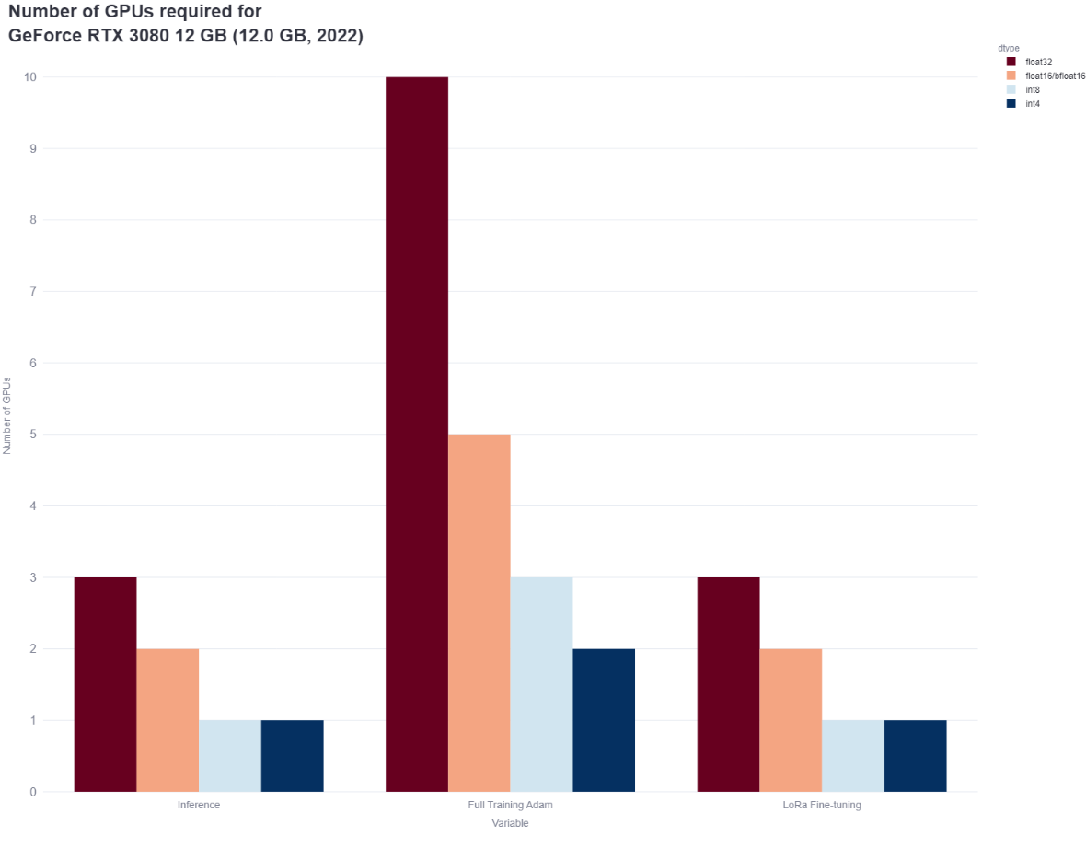
Fig. 1: No. of GPUs required for Inference, full training & fine tuning LLAMA 3

Following Table shows GPU memory (GB) requirement to handle float32/float16/int8/int4 models for
- Inference
- Full training (Adam)
- LoRA fine tuning

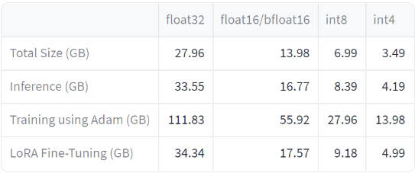
Table 1. GPU memory (GB) requirement to handle float32/float16/int8/int4 models

From the above, it can be noticed that we require
1 GPU for Inference (int4)
2 GPUs for full training using Adam (int4)
1 GPU for LoRA Fine-Tuning (int4)

Estimation of Training Cost

The basic equation giving the cost to train a transformer model is given by:
C ≈ τT = 6PD
where:
- C is the compute required to train the transformer model, in total floating-point operations
- C=C_{forward}+C_{backward}
- C_{forward}≈2PD
- C_{backward}≈4PD
- τ is the aggregate throughput of your hardware setup (τ=(No. GPUs)×(Actual FLOPs/GPU)), in FLOPs
- T is the time spent training the model, in seconds
- P is the number of parameters in the transformer model
- D is the dataset size, in tokens

C is a measure of total compute and can be quantified in various units such as:

- FLOP-seconds, which combines the number of floating point operations per second with the duration of computation: [ FLOP-seconds = [ Floating Point Operations per Second ] × [ Seconds ] ] [FLOP-seconds=[Floating Point Operations per Second]×[Seconds]]

- GPU-hours, which multiplies the number of GPUs by the time in hours: [ GPU-hours = [ No. of GPUs ] × [ Hours ] ] [GPU-hours=[No. of GPUs]×[Hours]]

- PetaFLOP-days, often used in scaling laws papers, measures the total floating point operations over days, specifically: [ PetaFLOP-days = 1 0 15 × 24 × 3600 total floating point operations ] [PetaFLOP-days=10 15 ×24×3600 total floating point operations]

These units provide different ways to conceptualize and quantify the computational effort required to train models, depending on the context and scale of the operations.

Infrastructure for Fine Tuning

Infrastructure Requirements

- The requirement is based on the following factors
  - Model Size: LLaMA 3 8B model, required approx. 8GB of VRAM for training on GPU
  - Dataset size: It contains at least 250k dialogues; the size is 142MB
  - Fine tuning method: Supervised Fine Tuning (SFT)
- Platform / Hardware considerations
  - Fine tuning locally on an available GPU
  - Cloud Platforms – Azure, Kaggle (for initial fine tuning of available dataset)
- Software considerations
  - Pytorch / Tensorflow frameworks
  - Hugging Face Transformers

Availed Resources
To accelerate the Fine-tuning process, we utilized two primary infrastructure setups:
- Local GPU: A local workstation equipped with NVIDIA GeForce RTX 3080 GPU was used for fine tuning. This has eliminated the need for cloud-based resources which will result in significant cost savings. Below is the specification of the GPU used.

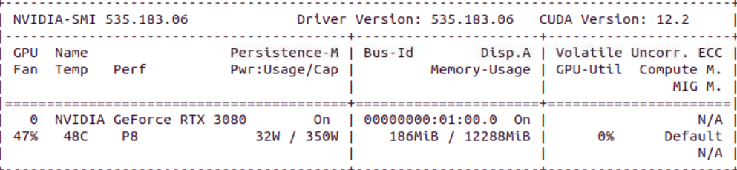
Fig. 2: Nvidia-smi report of Local GPU
- Cloud-based platform: We also utilized Google Colab ‘s free GPU resources. This cloud-based platform offered a convenient solution for experimenting with different hyperparameters and fine-tuning examples. Below is the specification of the GPU session availed from Google Colab’s free session.

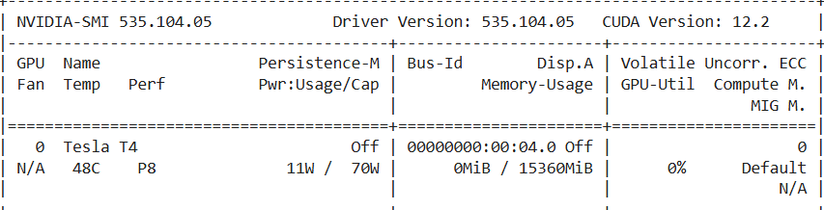
Fig. 3: Nvidia-smi report of Google Colab GPU

Google Colab Free Tier Resource Limitations

- GPU: The type of GPU provided can vary, but it's typically a mid-range option like a Tesla T4 or P100. This may not be suitable for very large models or extremely data-intensive tasks.

- RAM: The amount of RAM available can also be limited, especially for longer-running jobs or larger datasets.

- Runtime: There's a maximum runtime for each session, which can vary but is generally around 12 hours. If your training process takes longer, you'll need to restart the session.

- Internet connection: A stable internet connection is essential for uninterrupted training
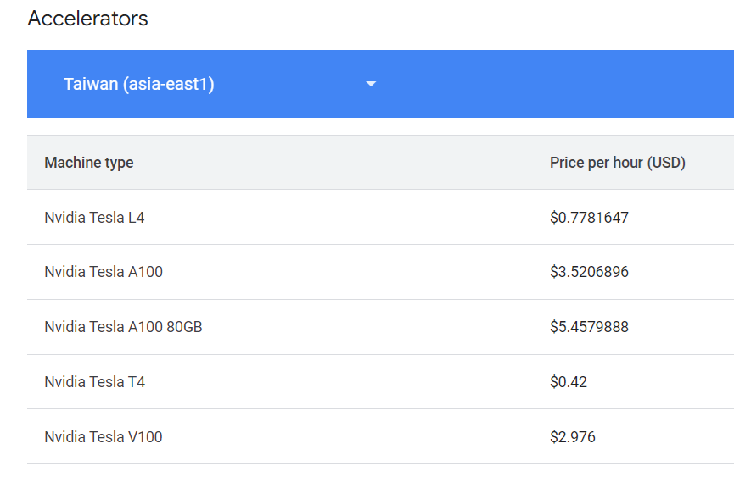
Table 2. Pricing of popular GPUs availed on Google Colab

GPU Runtime Limitations on Kaggle
- Kaggle has a runtime limit of 9 hours for notebooks, after which the session will automatically terminate. This limit applies to both CPU and GPU runtimes. However, if one is using Kaggle to train a deep learning model, he can save the progress periodically and resume training from where he left off after the session has ended.
- One can also use Kaggle's "Notebook Session Timeout" feature to extend the runtime limit up to 24 hours for a single session. To do this, click on "Settings" in the upper right-hand corner of the Kaggle notebook interface, scroll down to the "Notebook Session Timeout" option, and select a duration of up to 24 hours. Note that this feature is only available to users with a Kaggle Pro subscription.
- It's worth noting that Kaggle may terminate one’s session if he exceeds certain resource usage limits or violate the platform's terms of service. Therefore, it's important to monitor the resource usage and avoid any activities that could potentially violate the terms of service.

Example done for LLaMA3 fine tuning

Code: Meta-Llama3-Fine-Tuning/How-to-FineTune-Llama-3-with-SFTTrainer.ipynb at master · ruslanmv/Meta-Llama3-Fine-Tuning · GitHub
Dataset: https://huggingface.co/datasets/ruslanmv/ai-medical-dataset

Changes done for running the code on GPU locally

- Created a huggingface token for login and logout. This is required to load the model and the dataset
- Downloaded a portion of dataset (1000 rows of the full dataset) and used for finetuning. The dataset was saved in csv format (train and test separately – 900 for train and 100 for test)
- The dataset was read locally from the system (in the example code taken from web, the dataset was loaded directly from huggingface)
- The dataset was converted to python dataframe and removed rows with null values. Using the dataset library, it was then converted to dictionary format required for fine tuning
- Changed the parameters lora_r (value from 32 to 16) and lora_alpha (value from 16 to 8). This has reduced the number of trainable parameters and it has helped overcome the issue of OOM (CUDA out of memory) error during fine tuning
- Also reduced the batch size to 1 (previously 2) to avoid OOM
- Changed the save_steps to 50 instead of 10
- num_train_epochs was set to 10
- Removed max_steps parameter
- In the PEFT config, removed the arguments target_modules and modules_to_save (target_modules=["k_proj", "q_proj", "v_proj", "up_proj", "down_proj", "gate_proj"], modules_to_save=["embed_tokens", "input_layernorm", "post_attention_layernorm", "norm"]). It was noted that if we specially mention modules, it leads to CUDA OOM error.
- Changed the code to save the model locally to the system by giving a proper path

Significance of parameters changed for fine tuning

- r: the rank of the update matrices, expressed in int. Lower rank results in smaller update matrices with fewer trainable parameters.
- lora_alpha: LoRA scaling factor
- target_modules: The modules (for example, attention blocks) to apply the LoRA update matrices.
- modules_to_save: List of modules apart from LoRA layers to be set as trainable and saved in the final checkpoint. These typically include model’s custom head that is randomly initialized for the fine-tuning task.
- num_train_epochs(float, optional, defaults to 3.0) — Total number of training epochs to perform (if not an integer, will perform the decimal part percents of the last epoch before stopping training).
- max_steps (int, optional, defaults to -1) — If set to a positive number, the total number of training steps to perform. Overrides num_train_epochs. For a finite dataset, training is reiterated through the dataset (if all data is exhausted) until max_steps is reached.
- save_steps - Save is done every save_steps

Reference Links

  - https://www.datacamp.com/tutorial/llama3-fine-tuning-locally
  - https://www.datacamp.com/tutorial/run-llama-3-locally
  - https://www.kaggle.com/code/omgits0mar/llama-3-fine-tuning-on-arabic-chatbot-dataset
  - https://arxiv.org/pdf/2407.02147v1
  - https://arxiv.org/pdf/2303.14070
  - https://www.youtube.com/watch?v=0XPZlR3_GgI
  - https://huggingface.co/docs/transformers/perf_train_gpu_one#anatomy-of-models-mem
  - https://discuss.huggingface.co/t/llama-7b-gpu-memory-requirement/34323
  - https://www.substratus.ai/blog/calculating-gpu-memory-for-llm
  - https://huggingface.co/spaces/Vokturz/can-it-run-llm (estimating the memory requirement)
  - https://blog.eleuther.ai/transformer-math/ (estimating training cost)
  - https://medium.com/@dzmitrybahdanau/the-flops-calculus-of-language-model-training-3b19c1f025e4 (training cost example)

