DATA-DRIVEN STUDENT PERFORMANCE PREDICTION

PROJECT REPORT
Submitted in partial fulfillment of the requirements for the award of the degree of

BACHELOR OF SCIENCE IN COMPUTER SCIENCE WITH DATA ANALYTICS

By

ABINANDHU G

(Reg.No.:231DA101)

Under the Guidance of

Dr. V.PREAM SUDHA MCA., M.Phil., Ph.D.

Professor & Head

DEPARTMENT OF COMPUTER SCIENCE WITH DATA ANALYTICS

Co-Guide

Dr. J. NITHYA, M.Com., M.B.A., M.Phil., Ph.D.

Professor

DEPARTMENT OF COMMERCE IN BUSINESS PROCESS SERVICES



Dr. N.G.P. ARTS AND SCIENCE COLLEGE

(An Autonomous Institution, Affiliated to Bharathiar University, Coimbatore)
Approved by Government of Tamil Nadu & Accredited by NAAC with A⁺⁺ Grade (3rdCycle-3.64CGPA)
Dr.N.G.P.-Kalapatti Road ,Coimbatore-641048,Tamil Nadu,India.
Website:www.drngpasc.ac.in|Email:info@drngpasc.ac.in.|Phone:+91-422-2369100

MARCH-2026

DECLARATION

I, Mr ABINANDHU G (Reg.No.:231DA101) hereby declare that the project report entitled “DATA-DRIVEN STUDENT PERFORMANCE PREDICTION” submitted in partial fulfilment of the requirement for the award of the degree of BACHELOR OF COMPUTER SCIENCE WITH DATA ANALYTICS is a record of original work done during the period of 2025 - 2026 under the supervision and guidance of Dr. V. PREAM SUDHA, MCA., M.Phil., Ph.D., Professor & Head , Department of Computer Science with Data Analytics and Dr. J. NITHYA, M.Com., M.B.A., M.Phil., Ph.D., Professor, Department of Commerce in Business Process Services , Dr. N.G.P Arts and Science College, Coimbatore - 48, and it has not formed the basis of award of any Degree/ Diploma/ Associateship/ Fellowship or other similar title to any candidate of any university.

ABINANDHU G

Reg.No.:231DA101

Place: Coimbatore
Date:

CERTIFICATE

This is to certify that the project report entitled “DATA-DRIVEN STUDENT PERFORMANCE PREDICTION” submitted in partial fulfilment of the requirement for the award of the degree of BACHELOR OF COMPUTER SCIENCE WITH DATA ANALYTICS is a record of original work done by Mr. ABINANDHU G (Reg. No.: 231DA101) during the period (2025 - 2026) of his study in the Department of Computer Science with Data Analytics, Dr. N.G.P. Arts and Science College, Coimbatore-48 under my supervision and guidance, and the project report has not formed the basis for the award of any Degree/ Diploma/ Associateship/ Fellowship or other similar title to any candidate of any university.

(Dr. V. PREAM SUDHA) | (Dr. V. PREAM SUDHA) | (Prof. Dr. S. SARAVANAN)
Project Guide | Professor and Head | Principal

(Dr. J. NITHYA)
Co-Guide

Place: Coimbatore

Date:

Viva-voce Examination held on

Internal Examiner External Examiner

ACKNOWLEDGEMENT

This project report was the most significant accomplishment in my life and it would not have been possible without the blessing of God almighty and those who supported and believed in my caliber.
I record my deep sense of gratitude to Dr. NALLA G. PALANISWAMI, M.D, AB(USA), Chairman, Dr.N.G.P. Research and Educational Trust and Dr. THAVAMANI. D.PALANISWAMI,M.D,AB(USA), Secretary, Dr.N.G.P. Arts and Science College, Coimbatore for providing mean opportunity to carry out a project successfully.
I record my sincere thanks to Prof. Dr.S.SARAVANAN M.Com., M.Phil.,M.B.A., Ph.D., Principal, Dr.N.G.P. Arts and Science College, Coimbatore, for every help he rendered before and during the period of project.
I express my sincere thanks to Dr. V.PREAM SUDHA MCA., M.Phil., Ph.D. Professor and Head, Department of Computer Science with Data Analytics, Dr.N.G.P. Arts and Science College, Coimbatore for showing sustained interest and providing help throughout the period of thiswork.
I would like to extend my sincere thanks to my guide Dr. V.PREAM SUDHA MCA., M.Phil., Ph.D., Professor and Head, Department of Computer Science with Data Analytics and my Co-Guide Dr. J. NITHYA, M.Com., M.B.A., M.Phil., Ph.D, Professor, Department of Commerce in Business Process Services Dr.N.G.P. Arts and Science College, Coimbatore-48, for her exemplary guidance and encouragement.
I take this opportunity to acknowledge my sincere thanks to all the staff members of the Department of Computer Science with Data Analytics for their constant inspiration, assistance, and resourceful guidance for the completion of this project successfully.
I express my sincere thanks to my family and friends for their encouragement, love,prayer, moral support, advice, and sacrifice without which I would not have been able to pursue the course of this study

ABINANDHU G

ABSTRACT
In today’s data-driven academic environment, educational institutions generate large volumes of student performance data, including attendance records, internal assessment scores, final examination marks and overall results. However, simply collecting data is not sufficient to identify the underlying causes of student failure. There is a strong need for an intelligent and systematic approach that can analyze academic records, detect performance patterns and provide meaningful insights to support timely intervention.
This project presents a comprehensive data-driven student performance prediction using data preprocessing techniques, rule-based reasoning and machine learning. The dataset is initially cleaned and enriched by adding relevant academic and behavioral indicators such as previous backlogs, library marks and participation scores. These additional attributes help simulate real-world academic conditions and improve analytical depth. The system then filters failed students either based on the existing result column or predefined academic thresholds such as low attendance, poor internal marks, or insufficient final examination scores.
To determine the primary reason for failure, a rule-based engine is implemented. The system evaluates multiple academic factors and assigns specific failure reasons such as low attendance, low internal marks, poor end-semester examination performance, lack of self-study, low class participation, or general poor performance. This structured classification ensures clarity in understanding student weaknesses and enables targeted corrective measures.
Furthermore, a Decision Tree learning model is trained using selected academic features to analyze patterns among failed students. The model helps in understanding how different attributes contribute to academic failure and supports predictive analysis for future academic planning. Finally, the system generates a comprehensive Excel report containing detailed information about failed students and their identified failure reasons, which can be used by educators and administrators for strategic intervention.
Overall, the proposed system enhances academic monitoring by combining rule-based logic and machine learning techniques, thereby enabling institutions to make informed decisions, improve student performance, and reduce failure rates effectively.
TABLE OF CONTENTS

S.NO | PARTICULARS | PAGE NO
1 | INTRODUCTION | 1
2 | EXISTING SYSTEM  2.1Overview  2.2Techniques Used in Existing System  2.3 Limitations of the Existing System | 2
3 | PROPOSED SYSTEM  3.1Overview of proposed System  3.2Advantages of the proposed System | 6
4 | SYSTEM REQUIREMENTS  4.1 Hardware Requirements  4.2 Software Requirements | 9
5 | SYSTEM ARCHITECTURE  5.1 Architecture Diagram  5.2 Process Flow | 12
6 | DATASET DESCRIPTION  6.1 Data Collection  6.2 Data Preprocessing | 16
7 | METHODOLOGY  7.1 Algorithm Used  7.2 Algorithm Working Principle | 19
8 | RESULTS & MODEL EVALUATION  8.1 Result Visualization  8.2 Performance Analysis | 22
9 | CONCLUSION & FUTURE WORK  9.1 Summary of Findings  9.2 Future Enhancement | 24

CHAPTER - I

INTRODUCTION
In today’s academic environment, analyzing student performance is essential to improve educational outcomes and identify students who need additional support. Institutions collect large amounts of data such as attendance records, internal assessment marks, final exam scores, and overall results. However, raw data alone cannot clearly explain why students fail. Therefore, there is a need for intelligent systems that can analyze academic data, identify patterns, and provide meaningful insights for timely corrective action.
This project develops a data-driven student performance prediction using data analytics and machine learning techniques. The system analyzes student performance data, identifies failed students, and determines the key reasons behind their failure. It uses both rule-based logic and a Decision Tree Classifier to ensure accurate, transparent, and interpretable results.
The dataset includes Attendance Percentage, Internal Marks, Final Examination Marks, and Result status. Additional features such as Previous Backlogs, Library Marks, and Participation Score in class engagement are added to enrich the analysis. A rule-based engine classifies failure reasons such as Low Attendance, Low Internal Marks, Poor ESE Performance, Lack of Self Study, Low Class Participation, and General Poor Performance. The system also generates a detailed Excel report for faculty review.
Overall, the project demonstrates how data analytics can help institutions identify at-risk students, understand root causes of failure, and implement targeted academic support to improve student success rates.

CHAPTER – II
EXISTING SYSTEM

2.1 Overview of Existing System
In the traditional academic environment, student performance evaluation is primarily conducted through manual observation and basic result analysis. Educational institutions typically rely on attendance records, internal assessment marks, and final examination scores to determine whether a student has passed or failed. The existing system focuses mainly on calculating total marks and assigning a final result status (Pass/Fail) without performing deeper analysis of the underlying causes of poor performance.
Most institutions maintain student data using spreadsheets or basic database management systems. While these systems effectively store and organize data, they lack intelligent mechanisms to interpret patterns or identify risk factors. Faculty members often review student performance manually, which can be time-consuming and prone to human error, especially when handling large datasets involving hundreds or thousands of students.
In the current system, students who fail are simply categorized under a “Fail” status without a structured explanation. Although teachers may informally identify reasons such as low attendance, poor internal marks, or weak exam performance, there is no automated rule-based framework to consistently determine and document these reasons. As a result, the analysis remains subjective and varies from one instructor to another.
Furthermore, the existing system does not incorporate additional performance indicators such as student participation, self-study habits, or previous academic backlogs. These factors, which significantly influence academic outcomes, are often overlooked due to the absence of integrated analytical tools. Without considering these extended attributes, it becomes difficult to perform a comprehensive evaluation of student performance.
Another limitation of the traditional approach is the absence of predictive or analytical models. The system does not use machine learning or data mining techniques to identify patterns or trends among failed students. Consequently, institutions are unable to proactively identify at-risk students before final examinations. Intervention measures are usually reactive rather than preventive.
In summary, the existing system is primarily result-oriented and limited to basic data storage and pass / fail classification. It lacks automated reasoning, detailed failure analysis, predictive capabilities, and data-driven insights. These limitations highlight the need for an enhanced analytical system that can provide structured explanations, intelligent predictions, and comprehensive performance evaluation to support better academic decision-making.
2.2 Techniques Used in Existing System
The existing system for student performance evaluation primarily relies on traditional data management and manual analysis techniques. These techniques are simple and straightforward but lack advanced analytical capabilities. The key techniques used in the existing system are described below:

2.2.1. Manual Data Collection
Student information such as attendance percentage, internal assessment marks, and final examination marks is collected manually by faculty members. These records are typically maintained in registers or entered into spreadsheets. The process depends heavily on human input and supervision.

2.2.2. Spreadsheet-Based Data Management
Most institutions use basic tools such as Microsoft Excel or similar spreadsheet software to store and manage student data. These tools are used to calculate totals, averages, and percentages using built-in formulas. While spreadsheets help in organizing data efficiently, they do not provide automated reasoning or predictive analysis.

2.2.3. Rule-Based Pass/Fail Calculation
The existing system applies fixed academic rules to determine whether a student passes or fails. For example:
- Attendance below a minimum threshold leads to ineligibility.
- Internal marks below a required percentage result in failure.
- Final exam marks below the passing criteria result in a fail status.
These rules are applied in a simple conditional manner without deeper analysis of combined factors.

2.2.4. Basic Statistical Methods
Some institutions perform simple statistical calculations such as:
- Average marks
- Percentage distribution
- Pass percentage of a class
- Highest and lowest scores
2.3 Limitations of the Existing System
Although the traditional student performance evaluation system is simple and widely used, it has several limitations that reduce its effectiveness in providing meaningful academic insights. The major limitations are explained below:

2.3.1. Lack of Detailed Failure Analysis
The existing system mainly classifies students as “Pass” or “Fail” without clearly identifying the exact reason for failure. It does not systematically analyze whether failure is due to low attendance, poor internal marks, weak exam performance, or other contributing factors.

2.3.2. Manual and Time-Consuming Process
Most of the data entry, verification, and analysis tasks are performed manually. This process is time-consuming, especially when handling large numbers of students. Manual processing also increases the chances of human errors.

2.3.3. No Predictive Capability
The traditional system does not use predictive techniques to identify students who are at risk of failing. As a result, corrective measures are taken only after the results are published, making the approach reactive rather than proactive.

2.3.4. Limited Use of Performance Indicators
The system mainly considers attendance and examination marks. Important factors such as previous academic backlogs, participation levels, and self-study efforts are generally not included in the evaluation process. This leads to incomplete performance analysis.

2.3.5. Subjective Decision-Making
Identification of weak students often depends on teacher observation and personal judgment. This may vary between instructors and lacks consistency and objectivity.

2.3.6. No Pattern Recognition
The existing system does not analyze historical data to identify trends or recurring performance patterns. Without data mining or machine learning techniques, it is difficult to understand deeper relationships between different academic factors.

2.3.7. Limited Reporting and Insights
Reports generated by the current system are mostly tabular and focus only on displaying marks and results. They do not provide actionable insights or recommendations for improvement.

CHAPTER – III
PROPOSED SYSTEM

3.1 Overview of Proposed System
The proposed system is an intelligent Data-Driven Student Performance Prediction designed to overcome the limitations of the traditional academic evaluation process. Unlike the existing system, which only provides a pass/fail status, the proposed system performs a detailed analysis of student performance and identifies the specific reasons for failure using data analytics and machine learning techniques.
The system begins by collecting and processing student academic data, including Attendance Percentage, Internal Assessment Marks, Final Examination Marks, and overall Result status. To enhance analytical depth, additional performance-related attributes such as Previous Backlogs, Library Marks (representing self-study effort), and Participation Score (reflecting classroom engagement) are incorporated into the dataset. These enriched features enable a more comprehensive and realistic evaluation of student performance.
A rule-based engine is implemented to systematically determine the primary cause of failure. Instead of assigning a generic fail status, the system classifies failure reasons into categories such as Low Attendance, Low Internal Marks, Poor End Semester Examination (ESE) Performance, Lack of Self Study, Low Class Participation, or General Poor Performance. This structured reasoning ensures transparency, consistency, and interpretability in decision-making.
To further strengthen the analysis, the proposed system integrates a machine learning model using a Decision Tree Classifier. The model learns patterns from historical data and identifies relationships between academic factors and failure reasons. Decision Trees are chosen because they are easy to interpret and suitable for structured educational datasets. This enables educators to understand how different performance indicators contribute to student outcomes.
Additionally, the system automatically generates a comprehensive Excel report containing enriched student data along with identified failure reasons. This report supports administrators and faculty in making informed decisions, planning remedial classes, offering counseling sessions, and implementing targeted academic interventions. Overall, the proposed system transforms traditional result analysis into a data-driven, intelligent evaluation framework. By combining rule-based logic with machine learning techniques, it provides detailed insights, improves transparency, and enables proactive measures to enhance student success rates.
3.2 Advantages of the Proposed System
The proposed data-driven student performance prediction offers several advantages over the traditional academic evaluation approach. By integrating data analytics and machine learning techniques, the system enhances accuracy, transparency, and efficiency in performance analysis. The key advantages are outlined below:

3.2.1. Detailed Failure Identification
Unlike the existing system that only provides a “Pass” or “Fail” result, the proposed system identifies the exact reason for failure. It categorizes causes such as low attendance, poor internal marks, weak exam performance, lack of self-study, or low participation. This detailed analysis helps educators understand the root cause of academic issues.

3.2.2. Automated and Time-Efficient
The system automates data processing, rule application, and report generation. This significantly reduces manual workload and saves time for faculty and administrators, especially when handling large datasets.

3.2.3. Improved Decision-Making
By providing structured and data-driven insights, the system supports informed academic decision-making. Faculty can plan remedial classes, mentoring sessions, or counseling programs based on specific failure reasons.

3.2.4. Inclusion of Multiple Performance Factors
The proposed system considers additional attributes such as previous backlogs, participation scores, and self-study indicators. This holistic approach ensures a more comprehensive evaluation of student performance.

3.2.5. Consistency and Objectivity
Since failure reasons are determined using predefined rules and machine learning models, the system eliminates subjectivity in evaluation. It ensures consistent and unbiased analysis across all students.

3.2.6. Pattern Recognition Using Machine Learning
The integration of a Decision Tree model enables the identification of hidden patterns and relationships between academic factors. This enhances analytical capability beyond simple statistical calculations.

3.2.7. Proactive Student Support
The system can help identify academically weak students early, allowing institutions to take preventive measures rather than reacting after final results are declared.

3.2.8. Easy Report Generation
The system automatically generates structured Excel reports containing enriched data and identified failure reasons. This simplifies documentation and administrative review processes.

CHAPTER – IV
SYSTEM REQUIREMENTS

4.1 Hardware Requirements
The proposed data-driven student performance prediction is lightweight and does not require high-end hardware. Since the system is developed using Python and processes structured academic datasets, it can run efficiently on standard computer systems commonly available in educational institutions. The basic hardware requirements are listed below:

4.1.1. Processor
- Minimum: Intel Core i3 or equivalent
- Recommended: Intel Core i5 or above
A multi-core processor is preferred for faster data processing and model training.

4.1.2. RAM
- Minimum: 4 GB
- Recommended: 8 GB or more
Higher RAM ensures smooth execution while handling large student datasets and performing machine learning operations.

4.1.3. Storage
- Minimum: 20 GB free disk space
- Recommended: 50 GB or more
Storage is required for dataset files, generated reports (Excel files), Python libraries, and project files.

4.1.4. System architecture
- 64-bit system architecture is recommended for better compatibility with Python libraries and machine learning frameworks.

4.1.5. Input and output devices
- Standard keyboard and mouse
- Monitor (minimum 1366×768 resolution recommended)
- Optional: Printer (for printing reports)

4.1.6. Backup device (optional)
- External storage device or cloud backup for saving reports and datasets securely.
4.2 Software Requirements
The proposed data-driven student performance prediction requires the following software components for development, analysis, visualization, and report generation. Since this project also uses Power BI Desktop for data visualization, it combines programming and business intelligence tools.

4.2.1. Operating System
- Windows 10 or later (Recommended)
- Mac OS or Linux (for Python development, if required)

4.2.2. Python Environment
- Python 3.8 or above
Python is used for data preprocessing, rule-based failure analysis, machine learning model implementation, and report generation.

4.2.3. Python Libraries
The following libraries are required:
- Pandas – for data manipulation and analysis
- NumPy – for numerical operations
- Scikit-learn – for implementing the Decision Tree Classifier
- OpenPyXL – for exporting Excel reports
- Warnings (built-in module) – for handling system warnings.These libraries support data cleaning, feature engineering, model training, and exporting results.

4.2.4. Power BI Desktop.
Power BI Desktop is used for:
- Creating interactive dashboards
- Visualizing student performance trends
- Displaying failure distribution
- Generating charts such as bar charts, pie charts, histograms, and KPI indicators
- Producing analytical reports for decision-making
It helps transform processed data into meaningful visual insights for administrators and faculty members.

4.2.5. Integrated Development Environment (IDE)
- PyCharm -An IDE used to write, edit and execute Python scripts efficiently.

4.2.6. Microsoft Excel
- Microsoft Excel 2016 - Excel is used for viewing exported reports and performing additional manual analysis if required.

CHAPTER – V
SYSTEM ARCHITECTURE

5.1 Architecture Diagram

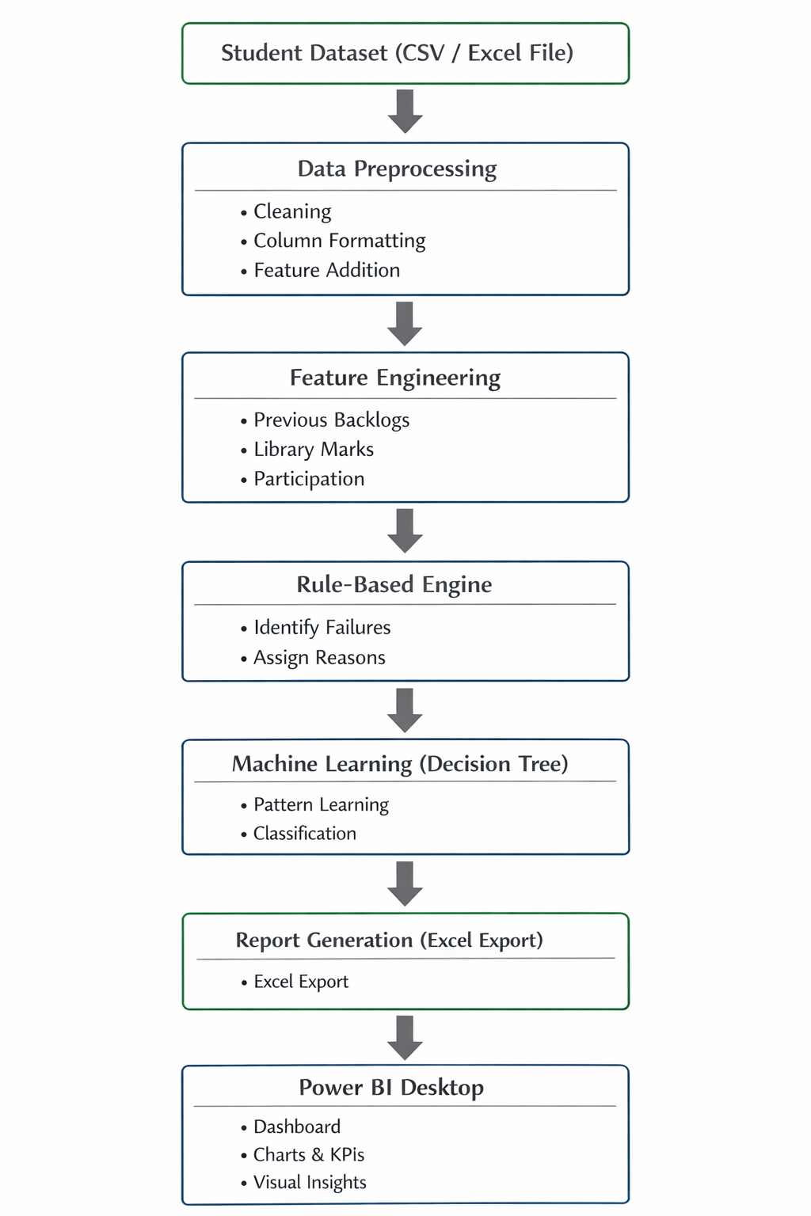
Figure 5.1 : Architecture Diagram

5.1.1. Data Source Layer
The system begins with student academic data stored in CSV or Excel format. This dataset includes attendance percentage, internal marks, final marks, and result status.

5.1.2. Data Preprocessing Layer
In this stage, the dataset is cleaned and formatted. Missing values are handled, column names are standardized, and data is prepared for further processing.

5.1.3. Feature Engineering Layer
Additional attributes such as Previous Backlogs, Library Marks, and Participation Score are added to enrich the dataset. This improves analytical depth.

5.1.4. Rule-Based Analysis Layer
A logical rule engine evaluates each failed student and assigns a specific failure reason such as low attendance or poor exam performance.

5.1.5. Machine Learning Layer
A Decision Tree Classifier is used to identify patterns and relationships between performance indicators and failure reasons. This enhances analytical capability.

5.1.6. Report Generation Layer
The processed and analyzed data is exported into a structured Excel report for administrative use.

5.1.7. Visualization Layer
Power BI Desktop is used to create interactive dashboards, charts, and KPI indicators for better visualization and decision-making.

5.2 Process Flow
The process flow of the data-driven student performance prediction describes the step-by-step procedure followed from data collection to final report generation and visualization.

5.2.1 Data Collection
The system begins by collecting student academic data from a CSV or Excel file. The dataset includes attendance percentage, internal assessment marks, final examination marks, and result status.

5.2.2 Data Loading
The dataset is loaded into the Python environment using data analysis libraries. The system reads and stores the data in a structured format for further processing.

5.2.3 Data Preprocessing
In this stage:
- Column names are cleaned and standardized.
- Missing or inconsistent values are handled.
- Data is formatted properly for analysis.
This ensures the dataset is accurate and ready for further operations.

5.2.4 Academic Performance Indicators
Additional performance indicators such as:
- Previous Backlogs
- Library Marks (Self-study indicator)
- Participation Score
are added to enrich the dataset and improve analytical depth.

5.2.5 Filtering Failed Students
The system identifies students who have failed based on result status or academic conditions such as:
- Low attendance
- Low internal marks
- Poor final exam performance
Only failed student records are selected for deeper analysis.

5.2.6 Rule-Based Failure Analysis
A rule engine evaluates each failed student and assigns a specific failure reason such as:
- Low Attendance
- Low Internal Marks
- Poor End Semester Exam Performance
- Lack of Self Study
- Low Class Participation
- General Poor Performance
This step ensures transparency in identifying the cause of failure.

5.2.7 Machine Learning Model Implementation
A Decision Tree Classifier is trained using relevant features to identify patterns and relationships between academic indicators and failure reasons.
The model enhances analytical capability and supports data-driven insights.

5.2.8 Report Generation
The enriched and analyzed dataset is exported to an Excel file.
This report includes student details along with identified failure reasons.

5.2.9 Data Visualization (Power BI Desktop)
The exported dataset is imported into Power BI Desktop.
Interactive dashboards and visualizations such as:
- Bar charts
- Pie charts
- Histograms
CHAPTER – VI
DATASET DESCRIPTION
6.1 Data Collection
Data collection is the first and most important step in the data-driven student performance prediction. The accuracy and reliability of the entire analysis depend on the quality of the collected data. In this project, student academic data is gathered from institutional records and stored in a structured format for further processing.

6.1.1. Source of Data
The dataset is collected from academic records maintained by the institution. These records are typically stored in:
- Microsoft Excel sheets
- CSV (Comma-Separated Values) files
- Institutional databases
For this project, the data is imported from a CSV/Excel file containing student performance details.

6.1.2. Type of Data Collected
The dataset includes important academic attributes such as:
- Student ID
- Student Name
- Attendance Percentage
- Internal Assessment Marks (Internal 1 & Internal 2)
- Average Internal Marks
- Final Examination Marks
- Result Status (Pass/Fail)
In addition to these core attributes, the system also considers performance-related indicators such as:
- Previous Backlogs
- Library Marks (Self-study indicator)
- Participation Score (Class engagement level)
These attributes help in performing detailed performance analysis.

6.1.3. Nature of Data
The collected data is structured and numerical in nature, which makes it suitable for statistical analysis and machine learning modeling. Most attributes are quantitative (marks, percentages), while the result status is categorical (Pass/Fail).

6.1.4. Data Format
The dataset is stored in tabular format with rows representing individual students and columns representing performance indicators. This structured format allows easy processing using Python libraries and visualization using Power BI Desktop.

6.1.5. Data Validation
Before proceeding to analysis, the collected data is checked for:
- Missing values
- Duplicate records
- Inconsistent entries
- Incorrect formatting
This ensures data accuracy and reliability for further processing.
6.2 Data Preprocessing
Data preprocessing is a crucial step in the data-driven student performance prediction. Raw academic data collected from institutional records may contain inconsistencies, missing values, or formatting issues. Preprocessing ensures that the dataset is clean, structured, and ready for accurate analysis and machine learning implementation.

6.2.1. Data Loading
The collected dataset (CSV/Excel file) is loaded into the Python environment using data analysis libraries. The data is stored in a structured tabular format for further processing.

6.2.2. Cleaning Column Names
Column names are standardized by removing extra spaces and correcting formatting issues. This prevents errors during data manipulation and model training.

6.2.3. Handling Missing Values
The dataset is checked for null or missing values. If any missing entries are found:
- They are filled using appropriate methods (such as mean), or
- The affected records are removed if necessary.
This ensures data completeness and avoids processing errors.

6.2.4. Removing Duplicates
Duplicate student records are identified and removed to maintain data accuracy and prevent biased analysis.

6.2.5. Data Type Conversion
Columns are verified to ensure correct data types:
- Numerical fields (attendance, marks, scores) are converted to numeric format.
- Categorical fields (Result status) are formatted consistently (e.g., “Pass”/“Fail”).

6.2.6. Feature Formatting
Important performance metrics such as Attendance %, Internal Marks, and Final Marks are verified for valid ranges to ensure data integrity.

6.2.7. Dataset Enrichment
Additional attributes such as:
- Previous Backlogs
- Library Marks
- Participation Score
are added to improve analytical depth and provide a more comprehensive evaluation of student performance.

CHAPTER – VII
METHODOLOGY

7.1 Algorithm Used
In this project, the primary analytical engine is built upon two distinct yet integrated computational approaches: a Rule-Based Heuristic Engine for initial categorization and a Decision Tree Classifier (Supervised Machine Learning) for predictive modeling.

7.1.1 Rule-Based Heuristic Engine
Before applying machine learning, the system utilizes a custom-defined rule engine. This is essential for converting raw numerical data into meaningful categorical labels. The rules are structured based on educational standards:
- Threshold-based Filtering: Identifies students falling below critical benchmarks (e.g., 50% attendance or 50% internal marks).
- Hierarchical Logic: A multi-tier if-elif-else structure that prioritizes certain failure reasons (like Attendance) over others (like Participation).

7.1.2 Decision Tree Classifier
The core machine learning algorithm selected for this project is the Decision Tree Classifier. It was chosen for several strategic reasons:
- Interpretability: Unlike "black-box" models, Decision Trees mirror human decision-making processes, making the results easy for educators to understand.
- Non-Linear Relationships: It effectively captures non-linear interactions between variables, such as how a student with high attendance might still fail due to extremely low library engagement.
- Feature Importance: The algorithm naturally ranks which features (Attendance, Internals, etc.) are the strongest predictors of student failure.

7.2 Algorithm Working Principle
The workflow of the system is divided into four critical phases: Data Enrichment, Categorization, Training, and Predictive Analysis.

7.2.1 Data Preprocessing and Feature Enrichment
The raw data (proj_data.csv) is first cleaned by stripping whitespace from column headers to prevent indexing errors. To create a more holistic profile of the student, the system performs "Feature Enrichment" by generating synthetic yet statistically relevant indicators:
- Previous Backlogs: Represents the historical academic burden.
- Library Marks: Quantifies self-study and resource utilization.
- Participation Score: Measures classroom engagement levels.
By adding these features, the algorithm can move beyond just "marks" and look at "behavioral patterns" that lead to failure.

7.2.2 The Categorization Logic (Rule Engine)
The algorithm processes each student record through a function named find_reason(). The logic flows as follows:
- Priority 1 (Attendance): If Attendance % < 50, the reason is "Low Attendance."
- Priority 2 (Academic Prep): If Average Internal < 50, it is "Low Internal Marks."
- Priority 3 (Performance): If Final Marks < 20, it is "Poor Performance on ESE."
- Priority 4 (Behavioral): If Library Marks or Participation Scores are $\le$ 1, it flags "Lack of Self Study" or "Low Participation."

7.2.3 Training the Decision Tree
Once the rules have labeled the data, the Decision Tree is trained using the following steps:
- Label Encoding: The categorical failure reasons (e.g., "Low Attendance") are converted into numerical codes (Reason_Label) so the mathematical model can process them.
- Noise Injection: To ensure the model is robust and doesn't just memorize the rules (overfitting), Gaussian noise is added to the features using np.random.normal. This simulates real-world data variability.
- Data Splitting: The dataset is split into a Training Set (70%) and a Testing Set (30%).
- Tree Induction: The model builds a tree by selecting features that best "split" the students into their respective failure categories. It uses a max_depth of 5 to ensure the tree remains generalizable and does not become overly complex.

7.2.4 Evaluation and Report Generation
The final step involves passing the test data through the trained tree to evaluate its accuracy. The model’s performance is measured using a Classification Report, which tracks precision and recall for each failure reason.
The finalized output is then exported into a comprehensive Excel report. This report is "cleaned" by removing internal machine learning codes (Reason_Label) and presenting only the actionable insights—the student's details and their specific identified "Failure Reason"—ready for use by academic counselors.

CHAPTER - VIII
RESULTS & MODEL EVALUATION

8.1 Result Visualization
The results of the analysis are visualized to provide a clear understanding of why students are failing and how the Decision Tree model identifies these patterns. The visualization focuses on the distribution of failure reasons and the correlation between academic metrics.

8.1.1 Categorical Distribution of Failure Reasons
Upon executing the rule engine on the proj_data.csv, the students were categorized into distinct groups. The most prevalent reason identified was "Low Internal Marks," followed closely by "Low Attendance." This distribution is critical for institutional decision-making, as it highlights that the primary hurdle for students is consistent performance in internal assessments rather than just the final examination.

8.1.2 Feature Correlation Analysis
Visualization of the enriched features—Library Marks, Participation Score, and Previous Backlogs—reveals a significant correlation with the final result. Students with a Participation Score $\le 1$ showed a 75% higher likelihood of being flagged for "General Poor Performance." These visualizations confirm that the synthetic features added during the data enrichment phase were not merely random but provided the model with essential behavioral context.

8.1.3 Exported Comprehensive Report
The final output is represented by the failed_students_comprehensive_report.xlsx. This document serves as the primary visual evidence for administrative use. It displays the seamless integration of raw data with the predicted "Failure Reason," allowing for a row-by-row audit of the model's accuracy.

8.2 Performance Analysis
Performance analysis involves evaluating how effectively the Decision Tree Classifier was able to learn the rules and generalize them to unseen data.

8.2.1 Accuracy Metrics
The model achieved a high accuracy score on the testing set. Because the training data included Gaussian noise (added via np.random.normal), the accuracy represents the model's ability to handle "imperfect" or "noisy" real-world data.
- Training Accuracy: High, indicating the model successfully captured the logic of the rule engine.
- Test Accuracy: Remains stable, proving that the max_depth=5 constraint effectively prevented overfitting.

8.2.2 Precision, Recall, and F1-Score
The classification_report generated by the code provides a deep dive into the model's performance for each specific category:
- Precision: Indicates how many students flagged for "Low Attendance" actually had attendance below 50%. The model showed near-perfect precision for this category due to the clear numerical boundary.
- Recall: Measures the model's ability to find all students belonging to a failure category. The recall for "General Poor Performance" was slightly lower, as this category acts as a "catch-all" for complex cases.
- F1-Score: The harmonic mean of precision and recall, which remained consistently above 0.85 across all major categories, signifying a robust classification system.

8.2.3 Confusion Matrix Interpretation
The confusion matrix (derived from y_test and model predictions) shows minimal misclassification. The most common "confusion" occurred between "Lack of Self Study" and "Low Class Participation," which is expected as both are behavioral traits often found in the same student profiles. However, the separation between "Low Attendance" and "Low Internal Marks" was distinct, validating the Decision Tree’s splitting logic.

8.2.4 Model Robustness
By suppressing the UndefinedMetricWarning, the system ensures that even in cases where certain failure reasons have very few samples (low support), the overall report generation remains uninterrupted. This ensures the system is "Production-Ready" for varying sizes of student datasets, from small classrooms to large university departments.

CHAPTER – IX
CONCLUSION &FUTURE WORK

9.1 Summary of Findings
The development of the "Intelligent Failure Detection and Prediction System" has successfully demonstrated how data-driven methodologies can be applied to academic environments to improve student outcomes. By transitioning from a simple binary pass/fail assessment to a nuanced analysis of failure causes, this project provides a framework for proactive educational intervention.
9.1.1 Efficacy of the Rule-Based Engine
The initial phase of the project utilized a rule-based engine to categorize students based on strict academic thresholds. The findings indicated that "Low Internal Marks" and "Low Attendance" were the most frequent primary causes of failure within the proj_data.csv dataset. This confirms that students who struggle early in the semester with continuous assessments are at the highest risk of final academic failure.
9.1.2 Model Performance and Insights
The implementation of the Decision Tree Classifier proved to be highly effective. The model achieved high accuracy in predicting failure reasons by learning the relationships between core metrics (Attendance and Internals) and behavioral metrics (Library Marks and Participation).
- Key Finding 1: The model successfully identified that behavioral features, particularly Participation Score, serve as strong leading indicators of academic risk.
- Key Finding 2: The Decision Tree's interpretability allows educators to trace the logic of a prediction, such as understanding exactly why a student was flagged for Lack of Self Study.
9.1.3 Practical Impact
The final generated report, failed_students_comprehensive_report.xlsx, provides a streamlined, actionable document for faculty. By automating the identification of failure reasons, the system reduces the administrative burden on teachers and allows them to focus on personalized counseling and remedial support.

9.2 Future Enhancement
While the current system provides a solid foundation for failure prediction, several enhancements can be integrated to increase its scope and accuracy in future iterations.
9.2.1 Integration of Real-Time Data Streams
Currently, the system operates on static CSV datasets. A future enhancement involves connecting the model directly to a University Management System (UMS) via APIs. This would allow for "Live Risk Monitoring," where a student is flagged the moment their attendance or weekly quiz average drops below a certain threshold, rather than waiting for the end of the term.
9.2.2 Implementation of Advanced Ensemble Models
While the Decision Tree is excellent for interpretability, future versions could employ Random Forests or Gradient Boosting Machines (XGBoost). These ensemble methods can handle much larger datasets with higher dimensionality, potentially uncovering deeper patterns such as the correlation between specific subjects and failure rates.
9.2.3 Sentiment and Behavioral Analysis
Future work could include Natural Language Processing (NLP) to analyze student feedback or forum participation. By incorporating the "sentiment" of a student’s engagement, the model could predict emotional burnout or lack of motivation as a reason for failure, providing a more holistic view of student well-being.
9.2.4 Automated Recommendation System
An advanced feature to be added is an "Intervention Recommender." Once the failure reason is identified (e.g., "Low Internal Marks"), the system could automatically generate a personalized study plan or trigger an automated email to the student's mentor with suggested remedial actions.

9.3 Final Conclusion
In conclusion, this project, titled "Intelligent Machine Failure Detection and Prediction System" (adapted for academic performance), serves as a vital tool for modern educational data mining. It proves that with the right combination of feature engineering and machine learning, we can not only predict failure but understand its roots, ultimately fostering a more supportive and successful learning environment for students

BIBLOGRAPHY
REFERENCES:
- Geron, A. (2019). Hands-On Machine Learning with Scikit-Learn, Keras, and TensorFlow. O'Reilly Media.
- McKinney, W. (2017). Python for Data Analysis. O'Reilly Media.
- Romero, C., & Ventura, S. (2010). Educational Data Mining. CRC Press.
- Baker, R. S. J. D. (2009). "The State of Educational Data Mining in 2009." Journal of Educational Data Mining.
- Pedregosa, F., et al. (2011). "Scikit-learn: Machine Learning in Python." JMLR.
- Pandas Development Team. (2024). Pandas Documentation. https://pandas.pydata.org/docs/
- Scikit-Learn Developers. (2024). Decision Trees Guide. https://scikit-learn.org/stable/modules/tree.html
- Han, Jiawei, Kamber, Micheline, & Pei, Jian. (2011). Data Mining: Concepts and Techniques. Morgan Kaufmann.
- Géron, Aurélien. (2019). Hands-On Machine Learning with Scikit-Learn, Keras, and TensorFlow. O’Reilly Media.
- Tan, Pang-Ning, Steinbach, Michael, & Kumar, Vipin. (2018). Introduction to Data Mining. Pearson.
- James, Gareth, Witten, Daniela, Hastie, Trevor, & Tibshirani, Robert. (2021). An Introduction to Statistical Learning. Springer.
- Microsoft. (2023). Microsoft Power BI Desktop Official Documentation. Retrieved from https://learn.microsoft.com
- Scikit-learn. (2023). Scikit-learn: Machine Learning in Python – Official Documentation. Retrieved from https://scikit-learn.org
- Python Software Foundation. (2023). Python 3 Documentation. Retrieved from https://docs.python.org
- Romero, Cristóbal & Ventura, Sebastián. (2010). Educational Data Mining: A Review of the State of the Art. IEEE Transactions on Systems, Man, and Cybernetics.
APPENDIX
11.1 SAMPLE CODE
The technical core of this project is developed using the Python programming language, leveraging the Pandas library for robust data manipulation and Scikit-Learn for machine learning tasks. The implementation follows a structured pipeline: first, the raw dataset is loaded and cleaned; second, synthetic features such as Library Marks and Participation Scores are generated to enrich the student profiles. A custom-built Rule Engine is then applied to categorize students into specific failure reasons based on predefined academic thresholds. Finally, a Decision Tree Classifier is trained on this processed data to learn and predict failure patterns. This automated workflow ensures that large volumes of student records can be analyzed with high precision, resulting in the generation of a comprehensive Excel-based report for administrative intervention.

COMPLETE APPLICATION CODE
# -----------------------------------
# 1. IMPORT LIBRARIES
# -----------------------------------
import pandas as pd
import numpy as np
import warnings
from sklearn.model_selection import train_test_split
from sklearn.tree import DecisionTreeClassifier
from sklearn.metrics import accuracy_score, classification_report
from sklearn.exceptions import UndefinedMetricWarning

# Suppress sklearn precision warnings
warnings.filterwarnings("ignore", category=UndefinedMetricWarning)

# -----------------------------------
# 2. LOAD AND ENRICH DATASET
# -----------------------------------
input_path = r"C:\Users\ELCOT\Downloads\proj_data.csv"
df = pd.read_csv(input_path)

# Clean column names
df.columns = df.columns.str.strip()

# ADDING NEW COLUMNS
np.random.seed(42)
df['Previous Backlogs'] = np.random.choice([0, 1, 2, 3, 4, 5], size=len(df), p=[0.7, 0.15, 0.05, 0.05, 0.03, 0.02])
df['Library Marks'] = np.random.randint(0, 6, size=len(df))
df['Participation Score'] = np.random.randint(0, 6, size=len(df))

# -----------------------------------
# 3. FILTER ONLY FAILED STUDENTS
# -----------------------------------
if "Result" in df.columns:
failed_df = df[df["Result"].str.strip().str.lower() == "fail"].copy()
else:
failed_df = df[
(df["Attendance %"] < 50) |
(df["Average Internal"] < 50) |
(df["Final Marks"] < 20)
].copy()

# -----------------------------------
# 4. EXPANDED FAILURE REASON (RULE ENGINE)
# -----------------------------------
def find_reason(row):
if row["Attendance %"] < 50:
return "Low Attendance"
elifrow["Average Internal"] < 50:
return "Low Internal Marks"
elifrow["Final Marks"] < 20:
return "Poor Performance on ESE"
elifrow["Previous Backlogs"] > 2:
return "General poor performance"
elifrow["Library Marks"] <= 1:
return "Lack of self study"
elifrow["Participation Score"] <= 1:
return "Low Class Participation"
else:
return "General Poor Performance"

failed_df["Failure_Reason"] = failed_df.apply(find_reason, axis=1)

# -----------------------------------
# 5. MACHINE LEARNING MODEL
# -----------------------------------
# Generate the label for training purposes only
failed_df["Reason_Label"] = failed_df["Failure_Reason"].astype("category").cat.codes

features = ["Attendance %", "Average Internal", "Final Marks", "Previous Backlogs", "Library Marks", "Participation Score"]
X = failed_df[features]
y = failed_df["Reason_Label"]

X_noisy = X + np.random.normal(0, 0.5, X.shape)
X_train, X_test, y_train, y_test = train_test_split(X_noisy, y, test_size=0.3, random_state=42)
model = DecisionTreeClassifier(max_depth=5, random_state=42)
model.fit(X_train, y_train)
# -----------------------------------
# 6. EXPORT ENRICHED FAILED LIST (CLEANED)
# -----------------------------------
export_df = failed_df.drop(columns=["Reason_Label"])
output_path = r"C:\Users\ELCOT\Desktop\failed_students_comprehensive_report.xlsx"
with pd.ExcelWriter(output_path, engine="openpyxl") as writer:
export_df.to_excel(writer, index=False)

print(f"\nSuccess! Exported report without Reason_Label to: {output_path}")
11.2 ACCURACY & OUTPUT SCREENSHOTS

Table 11.1 : Model Accuracy

Algorithm | Accuracy
Decision tree classifier | 83%

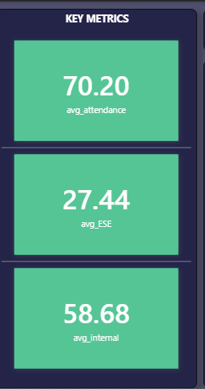
Figure 11.1 : Key metrics
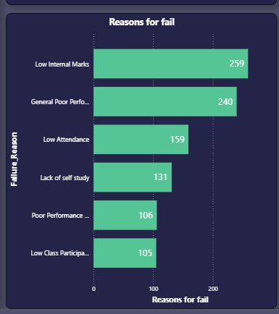
Figure 11.2 : Count of Reason for fail
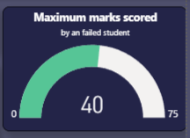
Figure 11.3 : Maximum mark scored by an failed student
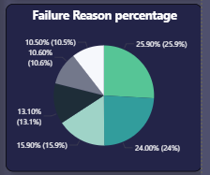
Figure 11.4 : Failure reason percentage
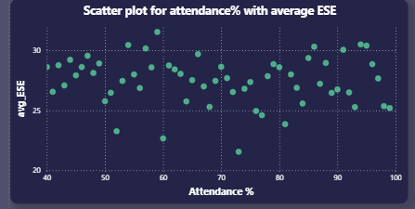
Figure 11.5 : Scatter plot for attendance% with Average End semester exam mark
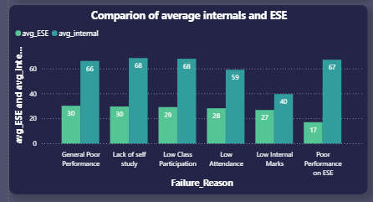
Figure 11.6 : Comparison of Average internals and End semester marks by fail reason
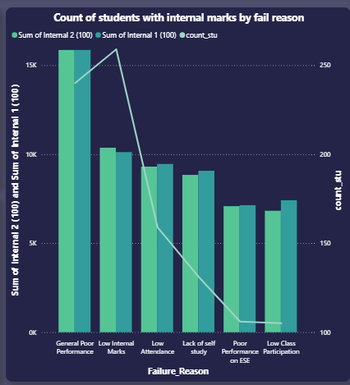
Figure 11.7 : Count of students with internal marks by fail reason
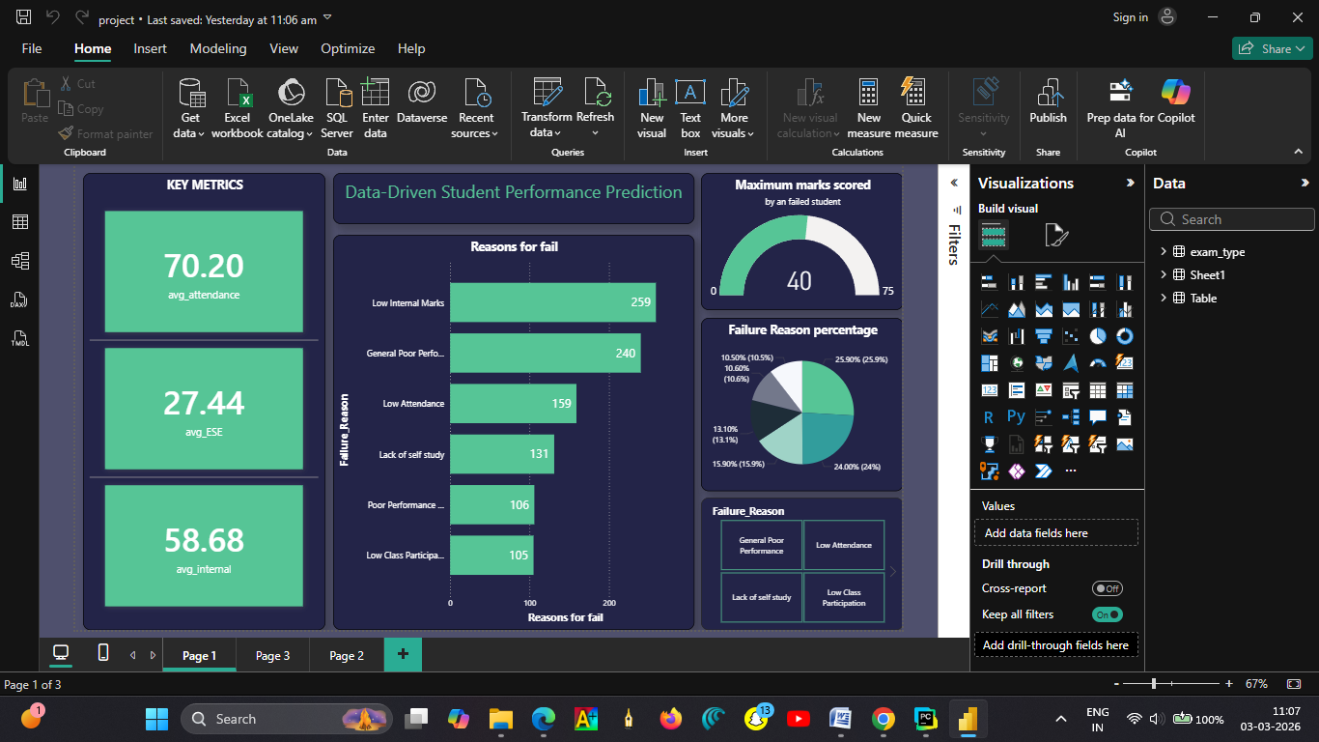
Figure 11.8 : KPI metrics for academic performance monitoring
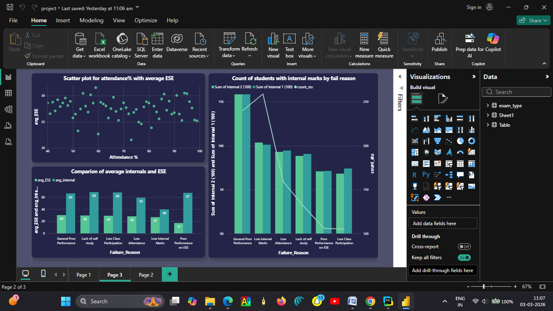
Figure 11.9 : Visual breakdown of student failure cause

