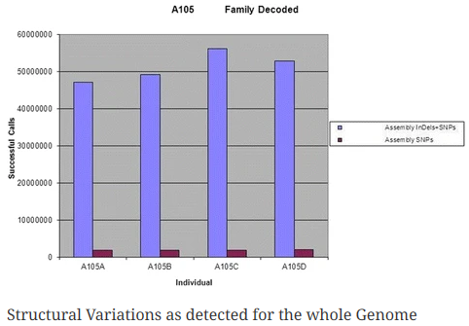

**Fig. 0.** **Here we see the Figure 4. from paper [21] where clearly higher deviation is observed for sum of nucleotides of SNPs plus DIPs (blue) compared to sum of bases for the SNPs (magenta).**

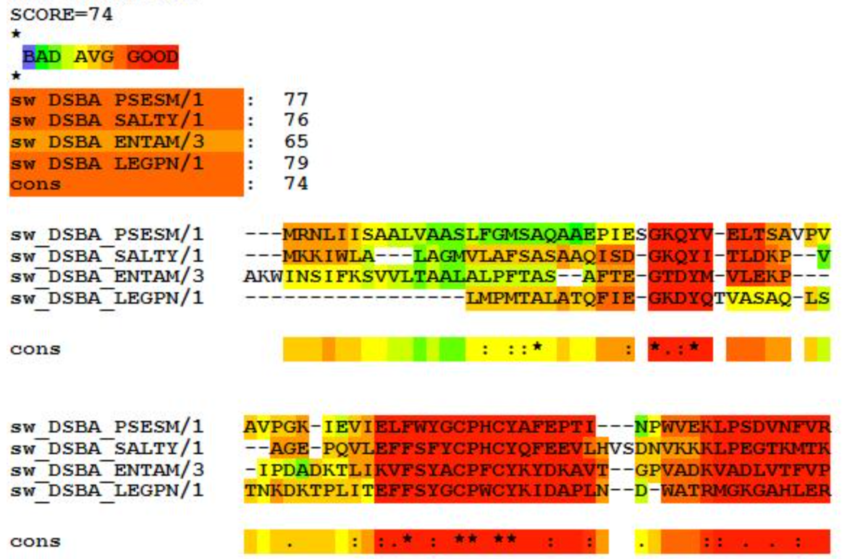

**Figure 2.5** **Example of a sample multiple sequence alignment with consensus regions and the consensus score with individual scores as well (which we call divergence score in this paper).**

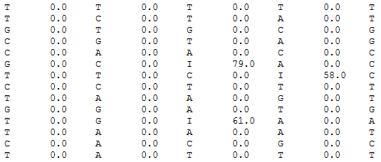

**Figure 3. The DIPs are replaced by the corresponding divergence from consensus score, lying between 0 and 100.**

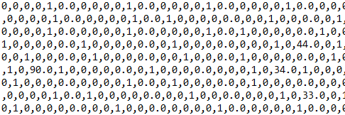

**Figure 4. Now, the single nucleotide variations, SNVs or SNPs, are also one-hot encoded**

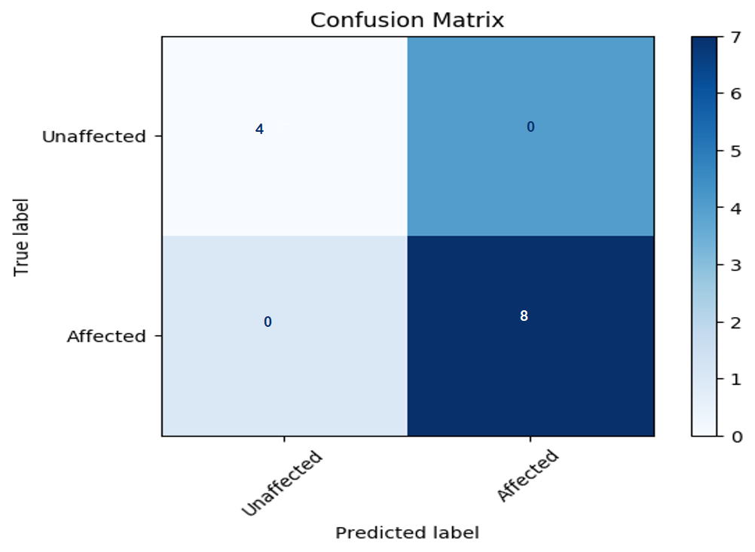

**Figure 4.5. Confusion MATRIX for ExhaustiveDNN model.**

|  |  |
| --- | --- |
|  |  |
|  |  |
|  |  |
|  |  |

**Fig 5. Top left to bottom right: Confusion MATRIX for logistic regression, Naïve Bayes, Gradient Boost, Bagging approach, AdaBoost, RandomForest, Support Vector & Extratree Classifier respectively**