What Happens If a Worker Node Fails?
The System Design Answer Interviewers Want to Hear
One of the most common System Design interview questions is: “What happens if a worker node fails? How would you design the system to recover from it?”
At first it looks like a simple fault-tolerance question. But the interviewer is not looking for one tool like ZooKeeper or Kubernetes. They want to see how you think — whether you can start with a basic idea, find its weak points, and slowly improve the design.
That is exactly how you should answer.

Start by Asking a Clarifying Question
Before giving a solution, ask one important question:
“Are there many worker nodes doing the work, or is there only one worker node?”
This changes the whole answer. There are two cases:
- Many worker nodes are processing tasks.
- Only one worker node handles all the requests.
Let’s look at both.

Scenario 1: Many Worker Nodes
Imagine three workers picking up jobs from a queue. Now suppose Worker B crashes. How does the system recover?
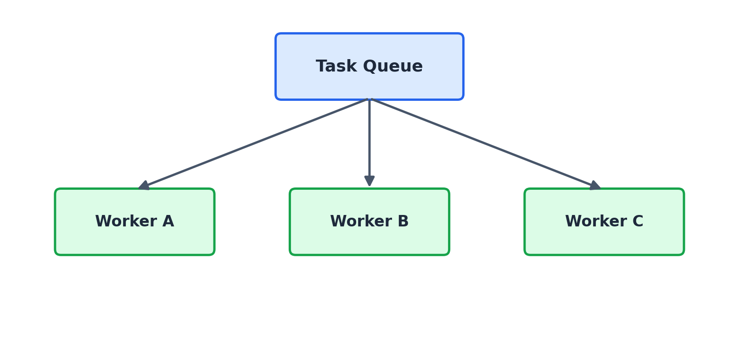

Step 1: Retry Before Assuming Failure
Never decide a worker is dead the moment it stops replying. Many failures are only temporary:
- A short network glitch
- A brief CPU spike
- A garbage-collection pause
- A container restarting
So the first step is always a retry. Try a few times before declaring the worker unhealthy. This avoids unnecessary failovers caused by small, temporary problems.
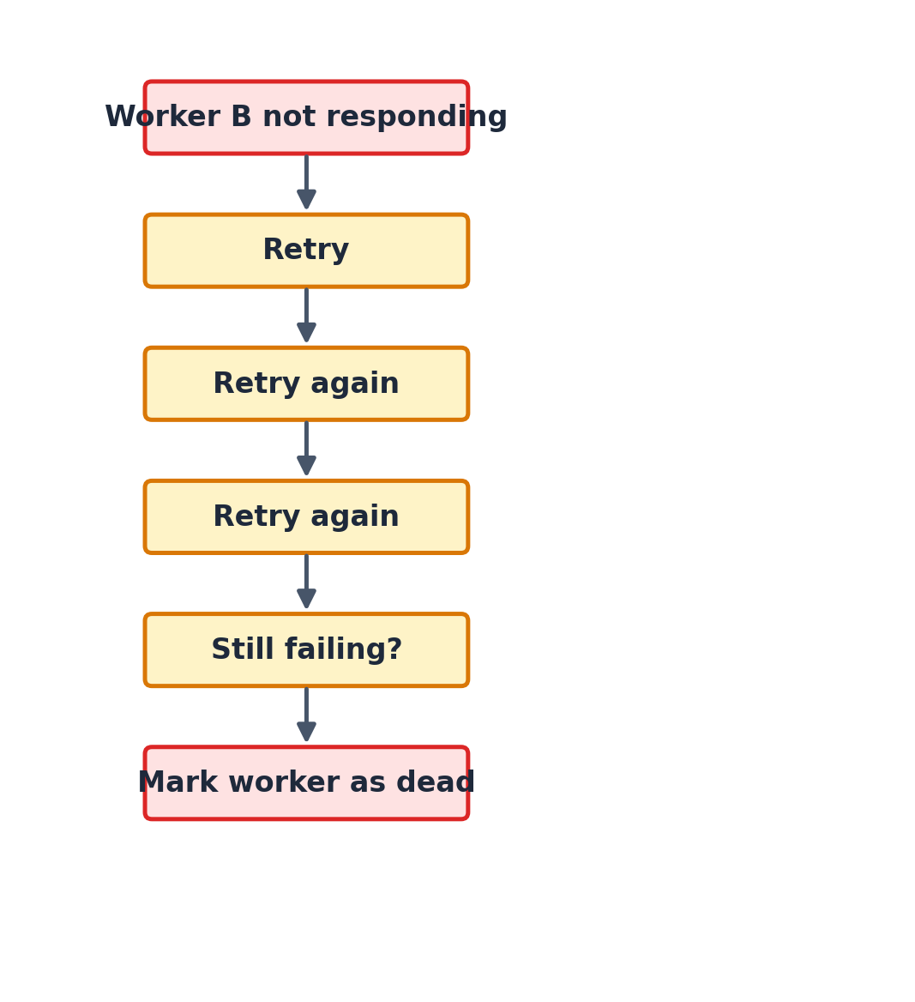

Step 2: Add a Central Coordinator
Once the retries are used up, some component must manage the recovery. This is where a tool like Apache ZooKeeper fits in.
The coordinator keeps checking each worker’s health using heartbeat signals — small “I’m alive” messages sent at regular intervals.
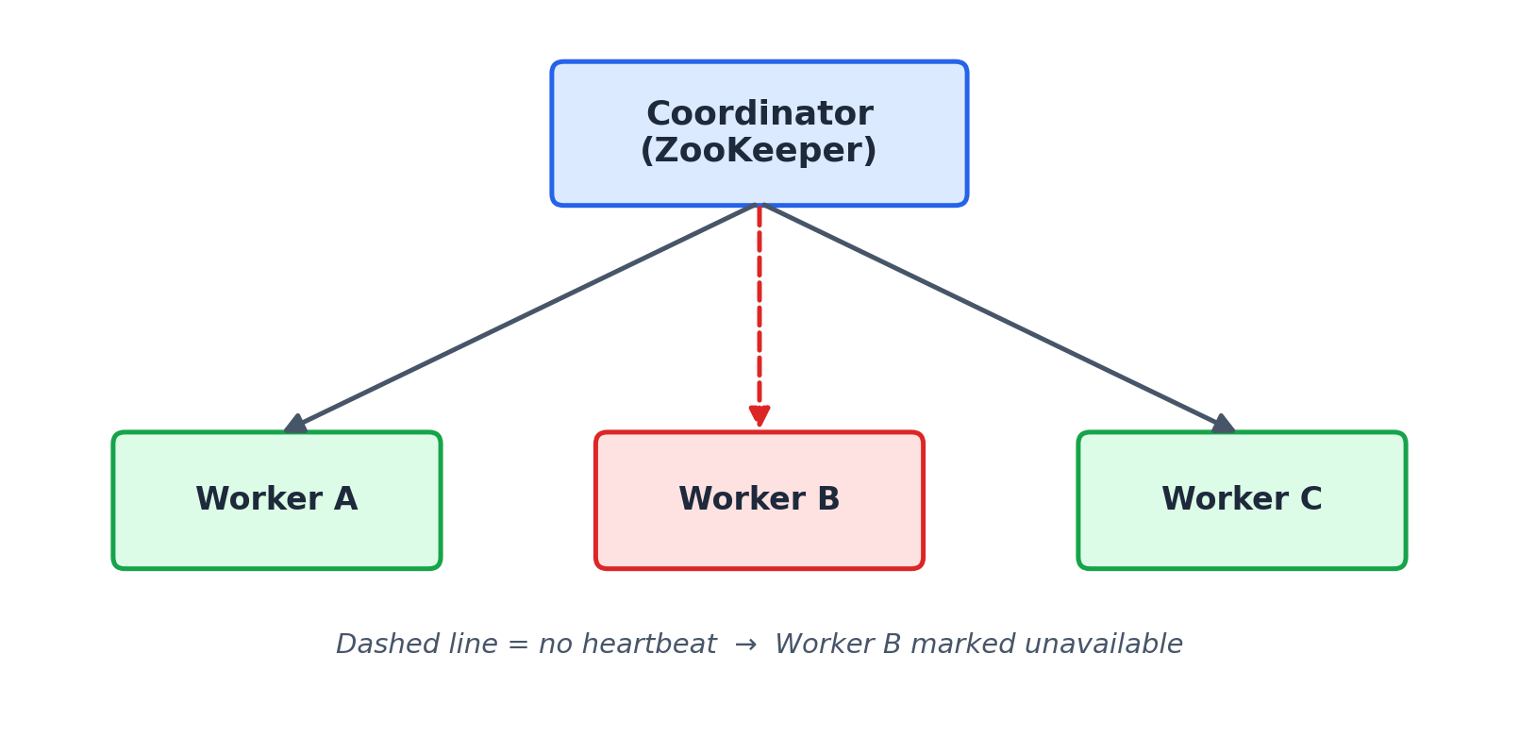
If Worker B stops sending heartbeats, the coordinator:
- Detects the failure,
- Marks Worker B as unavailable, and
- Gives its pending work to Worker A and Worker C.
This is called the Competing Consumers pattern. Instead of one worker owning all the tasks forever, many workers pull work from the same queue — so the system keeps running even if one worker disappears.

A Common Follow-Up
Most interviewers will push further:
“What if Worker B was running a long job? How will Worker A know where to continue?”
This is where many candidates get stuck.

Step 3: Use Checkpoints
The answer is checkpointing. Instead of saving progress only at the very end, the worker saves its progress into permanent storage from time to time.
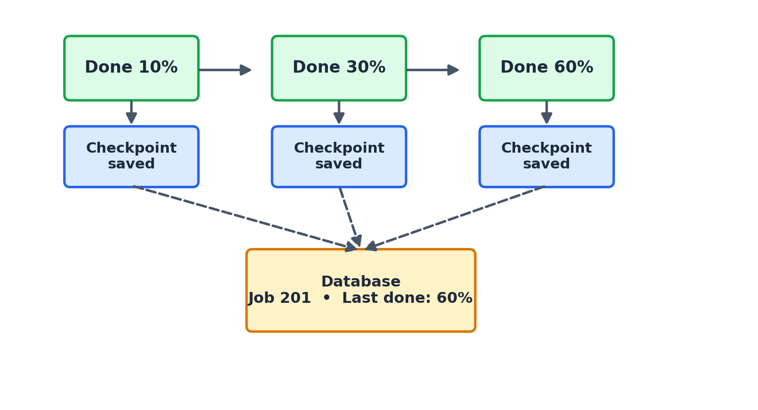
Say Worker B crashes after finishing 60% of the job. Worker A picks up the same job, reads the last checkpoint from the database, and continues from 60% — not from zero.
A simple way to picture the code:
while (job is not finished) {
processNextBatch()
saveCheckpoint(jobId, currentProgress)
}
// After a crash, another worker does:
progress = fetchCheckpoint(jobId)
resumeJob(progress)
This approach:
- Avoids repeating finished work,
- Reduces recovery time, and
- Makes long jobs fault tolerant.
Checkpointing is widely used in batch processing, ETL pipelines, stream-processing systems, and distributed schedulers.

Scenario 2: Only One Worker Node
Now the interviewer changes the problem:
“There is only one worker node handling all writes. What if it crashes?”
This case is very common. Examples include:
- A primary database server,
- A Redis primary node,
- A Kafka controller, or
- A master node in a distributed system.
If that single node goes down, the whole system can become unavailable.

Step 1: Use a Leader–Replica Setup
Instead of trusting one machine, keep several copies. One node is the Leader; the others are Replicas.
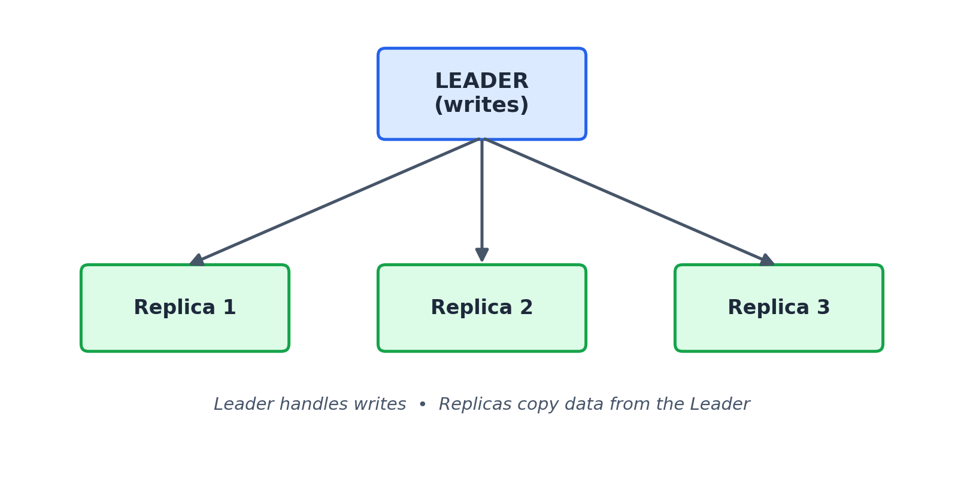
The Leader handles all writes. The Replicas keep copying data from the Leader. As long as the Leader is healthy, everything runs normally.

Step 2: The Leader Fails
Now suppose the Leader crashes. Someone has to decide which Replica becomes the new Leader. This decision cannot be left to each node on its own — otherwise two replicas might both think they are the Leader, which corrupts the data.

Step 3: Leader Election
Again, a coordinator like ZooKeeper solves this. It watches all replicas, and when the Leader fails it:
- Detects the failure,
- Compares the replica states,
- Picks the most up-to-date replica, and
- Promotes it to the new Leader.
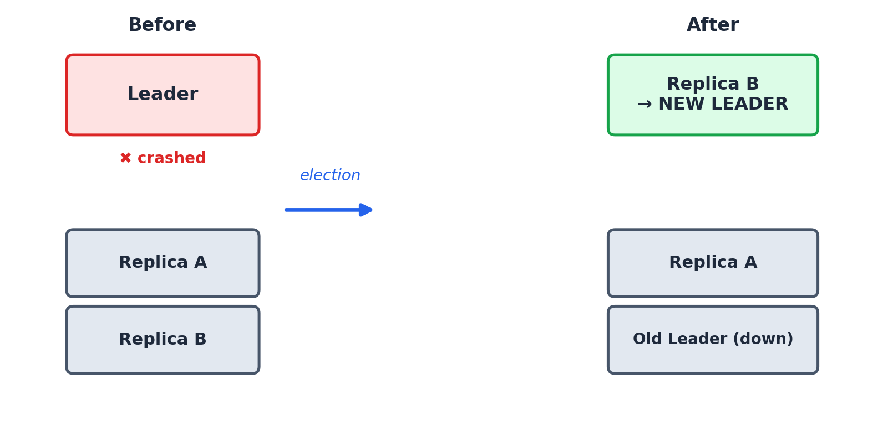
This is called Leader Election. The goal is to keep downtime small while making sure no committed data is lost.

What If the Old Leader Comes Back?
Another great follow-up:
“Suppose the old Leader comes back a few minutes later. What should happen?”
It must not become the Leader again right away. Instead:
- ZooKeeper sees that a new Leader already exists,
- The old Leader is demoted to a Replica,
- It copies all the updates it missed while it was down, and
- Only after it is fully in sync does it act as a normal replica.
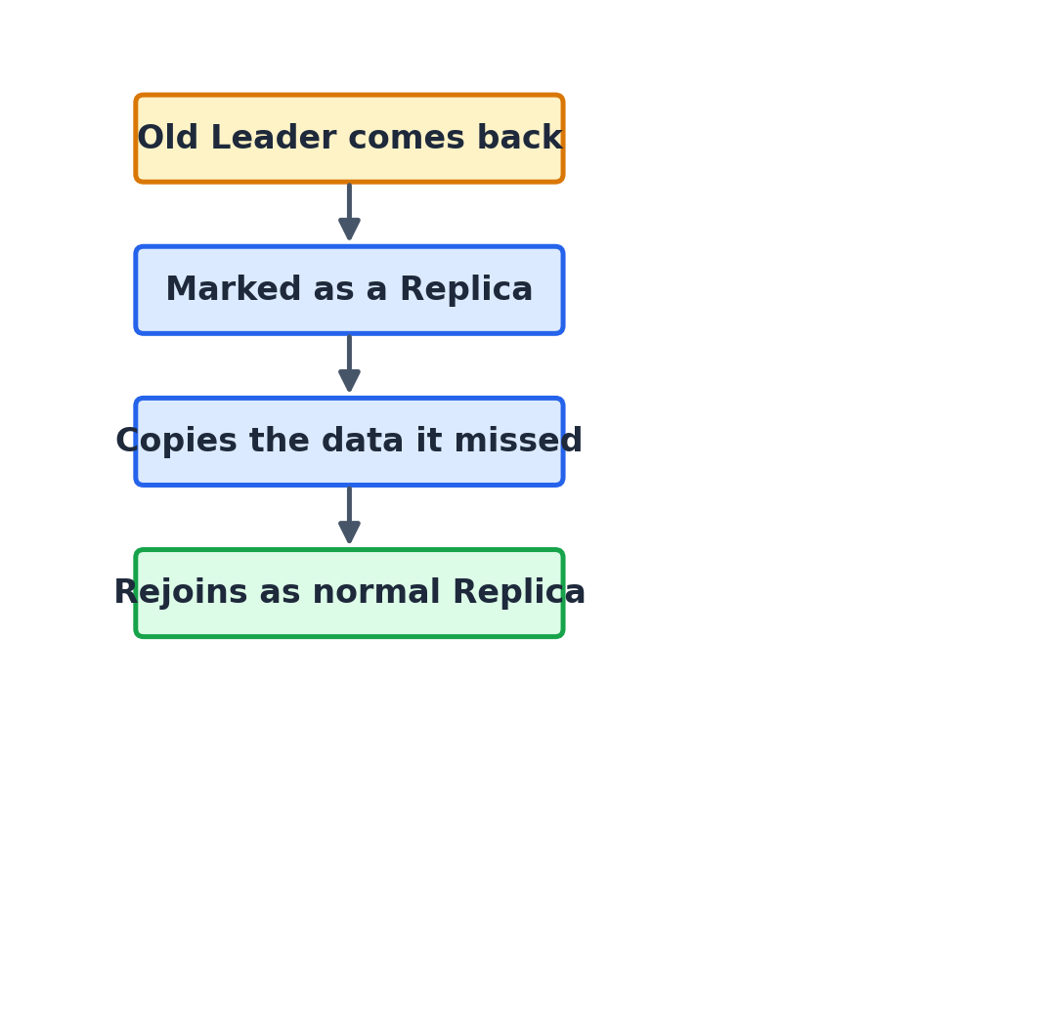
This prevents split-brain situations — where two nodes both think they are in charge — and keeps exactly one active Leader at all times.

Putting It All Together
When answering this question, don’t jump straight to tool names. Walk the interviewer through how your design grows:
- Ask whether there are many workers or a single worker.
- For many workers, start with retries to handle temporary failures.
- Add a coordinator like ZooKeeper to spot real failures and hand work to other workers (Competing Consumers).
- Handle long jobs with checkpoints so a new worker can continue from the last saved point.
- For a single worker, move to a Leader–Replica setup.
- Use Leader Election to promote the most up-to-date replica automatically.
- Let the old Leader rejoin as a Replica instead of taking charge again.

Key Takeaways
Problem | Solution
Worker briefly unresponsive | Retry a few times before giving up
Worker truly dead | Coordinator (ZooKeeper) redistributes its work
Long job interrupted | Checkpoints let another worker resume midway
Single point of failure | Leader–Replica architecture
Leader crashes | Leader Election promotes the best replica
Old leader returns | It rejoins as a replica and syncs missing data

Final Thoughts
Worker node failures are unavoidable in distributed systems. The real challenge is not stopping failures — it is building systems that recover smoothly, with little downtime and no lost data.
Interviewers don’t expect you to memorize every framework or algorithm. They want to see whether you can start with a simple design, find its weak spots, and grow it into a resilient, production-ready architecture. That mindset is what separates strong system designers from people who only know the terminology.

