**Photoshop**

**Experiment: 1**

**The concept of Photoshop.**

*Photoshop Interface Example:-*

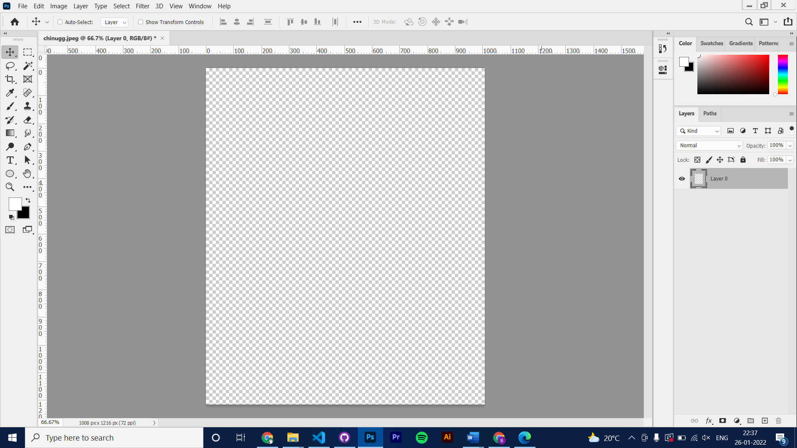

Palettes

Work Area

Menu Bar

Tool Bar

**Experiment: 2**

**How to open a document ?**

**Step – 1**

Open Photoshop

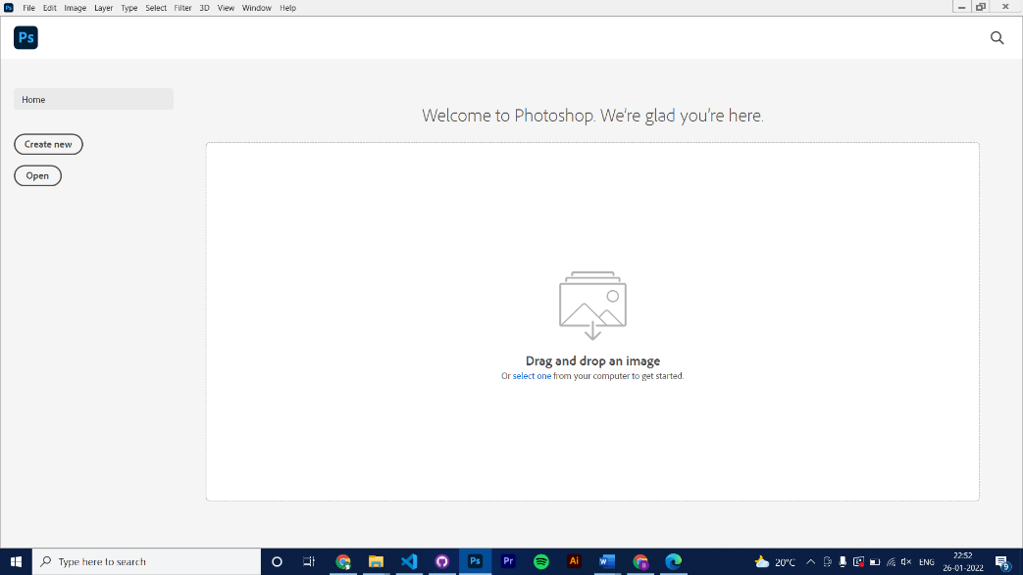

**Step – 2**

Click on open or press **ctrl + o** or go to **FILE >** Click on **New or Open** or you can simply open by **drag and drop.**

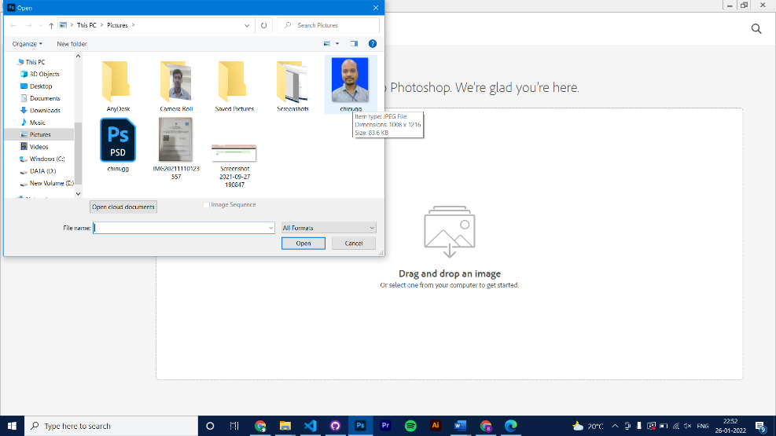

**Experiment 3**

**How to create a new document with needed resolution ?**

**Ans:** Click on **create new**, Then choose your required resolution. Then click on **create**

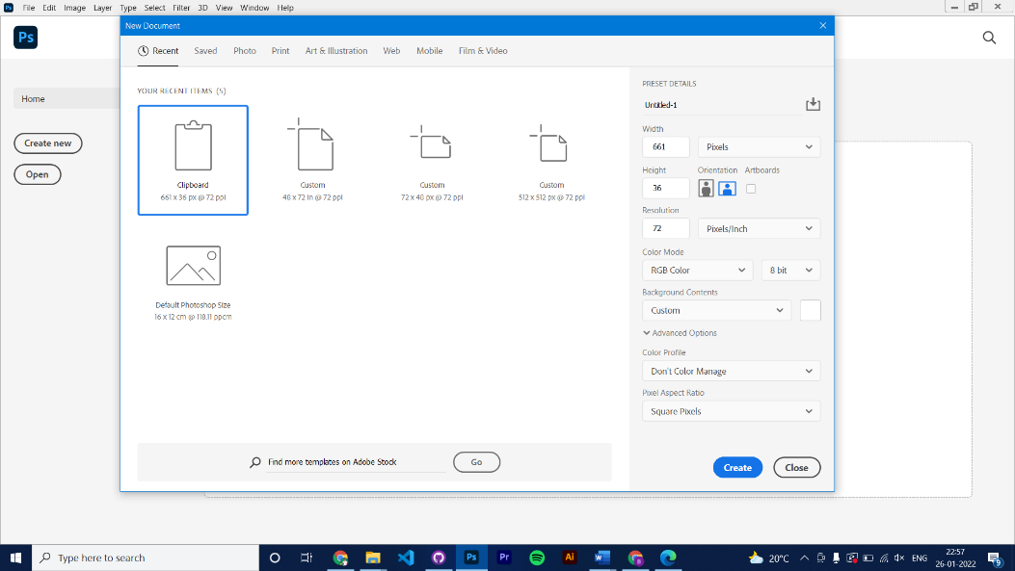

**Experiment 4**

**How to select an area and copy paste the selection ?**

**Ans:** Step-1 : Select required area using lasso tool or marqwee tool

Step 2: Then press ctrl + c to copy the selected area and tap ctrl + v to paste the selection and adjust your selection.

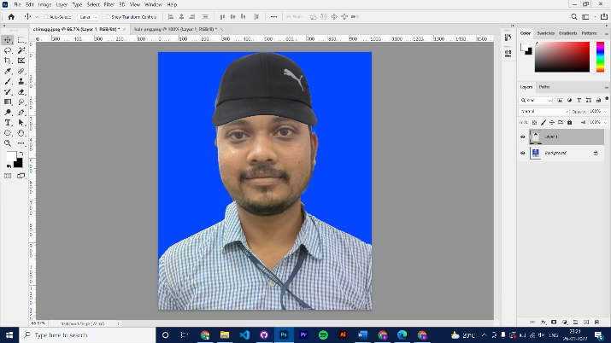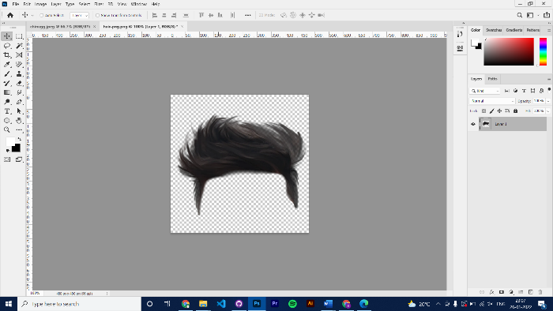

Step 2

Step 1

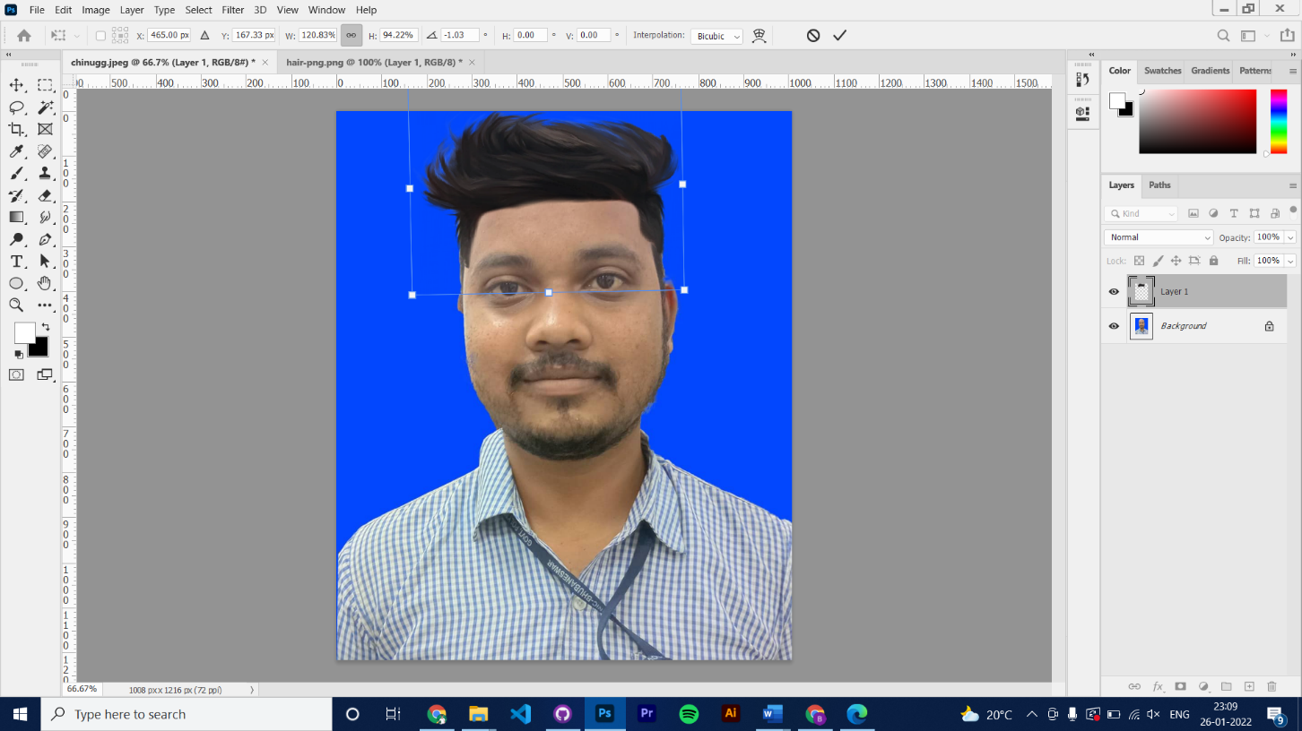

Step 3

**Experiment – 5**

**How to save images for the web and their formats ?**

Ans: Click on **file > Save** as or Press **Shift + Ctrl + s.** Then choose your required format and click on save.

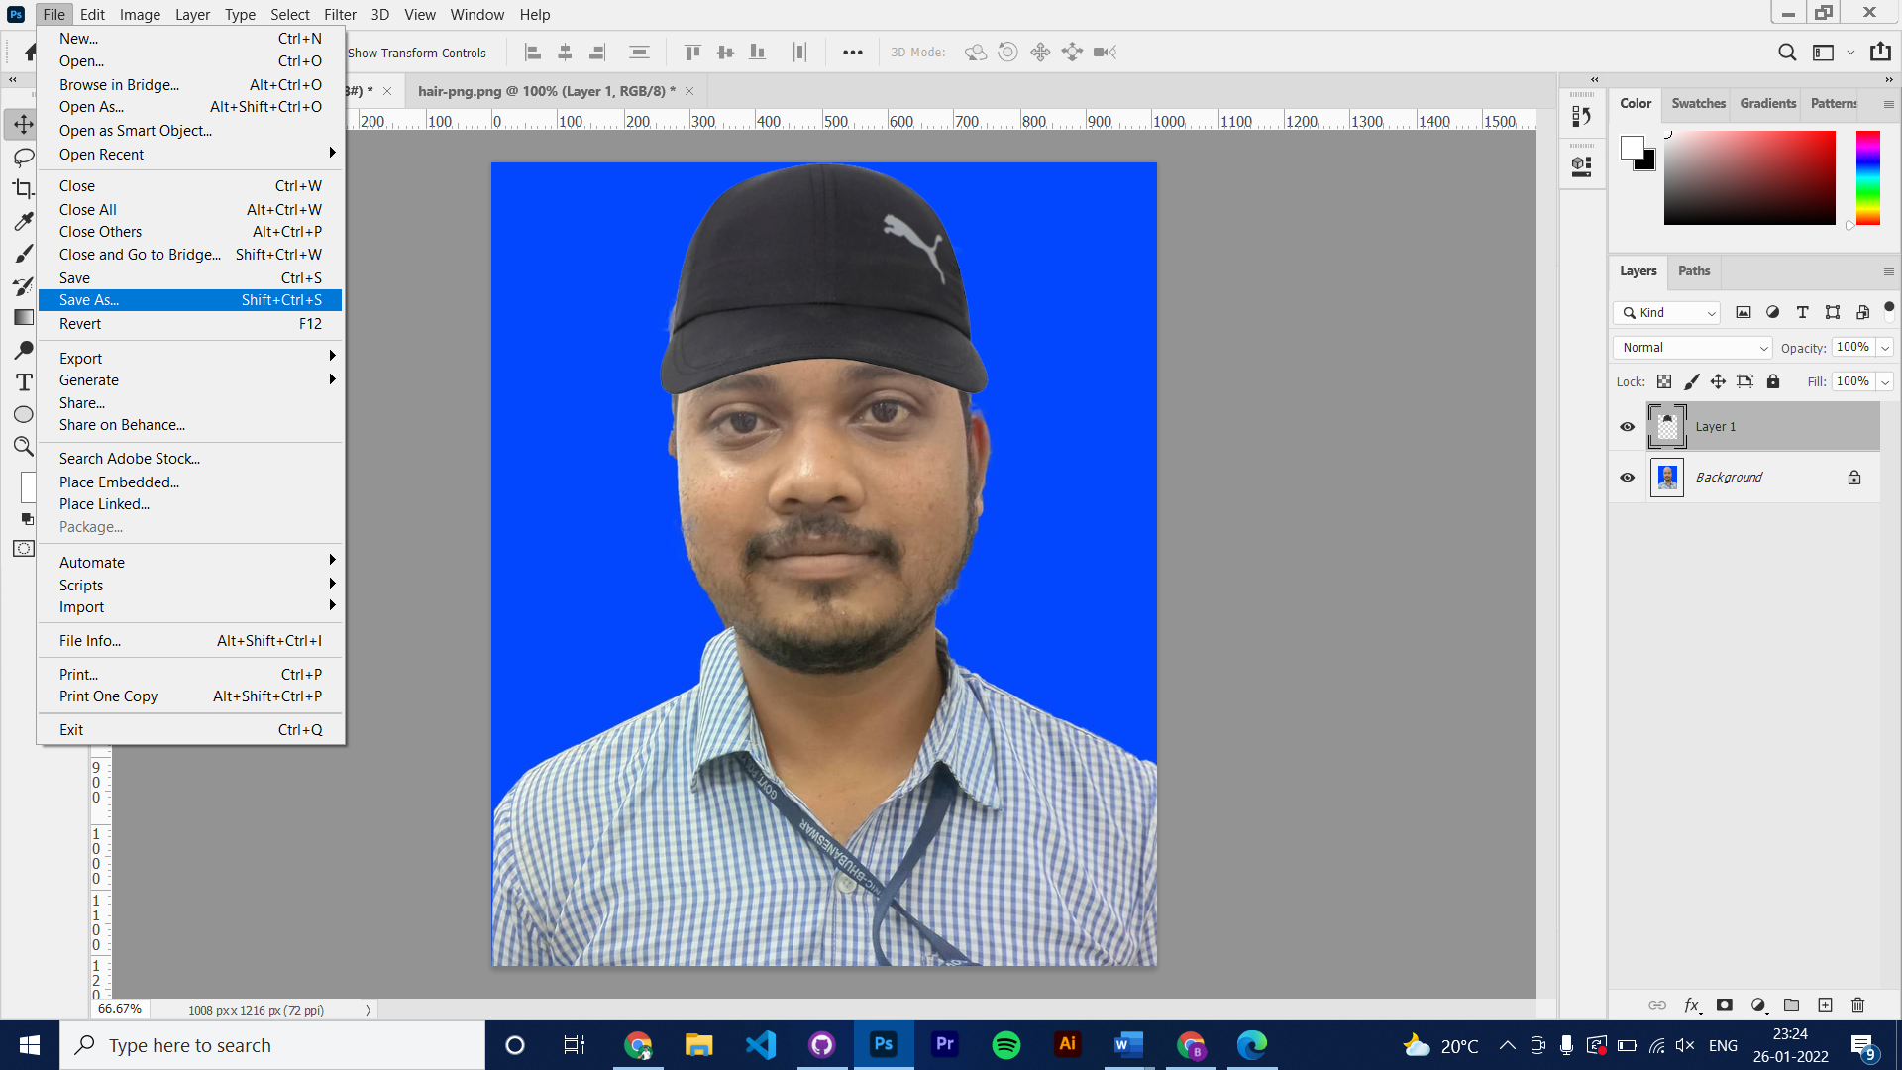

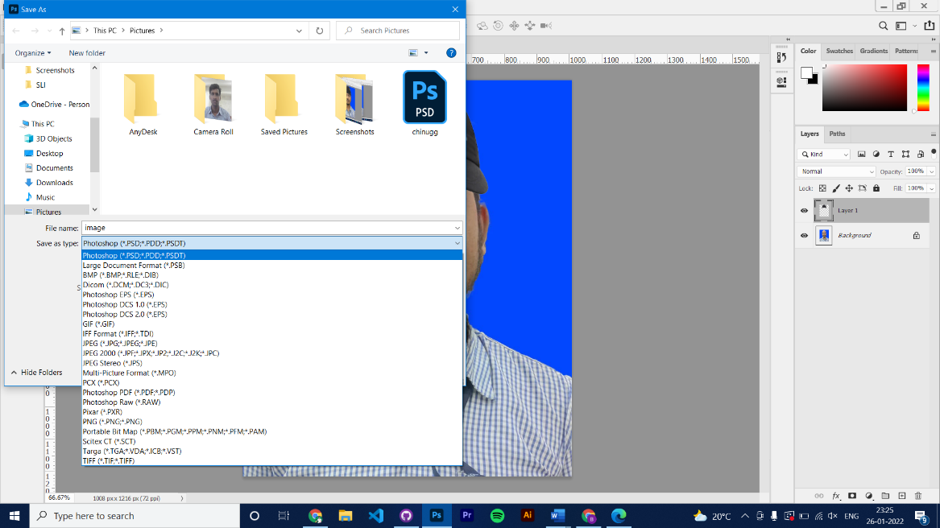

Step - 2

Step - 1