
MINI PROJECT
Real-Time JPEG-Style Colour Image Compression
on FPGA with Live Camera Input
DE2-115 (Cyclone IV E) | TRDB-D5M Camera | VGA Display | Verilog HDL
Submitted to
JAGANNADHA NAIDU K
Submitted by
Aditya Prakash Chaurasia (26MVD0090)
Team Members
Name | Register No.
Aditya Prakash Chaurasia | 26MVD0090
Abinash R | 26MVD0104
Dev Vijay | 26MVD0093

Vellore Institute of Technology, Vellore
November 2026

Table of Contents

(If page numbers are not shown, right-click the table and choose Update Field.)

1. Objective and Specification

1.1 Objective
The objective of this mini project is to design and implement, entirely in Verilog HDL, a real-time image compression system on the Altera DE2-115 FPGA board. The system captures a colour picture from a TRDB-D5M camera, compresses it in hardware using the main steps of the JPEG standard, and shows the original and the compressed picture side by side on a VGA monitor. The memory saved by the compression is shown on the seven-segment displays.
The specific goals were:
- Capture a 320 x 320 colour picture from a live camera, both as a single snapshot and continuously.
- Implement the core of JPEG compression in hardware: colour conversion, chroma subsampling, 8 x 8 DCT, quantization, zigzag ordering and run-length coding.
- Make the trade-off between picture quality and compression visible on screen and measurable as a number.
- Use only Verilog HDL (no IP cores, no software processor) and keep every memory on the FPGA chip.

1.2 Features Implemented
- Live camera input: the TRDB-D5M camera is configured over I2C by our own Verilog I2C master; its Bayer output is converted to 320 x 320 RGB pixels.
- Snapshot and live modes: KEY1 takes one picture; with SW17 on, the system keeps capturing and compressing (about 3-4 pictures per second).
- JPEG-style colour compression: RGB to YCbCr, 4:2:0 chroma subsampling, 8 x 8 DCT, JPEG standard luminance and chrominance quantization tables, zigzag scan and run-length bit counting.
- Four compression levels: SW1-SW0 scale the quantization tables by 1, 2, 4 or 8.
- Side-by-side display: VGA 640 x 480 at 60 Hz, original picture on the left and decompressed picture on the right.
- Memory saved display: the percentage of memory saved, with one decimal place, on HEX3-HEX0.
- Camera adjustments: exposure (SW16-SW13) and Bayer colour order (SW3-SW2) can be changed without recompiling.
- Hardware-efficient design: one shared multiplier for all DCT/IDCT work, no dividers (multiply-and-shift instead), fixed-point arithmetic, and a safe asynchronous FIFO between the camera clock and the system clock.
- Status LEDs: LEDG1 camera configured, LEDG2 capturing, LEDG0 compression finished.

1.3 Specifications
Parameter | Value
Target device | Altera Cyclone IV E EP4CE115F29C7 on the Terasic DE2-115 board
Design language | Verilog HDL only (no IP cores)
Image size | 320 x 320 pixels, colour
Camera | Terasic TRDB-D5M, 5 MP; centre 1280 x 1280 window, 2x row/column skip -> 640 x 640 Bayer frame
Pixel storage | RGB565 (16 bits per pixel)
Colour space | YCbCr with 4:2:0 subsampling (Y 320 x 320, Cb and Cr 160 x 160)
Transform | 8 x 8 2-D DCT and IDCT, fixed-point constants scaled by 4096
Quantization | JPEG standard luminance and chrominance tables, scaled x1 / x2 / x4 / x8
Size estimate | Zigzag scan, DC difference coding, run-length symbols of 8 bits, end-of-block symbol
System clock | 25 MHz, derived from the 50 MHz on-board oscillator
Compression time | About 5.53 million clock cycles = 0.22 s per picture
Display | VGA 640 x 480 at 60 Hz
Result display | Memory saved in %, one decimal, on HEX3-HEX0
On-chip memory used | About 2.87 Mbit (about 350 of the 432 M9K blocks)

1.4 Components Required
Component | Details | Used for
DE2-115 FPGA board | Cyclone IV E EP4CE115F29C7, 50 MHz clock, VGA DAC (ADV7123), 8 seven-segment displays, switches, keys, LEDs | Runs the complete design
TRDB-D5M camera module | 5 MP CMOS sensor (2592 x 1944), 12-bit output, I2C configuration, 40-pin ribbon cable | Live picture source (GPIO header)
VGA monitor and cable | Any monitor supporting 640 x 480 at 60 Hz | Shows original and compressed pictures
USB-Blaster cable | On-board USB-Blaster (USB type-B) | Programming the FPGA
Power adapter | 12 V DC adapter supplied with the board | Board power
PC with Quartus Prime | Quartus Prime 25.1 Standard Edition | Synthesis, fitting, programming
ModelSim | ModelSim - Intel FPGA Edition | Simulation of the compression engine
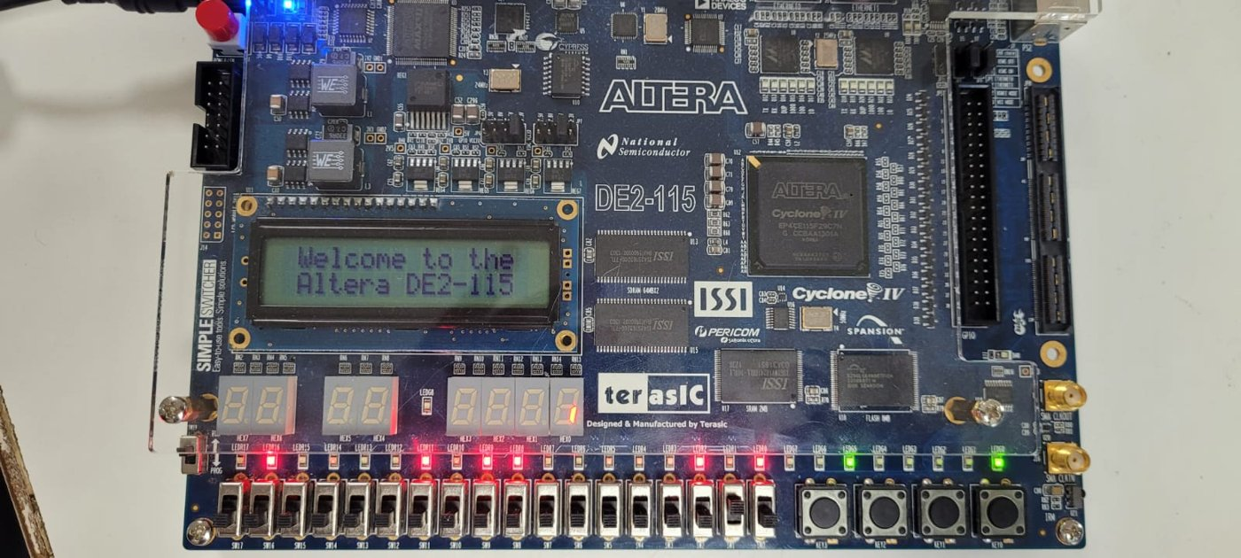
Figure 1.1: DE2-115 FPGA board used in the project
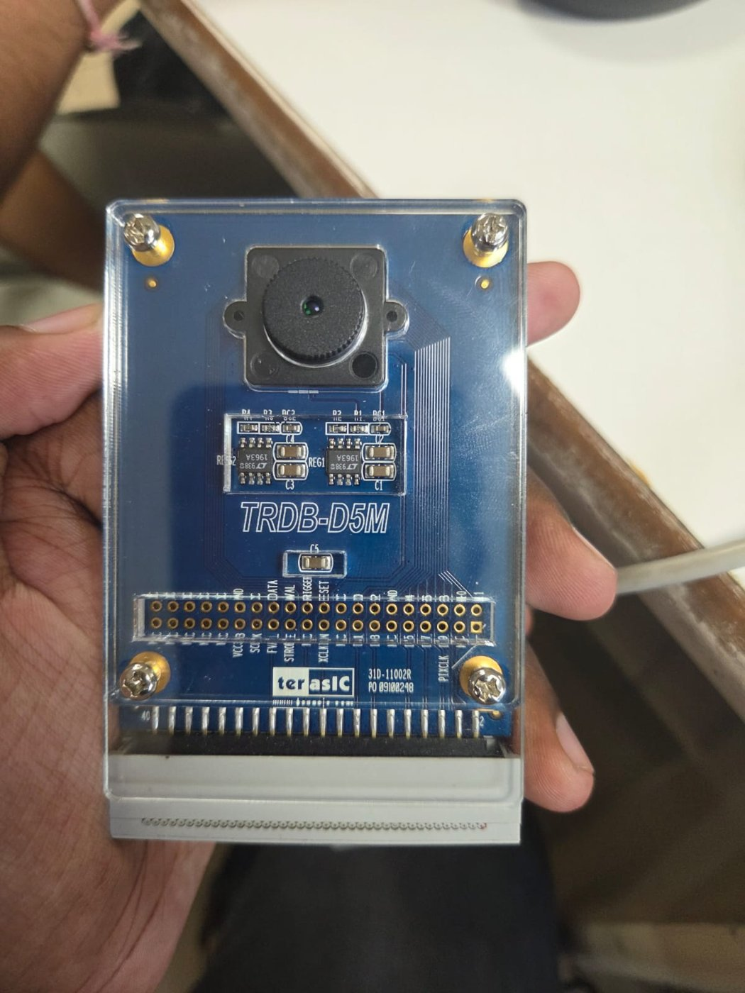
Figure 1.2: TRDB-D5M camera module with its 40-pin ribbon cable

1.5 User Controls
Control | Function
KEY0 | Reset: configure the camera again, take a picture and compress it
KEY1 | Take one new picture and compress it (snapshot mode)
SW17 | 1 = live mode (capture and compress continuously), 0 = snapshot mode
SW16-SW13 | Camera exposure, 0000 = darkest to 1111 = brightest (press KEY0 after changing)
SW3-SW2 | Bayer colour order of the camera pixels (choose the setting with natural colours)
SW1-SW0 | Compression strength: 00 = light, 01 = medium, 10 = strong, 11 = very strong
LEDG0 / LEDG1 / LEDG2 | Compression finished / camera configured / capturing
HEX3-HEX0 | Memory saved in %, e.g. 96 4 = 96.4 %; dashes while compressing

2. Architecture and Block Diagram

2.1 System Block Diagram
Figure 2.1 shows the complete system. The camera blocks run on the camera's own pixel clock (PIXCLK); everything else runs on a single 25 MHz clock. The asynchronous FIFO is the only place where data crosses between the two clocks.
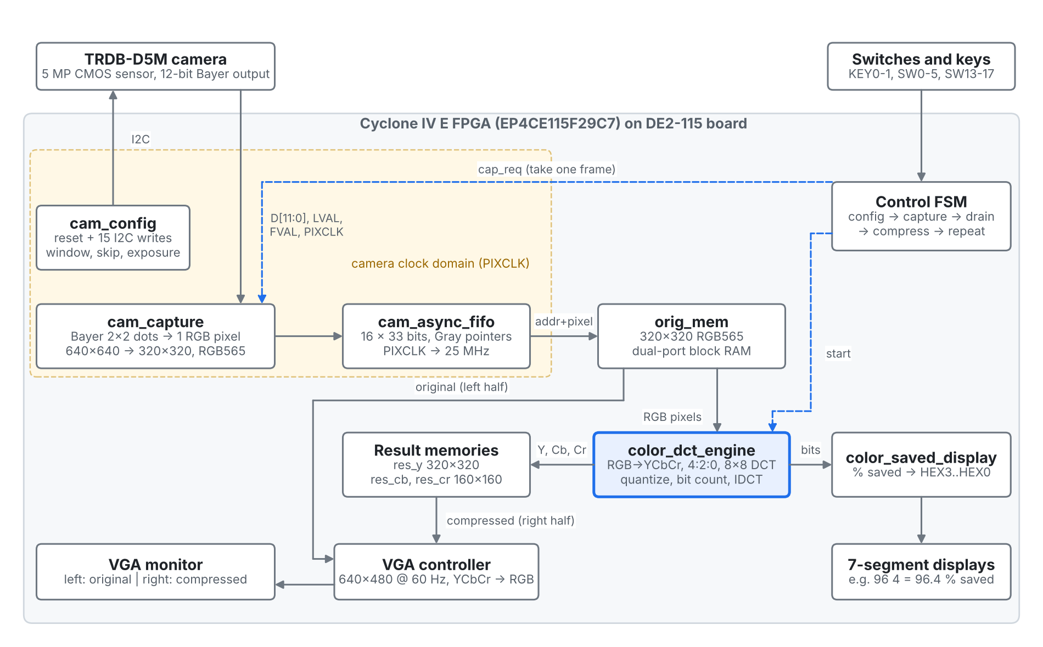
Figure 2.1: System block diagram
A picture passes through five stages:
- Camera set-up (cam_config): after power-up or KEY0 the camera is reset and 15 registers are written over I2C. They select a 1280 x 1280 window in the centre of the sensor, skip every second row and column (640 x 640 output), and set exposure and colour gains.
- Capture (cam_capture): on a capture request the module waits for the start of the next frame and processes one complete frame. Each 2 x 2 group of Bayer dots (G R / B G) becomes one RGB pixel, giving 320 x 320 pixels in RGB565 format.
- Clock crossing (cam_async_fifo): pixels and their addresses are passed through a 16-entry FIFO with Gray-code pointers into the 25 MHz domain and written into orig_mem.
- Compression (color_dct_engine): the engine reads orig_mem, converts pixels to Y, Cb and Cr, and compresses each 8 x 8 block. It writes the decompressed values into three result memories and counts the compressed size in bits.
- Display: the VGA controller shows orig_mem on the left and the result memories (converted back to RGB) on the right; color_saved_display shows the memory saved on the seven-segment displays.

2.2 Module Description
Module (file) | Clock | Function
cam_jpeg_top.v | 25 MHz | Top-level entity: board pins, control FSM, original and result memories, VGA timing, YCbCr to RGB conversion
cam_config.v | 25 MHz | Camera reset and I2C master that writes 15 camera registers (window, skipping, exposure, gains)
cam_capture.v | PIXCLK | Captures exactly one frame; line buffer; Bayer 2 x 2 to RGB565; pixel address generation
cam_async_fifo.v | PIXCLK / 25 MHz | 16 x 33-bit asynchronous FIFO with Gray-code pointers and 2-flip-flop synchronisers
color_dct_engine.v | 25 MHz | JPEG-style compression: RGB to YCbCr, 4:2:0, DCT, quantization, zigzag and run-length bit count, IDCT
color_saved_display.v | - | Converts the compressed bit count to % saved and drives HEX3-HEX0 (combinational)

2.3 Compression Algorithm
The engine processes the Y channel as 40 x 40 = 1,600 blocks and the Cb and Cr channels as 20 x 20 = 400 blocks each. Every 8 x 8 block goes through the steps in Figure 2.2.
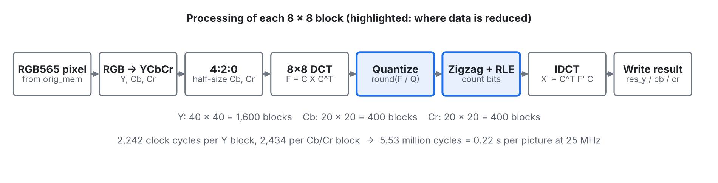
Figure 2.2: Processing of one 8 x 8 block inside color_dct_engine
- Colour conversion: Y = 0.299R + 0.587G + 0.114B, Cb = -0.169R - 0.331G + 0.5B + 128, Cr = 0.5R - 0.419G - 0.081B + 128. In hardware the coefficients are multiplied by 256 (77, 150, 29, ...) so that only integer multiplication and a shift are needed.
- 4:2:0 subsampling: each Cb and Cr sample is the average of a 2 x 2 group of pixels, so the colour channels are stored at 160 x 160. This alone halves the amount of data.
- Level shift and 2-D DCT: 128 is subtracted from Y and the block X is transformed as F = C X C^T, where C[u][i] = c(u) cos((2i+1)u pi / 16), c(0) = sqrt(1/8) and c(u) = sqrt(2/8). The constants are stored multiplied by 4096. The 2-D DCT is computed as two 8 x 8 matrix multiplications of 512 multiply-accumulate cycles each, using one shared multiplier.
- Quantization: each coefficient is divided by its entry in the JPEG table (scaled by 1, 2, 4 or 8) and rounded. Division is done as multiplication by a stored reciprocal 65536/Q followed by a shift. Most high-frequency coefficients become zero; this is where information is discarded.
- Zigzag and run-length bit count: coefficients are visited in zigzag order. The DC coefficient costs 4 bits plus the size of its difference from the previous block; each non-zero AC coefficient costs an 8-bit (run, size) symbol plus its value bits; 16 zeros in a row cost an 8-bit ZRL symbol; the trailing zeros cost one 8-bit end-of-block symbol. The sum is the compressed size, total_bits.
- Dequantization and IDCT: the quantized coefficients are multiplied back by the table and transformed back with X' = C^T F' C. After adding 128 and limiting to 0..255, the values are written to the result memories for display.
One Y block takes 2,242 clock cycles and one Cb/Cr block 2,434 cycles, so a full picture takes 1,600 x 2,242 + 800 x 2,434 = 5,534,400 cycles, about 0.22 s at 25 MHz.

2.4 Control State Machine
The control FSM in cam_jpeg_top sequences the whole system (Figure 2.3). Capture and compression never run at the same time, which allows the camera and the engine to share one port of orig_mem.
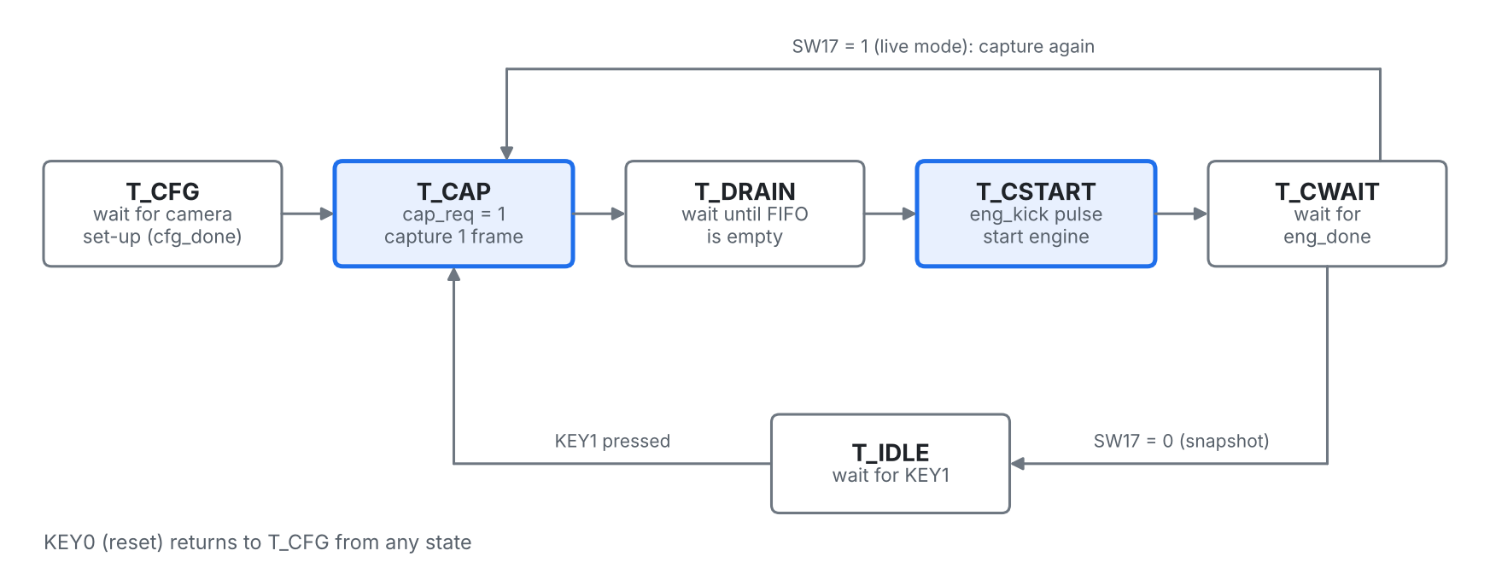
Figure 2.3: Control state machine
State | Action | Next state
T_CFG | Wait for cam_config to finish | T_CAP when cfg_done = 1
T_CAP | cap_req = 1, one frame is captured | T_DRAIN when cap_done arrives
T_DRAIN | Wait until the FIFO is empty (all pixels in orig_mem) | T_CSTART
T_CSTART | One-clock pulse that restarts the engine | T_CWAIT
T_CWAIT | Wait for eng_done | T_CAP if SW17 = 1, otherwise T_IDLE
T_IDLE | Wait for KEY1 | T_CAP when KEY1 is pressed

2.5 Memory Organisation
Memory | Size | Bits | Written by | Read by
orig_mem | 102,400 x 16 (RGB565) | 1,638,400 | Camera (through FIFO) | Engine and VGA (left half)
res_y | 102,400 x 8 | 819,200 | Engine, Y pass | VGA (right half)
res_cb | 25,600 x 8 (160 x 160) | 204,800 | Engine, Cb pass | VGA (right half)
res_cr | 25,600 x 8 (160 x 160) | 204,800 | Engine, Cr pass | VGA (right half)
Total |  | 2,867,200 |  | about 350 of 432 M9K blocks

3. Verilog Code
The design consists of six Verilog files. cam_jpeg_top is the top-level entity. All code is written in Verilog-2001 and synthesised with Quartus Prime 25.1 Standard Edition.

3.1 cam_jpeg_top.v (top-level entity)
Connects all modules to the board pins, contains the control FSM, the original and result memories, the VGA controller and the YCbCr to RGB conversion.
// ============================================================
// cam_jpeg_top : LIVE CAMERA + JPEG-style colour compression (DE2-115 + TRDB-D5M)
//
// LEFT of screen : camera snapshot (320 x 320 colour)
// RIGHT of screen : the same snapshot after compression
// HEX3..HEX0 : memory saved in %
//
// KEY0 : reset (set up camera again, take a new picture)
// KEY1 : take a new picture and compress it
// SW17 : 1 = live mode (keep taking + compressing pictures)
// SW16..SW13 : exposure (brightness) - press KEY0 after changing
// SW3 SW2 : colour order of the camera pixels (try until colours look right)
// SW1 SW0 : compression strength
// LEDG0 : compression finished
// LEDG1 : camera set up
// LEDG2 : capturing a picture
//
// Flow: camera -> cam_capture (camera clock) -> cam_async_fifo
// -> orig_mem (25 MHz) -> color_dct_engine -> res_y / res_cb / res_cr
// -> VGA
// ============================================================
module cam_jpeg_top (
input wire CLOCK_50,
input wire [1:0] KEY,
input wire [17:0] SW,

output reg [7:0] VGA_R,
output reg [7:0] VGA_G,
output reg [7:0] VGA_B,
output reg VGA_HS,
output reg VGA_VS,
output wire VGA_CLK,
output reg VGA_BLANK_N,
output wire VGA_SYNC_N,

output wire [2:0] LEDG,
output wire [6:0] HEX0, HEX1, HEX2, HEX3, HEX4, HEX5, HEX6, HEX7,

// TRDB-D5M camera (on the GPIO connector)
input wire [11:0] D5M_D,
input wire D5M_FVAL,
input wire D5M_LVAL,
input wire D5M_PIXLCK,
output wire D5M_RESET_N,
output wire D5M_SCLK,
inout wire D5M_SDATA,
output wire D5M_TRIGGER,
output wire D5M_XCLKIN
);

wire reset = ~KEY[0];

// ---------- 25 MHz clock (VGA, engine, and the camera's input clock) ----------
reg clk25 = 1'b0;
always @(posedge CLOCK_50) clk25 <= ~clk25;

assign D5M_XCLKIN = clk25;
assign D5M_TRIGGER = 1'b1;

// ---------- 1. Camera set-up over I2C ----------
wire cfg_done;
cam_config config_unit (
.clk (clk25),
.reset (reset),
.exposure_sel (SW[16:13]),
.cam_reset_n (D5M_RESET_N),
.sclk (D5M_SCLK),
.sdata (D5M_SDATA),
.done (cfg_done)
);

// ---------- 2. Capture one frame (camera clock domain) ----------
reg cap_req = 1'b0;
wire cap_done;
wire cam_wen;
wire [32:0] cam_wdata;

cam_capture capture_unit (
.pclk (D5M_PIXLCK),
.d (D5M_D),
.lval (D5M_LVAL),
.fval (D5M_FVAL),
.bayer_phase (SW[3:2]),
.cap_req (cap_req),
.cap_done (cap_done),
.wen (cam_wen),
.wdata (cam_wdata)
);

// ---------- 3. Cross from camera clock to 25 MHz ----------
wire [32:0] fifo_q;
wire fifo_empty;
wire fifo_full;

cam_async_fifo #(.W(33), .AW(4)) fifo_unit (
.wclk (D5M_PIXLCK),
.wen (cam_wen),
.wdata (cam_wdata),
.wfull (fifo_full),
.rclk (clk25),
.ren (1'b1), // always take a pixel when one is there
.rdata (fifo_q),
.rempty (fifo_empty)
);

wire pix_we = ~fifo_empty;
wire [16:0] pix_addr = fifo_q[32:16];
wire [15:0] pix_rgb = fifo_q[15:0];

// ---------- 4. Control: capture -> compress -> (repeat in live mode) ----------
localparam T_CFG = 3'd0, T_CAP = 3'd1, T_DRAIN = 3'd2,
T_CSTART = 3'd3, T_CWAIT = 3'd4, T_IDLE = 3'd5;

reg [2:0] ctl = T_CFG;
reg [1:0] capdone_s = 2'b00; // cap_done synchronised to 25 MHz
reg [2:0] key1_s = 3'b000; // KEY1 synchronised, for edge detection
reg [3:0] dly = 4'd0;
reg eng_kick = 1'b0; // 1-clock pulse: start the engine
reg first = 1'b1; // no picture compressed yet
wire eng_done;

always @(posedge clk25) begin
capdone_s <= {capdone_s[0], cap_done};
key1_s <= {key1_s[1:0], ~KEY[1]};
eng_kick <= 1'b0;

if (reset) begin
ctl <= T_CFG;
cap_req <= 1'b0;
first <= 1'b1;
end else begin
case (ctl)
T_CFG: // wait for camera set-up
if (cfg_done) ctl <= T_CAP;

T_CAP: begin // ask for one frame
cap_req <= 1'b1;
if (capdone_s[1]) begin
cap_req <= 1'b0;
dly <= 4'd0;
ctl <= T_DRAIN;
end
end

T_DRAIN: // let the FIFO empty out
if (!capdone_s[1] && fifo_empty) begin
dly <= dly + 4'd1;
if (dly == 4'd15) ctl <= T_CSTART;
end else
dly <= 4'd0;

T_CSTART: begin // start compression
eng_kick <= 1'b1;
first <= 1'b0;
dly <= 4'd0;
ctl <= T_CWAIT;
end

T_CWAIT: begin // wait until compression is done
if (dly != 4'd15) dly <= dly + 4'd1;
else if (eng_done) ctl <= SW[17] ? T_CAP : T_IDLE;
end

T_IDLE: // wait for KEY1
if (key1_s[1] && !key1_s[2]) ctl <= T_CAP;

default: ctl <= T_CFG;
endcase
end
end

assign LEDG[0] = eng_done & ~first;
assign LEDG[1] = cfg_done;
assign LEDG[2] = (ctl == T_CAP);

// ---------- VGA 640x480 timing ----------
localparam H_VISIBLE = 640, H_FRONT = 16, H_SYNC = 96, H_BACK = 48;
localparam V_VISIBLE = 480, V_FRONT = 10, V_SYNC = 2, V_BACK = 33;
localparam H_TOTAL = H_VISIBLE + H_FRONT + H_SYNC + H_BACK;
localparam V_TOTAL = V_VISIBLE + V_FRONT + V_SYNC + V_BACK;

reg [9:0] x = 0, y = 0;
always @(posedge clk25) begin
if (x == H_TOTAL - 1) begin
x <= 0;
y <= (y == V_TOTAL - 1) ? 10'd0 : y + 10'd1;
end else
x <= x + 10'd1;
end

wire hs_now = ~((x >= H_VISIBLE + H_FRONT) && (x < H_VISIBLE + H_FRONT + H_SYNC));
wire vs_now = ~((y >= V_VISIBLE + V_FRONT) && (y < V_VISIBLE + V_FRONT + V_SYNC));
wire visible_now = (x < H_VISIBLE) && (y < V_VISIBLE);
wire left_now = (x < 320) && (y < 320);
wire right_now = (x >= 320) && (x < 640) && (y < 320);

wire [9:0] x_right = x - 10'd320;
wire [16:0] row_base = ({7'd0, y} << 8) + ({7'd0, y} << 6); // y * 320
wire [16:0] addr_left = left_now ? row_base + {7'd0, x} : 17'd0;
wire [16:0] addr_right = right_now ? row_base + {7'd0, x_right} : 17'd0;

wire [8:0] cy = y[9:1];
wire [8:0] cx = x_right[9:1];
wire [16:0] addr_c = right_now ? ({8'd0, cy} << 7) + ({8'd0, cy} << 5) + {8'd0, cx} : 17'd0;

// ---------- Original picture memory (RGB565) ----------
// port A : camera writes (capture) / engine reads (compress)
// port B : VGA reads
reg [15:0] orig_mem [0:102399];

wire [16:0] eng_rd_addr;
wire [16:0] a_addr = pix_we ? pix_addr : eng_rd_addr;
reg [15:0] orig_eng, orig_vga;

always @(posedge clk25) begin
if (pix_we) orig_mem[a_addr] <= pix_rgb;
orig_eng <= orig_mem[a_addr];
end
always @(posedge clk25)
orig_vga <= orig_mem[addr_left];

// ---------- Result memories (engine writes, VGA reads) ----------
reg [7:0] res_y [0:102399];
reg [7:0] res_cb [0:25599];
reg [7:0] res_cr [0:25599];

wire [16:0] eng_wr_addr;
wire [7:0] eng_wr_data;
wire eng_we;
wire [1:0] eng_wr_chan;

reg [7:0] y_vga, cb_vga, cr_vga;
always @(posedge clk25) begin
if (eng_we && eng_wr_chan == 2'd0) res_y[eng_wr_addr] <= eng_wr_data;
y_vga <= res_y[addr_right];
end
always @(posedge clk25) begin
if (eng_we && eng_wr_chan == 2'd1) res_cb[eng_wr_addr[14:0]] <= eng_wr_data;
cb_vga <= res_cb[addr_c[14:0]];
end
always @(posedge clk25) begin
if (eng_we && eng_wr_chan == 2'd2) res_cr[eng_wr_addr[14:0]] <= eng_wr_data;
cr_vga <= res_cr[addr_c[14:0]];
end

// ---------- Compression engine (same as the colour project) ----------
wire [23:0] total_bits;

color_dct_engine engine (
.clk (clk25),
.reset (reset | eng_kick | first),
.quality (SW[1:0]),
.rd_addr (eng_rd_addr),
.rd_rgb (orig_eng),
.wr_addr (eng_wr_addr),
.wr_data (eng_wr_data),
.we (eng_we),
.wr_chan (eng_wr_chan),
.done (eng_done),
.total_bits (total_bits)
);

color_saved_display display (
.done (eng_done & ~first),
.total_bits (total_bits),
.HEX0 (HEX0), .HEX1 (HEX1), .HEX2 (HEX2), .HEX3 (HEX3),
.HEX4 (HEX4), .HEX5 (HEX5), .HEX6 (HEX6), .HEX7 (HEX7)
);

// ---------- Left side: RGB565 -> 8 bits per colour ----------
wire [7:0] o_r = {orig_vga[15:11], orig_vga[15:13]};
wire [7:0] o_g = {orig_vga[10:5], orig_vga[10:9]};
wire [7:0] o_b = {orig_vga[4:0], orig_vga[4:2]};

// ---------- Right side: Y Cb Cr -> R G B ----------
wire signed [17:0] yv = {10'd0, y_vga};
wire signed [17:0] cbd = $signed({10'd0, cb_vga}) - 18'sd128;
wire signed [17:0] crd = $signed({10'd0, cr_vga}) - 18'sd128;

wire signed [17:0] r_t = yv + ((18'sd359 * crd) >>> 8);
wire signed [17:0] g_t = yv - ((18'sd88 * cbd + 18'sd183 * crd) >>> 8);
wire signed [17:0] b_t = yv + ((18'sd454 * cbd) >>> 8);

function [7:0] clip;
input signed [17:0] v;
clip = (v < 0) ? 8'd0 : (v > 255) ? 8'd255 : v[7:0];
endfunction

// ---------- Delay control signals 1 clock (memory latency) ----------
reg left_d, right_d, visible_d;
always @(posedge clk25) begin
VGA_HS <= hs_now;
VGA_VS <= vs_now;
VGA_BLANK_N <= visible_now;
visible_d <= visible_now;
left_d <= left_now;
right_d <= right_now;
end

always @(*) begin
if (visible_d && left_d) begin
VGA_R = o_r; VGA_G = o_g; VGA_B = o_b;
end else if (visible_d && right_d) begin
VGA_R = clip(r_t); VGA_G = clip(g_t); VGA_B = clip(b_t);
end else begin
VGA_R = 8'd0; VGA_G = 8'd0; VGA_B = 8'd0;
end
end

assign VGA_CLK = clk25;
assign VGA_SYNC_N = 1'b0;

endmodule

3.2 cam_config.v (camera set-up over I2C)
Resets the camera and writes its 15 configuration registers using a bit-level I2C master running at about 99 kHz.
// ============================================================
// cam_config : resets the TRDB-D5M camera and sets it up over I2C
//
// 1. Holds the camera in reset for 2 ms, then waits 20 ms.
// 2. Writes 15 camera registers using I2C (2 wires: SCLK + SDATA,
// about 100 kHz). Every write is:
// START, 0xBA (camera address), register number,
// data high byte, data low byte, STOP
// 3. Sets 'done' = 1. The camera then sends frames by itself.
//
// Camera window: a 1280 x 1280 square from the middle of the sensor,
// reading every 2nd pixel and every 2nd row -> 640 x 640 frame.
// (The capture module then turns every 2x2 group into 1 pixel -> 320 x 320.)
// ============================================================
module cam_config (
input wire clk, // 25 MHz
input wire reset, // KEY0: reset camera and send settings again
input wire [3:0] exposure_sel, // SW16..SW13: 0 = darkest ... 15 = brightest
output reg cam_reset_n, // camera reset (active low)
output reg sclk, // I2C clock
inout wire sdata, // I2C data (open drain)
output reg done // 1 = camera is set up
);

localparam NREG = 15;

// ---------------- register list {register, value} ----------------
function [23:0] entry;
input [4:0] i;
input [15:0] expo;
case (i)
5'd0: entry = {8'h20, 16'hC000}; // read mode: mirror rows + columns (picture upright)
5'd1: entry = {8'h09, expo}; // exposure time (shutter width, in rows)
5'd2: entry = {8'h05, 16'h0000}; // horizontal blanking (minimum)
5'd3: entry = {8'h06, 16'h0019}; // vertical blanking (25 rows)
5'd4: entry = {8'h0A, 16'h8000}; // invert pixel clock (data stable on rising edge)
5'd5: entry = {8'h2B, 16'h0013}; // green 1 gain
5'd6: entry = {8'h2C, 16'h009A}; // blue gain
5'd7: entry = {8'h2D, 16'h019C}; // red gain
5'd8: entry = {8'h2E, 16'h0013}; // green 2 gain
5'd9: entry = {8'h01, 16'd386}; // first row (centre of the 1944-row sensor)
5'd10: entry = {8'h02, 16'd672}; // first column (centre of the 2592-column sensor)
5'd11: entry = {8'h03, 16'd1279}; // window height - 1 (1280 rows)
5'd12: entry = {8'h04, 16'd1279}; // window width - 1 (1280 columns)
5'd13: entry = {8'h22, 16'h0001}; // rows: skip 2x -> 640 rows out
5'd14: entry = {8'h23, 16'h0001}; // columns: skip 2x -> 640 columns out
default: entry = {8'h20, 16'hC000};
endcase
endfunction

// ---------------- I2C timing: 1 bit = 4 quarters of 63 clocks (~99 kHz) ----------------
reg [5:0] qdiv = 6'd0;
wire tick = (qdiv == 6'd62);
always @(posedge clk) qdiv <= tick ? 6'd0 : qdiv + 6'd1;

reg sda_o;
assign sdata = sda_o ? 1'bz : 1'b0; // open drain: release for 1, pull low for 0

localparam C_RST = 3'd0, C_WAIT = 3'd1, C_START = 3'd2, C_BIT = 3'd3,
C_STOP = 3'd4, C_DONE = 3'd5;

reg [2:0] st;
reg [19:0] wcnt;
reg [1:0] q; // quarter of the current bit (0..3)
reg [4:0] idx; // which register is being written
reg [1:0] byte_i; // byte 0..3 of the current write
reg [3:0] bit_i; // bit 0..7, 8 = acknowledge slot
reg [31:0] sh; // bits still to send
reg [15:0] exposure;

initial begin
st = C_RST; wcnt = 0; q = 0; idx = 0; byte_i = 0; bit_i = 0; sh = 0;
cam_reset_n = 1'b0; sclk = 1'b1; sda_o = 1'b1; done = 1'b0;
exposure = 16'h0100;
end

always @(posedge clk) begin
if (reset) begin
st <= C_RST;
wcnt <= 20'd0;
q <= 2'd0;
idx <= 5'd0;
done <= 1'b0;
cam_reset_n <= 1'b0;
sclk <= 1'b1;
sda_o <= 1'b1;
exposure <= ({12'd0, exposure_sel} + 16'd1) << 8; // 256 .. 4096 rows
end else begin
case (st)

C_RST: begin // camera in reset for 2 ms
cam_reset_n <= 1'b0;
wcnt <= wcnt + 20'd1;
if (wcnt == 20'd50000) begin wcnt <= 20'd0; st <= C_WAIT; end
end

C_WAIT: begin // release reset, wait 20 ms
cam_reset_n <= 1'b1;
wcnt <= wcnt + 20'd1;
if (wcnt == 20'd500000) begin q <= 2'd0; st <= C_START; end
end

C_START: if (tick) begin // START: SDA falls while SCL high
case (q)
2'd0: begin sda_o <= 1'b1; sclk <= 1'b1; end
2'd1: sda_o <= 1'b0;
2'd2: sclk <= 1'b0;
2'd3: begin
sh <= {8'hBA, entry(idx, exposure)};
byte_i <= 2'd0;
bit_i <= 4'd0;
st <= C_BIT;
end
endcase
q <= q + 2'd1;
end

C_BIT: if (tick) begin // one data bit or the ACK slot
case (q)
2'd0: begin
sclk <= 1'b0;
sda_o <= (bit_i == 4'd8) ? 1'b1 : sh[31]; // release SDA for ACK
end
2'd1: sclk <= 1'b1;
2'd2: sclk <= 1'b1;
2'd3: begin
sclk <= 1'b0;
if (bit_i == 4'd8) begin
bit_i <= 4'd0;
if (byte_i == 2'd3) st <= C_STOP;
else byte_i <= byte_i + 2'd1;
end else begin
sh <= {sh[30:0], 1'b0};
bit_i <= bit_i + 4'd1;
end
end
endcase
q <= q + 2'd1;
end

C_STOP: if (tick) begin // STOP: SDA rises while SCL high
case (q)
2'd0: begin sclk <= 1'b0; sda_o <= 1'b0; end
2'd1: sclk <= 1'b1;
2'd2: sda_o <= 1'b1;
2'd3: begin
if (idx == NREG - 1) st <= C_DONE;
else begin idx <= idx + 5'd1; st <= C_START; end
end
endcase
q <= q + 2'd1;
end

C_DONE: done <= 1'b1;

default: st <= C_RST;
endcase
end
end

endmodule

3.3 cam_capture.v (frame capture and Bayer to RGB)
Captures exactly one frame on the camera clock and converts each 2 x 2 Bayer group into one RGB565 pixel with its memory address.
// ============================================================
// cam_capture : takes ONE frame from the camera and turns it into
// 320 x 320 RGB565 pixels. Runs on the camera's own
// clock (PIXCLK).
//
// The camera sends a 640 x 640 "Bayer" picture: every pixel is only
// ONE colour, in a 2 x 2 pattern such as
// G R
// B G
// Each 2 x 2 group becomes one RGB pixel:
// R = the red one, B = the blue one, G = average of the 2 greens
// -> 320 x 320 colour pixels, exactly the size our engine uses.
//
// Because a 2 x 2 group spans two rows, the first row of each pair is
// kept in a small line buffer (one memory block).
//
// Handshake with the 25 MHz side:
// cap_req goes 1 -> wait for the next frame start (FVAL rising),
// capture the whole frame,
// then cap_done = 1
// cap_req goes 0 -> cap_done = 0
// Every finished pixel is sent out as {address, RGB565} with wen = 1.
// ============================================================
module cam_capture (
input wire pclk, // camera pixel clock
input wire [11:0] d, // camera pixel data (12 bits)
input wire lval, // line valid
input wire fval, // frame valid
input wire [1:0] bayer_phase, // SW3 SW2: which corner of 2x2 is red
input wire cap_req, // from the 25 MHz side (not synchronised yet)
output reg cap_done, // to the 25 MHz side
output reg wen, // 1 = wdata holds a new pixel
output reg [32:0] wdata // {address[16:0], RGB565[15:0]}
);

// ---------- register the camera inputs ----------
reg [7:0] d_r; // top 8 of the 12 bits are enough for display
reg lval_r, fval_r, lval_d, fval_d;
reg req_1, req_2; // 2-stage synchroniser for cap_req

always @(posedge pclk) begin
d_r <= d[11:4];
lval_r <= lval;
fval_r <= fval;
lval_d <= lval_r;
fval_d <= fval_r;
req_1 <= cap_req;
req_2 <= req_1;
end

// ---------- row / column counters ----------
reg [10:0] col = 11'd0;
reg [10:0] row = 11'd0;
always @(posedge pclk) begin
if (lval_r) col <= col + 11'd1;
else col <= 11'd0;

if (!fval_r) row <= 11'd0;
else if (lval_d && !lval_r) row <= row + 11'd1; // end of a line
end

// ---------- capture exactly one whole frame ----------
reg active = 1'b0;
initial cap_done = 1'b0;
always @(posedge pclk) begin
if (!req_2) begin
active <= 1'b0;
cap_done <= 1'b0;
end else if (!cap_done) begin
if (fval_r && !fval_d)
active <= 1'b1; // frame starts
else if (!fval_r && fval_d && active) begin
active <= 1'b0; // frame ends
cap_done <= 1'b1;
end
end
end

// ---------- line buffer: top row of each 2x2 group ----------
reg [15:0] lb [0:511]; // {top-left, top-right} for each column pair
reg [15:0] lb_q;
reg [7:0] prev; // pixel to the left of the current one
wire [8:0] pair = col[9:1];

always @(posedge pclk) begin
if (lval_r && !row[0] && col[0])
lb[pair] <= {prev, d_r}; // even row: store the pair
lb_q <= lb[pair]; // read it back on the odd row
if (lval_r && !col[0])
prev <= d_r;
end

// ---------- 2x2 group -> R G B ----------
wire [7:0] p00 = lb_q[15:8]; // top-left
wire [7:0] p01 = lb_q[7:0]; // top-right
wire [7:0] p10 = prev; // bottom-left
wire [7:0] p11 = d_r; // bottom-right (arriving now)
wire [8:0] g_a = p00 + p11;
wire [8:0] g_b = p01 + p10;

reg [7:0] R, G, B;
always @(*) begin
case (bayer_phase)
2'd0: begin R = p01; B = p10; G = g_a[8:1]; end // G R / B G
2'd1: begin R = p00; B = p11; G = g_b[8:1]; end // R G / G B
2'd2: begin R = p11; B = p00; G = g_b[8:1]; end // B G / G R
default: begin R = p10; B = p01; G = g_a[8:1]; end // G B / R G
endcase
end

// ---------- output pixel (row/2, col/2) ----------
wire [9:0] orow = row[10:1];
wire [9:0] ocol = col[10:1];
wire [16:0] oaddr = ({7'd0, orow} << 8) + ({7'd0, orow} << 6) + {7'd0, ocol}; // orow*320+ocol

always @(posedge pclk) begin
wen <= 1'b0;
if (active && lval_r && row[0] && col[0] && (orow < 10'd320) && (ocol < 10'd320)) begin
wen <= 1'b1;
wdata <= {oaddr, R[7:3], G[7:2], B[7:3]};
end
end

endmodule

3.4 cam_async_fifo.v (clock domain crossing)
Moves pixels safely from the camera clock to the 25 MHz clock using Gray-code pointers and 2-flip-flop synchronisers.
// ============================================================
// cam_async_fifo : small "first in, first out" buffer that safely
// moves data from the camera clock (PIXCLK) to our 25 MHz clock.
//
// The two clocks are not related, so the read and write positions
// are passed across in Gray code (only 1 bit changes per step) through
// 2 flip-flops each. This is the standard safe way to cross clocks.
// Depth 16 is plenty: the camera produces 1 pixel every 4 clocks on
// average, and the 25 MHz side removes 1 pixel every clock.
// ============================================================
module cam_async_fifo #(
parameter W = 33, // data width
parameter AW = 4 // 2^AW = 16 entries
)(
input wire wclk,
input wire wen,
input wire [W-1:0] wdata,
output wire wfull,

input wire rclk,
input wire ren,
output wire [W-1:0] rdata, // valid whenever rempty = 0
output wire rempty
);

reg [W-1:0] mem [0:(1<<AW)-1];

reg [AW:0] wbin = 0, wgray = 0, rbin = 0, rgray = 0;
reg [AW:0] rgray_w1 = 0, rgray_w2 = 0; // read pointer seen by the write side
reg [AW:0] wgray_r1 = 0, wgray_r2 = 0; // write pointer seen by the read side

// ---------- write side (camera clock) ----------
wire [AW:0] wbin_n = wbin + {{AW{1'b0}}, (wen & ~wfull)};
wire [AW:0] wgray_n = (wbin_n >> 1) ^ wbin_n;

always @(posedge wclk) begin
if (wen & ~wfull) mem[wbin[AW-1:0]] <= wdata;
wbin <= wbin_n;
wgray <= wgray_n;
rgray_w1 <= rgray;
rgray_w2 <= rgray_w1;
end

assign wfull = (wgray == {~rgray_w2[AW:AW-1], rgray_w2[AW-2:0]});

// ---------- read side (25 MHz) ----------
wire [AW:0] rbin_n = rbin + {{AW{1'b0}}, (ren & ~rempty)};
wire [AW:0] rgray_n = (rbin_n >> 1) ^ rbin_n;

always @(posedge rclk) begin
rbin <= rbin_n;
rgray <= rgray_n;
wgray_r1 <= wgray;
wgray_r2 <= wgray_r1;
end

assign rempty = (rgray == wgray_r2);
assign rdata = mem[rbin[AW-1:0]];

endmodule

3.5 color_dct_engine.v (compression engine)
Performs the JPEG-style compression of the Y, Cb and Cr channels and counts the compressed size.
// ============================================================
// color_dct_engine : JPEG-style COLOUR compression
//
// Input pixels are RGB565. Each pixel is split into
// Y (brightness) = 0.299 R + 0.587 G + 0.114 B
// Cb (blue colour) = -0.169 R - 0.331 G + 0.500 B (+128)
// Cr (red colour) = 0.500 R - 0.419 G - 0.081 B (+128)
//
// The engine works in 3 passes (one per channel):
// pass 0 : Y at full size 320 x 320 -> 40 x 40 = 1600 blocks of 8x8
// pass 1 : Cb at half size 160 x 160 -> 20 x 20 = 400 blocks of 8x8
// pass 2 : Cr at half size 160 x 160 -> 20 x 20 = 400 blocks of 8x8
// (half size = every 2x2 group of pixels is averaged into one colour
// sample, "4:2:0 chroma subsampling" - the eye hardly notices)
//
// For every 8x8 block:
// LOAD -> DCT (F = C*X*C') -> QUANTIZE in zigzag order + count bits
// -> DEQUANT -> IDCT (X' = C'*F*C) -> WRITE (+128, clip 0..255)
//
// Bits counted per block (JPEG-style run-length coding, fixed 8-bit symbols):
// DC = 4-bit size + amplitude bits of (DC - previous DC)
// AC = 8-bit (run,size) symbol + amplitude bits for each non-zero,
// 8-bit ZRL for every 16 zeros skipped, 8-bit EOB at the end
//
// Quantization: JPEG luminance table for Y, JPEG chrominance table for
// Cb/Cr, both multiplied by 1, 2, 4 or 8 (quality input = SW[1:0]).
// ============================================================
module color_dct_engine (
input wire clk,
input wire reset,
input wire [1:0] quality, // 0 = light ... 3 = heavy compression
output reg [16:0] rd_addr, // pixel address in the original image
input wire [15:0] rd_rgb, // RGB565 pixel (arrives 1 clock later)
output reg [16:0] wr_addr, // address in the result memory
output reg [7:0] wr_data, // value to write
output reg we, // write enable
output reg [1:0] wr_chan, // which result memory: 0 = Y, 1 = Cb, 2 = Cr
output reg done, // 1 when all 3 channels are finished
output reg [23:0] total_bits // compressed size of Y + Cb + Cr in bits
);

// ---------------- states ----------------
localparam S_START = 3'd0,
S_LOAD = 3'd1,
S_MUL = 3'd2,
S_QUANT = 3'd3,
S_WRITE = 3'd4,
S_NEXT = 3'd5,
S_DONE = 3'd6;

reg [2:0] state;
reg [1:0] chan; // 0 = Y, 1 = Cb, 2 = Cr
reg [1:0] mode; // which matrix multiply (0..3)
reg [8:0] cnt; // step counter inside a state
reg [5:0] bx, by; // block column / row
reg [1:0] shift; // quality latched at start
reg signed [31:0] acc; // multiply-accumulate register
reg signed [12:0] prev_dc; // DC value of the previous block
reg [5:0] run; // zeros seen since the last non-zero

reg signed [15:0] bufA [0:63]; // 8x8 working buffer A
reg signed [15:0] bufB [0:63]; // 8x8 working buffer B

wire is_y = (chan == 2'd0);

// ---------------- tables ----------------
// DCT matrix C[u][i] * 4096, index = {u, i}
function signed [13:0] coef;
input [5:0] n;
case (n)
6'd0: coef = 14'sd1448; 6'd1: coef = 14'sd1448; 6'd2: coef = 14'sd1448; 6'd3: coef = 14'sd1448;
6'd4: coef = 14'sd1448; 6'd5: coef = 14'sd1448; 6'd6: coef = 14'sd1448; 6'd7: coef = 14'sd1448;
6'd8: coef = 14'sd2009; 6'd9: coef = 14'sd1703; 6'd10: coef = 14'sd1138; 6'd11: coef = 14'sd400;
6'd12: coef = -14'sd400; 6'd13: coef = -14'sd1138; 6'd14: coef = -14'sd1703; 6'd15: coef = -14'sd2009;
6'd16: coef = 14'sd1892; 6'd17: coef = 14'sd784; 6'd18: coef = -14'sd784; 6'd19: coef = -14'sd1892;
6'd20: coef = -14'sd1892; 6'd21: coef = -14'sd784; 6'd22: coef = 14'sd784; 6'd23: coef = 14'sd1892;
6'd24: coef = 14'sd1703; 6'd25: coef = -14'sd400; 6'd26: coef = -14'sd2009; 6'd27: coef = -14'sd1138;
6'd28: coef = 14'sd1138; 6'd29: coef = 14'sd2009; 6'd30: coef = 14'sd400; 6'd31: coef = -14'sd1703;
6'd32: coef = 14'sd1448; 6'd33: coef = -14'sd1448; 6'd34: coef = -14'sd1448; 6'd35: coef = 14'sd1448;
6'd36: coef = 14'sd1448; 6'd37: coef = -14'sd1448; 6'd38: coef = -14'sd1448; 6'd39: coef = 14'sd1448;
6'd40: coef = 14'sd1138; 6'd41: coef = -14'sd2009; 6'd42: coef = 14'sd400; 6'd43: coef = 14'sd1703;
6'd44: coef = -14'sd1703; 6'd45: coef = -14'sd400; 6'd46: coef = 14'sd2009; 6'd47: coef = -14'sd1138;
6'd48: coef = 14'sd784; 6'd49: coef = -14'sd1892; 6'd50: coef = 14'sd1892; 6'd51: coef = -14'sd784;
6'd52: coef = -14'sd784; 6'd53: coef = 14'sd1892; 6'd54: coef = -14'sd1892; 6'd55: coef = 14'sd784;
6'd56: coef = 14'sd400; 6'd57: coef = -14'sd1138; 6'd58: coef = 14'sd1703; 6'd59: coef = -14'sd2009;
6'd60: coef = 14'sd2009; 6'd61: coef = -14'sd1703; 6'd62: coef = 14'sd1138; 6'd63: coef = -14'sd400;
endcase
endfunction

// JPEG standard luminance quantization table, index = {u, v}
function [6:0] qtab;
input [5:0] n;
case (n)
6'd0: qtab = 7'd16; 6'd1: qtab = 7'd11; 6'd2: qtab = 7'd10; 6'd3: qtab = 7'd16;
6'd4: qtab = 7'd24; 6'd5: qtab = 7'd40; 6'd6: qtab = 7'd51; 6'd7: qtab = 7'd61;
6'd8: qtab = 7'd12; 6'd9: qtab = 7'd12; 6'd10: qtab = 7'd14; 6'd11: qtab = 7'd19;
6'd12: qtab = 7'd26; 6'd13: qtab = 7'd58; 6'd14: qtab = 7'd60; 6'd15: qtab = 7'd55;
6'd16: qtab = 7'd14; 6'd17: qtab = 7'd13; 6'd18: qtab = 7'd16; 6'd19: qtab = 7'd24;
6'd20: qtab = 7'd40; 6'd21: qtab = 7'd57; 6'd22: qtab = 7'd69; 6'd23: qtab = 7'd56;
6'd24: qtab = 7'd14; 6'd25: qtab = 7'd17; 6'd26: qtab = 7'd22; 6'd27: qtab = 7'd29;
6'd28: qtab = 7'd51; 6'd29: qtab = 7'd87; 6'd30: qtab = 7'd80; 6'd31: qtab = 7'd62;
6'd32: qtab = 7'd18; 6'd33: qtab = 7'd22; 6'd34: qtab = 7'd37; 6'd35: qtab = 7'd56;
6'd36: qtab = 7'd68; 6'd37: qtab = 7'd109; 6'd38: qtab = 7'd103; 6'd39: qtab = 7'd77;
6'd40: qtab = 7'd24; 6'd41: qtab = 7'd35; 6'd42: qtab = 7'd55; 6'd43: qtab = 7'd64;
6'd44: qtab = 7'd81; 6'd45: qtab = 7'd104; 6'd46: qtab = 7'd113; 6'd47: qtab = 7'd92;
6'd48: qtab = 7'd49; 6'd49: qtab = 7'd64; 6'd50: qtab = 7'd78; 6'd51: qtab = 7'd87;
6'd52: qtab = 7'd103; 6'd53: qtab = 7'd121; 6'd54: qtab = 7'd120; 6'd55: qtab = 7'd101;
6'd56: qtab = 7'd72; 6'd57: qtab = 7'd92; 6'd58: qtab = 7'd95; 6'd59: qtab = 7'd98;
6'd60: qtab = 7'd112; 6'd61: qtab = 7'd100; 6'd62: qtab = 7'd103; 6'd63: qtab = 7'd99;
endcase
endfunction

// 65536 / Q (so "divide by Q" becomes "multiply, then shift right 16")
function [12:0] rtab;
input [5:0] n;
case (n)
6'd0: rtab = 13'd4096; 6'd1: rtab = 13'd5958; 6'd2: rtab = 13'd6554; 6'd3: rtab = 13'd4096;
6'd4: rtab = 13'd2731; 6'd5: rtab = 13'd1638; 6'd6: rtab = 13'd1285; 6'd7: rtab = 13'd1074;
6'd8: rtab = 13'd5461; 6'd9: rtab = 13'd5461; 6'd10: rtab = 13'd4681; 6'd11: rtab = 13'd3449;
6'd12: rtab = 13'd2521; 6'd13: rtab = 13'd1130; 6'd14: rtab = 13'd1092; 6'd15: rtab = 13'd1192;
6'd16: rtab = 13'd4681; 6'd17: rtab = 13'd5041; 6'd18: rtab = 13'd4096; 6'd19: rtab = 13'd2731;
6'd20: rtab = 13'd1638; 6'd21: rtab = 13'd1150; 6'd22: rtab = 13'd950; 6'd23: rtab = 13'd1170;
6'd24: rtab = 13'd4681; 6'd25: rtab = 13'd3855; 6'd26: rtab = 13'd2979; 6'd27: rtab = 13'd2260;
6'd28: rtab = 13'd1285; 6'd29: rtab = 13'd753; 6'd30: rtab = 13'd819; 6'd31: rtab = 13'd1057;
6'd32: rtab = 13'd3641; 6'd33: rtab = 13'd2979; 6'd34: rtab = 13'd1771; 6'd35: rtab = 13'd1170;
6'd36: rtab = 13'd964; 6'd37: rtab = 13'd601; 6'd38: rtab = 13'd636; 6'd39: rtab = 13'd851;
6'd40: rtab = 13'd2731; 6'd41: rtab = 13'd1872; 6'd42: rtab = 13'd1192; 6'd43: rtab = 13'd1024;
6'd44: rtab = 13'd809; 6'd45: rtab = 13'd630; 6'd46: rtab = 13'd580; 6'd47: rtab = 13'd712;
6'd48: rtab = 13'd1337; 6'd49: rtab = 13'd1024; 6'd50: rtab = 13'd840; 6'd51: rtab = 13'd753;
6'd52: rtab = 13'd636; 6'd53: rtab = 13'd542; 6'd54: rtab = 13'd546; 6'd55: rtab = 13'd649;
6'd56: rtab = 13'd910; 6'd57: rtab = 13'd712; 6'd58: rtab = 13'd690; 6'd59: rtab = 13'd669;
6'd60: rtab = 13'd585; 6'd61: rtab = 13'd655; 6'd62: rtab = 13'd636; 6'd63: rtab = 13'd662;
endcase
endfunction

// zigzag order: position 0..63 -> index {u, v} in the 8x8 block
function [5:0] zigzag;
input [5:0] p;
case (p)
6'd0: zigzag = 6'd0; 6'd1: zigzag = 6'd1; 6'd2: zigzag = 6'd8; 6'd3: zigzag = 6'd16;
6'd4: zigzag = 6'd9; 6'd5: zigzag = 6'd2; 6'd6: zigzag = 6'd3; 6'd7: zigzag = 6'd10;
6'd8: zigzag = 6'd17; 6'd9: zigzag = 6'd24; 6'd10: zigzag = 6'd32; 6'd11: zigzag = 6'd25;
6'd12: zigzag = 6'd18; 6'd13: zigzag = 6'd11; 6'd14: zigzag = 6'd4; 6'd15: zigzag = 6'd5;
6'd16: zigzag = 6'd12; 6'd17: zigzag = 6'd19; 6'd18: zigzag = 6'd26; 6'd19: zigzag = 6'd33;
6'd20: zigzag = 6'd40; 6'd21: zigzag = 6'd48; 6'd22: zigzag = 6'd41; 6'd23: zigzag = 6'd34;
6'd24: zigzag = 6'd27; 6'd25: zigzag = 6'd20; 6'd26: zigzag = 6'd13; 6'd27: zigzag = 6'd6;
6'd28: zigzag = 6'd7; 6'd29: zigzag = 6'd14; 6'd30: zigzag = 6'd21; 6'd31: zigzag = 6'd28;
6'd32: zigzag = 6'd35; 6'd33: zigzag = 6'd42; 6'd34: zigzag = 6'd49; 6'd35: zigzag = 6'd56;
6'd36: zigzag = 6'd57; 6'd37: zigzag = 6'd50; 6'd38: zigzag = 6'd43; 6'd39: zigzag = 6'd36;
6'd40: zigzag = 6'd29; 6'd41: zigzag = 6'd22; 6'd42: zigzag = 6'd15; 6'd43: zigzag = 6'd23;
6'd44: zigzag = 6'd30; 6'd45: zigzag = 6'd37; 6'd46: zigzag = 6'd44; 6'd47: zigzag = 6'd51;
6'd48: zigzag = 6'd58; 6'd49: zigzag = 6'd59; 6'd50: zigzag = 6'd52; 6'd51: zigzag = 6'd45;
6'd52: zigzag = 6'd38; 6'd53: zigzag = 6'd31; 6'd54: zigzag = 6'd39; 6'd55: zigzag = 6'd46;
6'd56: zigzag = 6'd53; 6'd57: zigzag = 6'd60; 6'd58: zigzag = 6'd61; 6'd59: zigzag = 6'd54;
6'd60: zigzag = 6'd47; 6'd61: zigzag = 6'd55; 6'd62: zigzag = 6'd62; 6'd63: zigzag = 6'd63;
endcase
endfunction

// how many bits are needed to write the number v (0 -> 0, 1 -> 1, 2..3 -> 2, 4..7 -> 3, ...)
function [3:0] nbits;
input [13:0] v;
integer t;
begin
nbits = 4'd0;
for (t = 0; t < 14; t = t + 1)
if (v[t]) nbits = t + 1;
end
endfunction

// JPEG standard CHROMINANCE quantization table (all other entries are 99)
function [6:0] qtab_c;
input [5:0] n;
case (n)
6'd0: qtab_c = 7'd17; 6'd1: qtab_c = 7'd18; 6'd2: qtab_c = 7'd24; 6'd3: qtab_c = 7'd47;
6'd8: qtab_c = 7'd18; 6'd9: qtab_c = 7'd21; 6'd10: qtab_c = 7'd26; 6'd11: qtab_c = 7'd66;
6'd16: qtab_c = 7'd24; 6'd17: qtab_c = 7'd26; 6'd18: qtab_c = 7'd56;
6'd24: qtab_c = 7'd47; 6'd25: qtab_c = 7'd66;
default: qtab_c = 7'd99;
endcase
endfunction

// 65536 / Q for the chrominance table
function [12:0] rtab_c;
input [5:0] n;
case (n)
6'd0: rtab_c = 13'd3855; 6'd1: rtab_c = 13'd3641; 6'd2: rtab_c = 13'd2731; 6'd3: rtab_c = 13'd1394;
6'd8: rtab_c = 13'd3641; 6'd9: rtab_c = 13'd3121; 6'd10: rtab_c = 13'd2521; 6'd11: rtab_c = 13'd993;
6'd16: rtab_c = 13'd2731; 6'd17: rtab_c = 13'd2521; 6'd18: rtab_c = 13'd1170;
6'd24: rtab_c = 13'd1394; 6'd25: rtab_c = 13'd993;
default: rtab_c = 13'd662;
endcase
endfunction

// ---------------- RGB565 -> Y / Cb / Cr ----------------
wire [7:0] r8 = {rd_rgb[15:11], rd_rgb[15:13]}; // 5/6/5 bits -> 8 bits
wire [7:0] g8 = {rd_rgb[10:5], rd_rgb[10:9]};
wire [7:0] b8 = {rd_rgb[4:0], rd_rgb[4:2]};
wire signed [17:0] rs = {10'd0, r8};
wire signed [17:0] gs = {10'd0, g8};
wire signed [17:0] bs = {10'd0, b8};

// x256 integer versions of the JPEG colour formulas
wire signed [17:0] y_t = 18'sd77 * rs + 18'sd150 * gs + 18'sd29 * bs;
wire signed [17:0] cb_t = -18'sd43 * rs - 18'sd85 * gs + 18'sd128 * bs;
wire signed [17:0] cr_t = 18'sd128 * rs - 18'sd107 * gs - 18'sd21 * bs;

wire signed [17:0] y_r = (y_t + 18'sd128) >>> 8; // 0..255
wire signed [17:0] cb_r = (cb_t + 18'sd128) >>> 8; // about -128..127 (= Cb - 128)
wire signed [17:0] cr_r = (cr_t + 18'sd128) >>> 8; // about -128..127 (= Cr - 128)

wire signed [15:0] y_val = $signed(y_r[15:0]) - 16'sd128; // level shift
wire signed [15:0] c_val = (chan == 2'd1) ? $signed(cb_r[15:0]) : $signed(cr_r[15:0]);

// ---------------- addresses ----------------
// Y pass : 8x8 pixels per block, pixel (i,j) = cnt[5:3], cnt[2:0]
// Cb/Cr pass: 16x16 pixels per block, pixel (i,j) = cnt[7:4], cnt[3:0]
wire [8:0] y_row = {by, 3'b000} + {6'd0, cnt[5:3]};
wire [8:0] y_col = {bx, 3'b000} + {6'd0, cnt[2:0]};
wire [8:0] p_row = {by[4:0], 4'b0000} + {5'd0, cnt[7:4]};
wire [8:0] p_col = {bx[4:0], 4'b0000} + {5'd0, cnt[3:0]};
wire [8:0] rrow = is_y ? y_row : p_row;
wire [8:0] rcol = is_y ? y_col : p_col;

always @(*) rd_addr = ({8'd0, rrow} << 8) + ({8'd0, rrow} << 6) + {8'd0, rcol}; // row*320+col

// write addresses: Y image is 320 wide, Cb/Cr images are 160 wide
wire [16:0] y_wr_addr = ({8'd0, y_row} << 8) + ({8'd0, y_row} << 6) + {8'd0, y_col};
wire [7:0] c_row = {by[4:0], 3'b000} + {5'd0, cnt[5:3]}; // 0..159
wire [7:0] c_col = {bx[4:0], 3'b000} + {5'd0, cnt[2:0]};
wire [16:0] c_wr_addr = ({9'd0, c_row} << 7) + ({9'd0, c_row} << 5) + {9'd0, c_col}; // row*160+col

// ---------------- LOAD helpers ----------------
wire [5:0] cnt_m1 = cnt[5:0] - 6'd1; // Y: data arriving now is pixel cnt-1
wire [7:0] p_m1 = cnt[7:0] - 8'd1; // Cb/Cr: pixel cnt-1 of the 16x16 area
wire [5:0] c_idx = {p_m1[7:5], p_m1[3:1]}; // colour sample = (row/2, col/2)
wire signed [15:0] c_acc = bufA[c_idx] + c_val; // running sum of the 2x2 group
wire signed [15:0] c_avg = (c_acc + 16'sd2) >>> 2; // average of 4

// ---------------- matrix multiply datapath ----------------
// mode 0 : bufB = C * bufA (DCT, step 1)
// mode 1 : bufA = bufB * C' (DCT, step 2)
// mode 2 : bufB = C' * bufA (IDCT, step 1)
// mode 3 : bufA = bufB * C (IDCT, step 2)
wire [2:0] a = cnt[8:6];
wire [2:0] b = cnt[5:3];
wire [2:0] k = cnt[2:0];

reg signed [13:0] c_op;
reg signed [15:0] d_op;
always @(*) begin
case (mode)
2'd0: begin c_op = coef({a, k}); d_op = bufA[{k, b}]; end
2'd1: begin c_op = coef({b, k}); d_op = bufB[{a, k}]; end
2'd2: begin c_op = coef({k, a}); d_op = bufA[{k, b}]; end
default: begin c_op = coef({k, b}); d_op = bufB[{a, k}]; end
endcase
end

wire signed [29:0] prod = d_op * c_op;
wire signed [31:0] acc_next = (k == 3'd0) ? prod : acc + prod;
wire signed [31:0] acc_rnd = acc_next + 32'sd2048;
wire signed [15:0] mul_out = acc_rnd[27:12]; // divide by 4096

// ---------------- quantize + dequantize (zigzag order) ----------------
wire [5:0] zz_n = zigzag(cnt[5:0]);
wire [6:0] q_tab = is_y ? qtab(zz_n) : qtab_c(zz_n);
wire [12:0] r_tab = is_y ? rtab(zz_n) : rtab_c(zz_n);
wire signed [15:0] q_in = bufA[zz_n];
wire q_neg = q_in[15];
wire [15:0] q_mag = q_neg ? -q_in : q_in;
wire [31:0] q_num = q_mag * r_tab + (32'd32768 << shift);
wire [31:0] q_val = q_num >> (5'd16 + shift); // round(|F| / Q)
wire [15:0] q_step = {9'd0, q_tab} << shift;
wire [31:0] dq = q_val * q_step;
wire signed [15:0] dq_out = q_neg ? -dq[15:0] : dq[15:0];

// ---------------- compressed-size counter ----------------
wire [11:0] q_small = q_val[11:0];
wire q_zero = (q_small == 12'd0);
wire signed [12:0] q_signed = q_neg ? -$signed({1'b0, q_small}) : $signed({1'b0, q_small});
wire signed [13:0] dc_diff = q_signed - prev_dc;
wire [13:0] dc_mag = dc_diff[13] ? -dc_diff : dc_diff;
wire [3:0] dc_size = nbits(dc_mag);
wire [3:0] ac_size = nbits({2'b00, q_small});

reg [9:0] bits_add;
always @(*) begin
if (cnt[5:0] == 6'd0)
bits_add = 10'd4 + {6'd0, dc_size}; // DC
else if (q_zero)
bits_add = (cnt[5:0] == 6'd63) ? 10'd8 : 10'd0; // EOB at the end
else
bits_add = {5'd0, run[5:4], 3'b000} // ZRL per 16 zeros
+ 10'd8 + {6'd0, ac_size}; // symbol + amplitude
end

// ---------------- output value (add 128, limit 0..255) ----------------
wire signed [15:0] o_val = bufA[cnt[5:0]] + 16'sd128;
wire [7:0] o_pixel = o_val[15] ? 8'd0 :
(o_val > 16'sd255) ? 8'd255 : o_val[7:0];

wire [5:0] last_blk = is_y ? 6'd39 : 6'd19; // 40x40 blocks for Y, 20x20 for Cb/Cr

// ---------------- control state machine ----------------
initial begin
state = S_START; chan = 0; mode = 0; cnt = 0; bx = 0; by = 0; shift = 0;
acc = 0; wr_addr = 0; wr_data = 0; we = 0; wr_chan = 0; done = 0;
prev_dc = 0; run = 0; total_bits = 0;
end

always @(posedge clk) begin
we <= 1'b0;

if (reset) begin
state <= S_START;
done <= 1'b0;
end else begin
case (state)

S_START: begin
shift <= quality;
chan <= 2'd0;
bx <= 6'd0;
by <= 6'd0;
cnt <= 9'd0;
done <= 1'b0;
total_bits <= 24'd0;
prev_dc <= 13'sd0;
state <= S_LOAD;
end

S_LOAD: begin
if (is_y) begin // Y: 64 pixels
if (cnt != 9'd0)
bufA[cnt_m1] <= y_val;
if (cnt == 9'd64) begin
cnt <= 9'd0; mode <= 2'd0; state <= S_MUL;
end else
cnt <= cnt + 9'd1;
end else begin // Cb/Cr: 256 pixels -> 64 samples
if (cnt != 9'd0) begin
if (!p_m1[4] && !p_m1[0]) bufA[c_idx] <= c_val; // 1st of 2x2
else if (p_m1[4] && p_m1[0]) bufA[c_idx] <= c_avg; // 4th -> average
else bufA[c_idx] <= c_acc; // 2nd, 3rd
end
if (cnt == 9'd256) begin
cnt <= 9'd0; mode <= 2'd0; state <= S_MUL;
end else
cnt <= cnt + 9'd1;
end
end

S_MUL: begin
acc <= acc_next;
if (k == 3'd7) begin
if (mode[0] == 1'b0) bufB[{a, b}] <= mul_out;
else bufA[{a, b}] <= mul_out;
end
if (cnt == 9'd511) begin
cnt <= 9'd0;
case (mode)
2'd0: mode <= 2'd1;
2'd1: state <= S_QUANT;
2'd2: mode <= 2'd3;
2'd3: state <= S_WRITE;
endcase
end else
cnt <= cnt + 9'd1;
end

S_QUANT: begin
bufA[zz_n] <= dq_out;
total_bits <= total_bits + {14'd0, bits_add};
if (cnt[5:0] == 6'd0) begin
prev_dc <= q_signed;
run <= 6'd0;
end else if (q_zero)
run <= run + 6'd1;
else
run <= 6'd0;
if (cnt == 9'd63) begin
cnt <= 9'd0; mode <= 2'd2; state <= S_MUL;
end else
cnt <= cnt + 9'd1;
end

S_WRITE: begin
we <= 1'b1;
wr_chan <= chan;
wr_addr <= is_y ? y_wr_addr : c_wr_addr;
wr_data <= o_pixel;
if (cnt == 9'd63) begin
cnt <= 9'd0; state <= S_NEXT;
end else
cnt <= cnt + 9'd1;
end

S_NEXT: begin
cnt <= 9'd0;
state <= S_LOAD;
if (bx == last_blk) begin
bx <= 6'd0;
if (by == last_blk) begin
by <= 6'd0;
if (chan == 2'd2)
state <= S_DONE; // all 3 channels done
else begin
chan <= chan + 2'd1; // next channel
prev_dc <= 13'sd0;
end
end else
by <= by + 6'd1;
end else
bx <= bx + 6'd1;
end

S_DONE: done <= 1'b1;

default: state <= S_START;
endcase
end
end

endmodule

3.6 color_saved_display.v (percentage display)
Calculates the memory saved in percent and drives the seven-segment displays.
// ============================================================
// color_saved_display : memory SAVED by the colour compression, in %,
// on the DE2-115 seven-segment displays.
//
// HEX3 HEX2 : saved percentage, whole part
// HEX1 : blank (acts as the decimal point)
// HEX0 : saved percentage, first decimal
// HEX7..HEX4: off
// Example: "96 4" -> 96.4 % of the memory was saved
//
// original colour image = 320 x 320 x 24 bits = 2,457,600 bits
// compressed (in tenths of %) = total_bits x 1000 / 2,457,600
// ~ total_bits x 3413 / 2^23
// (multiply + shift instead of a divider; error < 0.01 %)
// saved = 100 % - compressed
// While the engine is still working, dashes are shown.
// ============================================================
module color_saved_display (
input wire done, // engine finished
input wire [23:0] total_bits, // compressed size of Y + Cb + Cr in bits
output wire [6:0] HEX0, HEX1, HEX2, HEX3, HEX4, HEX5, HEX6, HEX7
);

// ---------- 1. Percentages in tenths (e.g. 964 = 96.4 %) ----------
wire [39:0] prod = {16'd0, total_bits} * 40'd3413 + 40'd4194304; // + 2^22 rounds
wire [39:0] comp_x10_full = prod >> 23;
wire [9:0] comp_x10 = (comp_x10_full > 40'd1000) ? 10'd1000 : comp_x10_full[9:0];
wire [9:0] saved_x10 = 10'd1000 - comp_x10;

// ---------- 2. Split into digits ----------
wire [3:0] d_tens = saved_x10 / 100;
wire [3:0] d_ones = (saved_x10 / 10) % 10;
wire [3:0] d_tenths = saved_x10 % 10;

// ---------- 3. Digit -> 7-segment pattern (segments are ON when 0) ----------
localparam [6:0] SEG_BLANK = 7'b1111111;
localparam [6:0] SEG_DASH = 7'b0111111;

function [6:0] seg;
input [3:0] d;
case (d)
4'd0: seg = 7'b1000000;
4'd1: seg = 7'b1111001;
4'd2: seg = 7'b0100100;
4'd3: seg = 7'b0110000;
4'd4: seg = 7'b0011001;
4'd5: seg = 7'b0010010;
4'd6: seg = 7'b0000010;
4'd7: seg = 7'b1111000;
4'd8: seg = 7'b0000000;
4'd9: seg = 7'b0010000;
default: seg = SEG_BLANK;
endcase
endfunction

assign HEX3 = !done ? SEG_DASH : ((d_tens == 4'd0) ? SEG_BLANK : seg(d_tens));
assign HEX2 = !done ? SEG_DASH : seg(d_ones);
assign HEX1 = !done ? SEG_DASH : SEG_BLANK;
assign HEX0 = !done ? SEG_DASH : seg(d_tenths);

assign HEX4 = SEG_BLANK;
assign HEX5 = SEG_BLANK;
assign HEX6 = SEG_BLANK;
assign HEX7 = SEG_BLANK;

endmodule

4. Test Bench and Simulation
The compression engine was verified with the test bench below. It feeds a known 320 x 320 test picture to color_dct_engine through a memory model that behaves like the FPGA block RAM (data one clock after the address), waits for done, and prints the compressed size, the memory saved and some decompressed pixels.

4.1 Test Bench Code (tb_color_dct_engine.v)
// ============================================================
// tb_color_dct_engine : ModelSim testbench for color_dct_engine
//
// Feeds a known 320 x 320 test picture to the engine, waits until it
// finishes, then prints the compressed size, the memory saved and a few
// decompressed pixel values.
//
// TEST = 1 : uniform gray picture (every pixel RGB565 16'h8410)
// TEST = 2 : vertical edge - black for columns 0..163, white after
// QUALITY : 0..3, same as SW1 SW0 on the board
//
// Run in ModelSim:
// vlib work
// vlog color_dct_engine.v tb_color_dct_engine.v
// vsim -gTEST=1 -gQUALITY=0 tb_color_dct_engine
// run -all
// ============================================================
`timescale 1ns/1ps
module tb_color_dct_engine;

parameter TEST = 1;
parameter [1:0] QUALITY = 2'd0;

reg clk = 1'b0;
reg reset = 1'b1;
always #20 clk = ~clk; // 25 MHz

// ---------- picture and result memories (same as in the top module) ----------
reg [15:0] img [0:102399];
reg [7:0] res_y [0:102399];
reg [7:0] res_cb [0:25599];
reg [7:0] res_cr [0:25599];

wire [16:0] rd_addr, wr_addr;
wire [7:0] wr_data;
wire we, done;
wire [1:0] wr_chan;
wire [23:0] total_bits;
reg [15:0] rd_rgb;

color_dct_engine dut (
.clk (clk),
.reset (reset),
.quality (QUALITY),
.rd_addr (rd_addr),
.rd_rgb (rd_rgb),
.wr_addr (wr_addr),
.wr_data (wr_data),
.we (we),
.wr_chan (wr_chan),
.done (done),
.total_bits (total_bits)
);

// memory model: read data arrives one clock after the address, like block RAM
always @(posedge clk) begin
rd_rgb <= img[rd_addr];
if (we) begin
case (wr_chan)
2'd0: res_y[wr_addr] <= wr_data;
2'd1: res_cb[wr_addr[14:0]] <= wr_data;
2'd2: res_cr[wr_addr[14:0]] <= wr_data;
endcase
end
end

integer i, c;
real saved;

initial begin
// ---------- build the test picture ----------
for (i = 0; i < 102400; i = i + 1) begin
c = i % 320;
if (TEST == 1) img[i] = 16'h8410; // gray
else img[i] = (c < 164) ? 16'h0000 : 16'hFFFF; // black | white
end

// ---------- run the engine ----------
repeat (4) @(posedge clk);
reset = 1'b0;
wait (done == 1'b1);
@(posedge clk);

// ---------- report ----------
saved = 100.0 - (total_bits * 100.0) / 2457600.0;
$display("--------------------------------------------------");
$display("TEST %0d, QUALITY %0d finished at %0t ns", TEST, QUALITY, $time);
$display("total_bits = %0d", total_bits);
$display("memory saved = %0.1f %%", saved);
$display("res_y[0..3] = %0d %0d %0d %0d", res_y[0], res_y[1], res_y[2], res_y[3]);
$write ("row 0, Y, columns 158-169 :");
for (c = 158; c < 170; c = c + 1) $write(" %0d", res_y[c]);
$display("");
$display("res_cb[0] = %0d res_cr[0] = %0d", res_cb[0], res_cr[0]);
$display("--------------------------------------------------");
$finish;
end

endmodule

4.2 Running the Simulation
vlib work
vlog color_dct_engine.v tb_color_dct_engine.v
vsim -gTEST=1 -gQUALITY=0 tb_color_dct_engine
run -all

TEST selects the picture (1 = uniform gray, 2 = vertical black/white edge at column 164) and QUALITY corresponds to SW1-SW0. One run takes about 5.53 million clock cycles (about 221 ms of simulated time).

4.3 Simulation Results
Expected results, computed with a bit-accurate model of the engine's fixed-point arithmetic:
Test picture | QUALITY | total_bits | Memory saved | Decompressed pixels (Y)
1: uniform gray (16'h8410) | 0 | 28,801 | 98.8 % | all 130
1: uniform gray (16'h8410) | 3 | 28,800 | 98.8 % | all 128
2: edge at column 164 | 0 | 31,560 | 98.7 % | row 0, col 158-169: 0 0 1 0 2 3 253 254 255 255 254 254
2: edge at column 164 | 3 | 30,559 | 98.8 % | row 0, col 158-169: 0 0 0 28 0 10 246 255 228 255 255 255

Sample transcript for TEST = 2, QUALITY = 0:
--------------------------------------------------
TEST 2, QUALITY 0 finished at ... ns
total_bits = 31560
memory saved = 98.7 %
res_y[0..3] = 0 0 0 0
row 0, Y, columns 158-169 : 0 0 1 0 2 3 253 254 255 255 254 254
res_cb[0] = 128 res_cr[0] = 128
--------------------------------------------------

Discussion:
- Uniform picture: every block contains only a DC coefficient. After the first block the DC difference is zero, so each block costs 4 bits (DC size) + 8 bits (end of block) = 12 bits. With 2,400 blocks this gives 28,800 bits; the first block adds 1 bit for its non-zero DC value, giving 28,801. The decompressed pixels are flat, as expected.
- Edge picture: the blocks that contain the edge need AC coefficients, so the size grows. The values next to the edge (1, 2, 3 on the black side and 253, 254 on the white side) are the ringing typical of JPEG; at QUALITY = 3 the ringing is much stronger (28, 10, 246, 228), showing the quality loss caused by coarser quantization.
- Gray input gives Cb = Cr = 128, i.e. no colour, which confirms the colour conversion.
[ModelSim transcript / waveform screenshot to be inserted]

5. Pin Assignment
Every port of cam_jpeg_top is assigned to a physical FPGA pin with the Tcl script cam_pins.tcl, which is run from Tools > Tcl Scripts in Quartus. Pin numbers are taken from the DE2-115 user manual; the camera pins correspond to the 40-pin GPIO header used by the TRDB-D5M. A weak pull-up is enabled on the I2C data line.
Group | Signals | Pins | Notes
Clock | CLOCK_50 | 1 | 50 MHz on-board oscillator (PIN_Y2)
Push buttons | KEY[1:0] | 2 | Active low
Slide switches | SW[17:0] | 18 | Control settings
Green LEDs | LEDG[2:0] | 3 | Status
VGA | VGA_R/G/B[7:0], VGA_HS, VGA_VS, VGA_CLK, VGA_BLANK_N, VGA_SYNC_N | 29 | ADV7123 video DAC
Seven-segment | HEX0[6:0] ... HEX7[6:0] | 56 | Active low segments
Camera (GPIO) | D5M_D[11:0], D5M_PIXLCK, D5M_FVAL, D5M_LVAL, D5M_XCLKIN, D5M_RESET_N, D5M_TRIGGER, D5M_SCLK, D5M_SDATA | 20 | TRDB-D5M on the GPIO header
Total |  | 129

5.1 cam_pins.tcl
# ---------- clock, keys ----------
set_location_assignment PIN_Y2 -to CLOCK_50
set_location_assignment PIN_M23 -to KEY[0]
set_location_assignment PIN_M21 -to KEY[1]
# ---------- switches ----------
set_location_assignment PIN_AB28 -to SW[0]
set_location_assignment PIN_AC28 -to SW[1]
set_location_assignment PIN_AC27 -to SW[2]
set_location_assignment PIN_AD27 -to SW[3]
set_location_assignment PIN_AB27 -to SW[4]
set_location_assignment PIN_AC26 -to SW[5]
set_location_assignment PIN_AD26 -to SW[6]
set_location_assignment PIN_AB26 -to SW[7]
set_location_assignment PIN_AC25 -to SW[8]
set_location_assignment PIN_AB25 -to SW[9]
set_location_assignment PIN_AC24 -to SW[10]
set_location_assignment PIN_AB24 -to SW[11]
set_location_assignment PIN_AB23 -to SW[12]
set_location_assignment PIN_AA24 -to SW[13]
set_location_assignment PIN_AA23 -to SW[14]
set_location_assignment PIN_AA22 -to SW[15]
set_location_assignment PIN_Y24 -to SW[16]
set_location_assignment PIN_Y23 -to SW[17]
# ---------- green LEDs ----------
set_location_assignment PIN_E21 -to LEDG[0]
set_location_assignment PIN_E22 -to LEDG[1]
set_location_assignment PIN_E25 -to LEDG[2]
# ---------- VGA ----------
set_location_assignment PIN_A12 -to VGA_CLK
set_location_assignment PIN_G13 -to VGA_HS
set_location_assignment PIN_C13 -to VGA_VS
set_location_assignment PIN_F11 -to VGA_BLANK_N
set_location_assignment PIN_C10 -to VGA_SYNC_N
set_location_assignment PIN_E12 -to VGA_R[0]
set_location_assignment PIN_E11 -to VGA_R[1]
set_location_assignment PIN_D10 -to VGA_R[2]
set_location_assignment PIN_F12 -to VGA_R[3]
set_location_assignment PIN_G10 -to VGA_R[4]
set_location_assignment PIN_J12 -to VGA_R[5]
set_location_assignment PIN_H8 -to VGA_R[6]
set_location_assignment PIN_H10 -to VGA_R[7]
set_location_assignment PIN_G8 -to VGA_G[0]
set_location_assignment PIN_G11 -to VGA_G[1]
set_location_assignment PIN_F8 -to VGA_G[2]
set_location_assignment PIN_H12 -to VGA_G[3]
set_location_assignment PIN_C8 -to VGA_G[4]
set_location_assignment PIN_B8 -to VGA_G[5]
set_location_assignment PIN_F10 -to VGA_G[6]
set_location_assignment PIN_C9 -to VGA_G[7]
set_location_assignment PIN_B10 -to VGA_B[0]
set_location_assignment PIN_A10 -to VGA_B[1]
set_location_assignment PIN_C11 -to VGA_B[2]
set_location_assignment PIN_B11 -to VGA_B[3]
set_location_assignment PIN_A11 -to VGA_B[4]
set_location_assignment PIN_C12 -to VGA_B[5]
set_location_assignment PIN_D11 -to VGA_B[6]
set_location_assignment PIN_D12 -to VGA_B[7]
# ---------- 7-segment displays ----------
set_location_assignment PIN_G18 -to HEX0[0]
set_location_assignment PIN_F22 -to HEX0[1]
set_location_assignment PIN_E17 -to HEX0[2]
set_location_assignment PIN_L26 -to HEX0[3]
set_location_assignment PIN_L25 -to HEX0[4]
set_location_assignment PIN_J22 -to HEX0[5]
set_location_assignment PIN_H22 -to HEX0[6]
set_location_assignment PIN_M24 -to HEX1[0]
set_location_assignment PIN_Y22 -to HEX1[1]
set_location_assignment PIN_W21 -to HEX1[2]
set_location_assignment PIN_W22 -to HEX1[3]
set_location_assignment PIN_W25 -to HEX1[4]
set_location_assignment PIN_U23 -to HEX1[5]
set_location_assignment PIN_U24 -to HEX1[6]
set_location_assignment PIN_AA25 -to HEX2[0]
set_location_assignment PIN_AA26 -to HEX2[1]
set_location_assignment PIN_Y25 -to HEX2[2]
set_location_assignment PIN_W26 -to HEX2[3]
set_location_assignment PIN_Y26 -to HEX2[4]
set_location_assignment PIN_W27 -to HEX2[5]
set_location_assignment PIN_W28 -to HEX2[6]
set_location_assignment PIN_V21 -to HEX3[0]
set_location_assignment PIN_U21 -to HEX3[1]
set_location_assignment PIN_AB20 -to HEX3[2]
set_location_assignment PIN_AA21 -to HEX3[3]
set_location_assignment PIN_AD24 -to HEX3[4]
set_location_assignment PIN_AF23 -to HEX3[5]
set_location_assignment PIN_Y19 -to HEX3[6]
set_location_assignment PIN_AB19 -to HEX4[0]
set_location_assignment PIN_AA19 -to HEX4[1]
set_location_assignment PIN_AG21 -to HEX4[2]
set_location_assignment PIN_AH21 -to HEX4[3]
set_location_assignment PIN_AE19 -to HEX4[4]
set_location_assignment PIN_AF19 -to HEX4[5]
set_location_assignment PIN_AE18 -to HEX4[6]
set_location_assignment PIN_AD18 -to HEX5[0]
set_location_assignment PIN_AC18 -to HEX5[1]
set_location_assignment PIN_AB18 -to HEX5[2]
set_location_assignment PIN_AH19 -to HEX5[3]
set_location_assignment PIN_AG19 -to HEX5[4]
set_location_assignment PIN_AF18 -to HEX5[5]
set_location_assignment PIN_AH18 -to HEX5[6]
set_location_assignment PIN_AA17 -to HEX6[0]
set_location_assignment PIN_AB16 -to HEX6[1]
set_location_assignment PIN_AA16 -to HEX6[2]
set_location_assignment PIN_AB17 -to HEX6[3]
set_location_assignment PIN_AB15 -to HEX6[4]
set_location_assignment PIN_AA15 -to HEX6[5]
set_location_assignment PIN_AC17 -to HEX6[6]
set_location_assignment PIN_AD17 -to HEX7[0]
set_location_assignment PIN_AE17 -to HEX7[1]
set_location_assignment PIN_AG17 -to HEX7[2]
set_location_assignment PIN_AH17 -to HEX7[3]
set_location_assignment PIN_AF17 -to HEX7[4]
set_location_assignment PIN_AG18 -to HEX7[5]
set_location_assignment PIN_AA14 -to HEX7[6]
# ---------- TRDB-D5M camera on the GPIO connector (JP5) ----------
# (check these against the .qsf of Terasic's DE2_115_CAMERA demo)
set_location_assignment PIN_AB22 -to D5M_PIXLCK
set_location_assignment PIN_AF15 -to D5M_D[0]
set_location_assignment PIN_AD19 -to D5M_D[1]
set_location_assignment PIN_AF16 -to D5M_D[2]
set_location_assignment PIN_AC19 -to D5M_D[3]
set_location_assignment PIN_AE15 -to D5M_D[4]
set_location_assignment PIN_AD15 -to D5M_D[5]
set_location_assignment PIN_AE16 -to D5M_D[6]
set_location_assignment PIN_AD21 -to D5M_D[7]
set_location_assignment PIN_Y16 -to D5M_D[8]
set_location_assignment PIN_AC21 -to D5M_D[9]
set_location_assignment PIN_Y17 -to D5M_D[10]
set_location_assignment PIN_AC15 -to D5M_D[11]
set_location_assignment PIN_AF25 -to D5M_XCLKIN
set_location_assignment PIN_AC22 -to D5M_RESET_N
set_location_assignment PIN_AF21 -to D5M_TRIGGER
set_location_assignment PIN_AD22 -to D5M_LVAL
set_location_assignment PIN_AG25 -to D5M_FVAL
set_location_assignment PIN_AD25 -to D5M_SDATA
set_location_assignment PIN_AH25 -to D5M_SCLK
set_instance_assignment -name WEAK_PULL_UP_RESISTOR ON -to D5M_SDATA

6. Output and Results

6.1 Input Configurations and Outputs
Input configuration | Output observed
Power-up or KEY0 pressed | Camera is configured (LEDG1 on); the first picture appears on the left, its compressed version on the right, and the memory saved on HEX3-HEX0
SW17 = 0, KEY1 pressed | A new snapshot is captured (LEDG2 on briefly), compressed in about 0.22 s, and LEDG0 turns on
SW17 = 1 | Live mode: the left picture and the compressed picture update continuously
SW1-SW0 changed from 00 to 11 | The right picture becomes progressively blockier and the memory saved increases
SW3-SW2 changed | Colour order of the camera pixels changes; one setting gives natural colours
SW16-SW13 changed, then KEY0 | Picture becomes brighter (longer exposure) or darker

6.2 Photographs
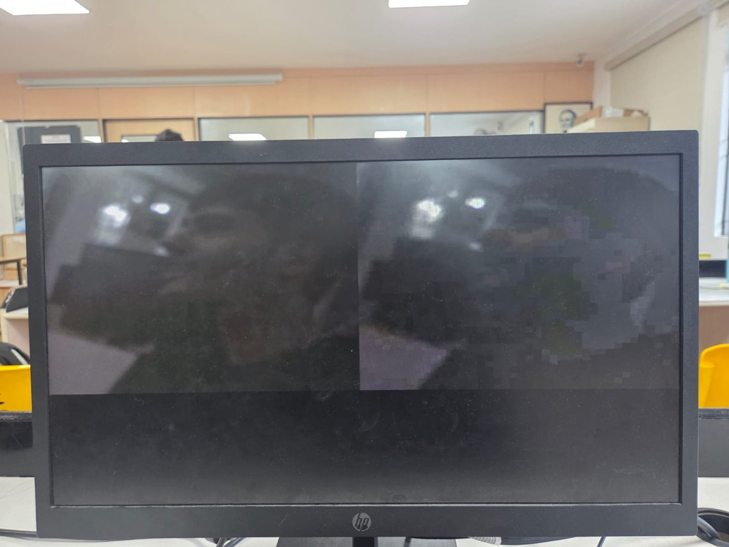
Figure 6.1: Live camera snapshot - original (left) and compressed (right) [switch setting: ____ ]
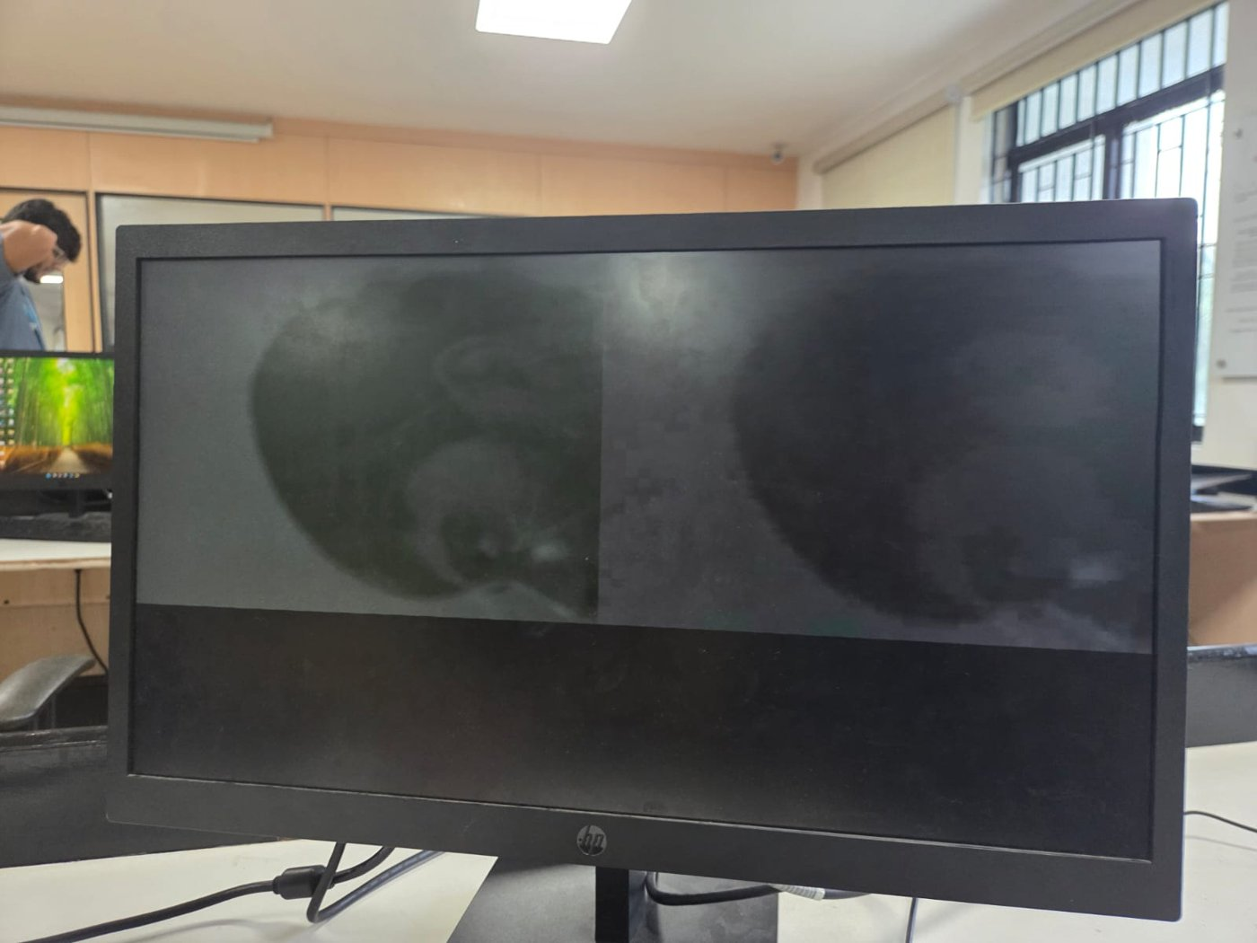
Figure 6.2: Second test scene - original (left) and compressed (right) [switch setting: ____ ]
[Photo to be inserted: seven-segment display showing the memory saved]
Figure 6.3: Memory saved shown on HEX3-HEX0
[Photo to be inserted: same scene with SW1-SW0 = 00 and SW1-SW0 = 11]
Figure 6.4: Effect of compression strength on picture quality and memory saved
[Photo to be inserted: board with status LEDs and switch settings]
Figure 6.5: Board during live operation

7. GitHub Repository
The complete source code, constraints, test bench and documentation are available in the project repository:
Repository link: [to be added]
Folder / file | Contents
rtl/ | cam_jpeg_top.v, cam_config.v, cam_capture.v, cam_async_fifo.v, color_dct_engine.v, color_saved_display.v
sim/ | tb_color_dct_engine.v
constraints/ | cam_pins.tcl
docs/ | Mini project report and module explanations
results/ | Photographs of the output
README.md | Project overview, controls and build instructions

