Blockchain-Based Supply Chain Tracker
A PROJECT REPORT
Submitted by
Abinash Behera,
Amit Pradhan,
Akshya Kumar Behera
Swornapriya Patra
Suchismita Priyadarsini

in partial fulfilment for the award of the
degree of
BACHELOR OF TECHNOLOGY
in
COMPUTER SCIENCE AND ENGINEERING


SCHOOL OF ENGINEERING AND TECHNOLOGY
BHUBANESWAR CAMPUS
CENTURION UNIVERSITY OF TECHNOLOGY AND MANAGEMENT
ODISHA
NOVEMBER 2025

DEPARTMENT OF COMPUTER SCIENCE AND ENGINEERING SCHOOL OF ENGINEERING AND TECHNOLOGY BHUBANESWAR CAMPUS
BONAFIDE CERTIFICATE
This is to certify that the project titled “Blockchain-Based Supply Chain Tracker” has been carried out by Abinash Behera (230301120453), Amit Pradhan (230301120443), Akshya Ku Behera (230301120450), Swornapriya Patra (230301120470), and Suchismita (230301120054) under the guidance of Prof. Abhi Mitra in partial fulfillment of the requirements for the award of the degree of Bachelor of Technology in Computer Science at Centurion University

(Prof.Abhimitra)
Signature of Supervisor

Certified that the above-mentioned project has been duly carried out as per the norms of the collage and statutes of the university

Signature of Head of the Department
Designation: Professor / Associate Professor /Asst. Professor

DECLARATION
I here by declare that the project entitled “Blockchain-Based Supply Chain Tracker” submitted for the “Minor Project” of 5th semester B. Tech in Computer Science and Engineering is my original work and the project has not formed the basis for the award of any Degree / Diploma or any other similar titles in any other University / Institute.

Name of the Student:
Signature of the Student:
Registration No:
Place:
Date:

ACKNOWLEDGEMENTS
I wish to express my profound and sincere gratitude to Prof. Abhi Mitra Department of Computer Science and Engineering, SoET, Bhubaneswar Campus, who guided me into the intricacies of this project nonchalantly with matchless magnanimity.
I thank Prof. Rajkumar Mohanta, Head of the Dept. of Department of Computer Science and Engineering, SoET, Bhubaneswar Campus and Dr. Sujata Chakravarty, Dean, School of Engineering and Technology, Bhubaneswar Campus for extending their support during Course of this investigation.
I would be failing in my duty if I don’t acknowledge the cooperation rendered during various stages of image interpretation by Prof. Abhi Mitra
I am highly grateful to by Prof. Abhi Mitra who evinced keen interest and invaluable support in the progress and successful completion of my project work.
I am indebted to by Prof. Abhi Mitra for their constant encouragement, cooperation and help. Words of gratitude are not enough to describe the accommodation and fortitude which they have shown throughout my endeavor.

Name of the Student:
Signature of the Student:
Registration No:
Place:
Date:

TABLE OF CONTENTS

Sl. No. | Content
1 | Abstract
2 | Introduction
3 | Problem Statement
4 | Objectives
5 | System Architecture
6 | Smart Contract Design
7 | Backend Implementation
8 | Frontend Design
9 | Frontend Implementation
10 | QR Code Implementation
11 | Advantages
12 | Limitations
13 | Future Enhancements
14 | Conclusion
15 | References

Abstract

- The Blockchain-Based Supply Chain Tracker is a decentralized application developed to track, record, and verify products throughout their journey in the supply chain. Built on the Ethereum blockchain, it leverages smart contracts to securely store product information and ensure data integrity.
- Each product is assigned a unique QR code, enabling users to easily scan and retrieve real-time details about its origin, authenticity, and movement across different supply chain stages.
- This system enhances transparency, traceability, and security by eliminating the need for intermediaries and preventing data manipulation. Through blockchain’s immutability and distributed ledger features, all transactions are permanently recorded, providing a trustworthy and tamper-proof product tracking mechanism.
- Overall, the project demonstrates how blockchain technology can revolutionize traditional supply chain operations by fostering trust, accountability, and efficiency among stakeholders.

Introduction

In today’s globalized world, supply chains involve multiple stakeholders such as manufacturers, suppliers, distributors, and retailers. Traditional supply chain management systems often face challenges such as lack of transparency, data manipulation, product counterfeiting, and inefficient tracking. These issues lead to mistrust among participants and result in financial losses and reduced customer confidence.

Blockchain technology offers a revolutionary solution to these challenges by providing a **decentralized, transparent, and tamper-proof** system for recording transactions. In a blockchain-based supply chain tracker, every product movement is securely recorded in a distributed ledger that is accessible to all authorized participants. This ensures that all supply chain events — from production to delivery — are verifiable and traceable in real time.

This project aims to develop a **Blockchain-Based Supply Chain Tracking System** that ensures **data transparency, security, and traceability** throughout the product lifecycle. By leveraging smart contracts, the system automates verification and updates, reducing the need for intermediaries and minimizing human errors.

Through this solution, stakeholders can verify the authenticity of goods, track their origin, and monitor their movement through the supply chain, ensuring accountability and building trust among all parties involved.

Problem Statement

Lack of real-time product verification.
Risk of counterfeit products entering the supply chain.
Difficulty in tracking product history.
Centralized databases can be manipulated, leading to mistrust.

Objectives

1. Implement a Decentralized Supply Chain Tracker:
Develop a blockchain-based system using the Ethereum network to ensure transparency, immutability, and decentralized record-keeping of product transactions.
2. Generate Unique QR Codes for Each Product:
Assign a blockchain-linked QR code to every product, allowing stakeholders to verify product authenticity and trace its journey across the supply chain.
3. Enable Scanning and Retrieval of Product Information:
Allow users, distributors, and customers to scan QR codes and instantly access verified product details stored on the blockchain.
4. Develop a User-Friendly React Frontend:
Build an interactive and responsive React-based interface to enable seamless interaction between users and the blockchain network.
5. Ensure Data Security and Integrity:
Utilize smart contracts and blockchain’s cryptographic principles to secure all product data, prevent tampering, and maintain transparency across all supply chain stages..

System Architecture

Users interact via a React frontend.
Smart contracts (SupplyChain.sol) store product details on Ethereum.
QR codes link to the product ID.
Events from smart contracts are captured by the frontend.
“The architecture ensures smooth communication between the frontend interface and blockchain network through smart contracts.”
“All product information is stored in an immutable ledger, ensuring that no unauthorized changes can occur.”
“The React app dynamically listens to blockchain events and updates product status instantly for all users.
Diagram:
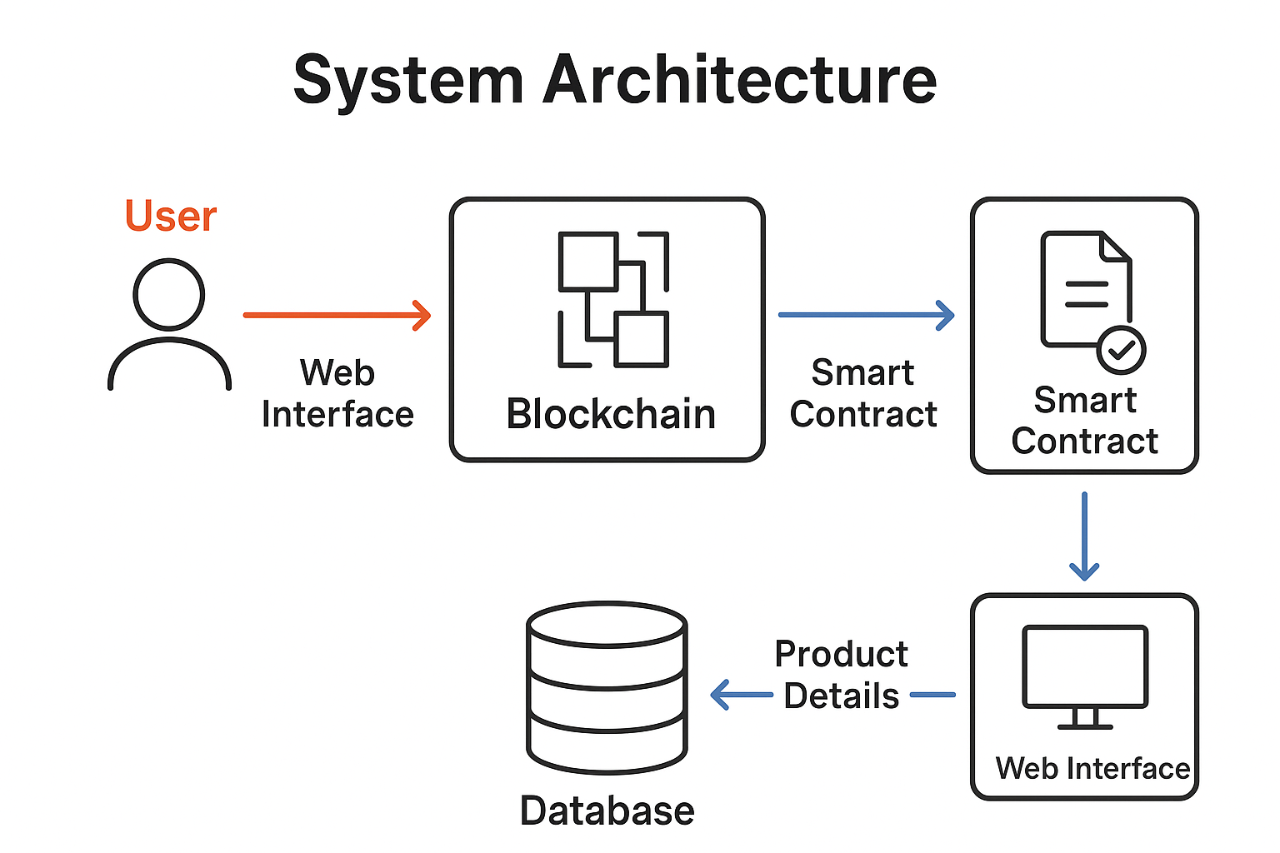

6. Smart Contract Design

Written in Solidity.
Product Struct: {name, location, timestamp}
Key Functions:
- addProduct(productID, name, location) → Adds product to blockchain.
- getProduct(productID) → Fetches product details.
Immutability ensures products cannot be modified once added.
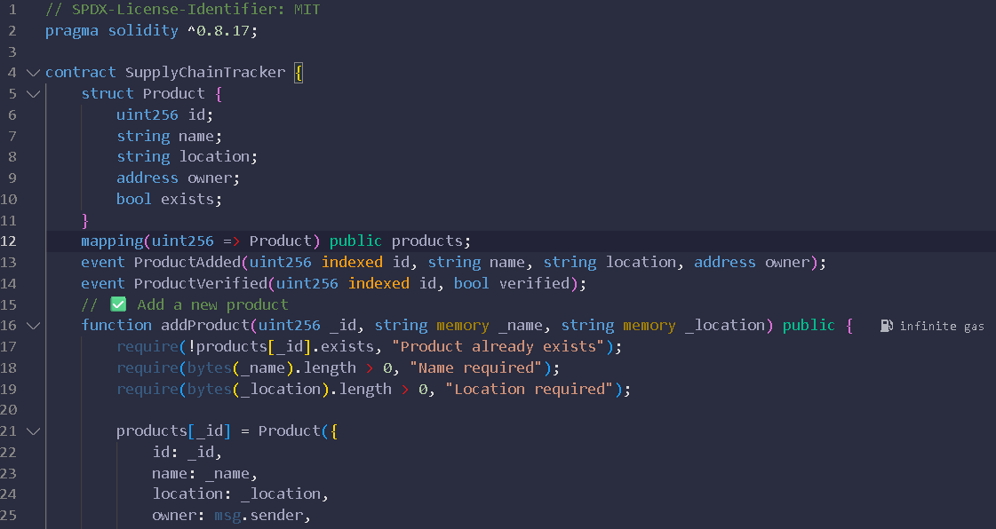
Smart Contract Screenshot 6.1
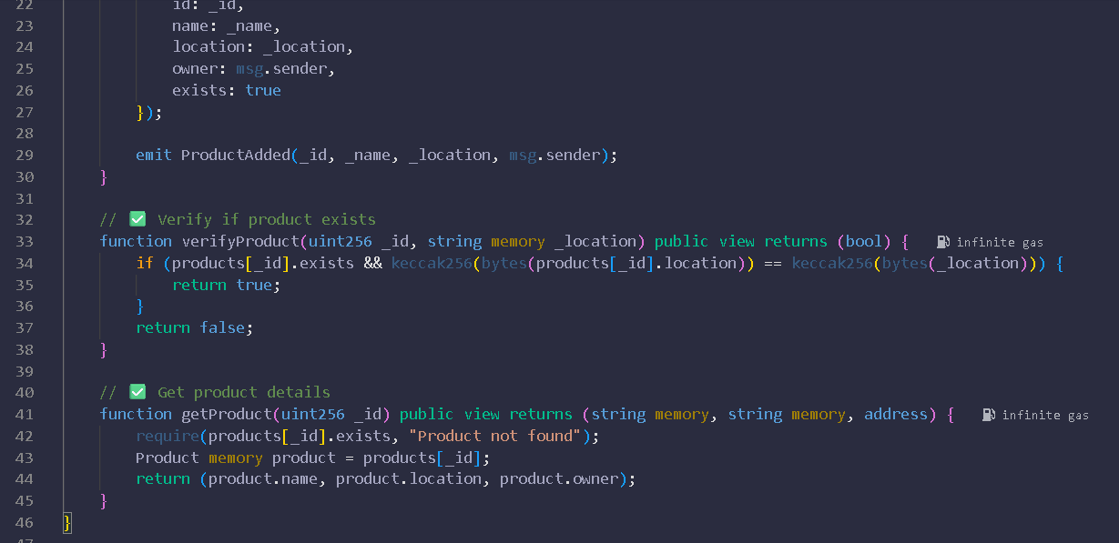
Smart Contract Screenshot 6.2

7. Backend Implementation
The backend of the Blockchain-Based Supply Chain Tracker acts as a bridge between the frontend application and the Ethereum blockchain network. It handles all blockchain interactions, smart contract communication, and user requests in a secure and efficient manner. The backend is primarily developed using Node.js and Express.js, with Ethers.js as the blockchain interaction library.

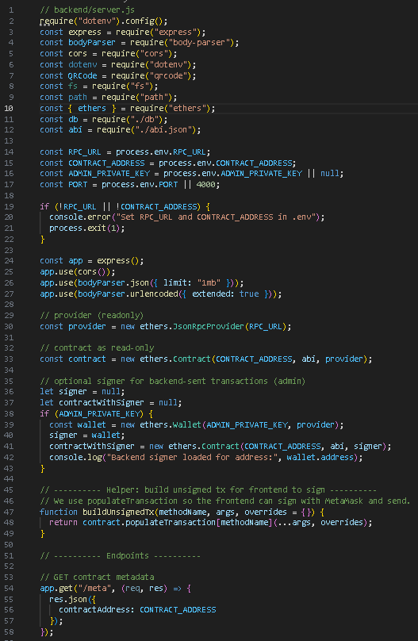
Backend screenshot 7.1

b

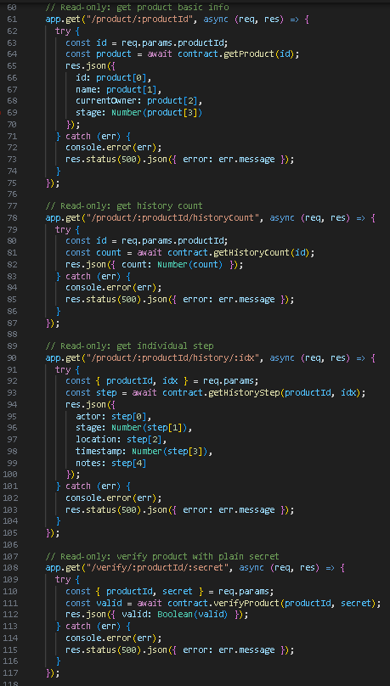
Backend Screenshot-7.2

Backend Screenshot-7.3

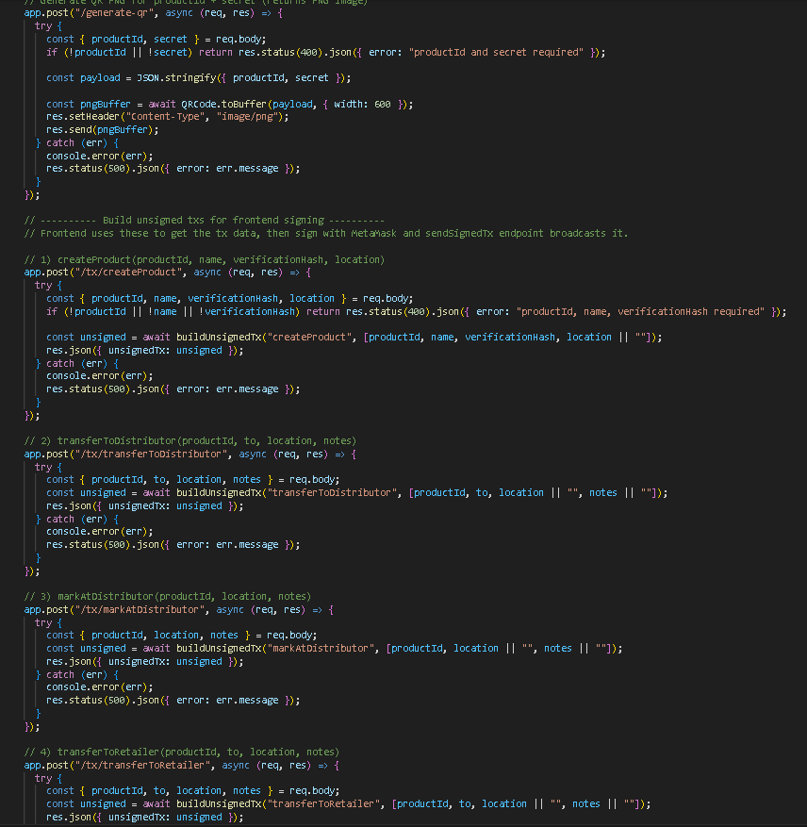

Backend Screenshot-7.4

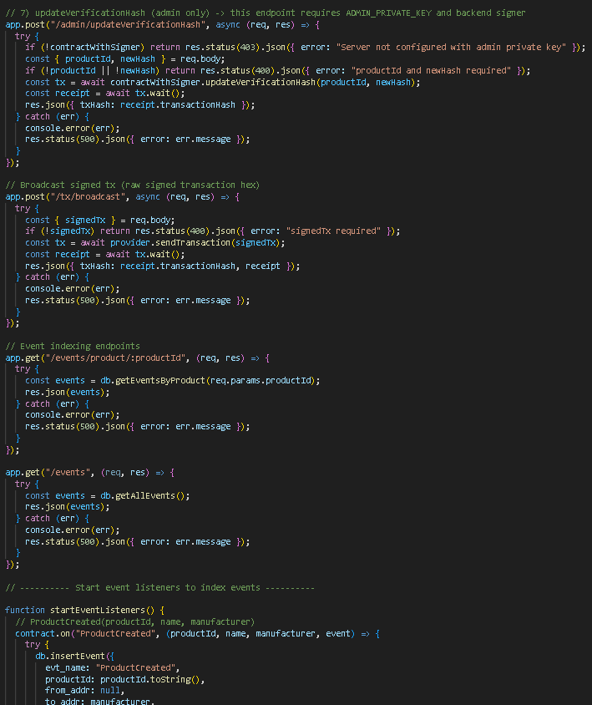

Backend Screenshot-7.5
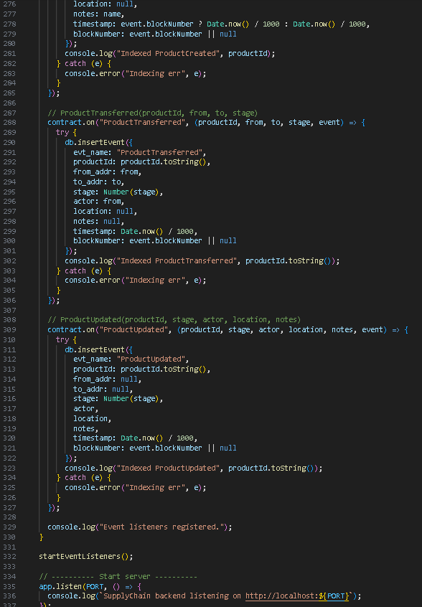

8. Frontend Design

Connect wallet using MetaMask.
Add product by entering ID, name, and location.
Generate and display QR code for product.
Scan QR codes to fetch product details.
Display product information including ID, Name, Location, and Timestamp.

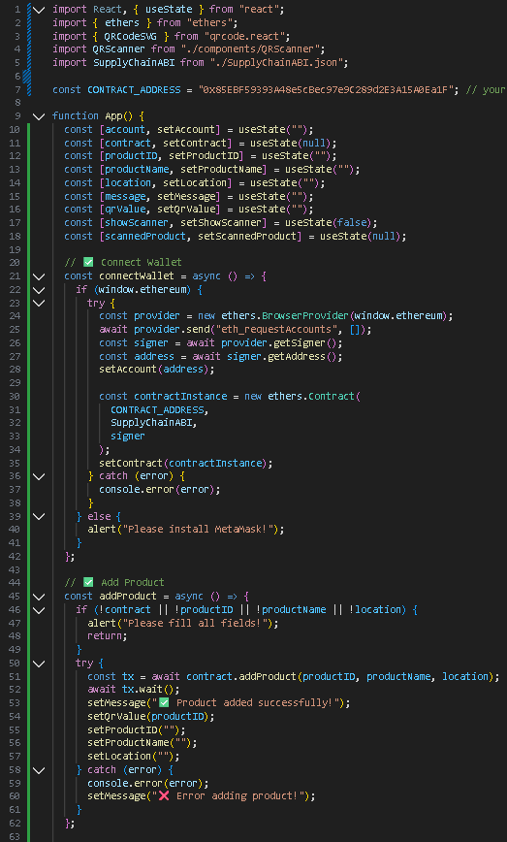
Frontend Screenshot 8.1
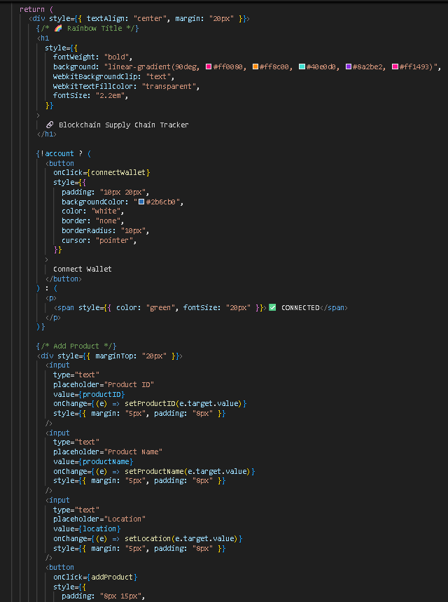
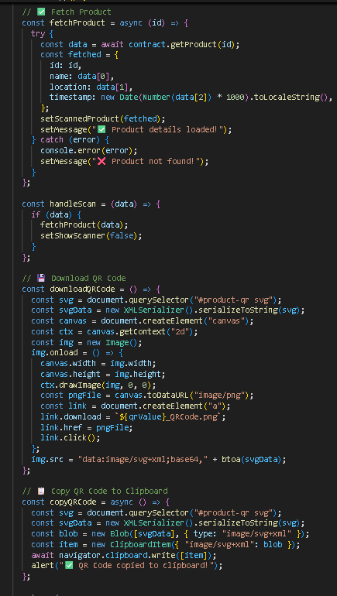

Frontend Screenshot 8.2 Frontend Screenshot 8.3

Frontend Screenshot 8.4

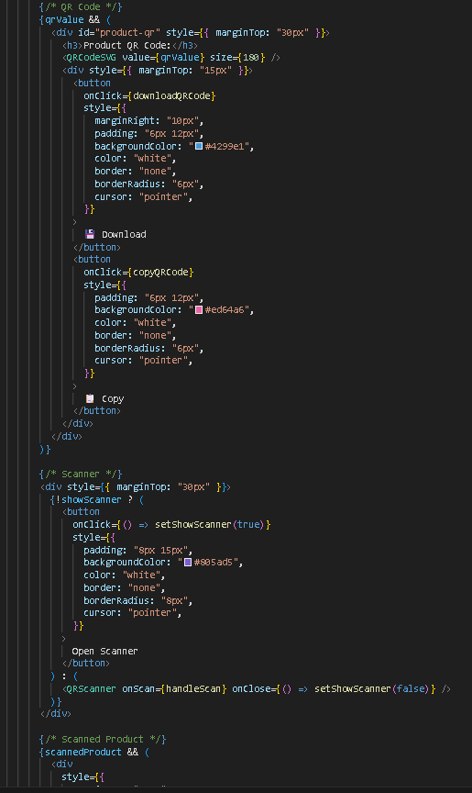

9. Frontend Implementation

1. Technologies Used
Component | Technology
Framework | React.js
Blockchain Interaction | Ethers.js
Wallet Connection | MetaMask
QR Code Generation | qrcode.react
QR Code Scanning | react-qr-reader / custom scanner
Styling | CSS / Tailwind (optional)

2. Key Frontend Features
✔ Connect to MetaMask
✔ Add products (Name, Location, Description)
✔ Generate QR code after adding product
✔ Scan QR code to fetch product data
✔ Display product details retrieved from blockchain
✔ Real-time step tracking UI
3. UI Flow
🟦 Step 1 — Connect Wallet
- Landing page prompts user to connect MetaMask.
- On success -> “Connected ✅” badge is shown.


🟩 Step 2 — Add Product
- User enters:
  - Product ID
  - Location
  - Product name
- Clicks Add Product
- Transaction is sent to blockchain
- Success message appears

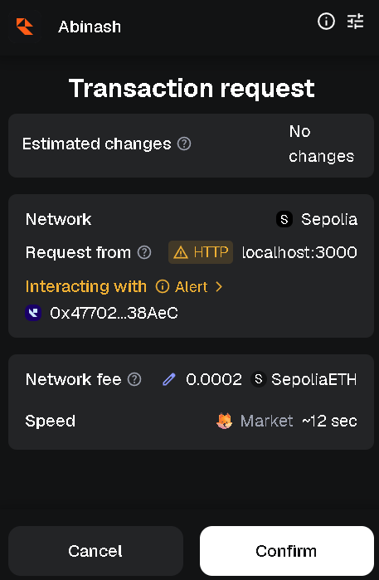

🟧 Step 3 — View Product + QR Code
- After adding product, a product ID is generated.
- QR code containing product ID is displayed.
- The user can download/scan QR code.
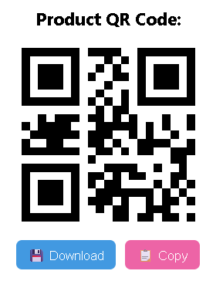

🟨 Step 4 — Scan QR Code
- Clicking Scan Product QR Code takes user to second page.
- Product details appear when scanned.
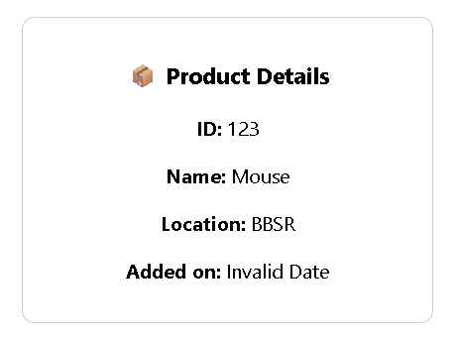
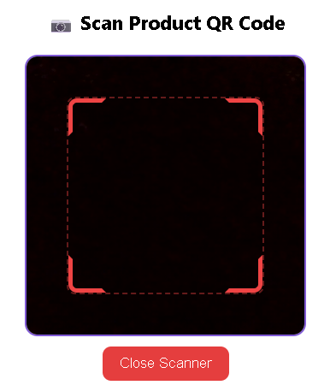

10. QR Code Implementation

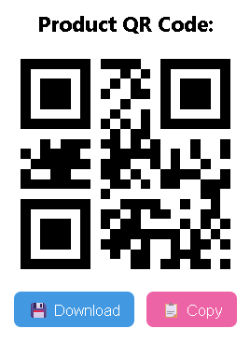
Each product has a unique QR code representing its ID.
QR code can be downloaded or copied.
Scanning QR code fetches product details from blockchain in real-time.

Copy:
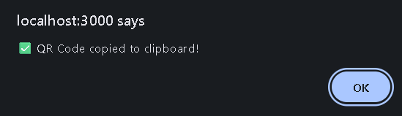

Download:
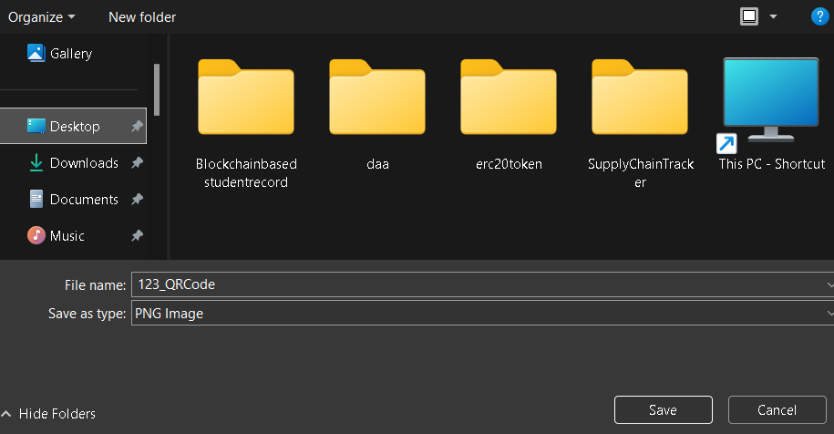

11. Advantages

Transparency: Data visible to all stakeholders.
Immutability: Cannot be tampered once recorded.
Decentralized: No single point of failure.
Security: Smart contracts validate all operations.

12. Limitations

Requires MetaMask and Ethereum network.
Gas fees on mainnet (testing done on Sepolia).
Internet required for scanning and verification.

13. Future Enhancements

Multi-user roles: Manufacturer, Distributor, Retailer.
Mobile-optimized QR scanner.
Full product history tracking across supply chain.
IPFS integration to store detailed product data off-chain.

14. Conclusion

The Blockchain-Based Supply Chain Tracker successfully demonstrates how blockchain technology can revolutionize supply chain management by ensuring transparency, traceability, and security throughout the product lifecycle. Traditional supply chain systems often face challenges such as data manipulation, lack of visibility, and counterfeit products. By integrating blockchain, every transaction or movement of goods is recorded as an immutable block, providing a tamper-proof and verifiable history.

This project establishes a decentralized network where all stakeholders — including manufacturers, suppliers, distributors, and customers — can access real-time and trustworthy information. The system enhances accountability by allowing each participant to validate data and verify product authenticity without relying on intermediaries. Additionally, smart contracts automate verification and payments, improving efficiency and reducing operational costs.

In conclusion, this blockchain-based solution proves to be a powerful step toward building trust, improving transparency, and minimizing fraud in modern supply chains. Future advancements can include integration with IoT devices, AI-driven analytics, and cross-chain communication, further enhancing supply chain intelligence and sustainability.

15. References

Ethereum Docs: https://ethereum.org/en/developers/docs/
React Docs: https://reactjs.org/docs/getting-started.html
Ethers.js Docs: https://docs.ethers.org/v5/
qrcode.react GitHub: https://github.com/zpao/qrcode.react

