Blockchain-Based Student Record System
A PROJECT REPORT
Submitted by
Abinash Behera,
Amit Pradhan,
Akshya Ku Behera,
Swornapriya Patra
Suchismita priyadarsini

in partial fulfilment for the award of the
degree of
BACHELOR OF TECHNOLOGY
in
COMPUTER SCIENCE AND ENGINEERING

SCHOOL OF ENGINEERING AND TECHNOLOGY
BHUBANESWAR CAMPUS
CENTURION UNIVERSITY OF TECHNOLOGY AND MANAGEMENT
ODISHA
NOVEMBER 2025
DEPARTMENT OF COMPUTER SCIENCE AND ENGINEERING SCHOOL OF ENGINEERING AND TECHNOLOGY BHUBANESWAR CAMPUS
BONAFIDE CERTIFICATE
This is to certify that the project titled “Blockchain-Based Student Record System” has been carried out by Abinash Behera (230301120453), Amit Pradhan (230301120470), Akshya Ku Behera (230301120443), Swornapriya Patra (230301120450), and Suchismita (230301120054) under the guidance of Prof. Abhi Mitra in partial fulfillment of the requirements for the award of the degree of Bachelor of Technology in Computer Science at Centurion University

Signature of Supervisor

Certified that the above-mentioned project has been duly carried out as per the norms of the collage and statutes of the university

Signature of Head of the Department
Designation: Professor / Associate Professor /Asst. Professor
_ ACKNOWLEDGEMENTS
I wish to express my profound and sincere gratitude to Prof. Abhimitra sir Department of Computer Science and Engineering, SoET, Bhubaneswar Campus, who guided me into the intricacies of this project nonchalantly with matchless magnanimity.
I thank Prof. Rajkumar Mohanta, Head of the Dept. of Department of Computer Science and Engineering, SoET, Bhubaneswar Campus and Dr. Sujata Chakravarty, Dean, School of Engineering and Technology, Bhubaneswar Campus for extending their support during Course of this investigation.
I would be failing in my duty if I don’t acknowledge the cooperation rendered during various stages of image interpretation by Prof. Abhimitra sir
I am highly grateful to by Prof. Abhimitra sir who evinced keen interest and invaluable support in the progress and successful completion of my project work.
I am indebted to by Prof. Abhimitra sir for their constant encouragement, cooperation and help. Words of gratitude are not enough to describe the accommodation and fortitude which they have shown throughout my endeavor.

Name of the Student:
Signature of the Student:
Registration No:
Place: Bhubaneswar
Date:

DECLARATION
I hereby declare that the project entitled “Blockchain-Based Student Record System” submitted for the “Smart Engineering Project” of 3rd Master in Computer Application is our original work, and the project has not formed the basis for the award of any Degree masters, or any other similar title in any other University / Institute.

Name of the Student:
Signature of the Student:
Registration No:
Place: Bhubaneswar
Date:

Abstract
This project explores the implementation of a **blockchain-based system** for securely storing, updating, and managing student academic records. Traditional centralized record-keeping systems are often prone to data tampering, unauthorized access, and single-point failures. To overcome these challenges, the proposed system leverages **blockchain’s decentralized architecture**, which ensures **immutability, transparency, and trustless verification** of data.
The system enables educational institutions to record and verify student credentials using **smart contracts**, eliminating the need for intermediaries and manual validation. Each transaction is cryptographically secured and permanently stored on the blockchain, providing a **tamper-proof audit trail** of academic achievements.
By integrating blockchain with a user-friendly web interface, this project demonstrates how **modern decentralized technologies** can transform traditional data management into a **secure, transparent, and efficient academic record ecosystem**. The results highlight blockchain’s potential to revolutionize the education sector by enhancing **data security, accountability, and interoperability** across institutions.
.

Table of Contents:-
1. Introduction
2. Literature Survey
3. System Design & Architecture
4. Smart Contract
5. Backend Implementation
6. Frontend Implementation
7. Frontend Flow Steps
8. Results & Discussion
9. Conclusion
10. Future Scope
11. References

Introduction:-
A student record system plays a crucial role in educational institutions by storing, maintaining, and managing student information such as academic details, personal data, and performance records. Traditional centralized systems often face challenges such as data tampering, loss of information, unauthorized access, and lack of transparency. These issues can lead to inefficiencies, security breaches, and reduced trust in data integrity.
To overcome these limitations, this project introduces a Blockchain-based Student Record Management System. Blockchain technology offers a decentralized, immutable, and transparent framework for securely recording and sharing data. By utilizing blockchain, student records can be permanently stored, verified, and accessed without relying on a single centralized authority.
The primary objective of this project is to design and implement a blockchain-powered student record system that ensures security, transparency, and data integrity. The system enables key operations such as:
- Adding new student records
- Updating existing information
- Viewing student data securely
- Deleting records (via authorized access only)
This decentralized approach eliminates data manipulation risks, enhances accountability, and provides a trustworthy platform for managing student academic data. Furthermore, the system aims to simplify data sharing between institutions and regulatory bodies while maintaining privacy and authenticity through cryptographic techniques.

Literature Survey:-
In recent years, educational institutions have increasingly adopted digital management systems to handle student information, academic records, and administrative tasks. Systems such as Enterprise Resource Planning (ERP) platforms and Learning Management Systems (LMS) have streamlined data handling and improved accessibility. However, these solutions are still centralized, relying on a single server or authority to maintain and secure data.
Centralized architectures face significant challenges, including:
- Single point of failure, leading to data loss or service disruption in case of system failure.
- Vulnerability to tampering, where unauthorized users can modify or delete records.
- Lack of transparency, making it difficult to verify the authenticity of stored information.
- Dependence on intermediaries, increasing maintenance costs and reducing efficiency.
To address these issues, researchers and developers have started exploring blockchain technology for academic data management. Blockchain provides a distributed ledger system where data is stored across multiple nodes, ensuring immutability, security, and transparency. Every record is timestamped and cryptographically secured, preventing unauthorized alterations.
Several studies highlight the potential of blockchain in the education sector:
- Student credential verification systems using blockchain enhance authenticity and reduce fraud in certificates and transcripts.
- Decentralized academic record systems ensure trust among institutions when transferring student data.
- Smart contracts can automate verification and access permissions, reducing administrative workload.
Despite these advantages, many existing systems still rely partially on centralized databases or hybrid models, which limit full decentralization. Therefore, there is a growing need for a fully blockchain-based student record management system that ensures complete data integrity, secure sharing, and transparent auditing.

3.System Design & Architecture:-
The proposed Blockchain-based Student Record Management System is designed using a client–server–blockchain architecture to ensure secure, decentralized, and transparent handling of student data. The system integrates smart contracts, backend APIs, and a user-friendly frontend interface, providing an efficient environment for performing essential CRUD (Create, Read, Update, Delete) operations on student records.
At the core of the system, a smart contract is deployed on the Ethereum blockchain. This smart contract handles all record-related transactions, ensuring that once data is added, it cannot be tampered with or deleted without proper authorization. The backend server acts as a bridge between the blockchain and the user interface, managing requests, signing transactions, and interacting with the blockchain through web3 libraries. The frontend interface allows users such as administrators, faculty, or students to interact seamlessly with the system using a connected crypto wallet.

Architecture Workflow:
- Connect Wallet:
The user connects a digital wallet (e.g., MetaMask) to authenticate and interact with the blockchain network securely.
- User Requests Action:
The user performs an operation such as adding, viewing, updating, or deleting student information through the frontend.
- Backend Sends Signed Transaction:
The backend API processes the request, validates it, and sends a digitally signed transaction to the Ethereum network using smart contract functions.
- Blockchain Stores Data:
The blockchain verifies and records the transaction in an immutable ledger, ensuring transparency and preventing data tampering.
- Frontend Displays Results:
Once the transaction is confirmed, the updated information is fetched from the blockchain and displayed to the user interface in real time.
This architecture ensures data immutability, traceability, and decentralized control, significantly improving trust and security in managing educational records.

System Components:
- Frontend: Developed using HTML, CSS, and JavaScript (or React.js), providing a responsive user interface for interacting with the blockchain.
- Backend: Built using Node.js and Express, responsible for handling API calls, validating inputs, and connecting to the Ethereum network via Web3.js.
- Smart Contract: Written in Solidity and deployed on Ethereum, responsible for securely executing record management logic.
- Blockchain Network: Ethereum blockchain ensures decentralized, verifiable storage of student records.

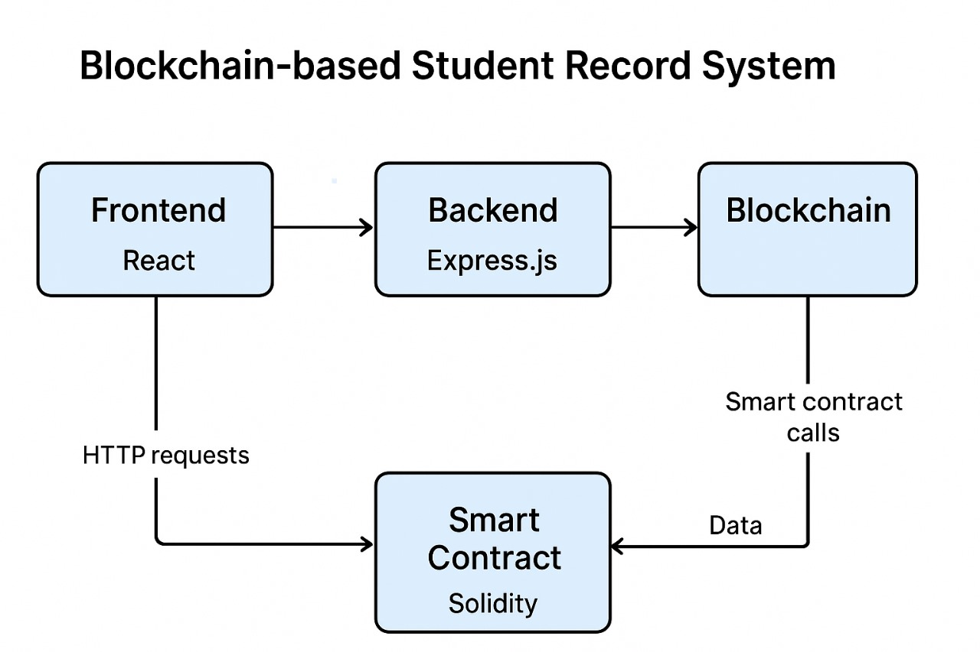
(The diagram can illustrate the interaction between the frontend, backend, wallet, smart contract, and blockchain network.)

4.Smart Contract:-
The smart contract is written in Solidity. It stores student ID, name, and marks. It contains functions addRecord, updateRecord, deleteRecord, getRecord, and getAllStudentIds.
Workflow:
1. Deploy contract
2. Store records on‑chain
3. Retrieve using functions

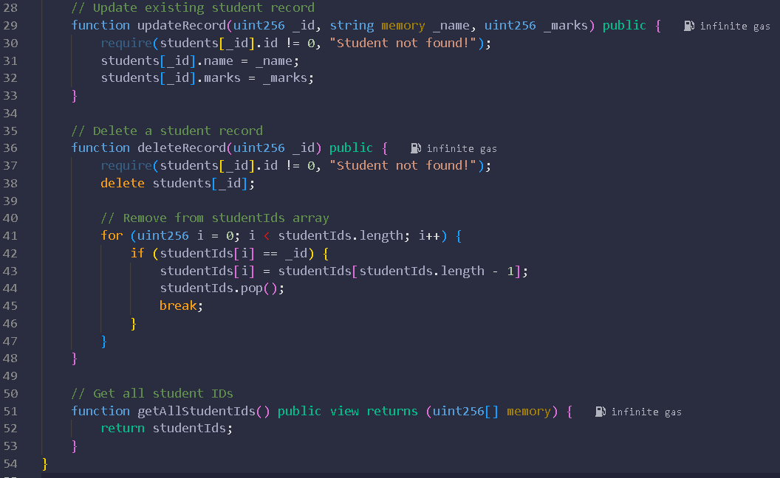
Smart Contract Screenshot-4.1

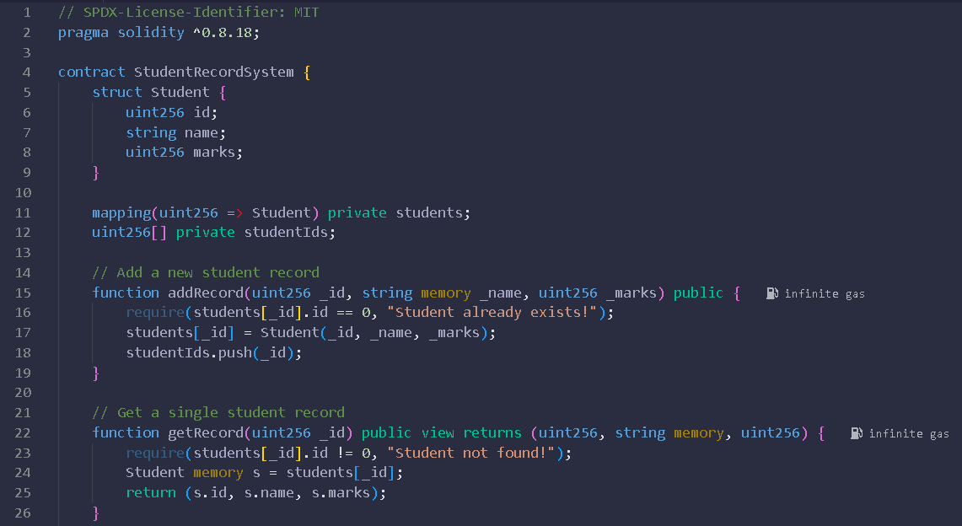
Smart Contract Screenshot-4.2

5.Backend Implementation:-
The backend is implemented with Node.js, Express.js and Ethers.js. It connects to the Ethereum blockchain via a JSON‑RPC URL and signs transactions using a private key.
Steps:
1. Load ABI and contract address
2. Initialize provider
3. Use contract object to call smart contract functions
4. Expose REST APIs

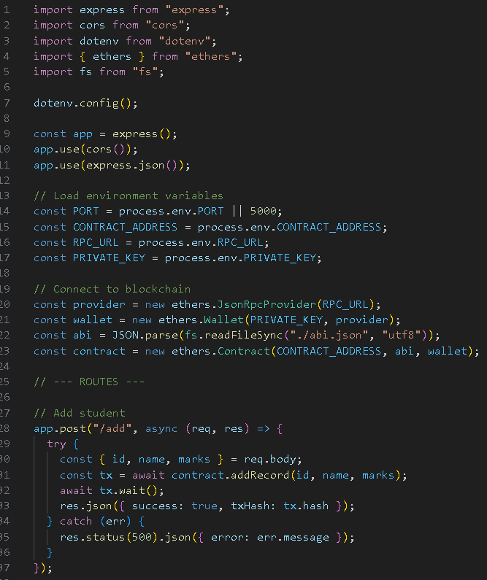
Backend Screenshot-5.1

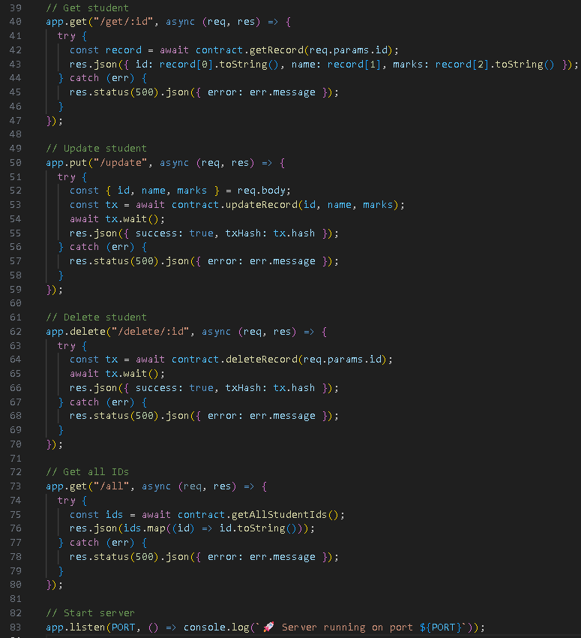
Backend Screenshot-5.2

6.Frontend Implementation:-
The frontend is built using React.js. Users connect MetaMask, enter data, and trigger actions. The interface displays records fetched using smart contract calls.
Key Components:
1. Wallet Connection
2. Input Fields
3.CRUD Buttons
4. Record Display

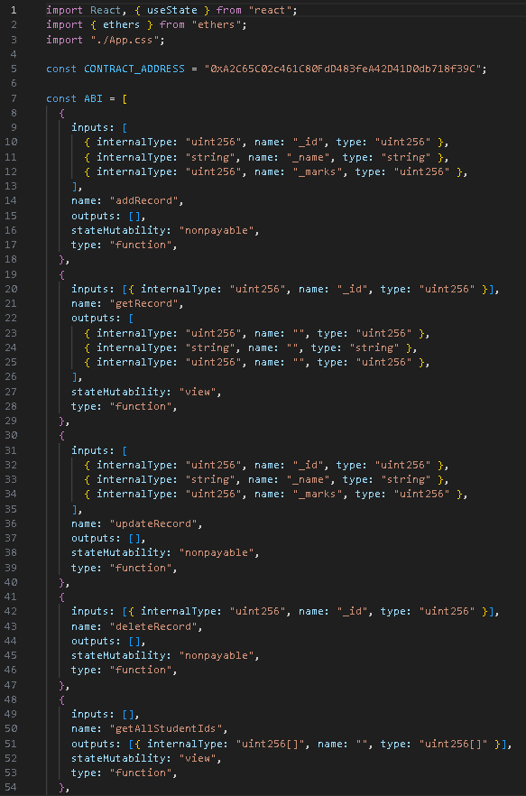
Frontend Screenshot-6.1

Frontend Screenshot-6.2
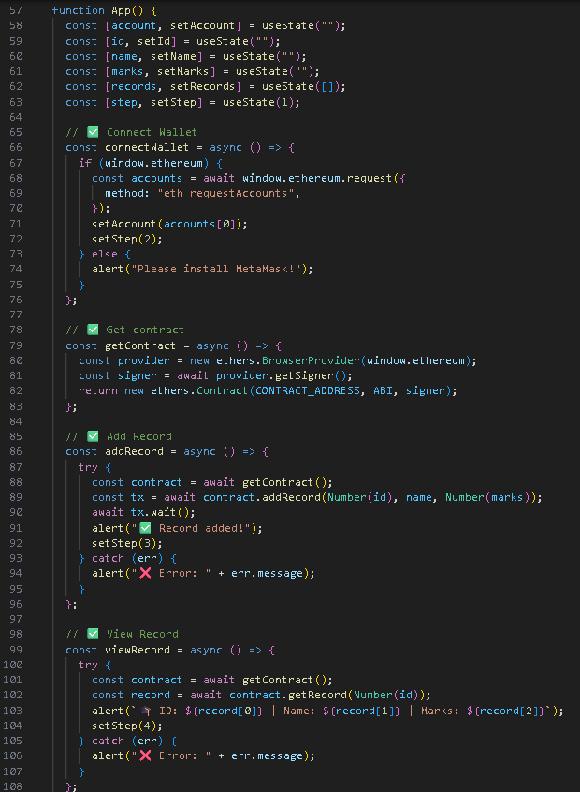

6.

Frontend Screenshot-6.3
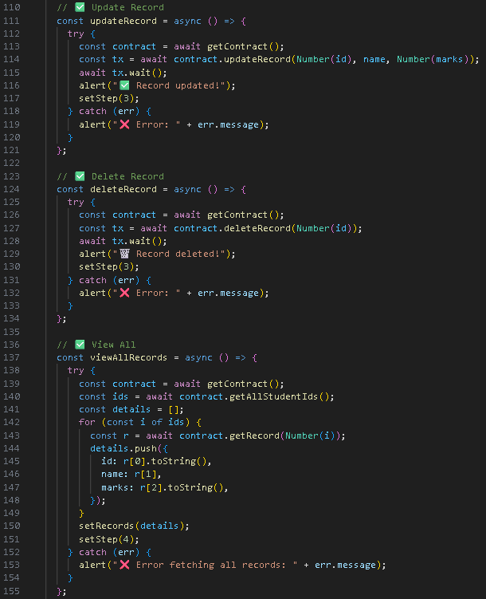

Frontend Screenshot-6.4
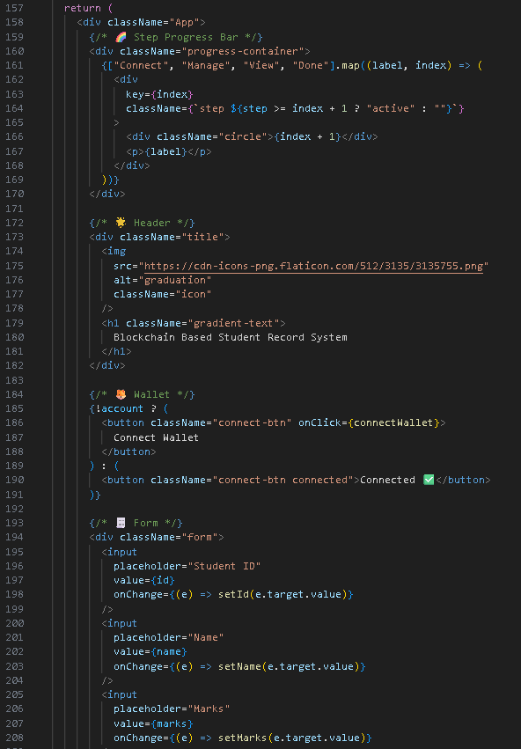

Frontend Screenshot-6.5
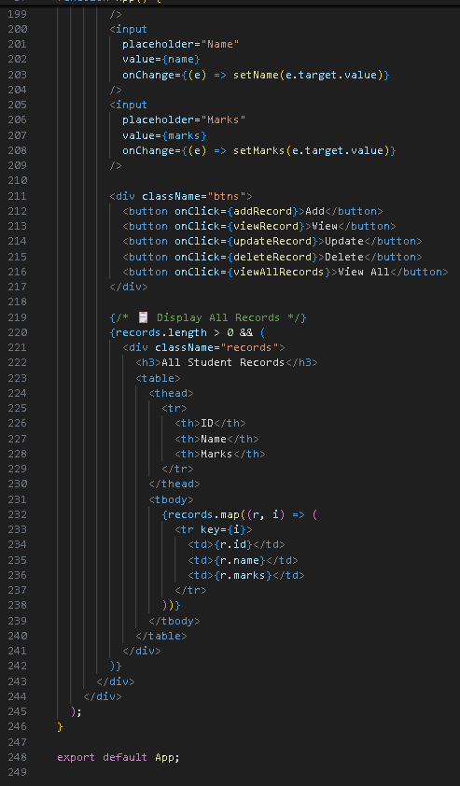

7. Frontend Flow Steps :-
1. Landing Page / Home Page
Purpose: Introduce the system and allow users to connect their Web3 wallet.
Components / Actions:
- Connect Wallet button (Metamask / WalletConnect).
- Detect network (e.g., Sepolia, Ethereum mainnet).
- Redirect to Dashboard after successful wallet connection.
Flow:
User → Clicks “Connect Wallet” → Wallet pop-up → Connection confirmed → Dashboard opens.
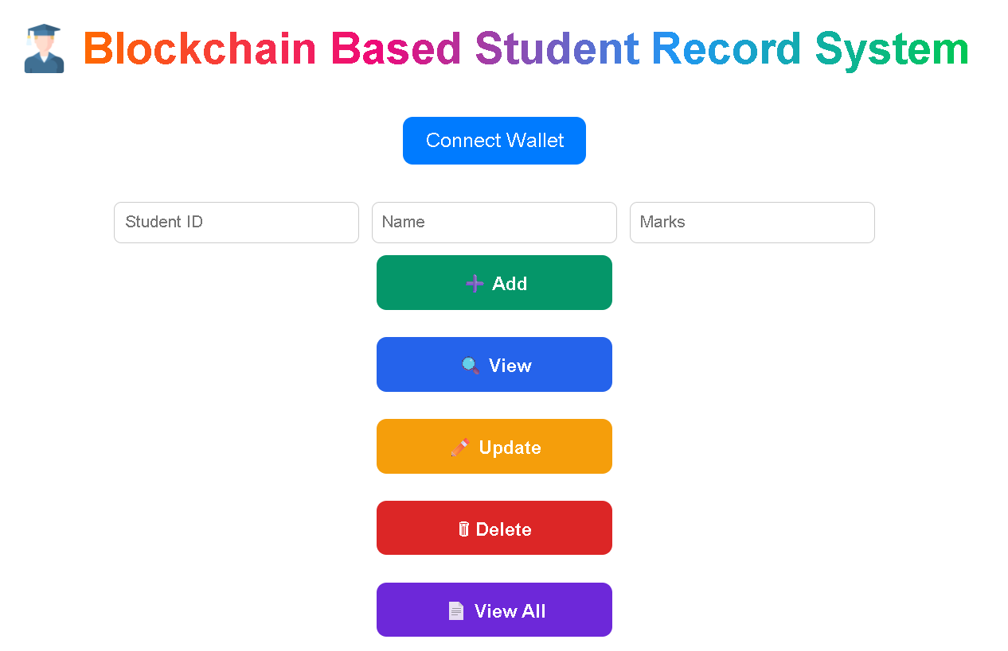

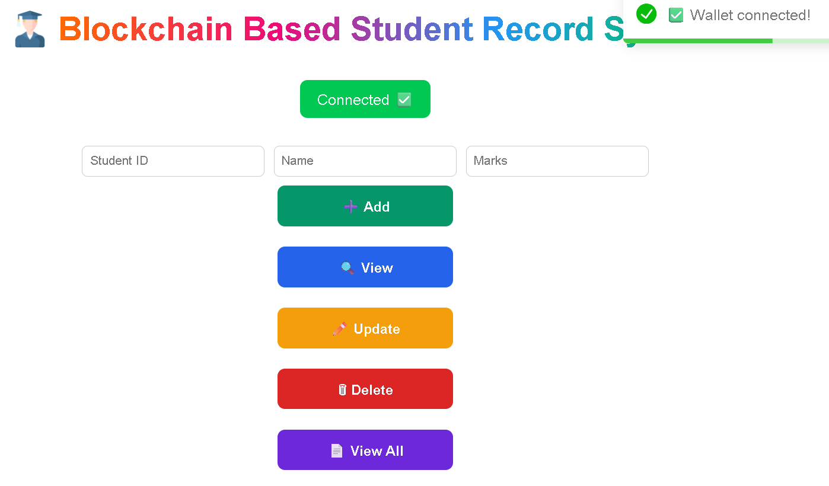

2. Dashboard
Purpose: Main navigation hub for students and admin.
Components / Actions:
- Navigation menu:
  - Add Student (Admin)
  - View Student Record (Student/Admin)
  - Update Record (Admin)
  - Delete Record (Admin)
- Show connected wallet address.
- Display View All Records

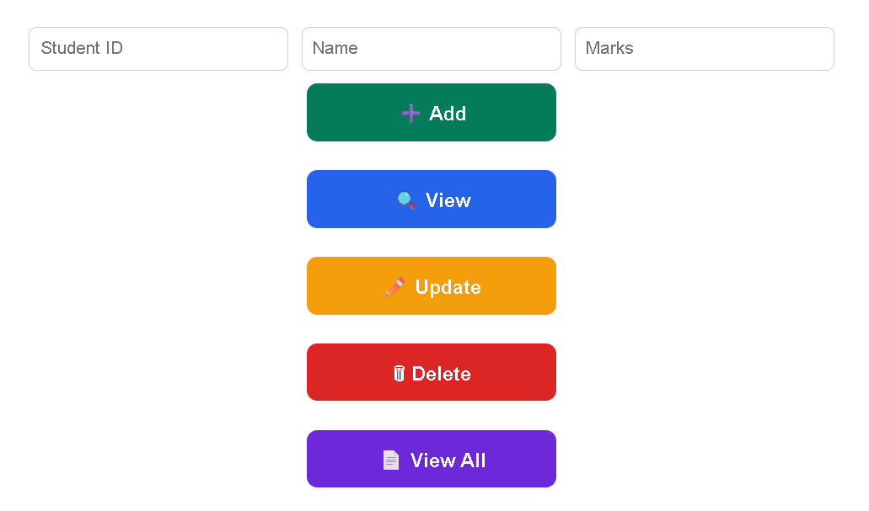

3. Add Student Record (Admin Only)
Purpose: Admin adds a student to the blockchain.
Components / Actions:
- Form fields:
  - Student Name
  - Roll Number / ID
  - Marks
- Add button → triggers smart contract function addStudent().
- Loading indicator while transaction is pending.
- Toast / notification on success or failure.
Flow:
Admin → Fills form → Clicks Submit → Transaction sent → Blockchain confirms → Record added → Success message.
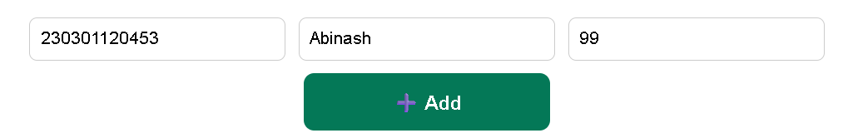

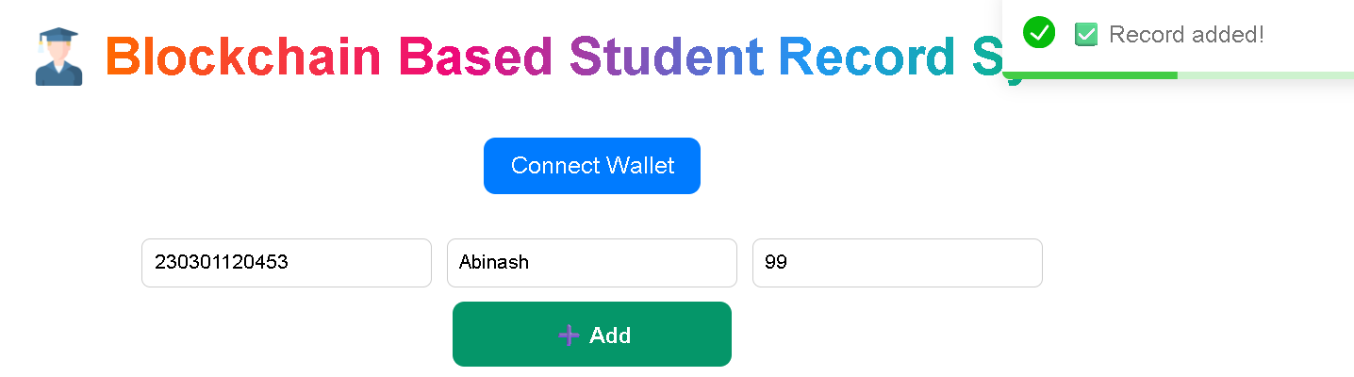

4. View Student Record
Purpose: Students or admin can view a specific record.
Components / Actions:
- Input field: Student ID / Roll Number.
- Fetch button → calls smart contract function getStudent().
- Display:
  - Name
  - ID
  - Marks
- Option to download or Export to Excel
Flow:
User → Enters ID → Clicks Fetch → Reads blockchain data → Displays record.
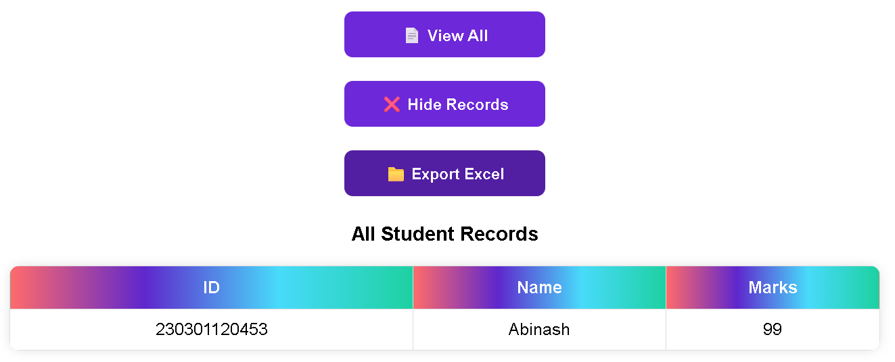
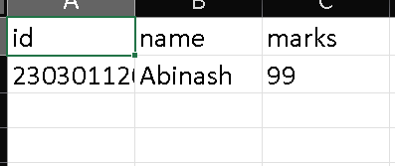

5. Update Student Record (Admin Only)
Purpose: Admin updates existing records.
Components / Actions:
- Input field: Student ID / Roll Number.
- Fetch existing record → pre-fill form fields.
- Update fields → Submit button → triggers updateStudent() smart contract function.
- Show transaction status → success / failure notification.
Flow:
Admin → Enters ID → Fetches record → Updates info → Clicks Submit → Blockchain transaction → Confirmation.
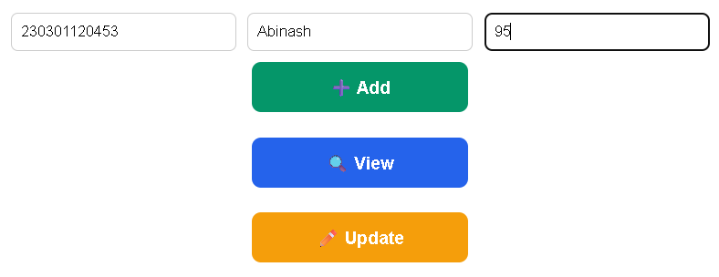
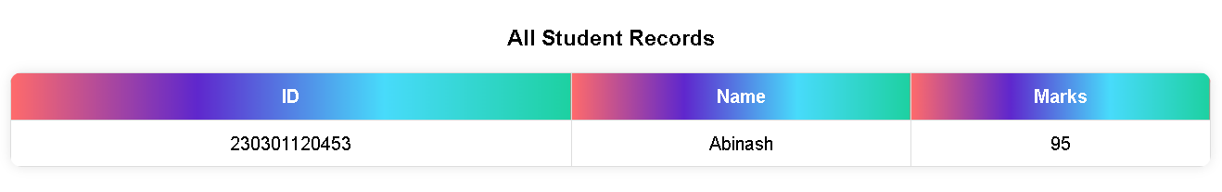

6. Transaction Status & Notifications
Purpose: Keep user informed about blockchain transactions.
Components / Actions:
- Loading spinner / pending transaction status.
- Toast notifications (success/failure).
- Optional: Display transaction hash with a link to Etherscan.
7. Mobile Responsiveness
Purpose: Make the app usable on mobile devices.
Components / Actions:
- Responsive navigation menu (hamburger menu on small screens).
- Forms and tables scale correctly.
- Buttons are large enough to tap.
8. Optional Features
- Search & Filter Records: Admin can search students by course/year.
- Audit Logs: Show list of recent transactions/updates for transparency.
- Excel Export: Students can download their records.
Summary of Frontend Flow:
- Landing Page → Connect Wallet
- Dashboard → Choose Action (Add/View/Update)
- Add Student → Fill Form → Submit → Confirm Transaction
- View Student → Enter ID → Fetch → Display Record
- Update Student → Enter ID → Fetch → Update → Submit
- Transaction Status → Show success/failure
- Logout / Disconnect
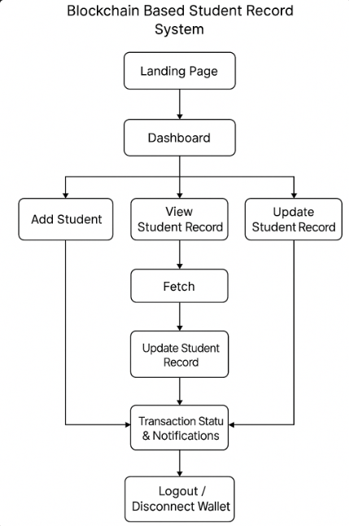

8.Results & Discussion:-
The system also demonstrated efficient interaction between the frontend, backend, and blockchain smart contract. By connecting a digital wallet, users were able to securely perform transactions and verify records on-chain. Gas usage during transactions was minimal, ensuring cost-effectiveness.

In addition, the project highlights the advantages of decentralization in academic record systems—removing dependency on a single authority and enabling trusted peer-to-peer verification. The system’s performance remained stable during multiple test cases, confirming its **reliability, scalability, and transparency.

Overall, the results indicate that blockchain technology can be effectively applied to academic record management, providing a secure, verifiable, and future-ready solution for educational institutions..

9.Conclusion:-
This project demonstrates the successful integration of blockchain technology with traditional data management systems to ensure secure, transparent, and tamper-proof record storage. It provides a robust foundation for the modernization of academic record-keeping systems, enabling trust, decentralization, and automation in credential verification. The system effectively reduces the risk of data manipulation and enhances the overall reliability and accessibility of student records.

In the future, this framework can be extended with features such as multi-institution integration, smart contract-based record sharing, and interoperability with national education databases. Overall, this project contributes to building a more transparent and efficient academic data ecosystem through the power of blockchain technology.

10.Future Scope:-
1. Multi‑institution support
2. IPFS for certificate storage
3. Mobile app support
4. Multi‑signature admin rights
5. Role‑based access

11.References:-
1. Ethereum Documentation. Available at: [https://ethereum.org/en/developers/docs/](https://ethereum.org/en/developers/docs/)
2. Solidity Documentation. Available at: [https://docs.soliditylang.org/](https://docs.soliditylang.org/)
3. Research Papers on Blockchain in Education:
Sharples, M., & Domingue, J. (2016). The blockchain and kudos: A distributed system for educational record, reputation, and reward. In Proceedings of the 11th European Conference on Technology Enhanced Learning (EC-TEL).
Grech, A., & Camilleri, A. F. (2017). Blockchain in Education. Publications Office of the European Union.
4. Web3.js Documentation.Available at: [https://web3js.readthedocs.io/](https://web3js.readthedocs.io/)
5. MetaMask Developer Documentation. Available at: [https://docs.metamask.io/](https://docs.metamask.io/)
6. Hardhat Ethereum Development Environment.Available at: [https://hardhat.org/](https://hardhat.org/)
7. Research Article:Alammary, A., Alhazmi, S., Almasri, M., & Gillani, S. (2019). Blockchain-based applications in education: A systematic review.Applied Sciences, 9(12), 2400.

