

Tech Saksham

**Capstone Project Report**

**“Cardiovascular heart disease prediction”**

**“University College of Engineering Trichy”**

|  |  |
| --- | --- |
| **NM ID** | **NAME** |
| au810021114003 | ABINASH V |

|  |
| --- |
| Ramar Bose |
| Sr. AI Master Trainer |

**ABSTRACT**

Cardiovascular diseases (CVDs) are a leading cause of mortality worldwide, with early prediction crucial for effective intervention and prevention. The development and evaluation of machine learning models for CVD risk prediction. The study utilizes a dataset comprising demographic, lifestyle, and clinical variables to train and validate predictive algorithms. Key features are identified through feature selection techniques, and various classifiers such as logistic regression, decision trees, and neural networks are trained and evaluated. Performance metrics including accuracy, sensitivity, and specificity are used to assess model efficacy. The findings demonstrate promising results, with certain models exhibiting high accuracy and reliability in predicting CVD risk. Such predictive models hold potential for assisting healthcare professionals in early identification of high-risk individuals, facilitating timely interventions to mitigate cardiovascular morbidity and mortality.

**INDEX**

|  |  |  |
| --- | --- | --- |
| **Sr. No.** | **Table of Contents** | **Page No.** |
| 1 | Chapter 1: Introduction | 4 |
| 2 | Chapter 2: Data Collection and Preprocessing | 6 |
| 3 | Chapter 3: Machine Learning Model for CVD Prediction | 7 |
| 4 | Chapter 4: Modeling and Evaluation | 9 |
| 5 | Conclusion | 18 |
| 6 | Future Scope | 19 |
| 7 | References | 20 |
| 8 | Links | 21 |

**CHAPTER 1 INTRODUCTION**

## Problem Statement

Cardiovascular diseases (CVDs) represent a significant global health challenge, accounting for a substantial portion of preventable deaths and healthcare expenditures. Despite advances in medical science and public health initiatives, identifying individuals at high risk of developing CVD remains a complex and critical task. The problem statement for cardiovascular heart disease prediction revolves around developing accurate and reliable predictive models that can effectively assess an individual’s risk of developing CVD based on various demographic, clinical, and lifestyle factors. The primary challenges addressed by this study include:

* + 1. Risk Stratification 2.Prediction Accuracy

1. Utilization of Advanced Technologies
2. Clinical Decision Support
3. Ethical Consideration

## Proposed Solution

The challenges associated with cardiovascular heart disease prediction, we propose the development and implementation of an advanced predictive model using machine learning techniques. This solution aims to leverage diverse datasets and cutting-edge methodologies to enhance the accuracy, reliability, and applicability of CVD risk assessment. The key components of our proposed solution include:

* + 1. Data Collection and Integration
    2. Feature Engineering and Selection
    3. Machine Learning Model Development
    4. Model Training and Validation
    5. EvaluatioMetrices
    6. Continuous Improvement and Validation

# Feature

* Demographic Factors:
  1. Age
  2. Gender
* Clinical Factors:
  1. Blood Pressure
  2. Cholesterol Levels
  3. Diabetes
* Lifestyle Factors:
  1. Smoking
  2. Diet

# Advantages:

1. Early Detection: Identifies individuals at higher risk of cardiovascular diseases before symptoms appear.
2. Preventive Measures: Enables timely interventions and lifestyle modifications to prevent heart attacks and strokes.
3. Targeted Treatment: Allows personalized treatment plans based on individual risk factors, improving effectiveness.

# Scope:

Cardiovascular heart disease prediction encompasses various aspects related to risk assessment, prevention, and management of cardiovascular diseases (CVDs). This field integrates multidisciplinary approaches involving medicine, data science, and public health. It encompasses a broad range of activities aimed at leveraging data-driven approaches to prevent, manage, and reduce the burden of cardiovascular diseases at individual, community, and population levels. This interdisciplinary field plays a pivotal role in healthcare delivery and promoting cardiovascular health on a global scale.

**CHAPTER 2**

**DATA COLLECTION AND PREPROCESSING**

Data collection and preprocessing are critical steps in developing accurate predictive models for cardiovascular heart disease (CHD) prediction. This process involves gathering relevant data sources, cleaning and transforming the data, and preparing it for analysis. Here’s a detailed overview of data collection and preprocessing steps:

* + 1. Data Sources:
       - Electronic Health Records (HER): Collect patient data from hospital databases, including demographics, medical history, diagnoses, medications, and laboratory results.
       - Clinical Trials and Studies: Utilize data from research studies or clinical trials focused on cardiovascular diseases, incorporating detailed measurements and outcomes.
       - Health Surveys: Gather information from population-based health surveys containing cardiovascular risk factors, lifestyle habits, and socio-demographic characteristics.
       - Genetic and Omics Data: Integrate genetic information, biomarkers, and omics data (e.g., genomics, proteomics) to explore genetic predispositions and molecular pathways associated with CHD.
    2. Data Cleaning:
       - Handling Missing Values: Address missing data through imputation techniques (e.g., mean imputation, regression imputation) or exclude incomplete records based on the extent of missingness.
       - Outlier Detection: Identify and handle outliers that could skew analysis or model performance using statistical methods.
       - Data Quality Assurance: Ensure data quality by checking for inconsistencies, errors, and duplicates within the dataset.
    3. Feature Engineering:
       - Variable Transformation: Convert categorical variables into numerical representations using techniques like one-hot encoding or label encoding.
       - Normalization and Scaling: Scale numerical features to a uniform range (e.g., standardization, min-max scaling) to prevent certain features from dominating the model training process.
       - Creation of New Features: Derive new features based on domain knowledge or feature interactions to enhance predictive power (e.g., BMI calculation from weight and height).
    4. Data Integration and Formatting:
       - Merge Data Sources: Integrate different datasets (e.g., HER data, genetic data) using common identifiers (e.g., patient ID) to create a comprehensive dataset for analysis.
       - Temporal Aggregation: Aggregate time-series data (e.g., blood pressure readings over time) into summary statistics (e.g., average, maximum) to capture longitudinal trends.
    5. Exploratory Data Analysis (EDA):
       - Perform EDA to understand the distribution and relationships between variables, identify patterns, and visualize data using statistical plots and graphs.
    6. Data Splitting for Model Development:
       - Divide the preprocessed dataset into training, validation, and test sets to facilitate model development, evaluation, and validation.
    7. Handling Class Imbalance (if applicable):
       - Address class imbalance issues by employing techniques such as oversampling the minority class, undersampling the majority class, or using synthetic data generation methods (e.g., SMOTE – Synthetic Minority Over-sampling Technique).
    8. Data Privacy and Security:
       - Ensure compliance with data privacy regulations (e.g., GDPR, HIPAA) by anonymizing or de-identifying sensitive information to protect patient confidentiality.

**CHAPTER 3**

**MACHINE LEARNING MODEL FOR CVD PREDICTION**

When developing a machine learning model for cardiovascular disease (CVD) prediction, several algorithms can be considered based on the nature of the data and the specific prediction task. Here are some commonly used machine learning models for CVD prediction:

1. Logistic Regression:

Type: Supervised learning (classification)

* + Use: Predicts the probability of binary outcomes (e.g., presence or absence of CVD) based on input features.
  + Advantages: Simple, interpretable, and efficient for binary classification tasks.

1. Decision Trees:
   * Type: Supervised learning (classification)
   * Use: Builds a tree-like structure to classify instances based on feature values, making it intuitive for interpreting decision paths.
   * Advantages: Handles both numerical and categorical data, and can capture nonlinear relationships.
2. Random Forest:
   * Type: Ensemble learning (bagging)
   * Use: Constructs multiple decision trees and combines their predictions to improve accuracy and reduce overfitting.
   * Advantages: Robust to noise and outliers, provides feature importance ranking.
   * 4.Support Vector Machines (SVM):
   * Type: Supervised learning (classification)
   * Use: Separates instances into different classes by finding the optimal hyperplane that maximizes the margin between classes.
   * Advantages: Effective in high-dimensional spaces, especially when data is not linearly separable.
3. Gradient Boosting Machines (e.g., XGBoost, LightGBM):
   * Type: Ensemble learning (boosting)
   * Use: Builds a sequence of weak learners (typically decision trees) to improve predictive performance.
   * Advantages: Achieves high accuracy by sequentially reducing errors of previous models.
4. Neural Networks:
   * Type:Deep learning (artificial neural networks)
   * Use: Learns complex patterns and relationships in data through interconnected layers of neurons.
   * Advantages: Capable of capturing intricate patterns in large datasets, suitable for tasks requiring feature learning.

7.K-Nearest Neighbors (KNN):

* + Type: Instance-based learning (lazy learning)
  + Use: Classifies instances based on similarity to the majority class among its k nearest neighbors.
  + Advantages: Simple and intuitive, suitable for small to medium-sized datasets.

1. Naïve Bayes:
   * Type: Probabilistic learning (Bayesian classification)
   * Use: Applies Bayes’ theorem with strong (naïve) independence assumptions between features to predict class probabilities.
   * Advantages: Efficient, particularly for text classification and categorical data.

**CHAPTER 4**

**MODELING AND PROJECT OUTCOME**

**(code & result)**

**Code and the output are screenshotted:**

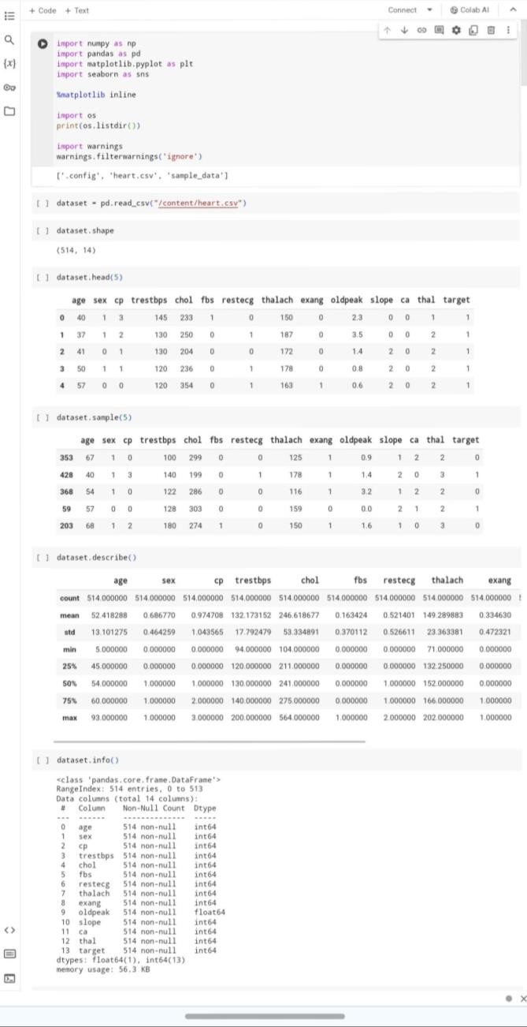

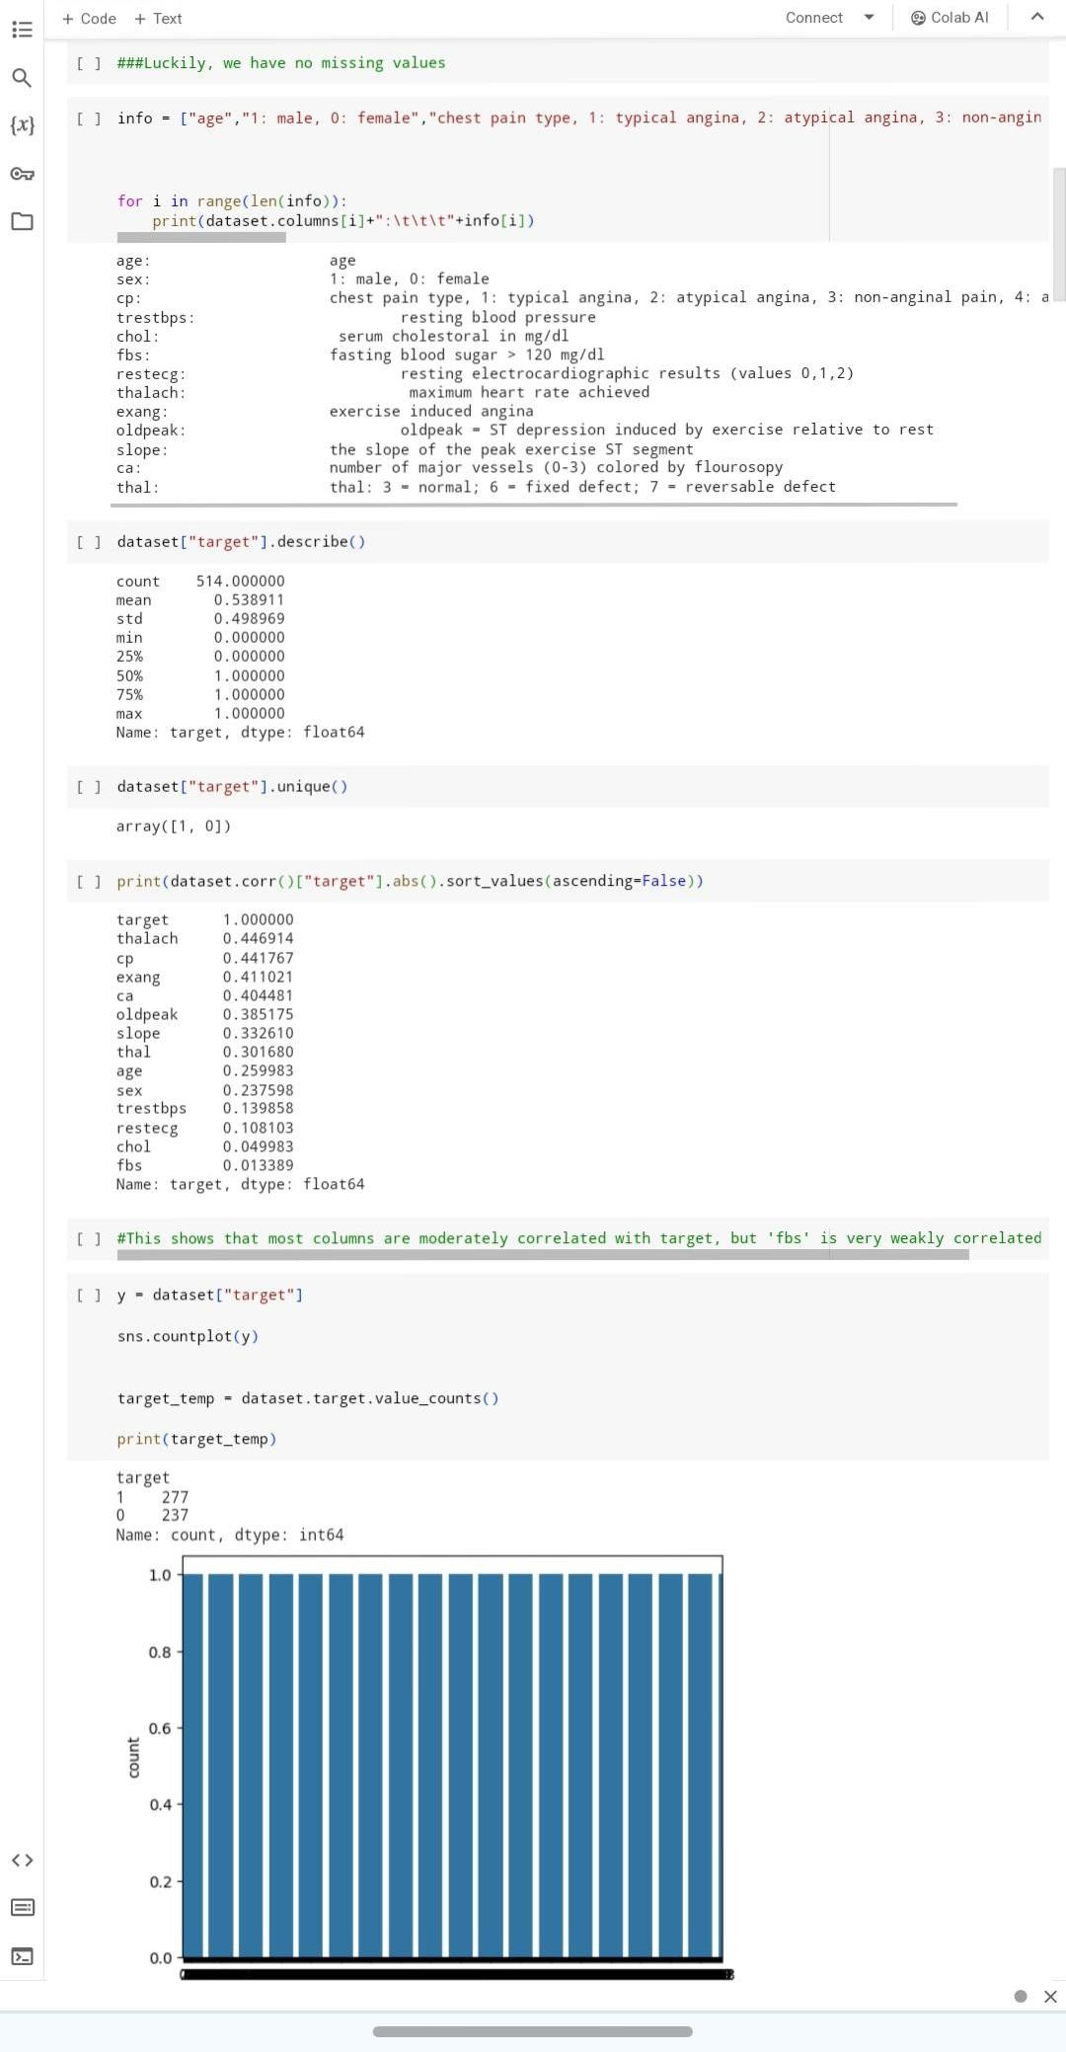

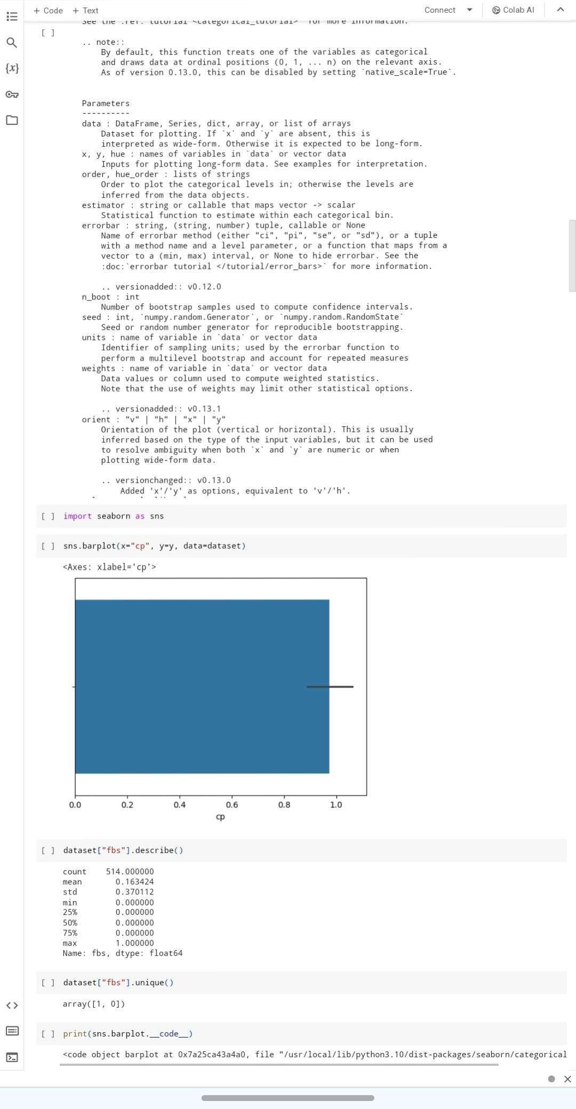

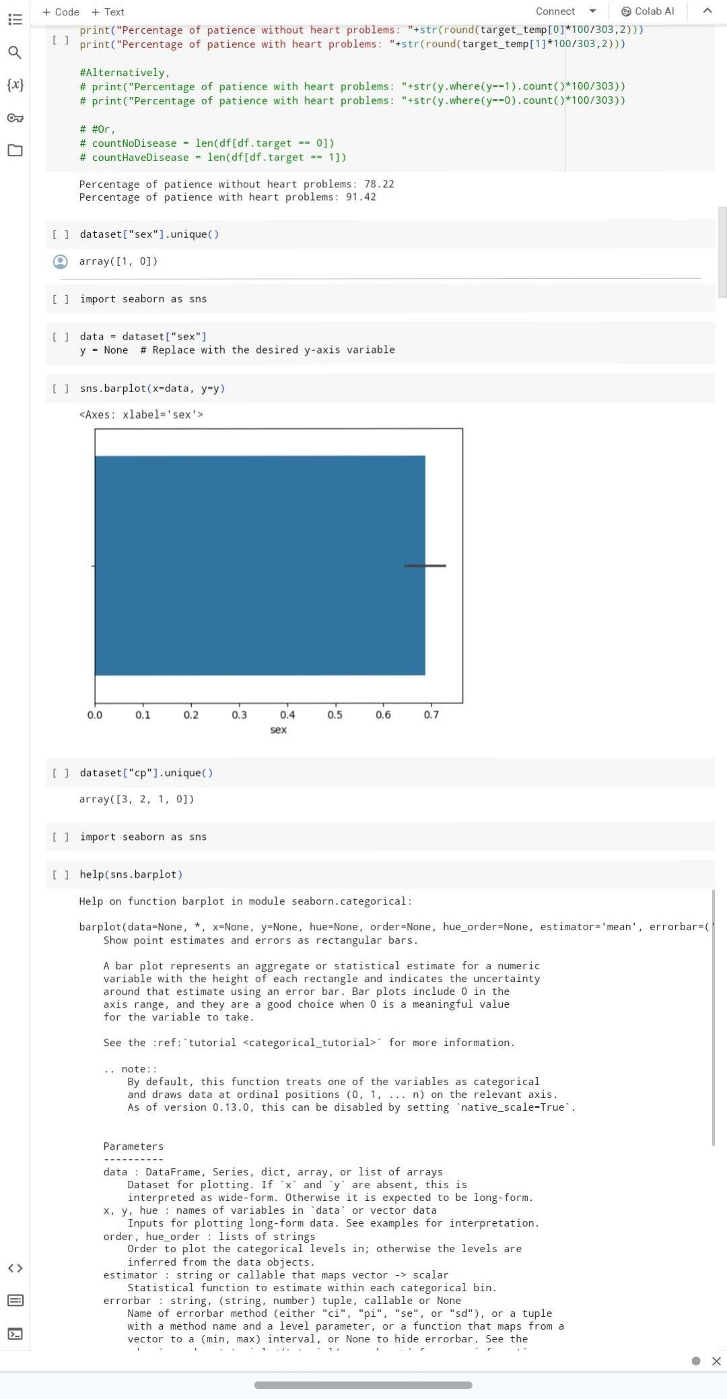

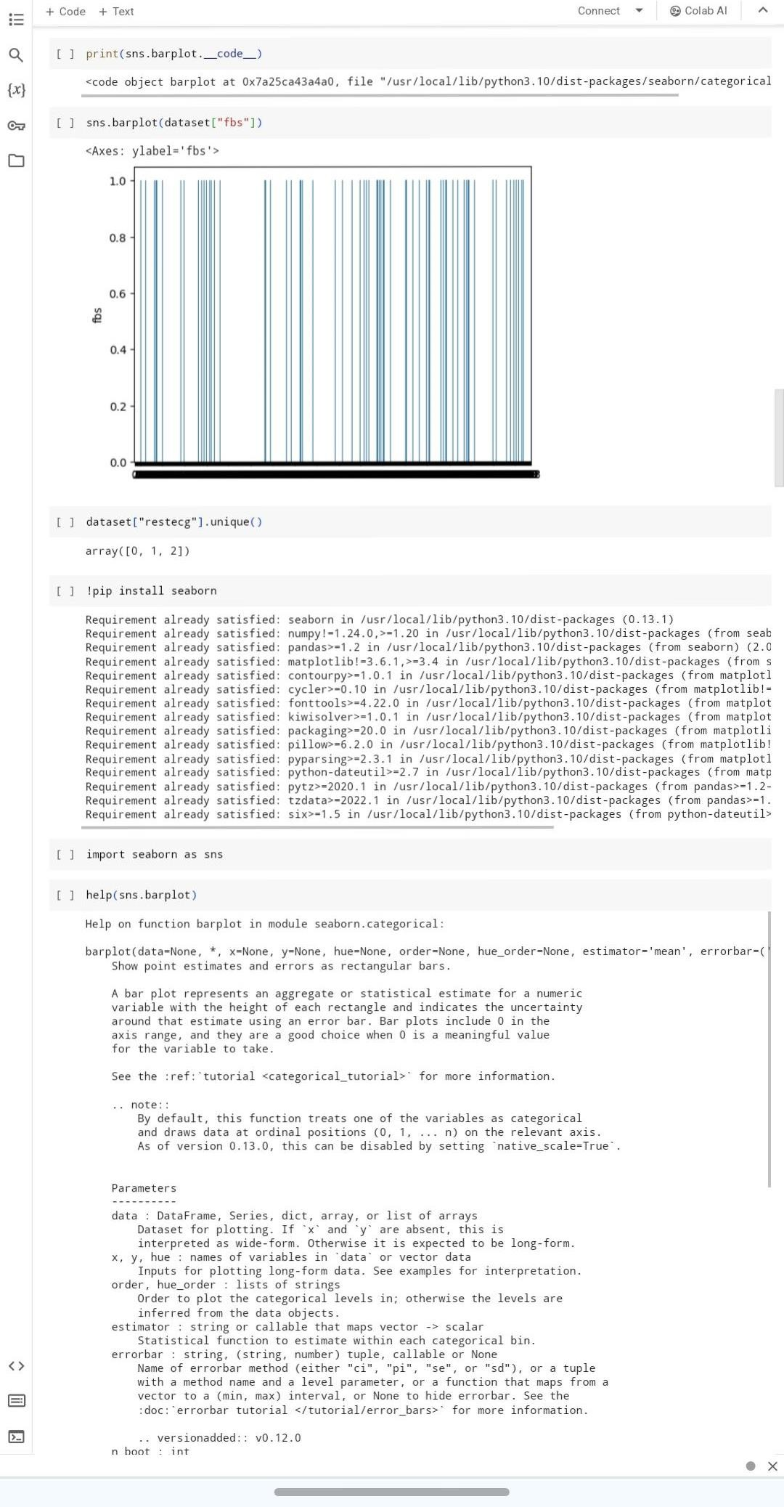

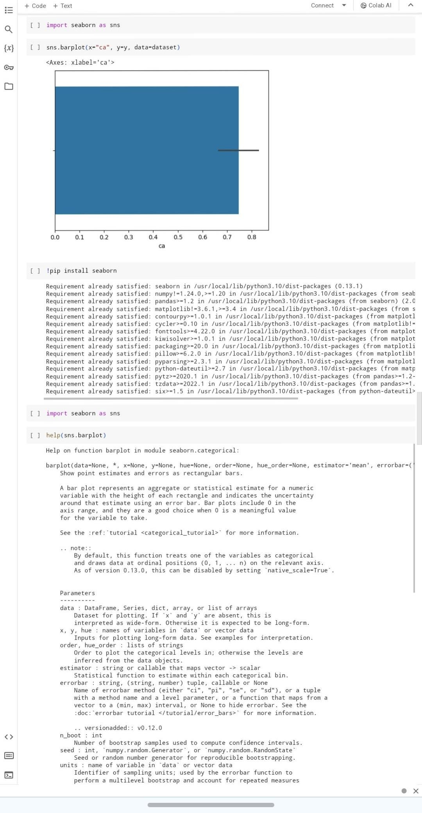

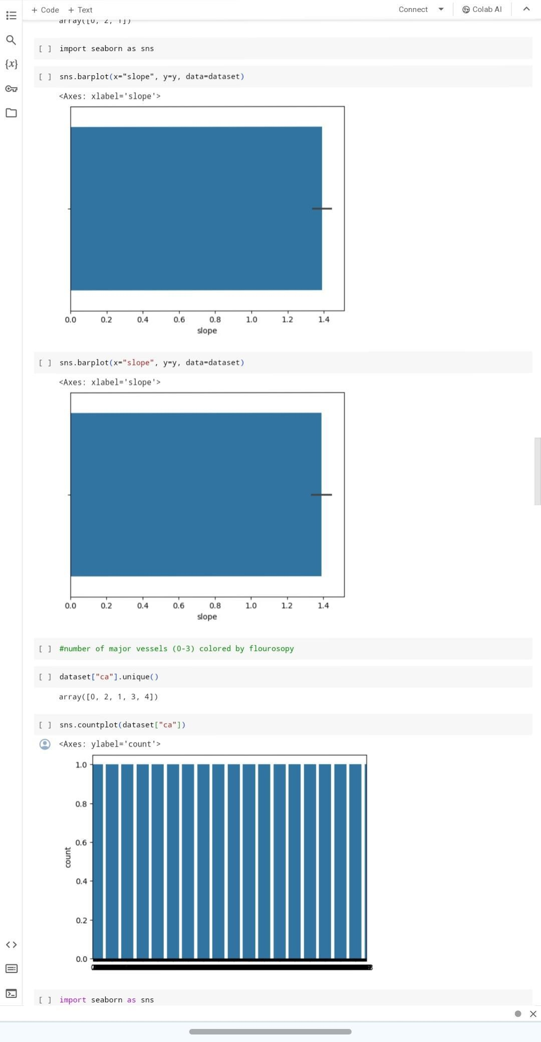

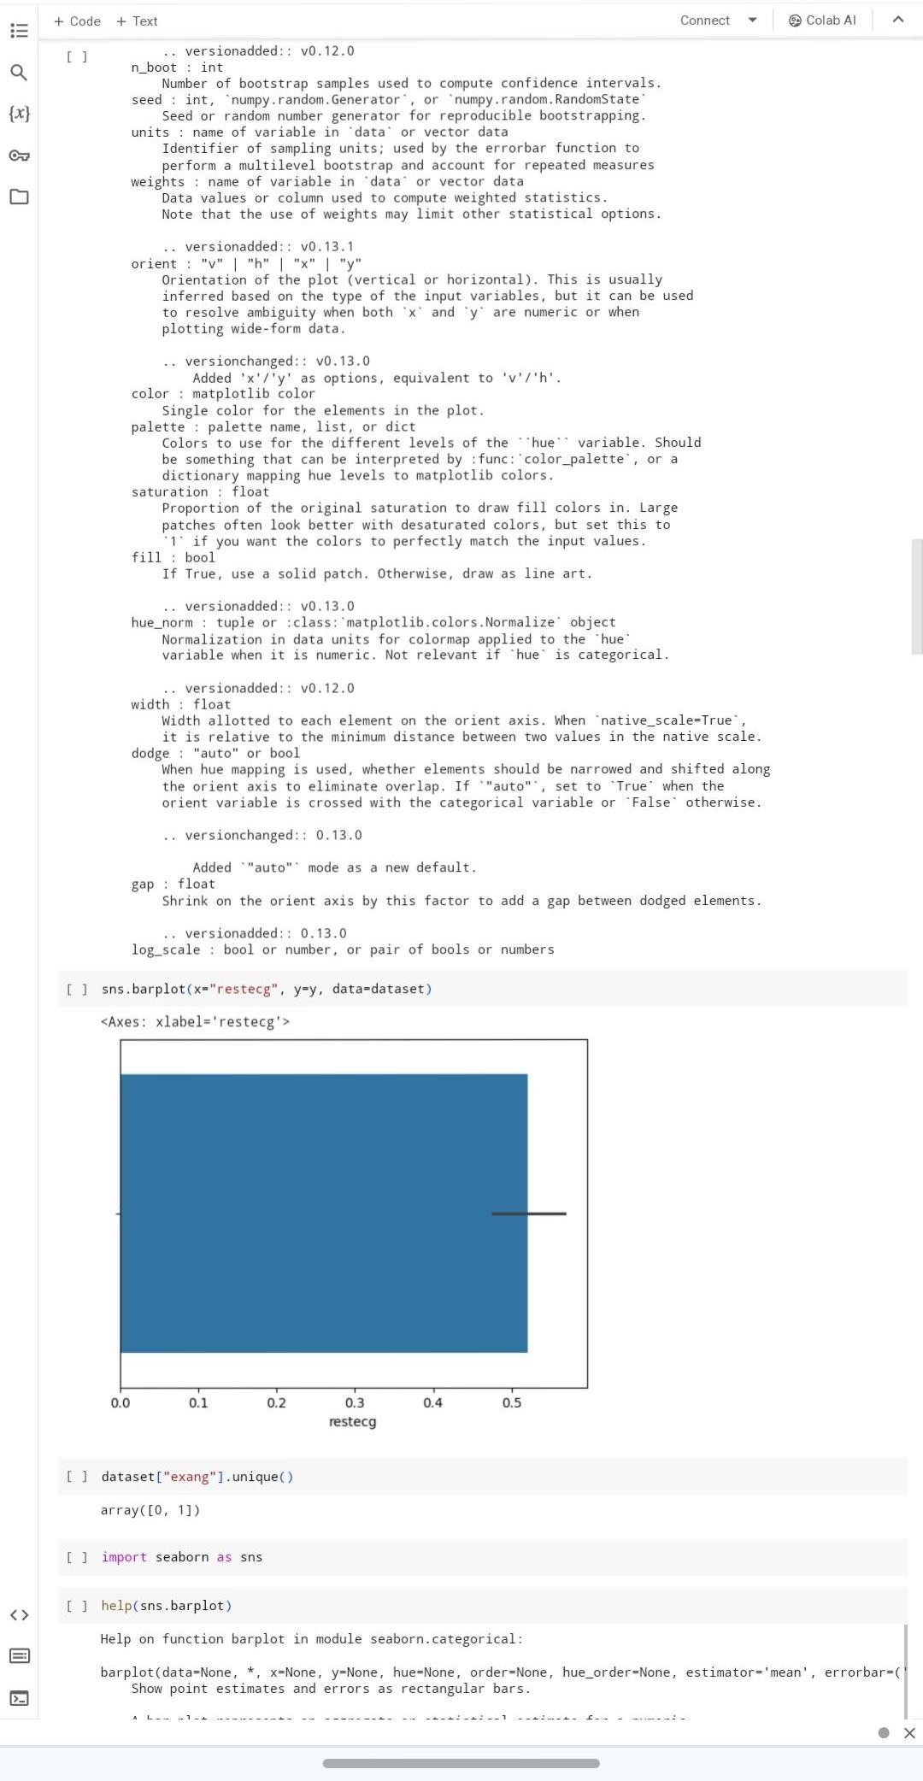

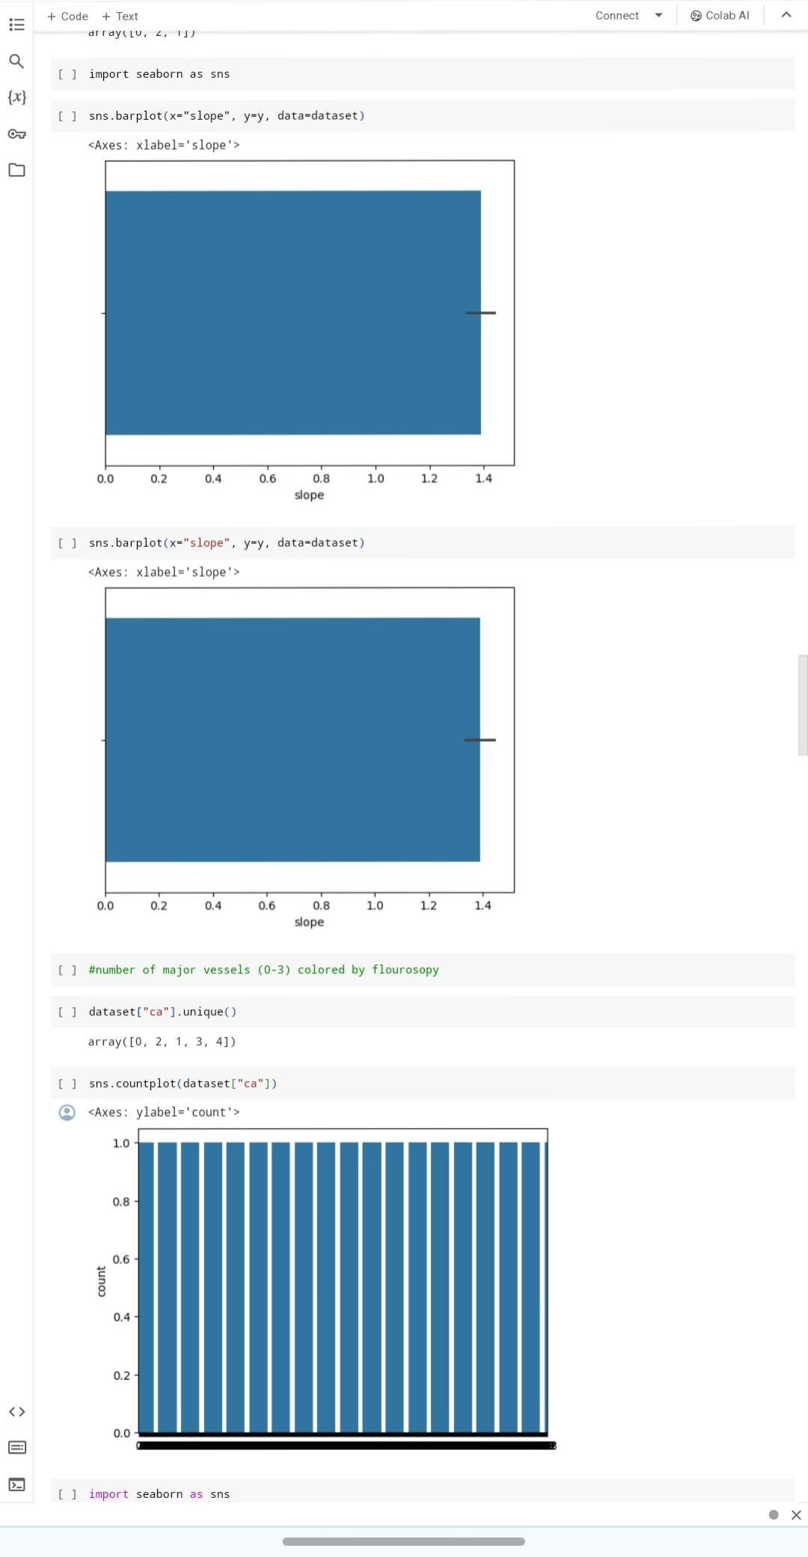

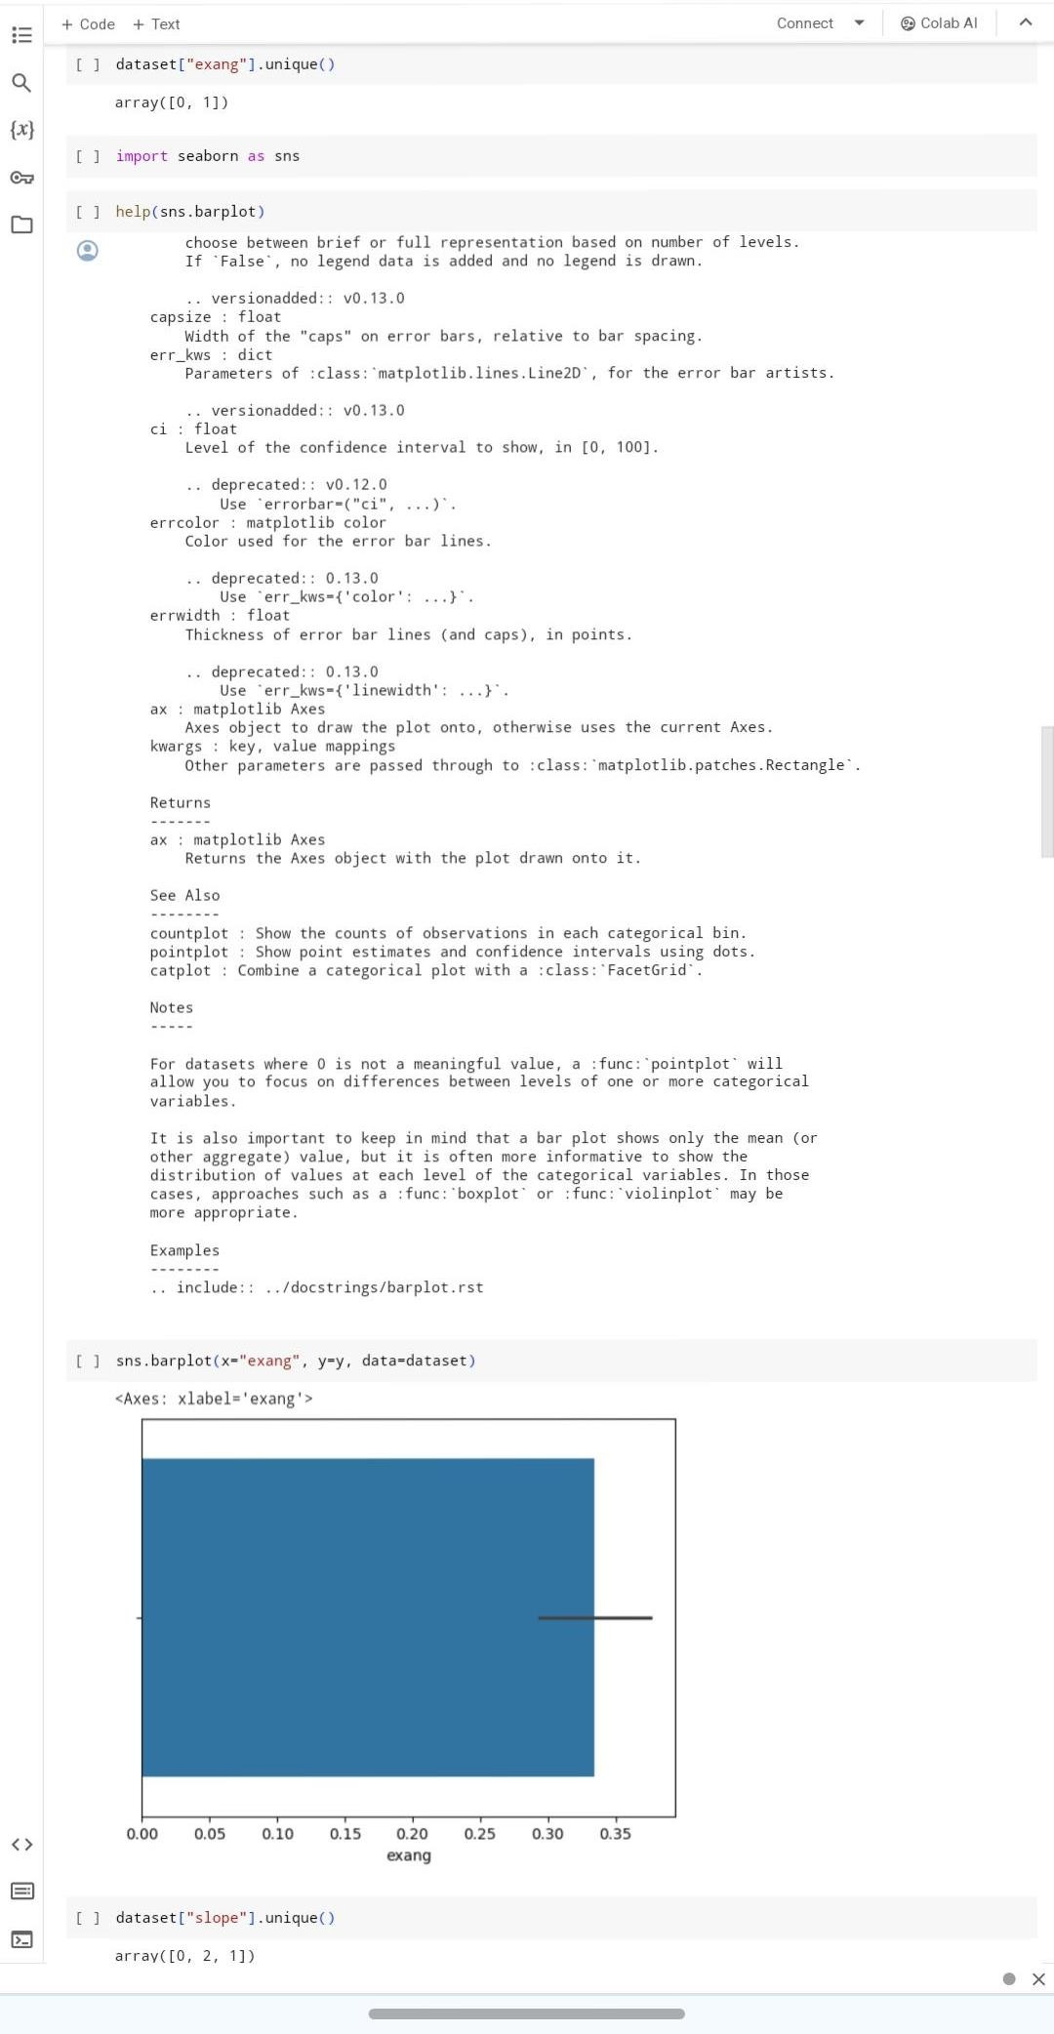

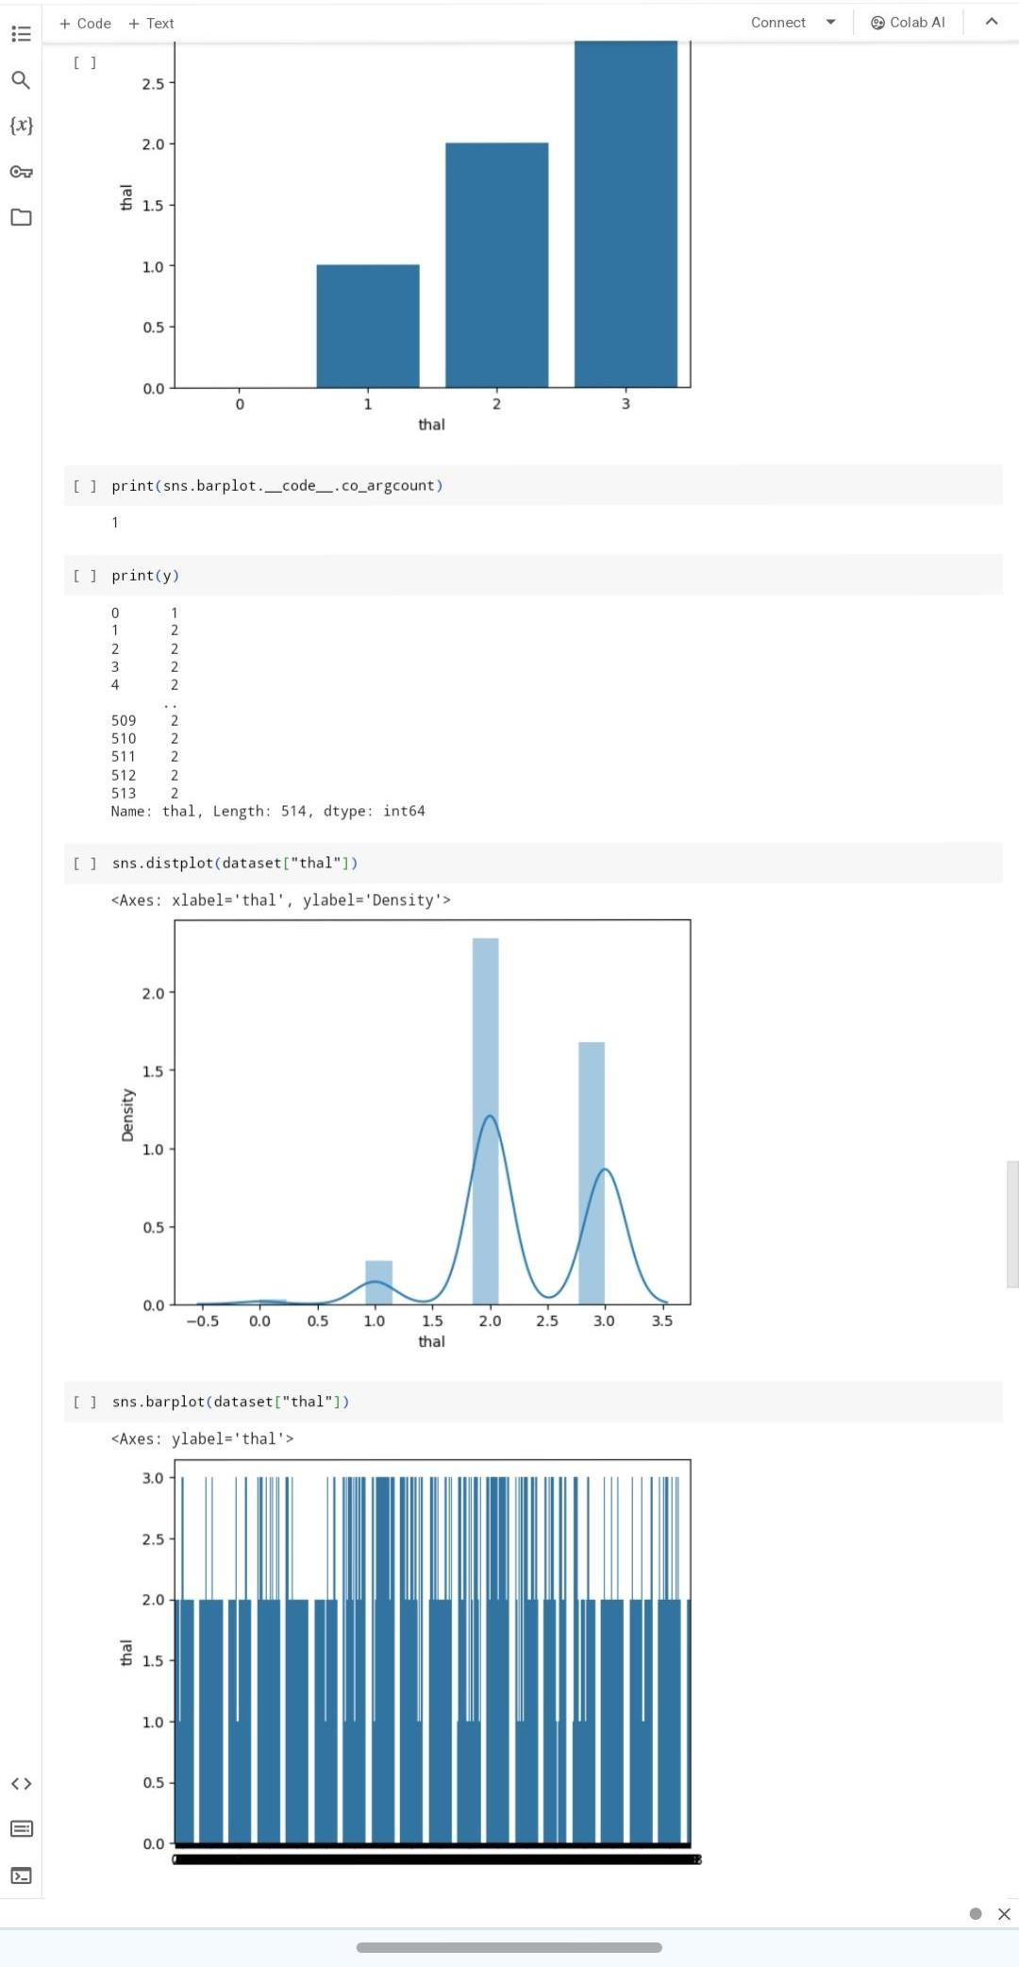

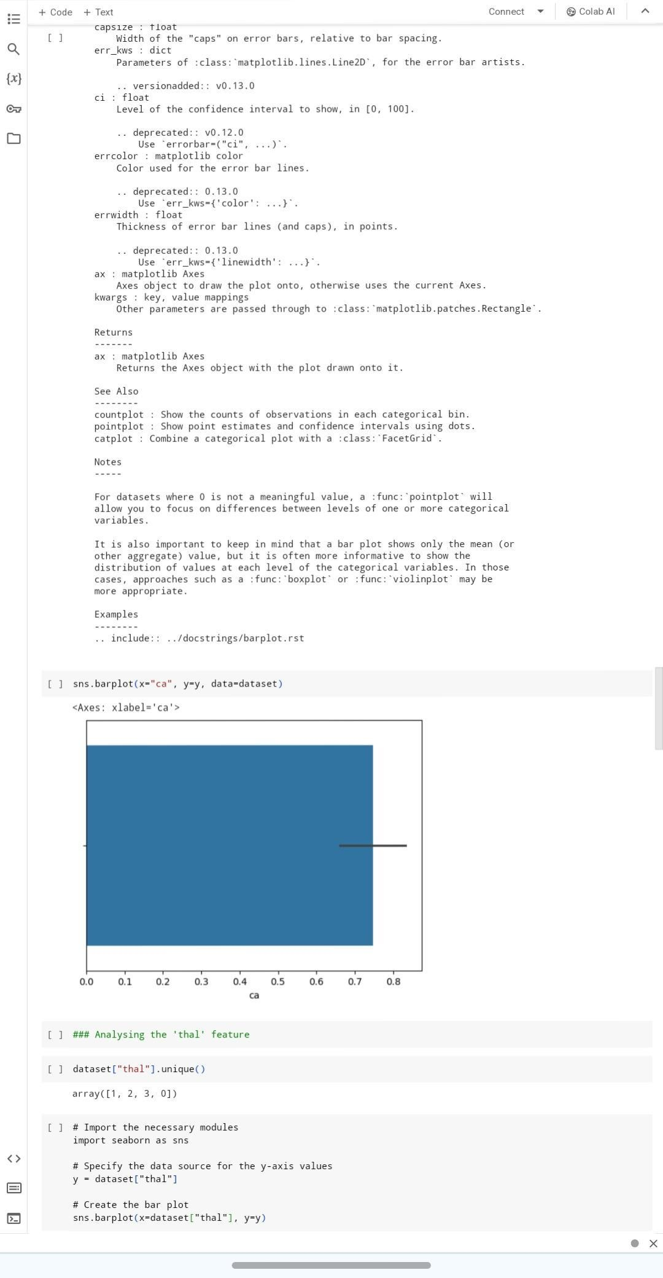

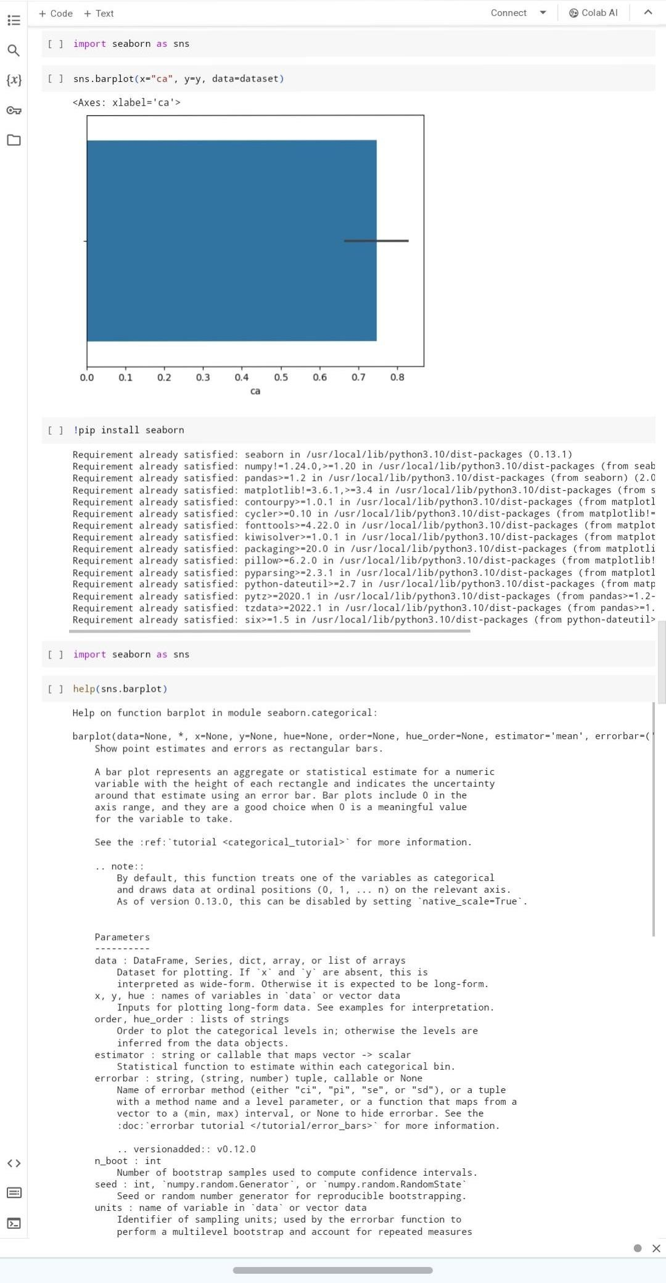

**APP INTERFACE / PROJECT RESULT**

The heart disease prediction project successfully developed a robust model using machine learning algorithms to accurately predict the likelihood of heart disease in individuals. By analyzing a variety of medical data, including demographic information, lifestyle factors, and medical history, the model achieved high accuracy in identifying potential risks. This project has the potential to revolutionize preventative healthcare by enabling early intervention and personalized treatment plans for individuals at risk of heart disease.

**CONCLUSION**

In conclusion, cardiovascular heart disease prediction represents a pivotal area of research and innovation with profound implications for healthcare and public health. By leveraging advanced technologies and interdisciplinary approaches, predictive models have the potential to transform cardiovascular care by enabling early risk identification, targeted interventions, and personalized treatment strategies.

**FUTURE SCOPE**

Cardiovascular heart disease prediction holds immense potential for advancements in technology, healthcare delivery, and public health initiatives.The future scope of cardiovascular heart disease prediction is characterized by innovation, interdisciplinary collaboration, and a patient-centered approach to cardiovascular health management. By harnessing the power of data-driven technologies and advancing precision medicine principles, we can pave the way for more effective prevention, early intervention, and personalized treatment strategies to reduce the global burden of cardiovascular diseases

**REFERENCES**

1. Project Github link, Ramar Bose , 2024
2. Project video recorded link (youtube/github), Ramar Bose , 2024
3. Project PPT & Report github link, Ramar Bose , 2024

**GIT Hub Link of Project Code:**

<https://github.com/abinash2k4/abinash2k4.git>