ABC | ZYZ | TEST | BYE | HELLO | TESTING | BTM
0 | 1 | 2 | 3 | 4 | 5 | 6

for(init ; condition; update)
{
// code
}
Array
String words[] = new String[];
arrayName[index] output
words[0] ABC
words[1] ZYZ
words[2] TEST
words[3] BYE
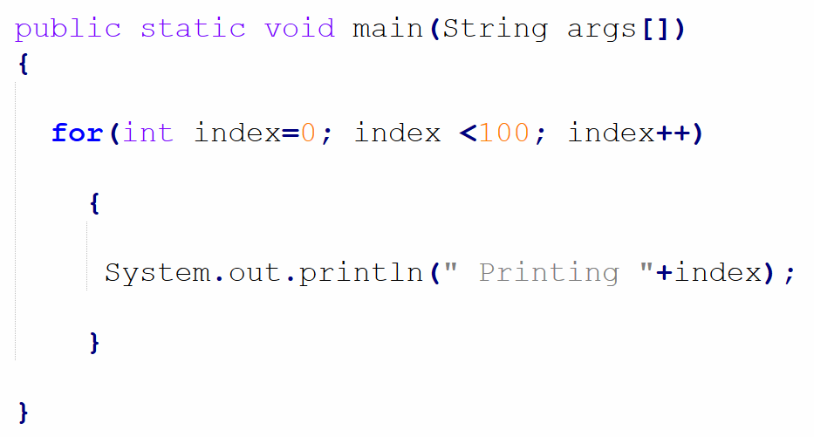
words[999] some word
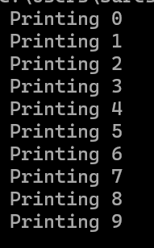
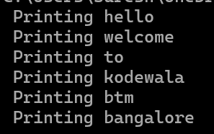
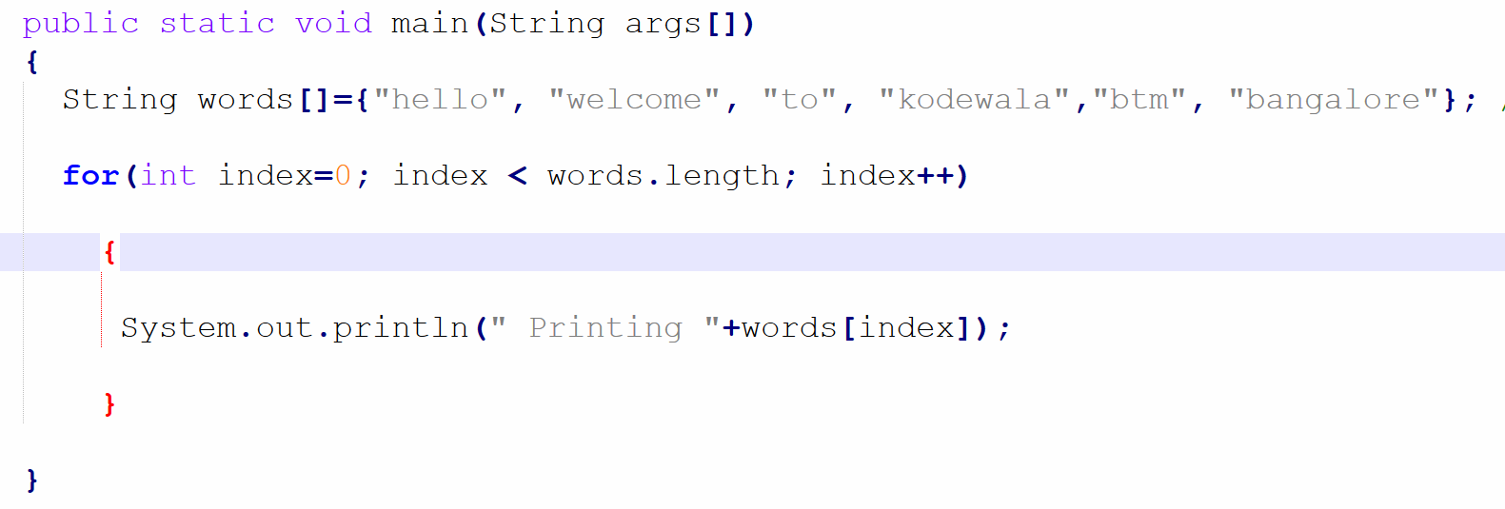

Write a program to find out even numbers a from given int array.
- When do you use for loop ?
program
Fdgadgfd
Gf
Gfadg
gfg
Ans : input size is fixed. read
write
While loop
Program(Youtube comments)

