Do 1st
{
// biz logic
}
While(condition) 2nd

- Use Do While loop and implement the email password reset functionality. If user entered 5-time wrong password then send alert / block the user.
Int case = 3;
Swtch(case)
{
Case : 1
// biz logic call method here
Case :2
// biz logic
Case :3
// biz logic
}
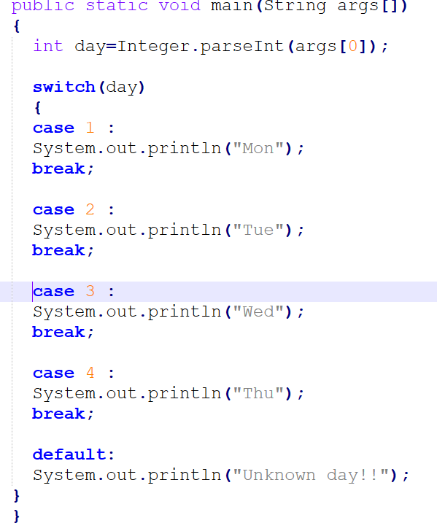

Write an application and allow user to perform activity based on user roles.
USER Allow to view his/her details
ADMIN Allow to view others details as well.
SUPER ADMIN Allow to modify others details.

Continue , Break and Return
Continue if you want to skip the iteration
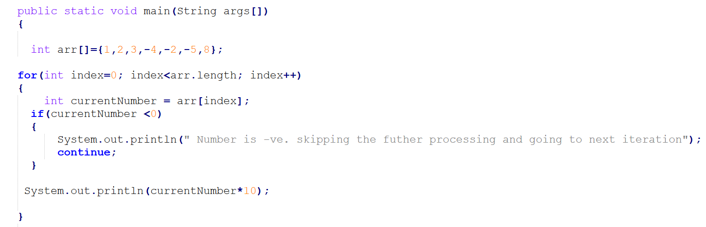

Customers Data(good customer + default) 100k

For()

\
Continue Skipp the current interation
Break exit the loop
Return exit the method.

