String :
- Immutable Once you create, it can not be changed. If you try to change it will create new object.
- Two areas -> 1. SCP(literal) 2.Heap(use new key keyowrd)
- == and equals()

Why String is immutable
- Performance optimization
- Security: password etc.. as string , database details like endpoint /
String pwd = “Test&^%$#@”;

String class is final()
Final class can not be inherited
Final method can not override
Variable final constant

StringBuffer and StringBuilder

- Mutable it allow you to change the object.
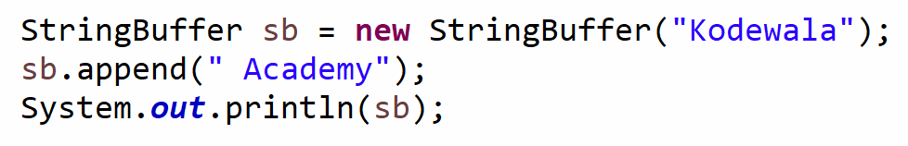

Develop a program for email template creation:
Dear <firstname>,

Thank you for placing order with us. You order summary below.
- <Order number>
- <Date>
- <Amount>
- <Delivery date>

Regards,
Team Zepto
StringBuffer | StringBuilder
Sync(Thread Safe) | Fast and not thread safe.
Slow

